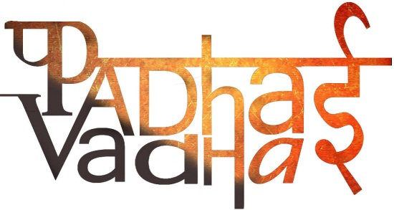

**Chapter 3**

**What is Government?**

1. **What does the term “Government” means?**

Government is the mechanism or groups which governs and implements decisions in an organised manner formed under certain written rules.

1. **What are the two types of Government system?**

Monarchy:- Rural makes all the decisions.

Democracy:- Allows people to choose their representative.

1. **How does a democratic government functions?**

Democratic government functions by passing laws and regulations.

1. **Why democratic government is also called representative government?**

Because laws and regulations are made by the representative selected by the people of the country.

1. **What are the three different levels of Indian Government?**

* The national level government,
* The state level government.
* The District level government.

1. **What does the term “Universal Adult Franchise” means?**

It means all adults those who are above or equal to 18 are allowed to vote.

1. **In case any law is not followed What action can a person take?**

The person has the right to approach if they feel any law is violated.

1. **In the earliest form who were allowed to vote?**

In the earliest form only those men were allowed to vote who owned property and were educated.

1. **What is the need of government in a country?**

Every country needs a government because of following reasons-

* Decisions for country’s Infrastructure.
* To control money flow in the country.
* Decisions on different social issues.
* To run postal and railway services.
* To protect the boundaries of the country.
* To maintain an peaceful relation with other countries.
* To ensure everyone have enough to eat and other facilities.
* To provide aid to disaster affected area.
* Courts are also a part of government.

1. **Why does the government needs to make rules for everyone in the form of laws?**

Government needs to make rules for everyone because of following reasons:-

* It helps in preventing the authority from the misuse of their powers.
* It helps in the functioning of the government.
* It helps the people in leading their normal and peaceful life. It ensures the security of the nation and its people.

1. **What was the suffrage movement?**

Suffrage means right to vote.

It gave right to vote to the America women in 1920 and women in the UK got to vote on the same terms as men in 1928.