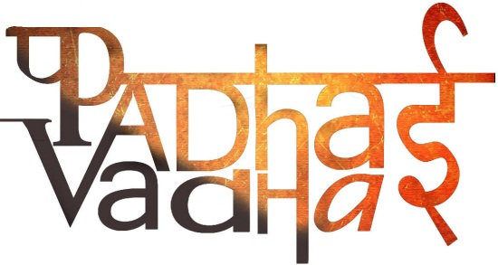

**CHAPTER-6**

**UNDERSTANDING MEDIA**

Qs 1. What is media?

Ans. It is the plural form of medium and it describes the various ways through which we communicate in society. Media refers to all means of communication and thus everything ranging from a phone call to the evening news on the TV, radio and newspapers are a form of media.

Qs 2(Imp). What do you mean by mass media?

Ans. A form of media that reaches millions of people, or the masses, across the country and the world are called mass media. EG: TV, radio and newspapers.

Qs 3. Newspapers and magazines are called ____ media.

Ans. Print

Qs 4. TV and radio are called ______ media.

Ans. Electronic

Qs 5. Television images travel huge distances through _____.

Ans. Satellite and cables

Qs 6. “Television has brought the world closer to us.” Explain.

Ans. Television has enabled us to think of ourselves as members of a larger global world. It allows us to view news and entertainment channels from other parts of the world. Even at sitting at our homes we can see images of a storm that has hit the coast of Florida in United States. Thus, television has brought the world closer.

Qs 7(Imp). Why television channels and newspapers are a part of big business houses?

OR

“The technologies that mass media use are expensive.” Comment.

Ans. In a news studio, it is not only the newsreader who needs to be paid but also a number of other people who help put the broadcast together. Also, since mass media use keeps changing and so a lot of money is spent on getting the latest technology. Due to these, the mass media needs a great deal to do its work.

Qs 8.How does the mass media earns money?

Ans. Mass media earns money by advertising different things like cars, chocolates, clothes, mobile phones, etc.

Qs 9(Imp). In what ways the media play an important role in a democracy?

Ans. It is on the basis of the information given by the mass media that citizens can learn how government works. They can take action on the basis of these news stories. They can do so by writing letters to the concerned minister, organizing a public protest, starting a signature campaign, asking the government to rethink its programme, etc.

Qs 10. What is a balanced report?

Ans. A balanced report is one that discusses all points of view of a particular story and then leaves it to the readers to make up their minds.

Qs 11(Imp). What is the role of an independent media in a democracy?

OR

Why there is a need for an independent media in democracy?

Ans. Writing a balanced report depends on the media being independent. An independent media means that no one should control and influence its coverage of news. No one should tell the media what can be included and what should be included in a news story.

Since it is on the basis of the information that the media provides that we take action as citizens, so it is important that his information is reliable and not biased.

Qs 12. What is censorship?

Ans. This refers to the powers that government has to disallow media from publishing or showing certain stories. EG: A news item, scenes from a movie or the lyrics of a song being shared with the larger public.

Qs 13(Imp). Despite the absence of censorship by the government, most newspapers nowadays still fail to provide a balanced story. Why?

Ans. Persons who research the media have said that this happens because business houses control the media. At times, it is the interest of these businesses to focus on only one side of the story. Media’s continual need for money and its links to advertising means that it becomes difficult for media to be reporting against people who give them advertisements. Media is, thus, no longer considered independent because of its close links to business.

Qs 14(Imp). Why it is often said that the media sets the agenda?

Ans. The media plays an important role in deciding what stories to focus on, and therefore, decides on what is newsworthy. Due to the significant influence it plays in our lives and in shaping our thoughts, it is commonly said that the media sets the agenda.