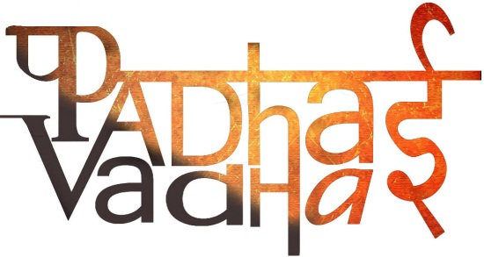

**Chapter 16**

**Water: A Precious Resource**

**1. What is water cycle?**

Ans. It is the process by which water circulates between earth’s oceans, atmosphere and land and involves processes like evaporation and transpiration.

**2. What are different forms of water?**

Ans. There are 3 different forms of water i.e.,

1. Solid
2. Liquid
3. Gas

**3. Where we can find water in its solid form?**

Ans. The solid form, snow and ice, is present as ice caps at the poles of the earth, snow-covered mountains and glaciers.

**4. What are major sources of liquid form of water?**

Ans. Liquid water is present in oceans, lakes, rivers, and even underground.

**5. What is water table?**

Ans. The upper limit of the layer where we can find water is referred as water table.

**6. Define groundwater.**

Ans. Water held underground in the soil and found below the water table is called groundwater.

**7. What is infiltration?**

Ans. The process of seeping (or draining) of water into the ground is called infiltration.

**8. What are the major causes of the depletion of water table?**

Ans. Rapid growth of industries, increasing population, growing irrigation requirements and scanty rainfall are some of the causes for depletion of water table.

**9. What is rainwater harvesting?**

Ans. It is the process by which rainwater is used to recharge the groundwater.

**10. What is drip irrigation?**

Ans. Drip irrigation is a technique of watering plants by making use of narrow tubings which deliver water directly at the base of the plant.