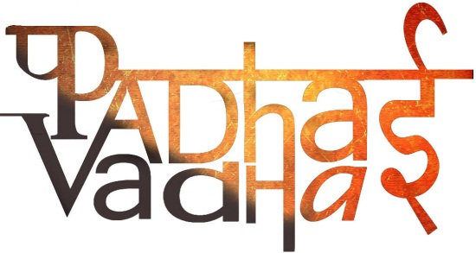

CH10 - Eighteenth Century Political Formations

Question 1.Who was the founder of Hyderabad?

A1.Asaf Jah or Chin Quilich Khan who gave himself title as Nizam-ul-Mul.

Question 2.Name the affairs of the province of Awadh for which Burhan-ul-Mulk Sa‘adat Khan was responsible to manage?

A2.Political

Financial

Military

Question 3.Which was the most prosperous region of India?

A3.Bengal

Question 4.Name the states which were carved out of the old Mughal provinces in the eighteenth century.

A4.Awadh

Bengal

Hyderabad

Question 5.In which year Aurangzeb died

A.1707

Question 6.In which year Burhan-ul-Mulk Sa‘adat Khan was appointed the subadar of Awadh?

A6.1722

Question 7.Guru Gobind Singh asked his Sikh men to wear how many sacred symbols?

A7. Five

Question 8.During the period of later Mughals, which Iranian ruler invaded Delhi?

A8.Nadir Shah in 1739

Question 9.who were misls? How many such political groups  were formed by the Sikhs?

A9. Sikhs organized themselves into smaller groups. These groups were called Jathas or Misls.  
Twelve misls were formed.

Question 10.which system was devised by the Sikhs that offered protection to cultivators on the payment of a tax of 20% of the produce?

*A10.Rakhi*

Question 11.Who was the last of the powerful Mughal rulers?

A11.Aurangzeb

Question 12.In which year Third Battle of Panipat took place ?

A12.1761

Question 13.Aurangzeb had lost the military and financial resources of his empire by fighting a long war in the _______?

A13.Deccan

Question 14.When was Khalsa instituted? Who founded its institution?

A14.1699  
Guru Gobind singh founded its institution.

Question 15.Who founded the city of Jaipur in Rajasthan?

A15.Sawai Raja Jai Singh

Question 16.Who was the governor of Bengal under the Mughals?

A16.Murshid Quli Khan

Question 17.Shivaji adopted the title of Chhatrapati in which year?

A17.1674

Question 18.Taxes levied by the Maratha king were called as

*A18.Chauth* and *Sardeshmukhi*

Question 19.Which Rajput ruler held the governorship of Gujarat in the eighteenth century?

A19.Raja Ajit Singh

Question 20.Who were the Jats? Name two prominent Jat leaders of the seventeenth and eighteenth centuries.  
  
A20.Jats were prosperous agriculturists who became an important community in the late seventeenth century.   
Two of its prominent leaders were:-  
-Churaman   
-Suraj Mal.  
  
Question 21.Who were Later Mughals?  
  
A21.The Mughal successors of Aurangzeb were known as Later Mughals. Mughal empire declined in their reigns.  
  
  
  
Question 22.which Afghan ruler invaded north India five times in Later Mughals period?  
  
A22. Ahmad Shah Abdali (between 1748 and 1761).  
  
  
Question 23. Name two powerful groups who controlled Mughal emperors .  
  
A23. The Iranis and Turanis (nobles of Turkish descent).  
  
  
  
  
Question 24. Name the founder of Maratha empire?  
A24.Shivaji

Question 25. Name the Jat king under whose leadership the kingdom of Bharatpur emerged as a strong state.  
A25.Suraj Mal

Question 26. Name the founder of the Sikhism?  
A26.Guru Nanak Dev

Question 27. What do you mean by Watan Jagirs?  
A27. States that had enjoyed considerable independence under the Mughals as watan jagirs.   
-These included several Rajput principalities (e.g. Marwar,Jodhpur).

Question 28.The state of Hyderabad was constantly engaged in a struggle against which kingdoms?  
  
A28.-The Marathas to the west  
-independent Telugu warrior chiefs (nayakas) of the plateau. -British of the Coromandel coast in the east.  
  
Question 29. Who found the state of Bengal after breaking away from Mughal control?  
A29.Murshid Quli Khan  
  
  
Question 30. Under whose reign the banking house of Jagat Seth became extremely prosperous.  
A30.Alivardi Khan  
  
Question 31. After the death of Guru Gobind Singh, who led the revolt against Mughal empire?  
A31.Banda Bahadur  
  
Question 32.Who were deshmukhs?  
A32.Powerful Maratha warrior families were known as deshmukhs.

Question 33.What was *Chauth*?  
A33. It was 25 per cent of the land revenue claimed by zamindars. In the Deccan this was collected by the Marathas.  
  
  
Question 34. Name the Jat king under whose leadership, Jats acquired the region between Delhi and Agra in 1680s?  
A34.Churaman