Week_8_Homework

Olivia Townsend

10/18/2017

# Import the temperature data from all 12 trials into a data frame called "temp"

### Use a for loop to convert the DateTime column into POSIX time values, calculate elapsed time, and make elapsed time a numeric value in a new column for each temperature trial. Also create a new column in "temp" to accomodate the trial number. Then rbind the new data in temp into the data frame "res".

fnames = dir("../data/temperature_trials",pattern = "*.csv",full.names = TRUE)  
for (i in 1:length(fnames)){  
 # open each file in turn  
 temp = read.csv(fnames[i])  
 # temp$TrialNumber =   
 temp$DateTime = as.POSIXct(temp$DateTime,origin = '1970-1-1',tz="")  
 temp$elapsedTime = difftime(temp$DateTime, temp$DateTime[1], units = 'mins')  
 temp$elapsedTimeMin = as.numeric(temp$elapsedTime)  
 # Grab the trial number  
 loc = regexpr(pattern = "Trial[0-9]*", text = fnames[i])  
  
 trialNumber = as.numeric(substr(fnames[i],start = loc[[1]][1]+5, stop = loc[[1]][1]+attr(loc,'match.length')-1))  
 temp$trialNumber = trialNumber  
   
 # rbind the new data in temp to the previous data in res  
 if (i==1){  
 res = temp  
 } else {  
 res = rbind(res,temp)  
 }  
   
}  
  
res$POSIXt = as.POSIXct(res$POSIXt,origin = '1970-1-1',tz='')

# Create a plot of all the temperature data from channel TC0 for each trial number

### First make an inital line graph of elapsed time versus temperature for trial 1 with proper labels and scales. Then make a for loop to add lines for trials 2-12 and have the line color change with each trial.

# make initial plot for trial 1  
plot(res$elapsedTime[res$trialNumber==1],res$TC0[res$trialNumber==1],type="l",xlab = "Elapsed Time, minutes", ylab = "Temperature, C",las=1,xlim = c(min(res$elapsedTimeMin),max(res$elapsedTimeMin)),ylim = c(min(res$TC0),max(res$TC0)))  
mtext(text = "Channel TC0 for each Trial", line = 1)  
# for loop to add lines for trial 2-12 and change line color each time  
trialNums = unique(res$trialNumber)  
for (y in 2:length(trialNums)){  
 lines(res$elapsedTimeMin[res$trialNumber==trialNums[y]], res$TC0[res$trialNumber==trialNums[y]],col = y)  
}

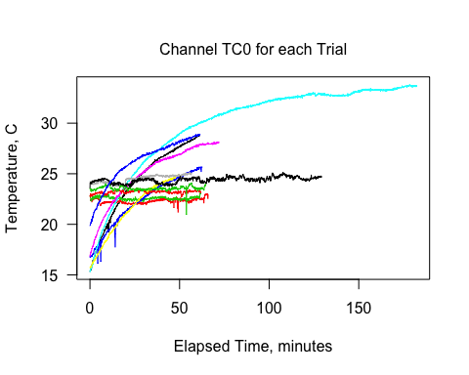

# Create a plot of temperature data from location In50 for each trial number

### First import the heating trial info which contains the location data. Use a for loop to extract the channel number for location In50 for each trial. Keep in mind the channel number for location In50 is going to vary depending on the trial number. Assign the temperature values to a dataset called "temps" and the corresponding elapsed time values into one called "times". Similar to the previous plot, the logic is to create an inital line graph for the first trial and add lines for the remaining trials. Execute this using an "if" statement for when x (the trial number) equals 1 to plot the "times" versus "temps" with proper labels and scales. Then use "else" (so when x does not equal 1) to add lines and have them change color with each trial.

library(xlsx)

## Loading required package: rJava

## Loading required package: xlsxjars

# import heating trial info  
heatinfo=read.xlsx("../data/Heating_trial_info.xlsx", sheetIndex = 1)  
heatinfo$TCchannel = as.character(heatinfo$TCchannel)  
# extract the channel number for location In50 from each trial  
for (x in 1:max(which(heatinfo$TrialNumber==12))){  
 if (heatinfo$TCLocation[x] == "In50"){  
 chloc = regexpr(pattern = "[[:digit:]]",heatinfo$TCchannel[x])  
 chNum = substr(heatinfo$TCchannel[x], start = chloc[[1]][1],stop = chloc[[1]][1])  
 chName = paste("TC",chNum,sep = "")  
 trialNumber = heatinfo$TrialNumber[x]  
   
 temps = res[res$trialNumber==trialNumber,chName]  
 times = res$elapsedTimeMin[res$trialNumber==trialNumber]  
# plot trial 1 first then add lines for remaining trials   
 if (x==1){  
 plot(times, temps,type="l",xlab = "Elapsed Time, minutes", ylab = "Temperature, C",las=1,xlim = c(0,180),ylim = c(15,35))  
 mtext(text = "Location In50 for each Trial Number", line = 1)  
 } else {  
 lines(times,temps,col = x)  
 }  
}  
}

