Rolling stock data for traction power simulation
Sample 6-car metro. Replace the values with the manufacturer's data. The model reads 'Parameter : value unit' lines, two-column parameter tables, curve tables with a Speed column, Word charts, and graph images (axes calibrated in the digitiser).

1. General data
Parameter | Value | Unit
Number of cars | 6
Number of traction motors | 16
Train length | 132 | m
Simulation mass (AW3, crush load) | 260 | t
Rotating mass allowance | 8 | %
Maximum operating speed | 80 | km/h
Starting acceleration | 1 | m/s²
Service braking rate | 1 | m/s²
Emergency braking rate | 1.3 | m/s²
Auxiliary power per car | 40 | kW per car
Nominal line voltage | 750 | V DC
Maximum regenerative braking power | 3500 | kW

Running resistance (Davis): R = A + B·v + C·v² with A = 3.5, B = 0.03, C = 0.0007 (kN, v in km/h)

2. Tractive and electric braking effort (whole train, at wheel)
Speed (km/h) | Tractive effort (kN) | Electric braking effort (kN) | Drive efficiency (%)
0 | 290 | 0.0 | 75.0
10 | 290 | 290.0 | 82.0
20 | 290 | 290.0 | 86.0
30 | 290 | 290.0 | 88.0
36 | 290 | 290.0 | 88.0
40 | 261 | 275.7 | 88.0
50 | 208.8 | 240.0 | 88.0
60 | 174 | 210.0 | 88.0
70 | 127.8 | 180.0 | 88.0
80 | 97.9 | 155.0 | 88.0
90 | 77.3 | 140.0 | 88.0

3. Tractive effort graph
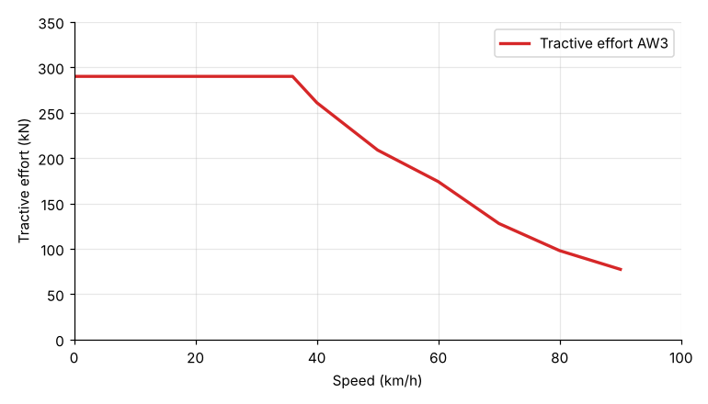
Graph image: X axis 0 - 100 km/h, Y axis 0 - 350 kN (plot frame edges). Use these values when calibrating the digitiser.

