Database Schema Design
Cash Management System

Document Version: 1.0
Date: July 2026
Prepared By: Osama Drbas
Status: Under Review
Related Documents:
- 01-requirements-analysis.docx
- 02-system-architecture.docx
- 04-ui-wireframes.docx

Contents
1. Introduction 1
1.1 Purpose 1
1.2 Scope 1
1.3 Database Technology 2
1.4 Design Principles 2
2. Database Design Overview 3
2.1 Entity Categories 3
2.2 Database Diagram Overview 4
3. Entity Relationship Diagram (ERD) 7
3.1 Complete Entity Relationship Diagram 7
3.2 Relationship Summary 7
4. Table Definitions 7
4.1 Users Table 7
4.2 Roles Table 7
4.3 Categories Table 7
4.4 Orders Table 9
4.5 Order Items Table 12
4.6 Documents Table 14
4.7 Daily Movements Table 15
4.8 Audit Logs Table 17
4.9 Notifications Table 19
4.10 Company Settings Table 20
5. Relationships and Constraints 22
5.1 Foreign Key Constraints 22
5.2 Check Constraints 22
5.3 Referential Integrity Rules 24
6. Indexes and Performance 24
6.1 Index Strategy Overview 24
6.2 Query Optimization Strategy 26
6.3 Estimated Performance Targets 27
7. Sample Data 28
7.1 Sample User Data 28
7.2 Sample Category Data 29
7.3 Sample Order Data 30
7.4 Sample Daily Movement Data 32
8. Migration Strategy 32
8.1 Migration Process 32
8.2 Migration Naming Convention 33
8.3 Rollback Procedure 34
9. Backup and Recovery 35
9.1 Backup Types 35
9.2 Backup Storage Locations 35
9.3 Recovery Time Objectives 36
10. Security Considerations 36
10.1 Data Security Measures 36
10.2 User Access Levels 37
10.3 Audit and Compliance 37
11. Appendix: Complete Schema Reference 38
11.1 Table Summary 38
11.2 Key Business Rules Summary 39

1. Introduction

1.1 Purpose
This document describes the database schema design for the Cash Management System. It provides a detailed view of all tables, fields, relationships, constraints, and indexes. This document serves as the blueprint for database implementation and data management.

1.2 Scope
The database design covers:
- All entities and their attributes
- Relationships between entities
- Primary and foreign keys
- Data types and constraints
- Indexes for performance
- Sample data examples
- Migration strategy

1.3 Database Technology
Aspect | Choice | Justification
Database Management System | PostgreSQL 15+ | ACID compliance, robust, open source, excellent JSON support
Character Encoding | UTF-8 | Supports Arabic and multilingual data
Collation | Arabic_CI_AS | Arabic language support with case-insensitive search

1.4 Design Principles
Principle | Description | Implementation
Normalization | 3rd Normal Form (3NF) | Reduces data redundancy and ensures data integrity
Data Integrity | Referential integrity enforced | Foreign key constraints ensure accurate relationships
Performance | Proper indexing strategy | Indexes on frequently queried columns
Scalability | Partition-ready design | Tables designed for future partitioning
Auditability | All changes tracked | Audit logs for all critical operations
Security | Data encryption and access control | Encrypted sensitive data, role-based access

2. Database Design Overview

2.1 Entity Categories
The database consists of three main categories of entities:
1. Master Data Entities
Entities that store core, relatively static information about the system, users, and business structure. These are typically set up once and rarely change.
Entity | Purpose | Key Fields
Users | System users and their credentials | username, email, password_hash, role_id
Roles | User permissions and access levels | name, permissions (JSON)
Categories | Income/expense classification | name, type, parent_id
Company Settings | System configuration | company_name, currency, timezone

2. Transaction Entities
Entities that record business transactions and daily operations. These are created frequently as users interact with the system.
Entity | Purpose | Key Fields
Orders | Main transaction record | order_number, type, amount, status
Order Items | Individual line items | category_id, description, amount
Documents | Attached files for orders | file_name, file_path, uploaded_by
Daily Movements | Daily cash flow tracking | transaction_date, amount, balance_after

3. Supporting Entities
Entities that provide audit, notification, and supporting functionality.
Entity | Purpose | Key Fields
Audit Logs | System activity tracking | user_id, action, table_name, old_data, new_data
Notifications | User alerts and messages | user_id, title, message, type

2.2 Database Diagram Overview
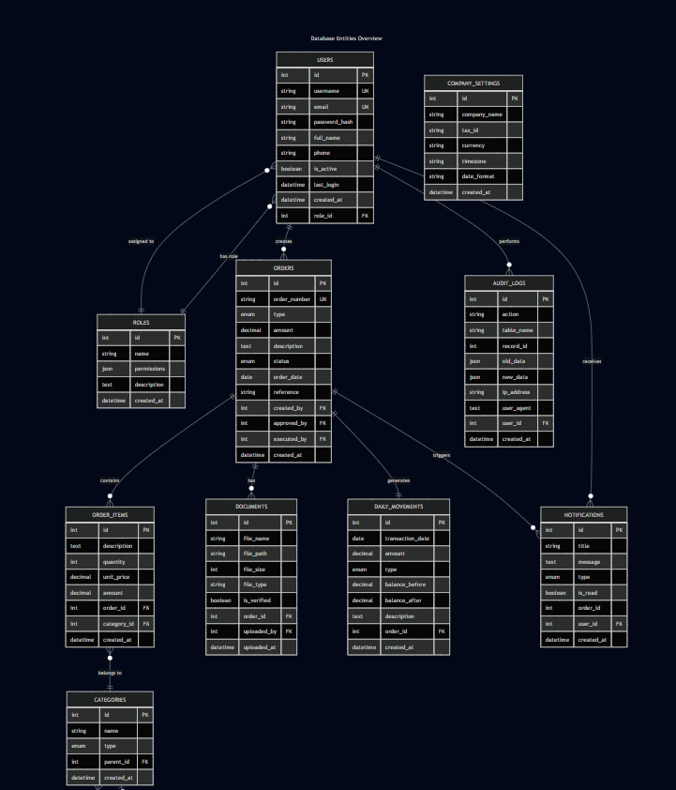

3. Entity Relationship Diagram (ERD)

3.1 Complete Entity Relationship Diagram
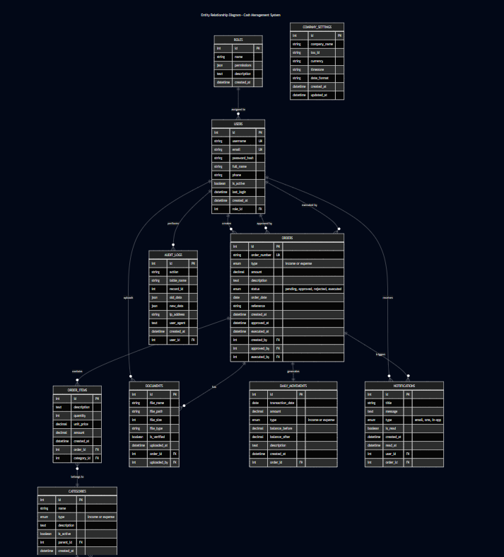

3.2 Relationship Summary
From Table | To Table | Relationship Type | Cardinality | Description
Users | Roles | belongs to | Many-to-One | Each user has one role; each role can have many users
Users | Orders (created) | has many | One-to-Many | One user can create many orders
Users | Orders (approved) | has many | One-to-Many | One user can approve many orders
Users | Orders (executed) | has many | One-to-Many | One user can execute many orders
Users | Audit Logs | has many | One-to-Many | One user can trigger many audit logs
Users | Notifications | has many | One-to-Many | One user can receive many notifications
Users | Documents | has many | One-to-Many | One user can upload many documents
Orders | Order Items | has many | One-to-Many | One order can have many items
Orders | Documents | has many | One-to-Many | One order can have many documents
Orders | Daily Movements | has one | One-to-One | One order creates one daily movement record
Order Items | Categories | belongs to | Many-to-One | Each order item belongs to one category
Categories | Categories (parent) | self-referential | Many-to-One | Categories can have subcategories

4. Table Definitions

4.1 Users Table
Purpose: Stores system user information and login credentials.
Business Rules:
- Each user must have a unique username and email
- Password is stored as a hash (never plain text)
- Each user is assigned exactly one role
- Users can be activated or deactivated
- Last login timestamp is tracked for audit purposes
Fields:
Column Name | Data Type | Key | Description
id | INTEGER | PRIMARY KEY | Unique system identifier for each user
username | VARCHAR(50) | UNIQUE | Username used for login
email | VARCHAR(100) | UNIQUE | User's email address
password_hash | VARCHAR(255) |  | Bcrypt-hashed password
role_id | INTEGER | FOREIGN KEY | Reference to the role assigned to this user
full_name | VARCHAR(100) |  | User's full name
phone | VARCHAR(20) |  | Contact phone number (optional)
is_active | BOOLEAN |  | Account status: true = active, false = inactive
last_login | TIMESTAMP |  | Date and time of last successful login
created_at | TIMESTAMP |  | Date and time the record was created
updated_at | TIMESTAMP |  | Date and time the record was last updated

Sample Data:
id | username | email | role_id | full_name | is_active
1 | admin | admin@hotel.com | 1 | System Admin | true
2 | fmgr1 | finance@hotel.com | 3 | Finance Manager | true
3 | emp1 | employee@hotel.com | 4 | Front Desk Employee | true

4.2 Roles Table
Purpose: Defines user roles and their associated permissions.
Business Rules:
- Each role must have a unique name
- Permissions are stored as JSON to allow flexibility
- Roles can be added or modified by administrators only
- Deleting a role requires reassigning users to another role
Fields:
Column Name | Data Type | Key | Description
id | INTEGER | PRIMARY KEY | Unique role identifier
name | VARCHAR(50) | UNIQUE | Role name (Admin, Investor, Finance Manager, Employee, Client)
permissions | JSON |  | JSON object containing all permissions for this role
description | TEXT |  | Brief description of the role's purpose
created_at | TIMESTAMP |  | Date and time the record was created

Sample Data:
id | name | permissions (example)
1 | Admin | {"create_users":true, "edit_users":true, "delete_users":true, "view_all":true}
2 | Investor | {"view_financials":true, "view_reports":true}
3 | Finance Manager | {"create_orders":true, "approve_orders":true, "execute_orders":true}
4 | Employee | {"create_orders":true, "upload_documents":true, "view_own_orders":true}
5 | Client | {"view_own_transactions":true, "view_receipts":true}

4.3 Categories Table
Purpose: Organizes transactions into income and expense categories.
Business Rules:
- Each category must have a name and type (income or expense)
- Categories can be nested (parent-child relationship)
- A category can have multiple subcategories
- Category names should be unique within the same parent
Fields:
Column Name | Data Type | Key | Description
id | INTEGER | PRIMARY KEY | Unique category identifier
name | VARCHAR(100) |  | Category name (e.g., Room Revenue, Salaries)
type | ENUM |  | Category type: 'income' or 'expense'
parent_id | INTEGER | FOREIGN KEY | Reference to parent category (null for top-level)
description | TEXT |  | Additional description of the category
is_active | BOOLEAN |  | Whether the category is currently active
created_at | TIMESTAMP |  | Date and time the record was created

Sample Data:
id | name | type | parent_id | is_active
1 | Room Revenue | income | null | true
2 | Food & Beverage | income | null | true
3 | Event Revenue | income | null | true
4 | Other Income | income | null | true
5 | Salaries | expense | null | true
6 | Utilities | expense | null | true
7 | Maintenance | expense | null | true
8 | Supplies | expense | null | true

4.4 Orders Table
Purpose: Main transaction record for all financial activities.
Business Rules:
- Each order must have a unique, auto-generated order number
- Order number format: ORD-YYYYMMDD-XXXX (e.g., ORD-20260701-0001)
- Order status flows in a specific sequence: draft → pending → approved → executed → completed
- Amount must be greater than zero
- Once approved, an order cannot be edited
- Only approved orders can be executed
Fields:
Column Name | Data Type | Key | Description
id | INTEGER | PRIMARY KEY | Unique order identifier
order_number | VARCHAR(50) | UNIQUE | Human-readable, auto-generated order number
type | ENUM |  | Order type: 'income' (قبض) or 'expense' (صرف)
amount | DECIMAL(15,2) |  | Total order amount (sum of all items)
description | TEXT |  | Detailed description of the order
status | ENUM |  | Order status: draft, pending, approved, rejected, executed, completed
created_by | INTEGER | FOREIGN KEY | User who created the order
approved_by | INTEGER | FOREIGN KEY | User who approved the order (null until approved)
approved_at | TIMESTAMP |  | Date and time the order was approved
executed_by | INTEGER | FOREIGN KEY | User who executed the order (null until executed)
executed_at | TIMESTAMP |  | Date and time the order was executed
order_date | DATE |  | Date of the transaction
reference | VARCHAR(100) |  | External reference number (invoice no., PO no.)
notes | TEXT |  | Additional notes or comments
created_at | TIMESTAMP |  | Date and time the record was created
updated_at | TIMESTAMP |  | Date and time the record was last updated

Status Flow:
text
draft → pending → approved → executed → completed
↓
rejected → (return to draft for revision)
Sample Data:
id | order_number | type | amount | status | created_by | order_date
1 | ORD-20260701-0001 | income | 1500.00 | executed | 3 | 2026-07-01
2 | ORD-20260701-0002 | income | 450.00 | executed | 3 | 2026-07-01
3 | ORD-20260701-0003 | expense | 800.00 | pending | 4 | 2026-07-01

4.5 Order Items Table
Purpose: Individual line items that make up an order.
Business Rules:
- Each order item belongs to exactly one order
- Each order item must have a category
- Amount is calculated automatically: quantity × unit_price
- Quantity must be greater than 0
- Unit price must be greater than or equal to 0
Fields:
Column Name | Data Type | Key | Description
id | INTEGER | PRIMARY KEY | Unique item identifier
order_id | INTEGER | FOREIGN KEY | Reference to the parent order
category_id | INTEGER | FOREIGN KEY | Category of this item
description | TEXT |  | Description of the item
quantity | INTEGER |  | Number of units
unit_price | DECIMAL(15,2) |  | Price per unit
amount | DECIMAL(15,2) |  | Total amount (quantity × unit_price)
created_at | TIMESTAMP |  | Date and time the record was created

Sample Data:
id | order_id | category_id | description | quantity | unit_price | amount
1 | 1 | 1 | Suite Room - 3 nights | 3 | 500.00 | 1500.00
2 | 2 | 2 | Dinner for 2 | 2 | 225.00 | 450.00
3 | 3 | 6 | Electricity bill | 1 | 800.00 | 800.00

4.6 Documents Table
Purpose: Attached files for orders (invoices, receipts, supporting documents).
Business Rules:
- Each document belongs to exactly one order
- Document types supported: PDF, JPG, JPEG, PNG
- Maximum file size: 10MB
- Documents can be verified by authorized users
- Deleted orders also delete associated documents
Fields:
Column Name | Data Type | Key | Description
id | INTEGER | PRIMARY KEY | Unique document identifier
order_id | INTEGER | FOREIGN KEY | Reference to the associated order
file_name | VARCHAR(255) |  | Original file name
file_path | VARCHAR(500) |  | Storage path of the file
file_size | INTEGER |  | File size in bytes
file_type | VARCHAR(50) |  | MIME type of the file
uploaded_by | INTEGER | FOREIGN KEY | User who uploaded the document
description | TEXT |  | Document description
is_verified | BOOLEAN |  | Verification status
verified_by | INTEGER | FOREIGN KEY | User who verified the document
verified_at | TIMESTAMP |  | Date and time of verification
created_at | TIMESTAMP |  | Date and time the record was created

4.7 Daily Movements Table
Purpose: Tracks daily cash flow and maintains running balance.
Business Rules:
- Each order creates exactly one daily movement record
- Running balance is automatically calculated
- Balance before and after are stored for audit purposes
- Income increases balance, expenses decrease balance
- Cannot delete movement records (audit requirement)
Fields:
Column Name | Data Type | Key | Description
id | INTEGER | PRIMARY KEY | Unique movement identifier
order_id | INTEGER | FOREIGN KEY | Reference to the executed order
transaction_date | DATE |  | Date of the transaction
amount | DECIMAL(15,2) |  | Transaction amount
type | ENUM |  | Transaction type: 'income' or 'expense'
balance_before | DECIMAL(15,2) |  | Running balance before this transaction
balance_after | DECIMAL(15,2) |  | Running balance after this transaction
description | TEXT |  | Movement description
reference | VARCHAR(100) |  | Reference number
created_at | TIMESTAMP |  | Date and time the record was created

Sample Data:
id | order_id | transaction_date | amount | type | balance_before | balance_after
1 | 1 | 2026-07-01 | 1500.00 | income | 0.00 | 1500.00
2 | 2 | 2026-07-01 | 450.00 | income | 1500.00 | 1950.00

4.8 Audit Logs Table
Purpose: Records all system activities for security and compliance.
Business Rules:
- Every critical action is logged automatically
- Logs cannot be modified or deleted
- Old and new data stored as JSON for complete history
- Logs are retained for 7 years (compliance requirement)
- IP address and user agent are captured for security
Fields:
Column Name | Data Type | Key | Description
id | INTEGER | PRIMARY KEY | Unique log identifier
user_id | INTEGER | FOREIGN KEY | User who performed the action
action | VARCHAR(100) |  | Action performed (create, update, delete, approve, etc.)
table_name | VARCHAR(50) |  | Target table name
record_id | INTEGER |  | ID of the affected record
old_data | JSON |  | Previous data (before the action)
new_data | JSON |  | New data (after the action)
ip_address | VARCHAR(45) |  | User's IP address
user_agent | TEXT |  | Browser/device information
created_at | TIMESTAMP |  | Date and time the action was performed

Sample Data:
id | user_id | action | table_name | record_id | ip_address | created_at
1 | 1 | login | users | 1 | 192.168.1.1 | 2026-07-01 08:00:00
2 | 2 | approve | orders | 1 | 192.168.1.2 | 2026-07-01 09:30:00
3 | 3 | create | orders | 2 | 192.168.1.3 | 2026-07-01 10:00:00

4.9 Notifications Table
Purpose: Stores system notifications for users.
Business Rules:
- Each notification is targeted at a specific user
- Notifications can be marked as read/unread
- Notifications are automatically created by system events
- Old notifications may be archived after 30 days
- Notification types include: order_created, order_approved, order_rejected, order_executed, system_alert
Fields:
Column Name | Data Type | Key | Description
id | INTEGER | PRIMARY KEY | Unique notification identifier
user_id | INTEGER | FOREIGN KEY | Target user
title | VARCHAR(255) |  | Notification title
message | TEXT |  | Notification content
type | VARCHAR(50) |  | Notification type
is_read | BOOLEAN |  | Read status: true = read, false = unread
order_id | INTEGER | FOREIGN KEY | Related order (if applicable)
link | VARCHAR(255) |  | Action link to navigate to related content
created_at | TIMESTAMP |  | Date and time the notification was created
read_at | TIMESTAMP |  | Date and time the notification was read

4.10 Company Settings Table
Purpose: Stores company configuration and system settings.
Business Rules:
- Only one record exists (singleton table)
- Only administrators can modify these settings
- Settings affect the entire system
- Currency and date format affect all financial displays
Fields:
Column Name | Data Type | Key | Description
id | INTEGER | PRIMARY KEY | Unique setting identifier
company_name | VARCHAR(255) |  | Company name
logo | VARCHAR(255) |  | Logo file path
address | TEXT |  | Company address
tax_id | VARCHAR(50) |  | Tax identification number
phone | VARCHAR(20) |  | Contact phone
email | VARCHAR(100) |  | Contact email
website | VARCHAR(255) |  | Company website
currency | VARCHAR(3) |  | Currency code (default: SAR)
timezone | VARCHAR(50) |  | System timezone (default: Asia/Riyadh)
date_format | VARCHAR(20) |  | Date format (default: dd/mm/yyyy)
created_at | TIMESTAMP |  | Date and time the record was created
updated_at | TIMESTAMP |  | Date and time the record was last updated

Sample Data:
id | company_name | currency | timezone | date_format
1 | Grand Plaza Hotel | SAR | Asia/Riyadh | dd/mm/yyyy

5. Relationships and Constraints

5.1 Foreign Key Constraints
Constraint Name | Source Table | Foreign Key | Target Table | On Delete Action | Purpose
fk_users_role | users | role_id | roles | SET NULL | Prevents orphaned roles when a role is deleted
fk_orders_created | orders | created_by | users | RESTRICT | Prevents deletion of users who created orders
fk_orders_approved | orders | approved_by | users | SET NULL | Preserves order history even if approver is deleted
fk_orders_executed | orders | executed_by | users | SET NULL | Preserves order history even if executor is deleted
fk_order_items_order | order_items | order_id | orders | CASCADE | Automatically deletes items when parent order is deleted
fk_order_items_category | order_items | category_id | categories | RESTRICT | Prevents deletion of categories used in orders
fk_documents_order | documents | order_id | orders | CASCADE | Automatically deletes documents when parent order is deleted
fk_documents_uploaded | documents | uploaded_by | users | RESTRICT | Prevents deletion of users who uploaded documents
fk_movements_order | daily_movements | order_id | orders | CASCADE | Automatically deletes movement when parent order is deleted
fk_audit_user | audit_logs | user_id | users | RESTRICT | Preserves audit trail even if user is deleted
fk_notifications_user | notifications | user_id | users | CASCADE | Automatically deletes notifications when user is deleted
fk_notifications_order | notifications | order_id | orders | SET NULL | Preserves notifications even if order is deleted
fk_categories_parent | categories | parent_id | categories | CASCADE | Automatically deletes subcategories when parent is deleted

5.2 Check Constraints
Table | Constraint Name | Constraint | Purpose
orders | chk_orders_type | type IN ('income', 'expense') | Validate order type
orders | chk_orders_status | status IN ('draft', 'pending', 'approved', 'rejected', 'executed', 'completed') | Validate order status
orders | chk_orders_amount | amount > 0 | Prevent zero/negative amounts
order_items | chk_items_quantity | quantity > 0 | Prevent zero/negative quantities
order_items | chk_items_unit_price | unit_price >= 0 | Prevent negative prices
order_items | chk_items_amount | amount >= 0 | Prevent negative amounts
categories | chk_categories_type | type IN ('income', 'expense') | Validate category type
daily_movements | chk_movements_type | type IN ('income', 'expense') | Validate movement type
daily_movements | chk_movements_amount | amount > 0 | Prevent zero/negative amounts

5.3 Referential Integrity Rules
Rule Type | Description | Enforcement
Cascade Delete | When a parent record is deleted, all child records are automatically deleted | Order → Order Items, Order → Documents
Restrict Delete | Cannot delete a parent record if child records exist | Category → Order Items, User → Orders
Set Null | When a parent record is deleted, the foreign key is set to NULL | Order → Approved By, Order → Executed By
Cascade Update | When a parent key changes, child keys update automatically | Not used (keys never change)

6. Indexes and Performance

6.1 Index Strategy Overview
Table | Index Name | Columns | Type | Purpose
users | idx_users_username | username | UNIQUE | Fast login lookups
users | idx_users_email | email | UNIQUE | Fast email-based searches
users | idx_users_role | role_id | BTREE | Role-based user queries
orders | idx_orders_status | status | BTREE | Status filtering in lists
orders | idx_orders_type | type | BTREE | Income/expense filtering
orders | idx_orders_created_by | created_by | BTREE | User-specific order queries
orders | idx_orders_order_date | order_date | BTREE | Date range queries for reports
orders | idx_orders_created_at | created_at | BTREE | Time-based reporting
order_items | idx_items_order | order_id | BTREE | Efficient order item retrieval
order_items | idx_items_category | category_id | BTREE | Category-based item queries
daily_movements | idx_movements_date | transaction_date | BTREE | Date range reports
daily_movements | idx_movements_type | type | BTREE | Income/expense filtering
audit_logs | idx_audit_user | user_id | BTREE | User activity lookup
audit_logs | idx_audit_table | table_name | BTREE | Table-specific audit queries
audit_logs | idx_audit_created | created_at | BTREE | Time-based audit reporting
notifications | idx_notif_user | user_id | BTREE | User notification retrieval
notifications | idx_notif_read | is_read | BTREE | Unread notification filtering

6.2 Query Optimization Strategy
Query Type | Optimization Technique | Expected Improvement
User Login | Index on username and email | < 50ms
Order List with Filters | Combined indexes on frequent filter columns | < 100ms
Date Range Reports | Index on date columns + date range optimization | < 1s
Balance Calculation | Materialized view for daily balance summary | < 500ms
Audit Reports | Partitioned audit_logs by date | < 2s
Category Tree | Recursive CTE with indexes | < 200ms
Search | Full-text search on description fields | < 300ms

6.3 Estimated Performance Targets
Operation | Target Time | Index Required
User Login | < 500ms | idx_users_username
Create Order | < 1s | None (INSERT)
List Orders (50/page) | < 500ms | idx_orders_status, idx_orders_order_date
Order Approval | < 300ms | idx_orders_status, idx_orders_id
Generate Daily Report | < 3s | idx_movements_date, idx_orders_order_date
View Dashboard | < 2s | Combined indexes
Search Orders | < 1s | Full-text index on description

7. Sample Data

7.1 Sample User Data
Users:
id | username | email | role_id | full_name | is_active
1 | admin | admin@hotel.com | 1 | System Admin | true
2 | investor1 | investor@hotel.com | 2 | Primary Investor | true
3 | fmgr1 | finance@hotel.com | 3 | Finance Manager | true
4 | emp1 | employee@hotel.com | 4 | Front Desk Employee | true
5 | emp2 | employee2@hotel.com | 4 | Accounting Employee | true

Roles:
id | name | permissions (JSON)
1 | Admin | {"create_users":true, "edit_users":true, "delete_users":true, "view_all":true, "system_settings":true}
2 | Investor | {"view_financials":true, "view_reports":true, "view_dashboard":true}
3 | Finance Manager | {"create_orders":true, "approve_orders":true, "execute_orders":true, "view_reports":true}
4 | Employee | {"create_orders":true, "upload_documents":true, "view_own_orders":true}
5 | Client | {"view_own_transactions":true, "view_receipts":true}

7.2 Sample Category Data
Income Categories:
id | name | type | parent_id | is_active
1 | Room Revenue | income | null | true
2 | Food & Beverage | income | null | true
3 | Event Revenue | income | null | true
4 | Other Income | income | null | true
5 | Restaurant | income | 2 | true
6 | Room Service | income | 2 | true

Expense Categories:
id | name | type | parent_id | is_active
7 | Salaries | expense | null | true
8 | Utilities | expense | null | true
9 | Maintenance | expense | null | true
10 | Supplies | expense | null | true
11 | Electricity | expense | 8 | true
12 | Water | expense | 8 | true

7.3 Sample Order Data
Orders:
id | order_number | type | amount | status | created_by | approved_by | order_date | description
1 | ORD-20260701-0001 | income | 1500.00 | executed | 4 | 3 | 2026-07-01 | Room booking - Suite 101 (3 nights)
2 | ORD-20260701-0002 | income | 450.00 | executed | 4 | 3 | 2026-07-01 | Restaurant Dinner - Table 5
3 | ORD-20260701-0003 | expense | 800.00 | pending | 5 | null | 2026-07-01 | Monthly Utilities - Electricity
4 | ORD-20260702-0004 | income | 1200.00 | approved | 4 | 3 | 2026-07-02 | Conference Room Rental - Full Day

Order Items:
id | order_id | category_id | description | quantity | unit_price | amount
1 | 1 | 1 | Suite Room - 3 nights | 3 | 500.00 | 1500.00
2 | 2 | 5 | Dinner for 2 | 2 | 225.00 | 450.00
3 | 3 | 11 | Electricity bill - July | 1 | 800.00 | 800.00
4 | 4 | 3 | Conference Room - Full Day | 1 | 1200.00 | 1200.00

7.4 Sample Daily Movement Data
id | order_id | transaction_date | amount | type | balance_before | balance_after
1 | 1 | 2026-07-01 | 1500.00 | income | 0.00 | 1500.00
2 | 2 | 2026-07-01 | 450.00 | income | 1500.00 | 1950.00
3 | 4 | 2026-07-02 | 1200.00 | income | 1950.00 | 3150.00

8. Migration Strategy

8.1 Migration Process
Step | Activity | Description | Tools
1 | Create Migration File | Create a new migration file with schema changes | Git, Database Client
2 | Write Up Migration | Add the schema changes (create table, add column, etc.) | SQL Editor
3 | Write Down Migration | Write the rollback script (reverse of up) | SQL Editor
4 | Test Migration | Run migration on development database | Testing Environment
5 | Review | Have another developer review the migration | Pull Request
6 | Apply to Staging | Run migration on staging environment | Staging Environment
7 | Apply to Production | Run migration on production environment | Production Environment

8.2 Migration Naming Convention
Type | Format | Example
New Table | YYYYMMDD_HHMMSS_create_table_name | 20260701_120000_create_users_table
Add Column | YYYYMMDD_HHMMSS_add_column_to_table | 20260702_140000_add_phone_to_users
Modify Column | YYYYMMDD_HHMMSS_modify_column_in_table | 20260703_150000_modify_status_in_orders
Add Index | YYYYMMDD_HHMMSS_add_index_to_table | 20260704_100000_add_index_orders_status
Create View | YYYYMMDD_HHMMSS_create_view_name | 20260705_110000_create_monthly_summary_view

8.3 Rollback Procedure
Scenario | Action | Steps
Minor Issue | Rollback latest migration | 1. Run rollback script  2. Fix issue  3. Run migration again
Major Issue | Full database restore | 1. Stop application  2. Restore from backup  3. Verify data  4. Start application
Data Corruption | Point-in-time recovery | 1. Identify corruption time  2. Restore to point before corruption  3. Replay transactions after restore

9. Backup and Recovery

9.1 Backup Types
Type | Description | Frequency | Retention
Full Backup | Complete database dump | Daily (2:00 AM) | 30 days
Incremental Backup | Changes since last backup | Hourly | 7 days
Schema Backup | Database structure only | After schema changes | Permanent
Document Backup | All uploaded files | Daily (3:00 AM) | 30 days

9.2 Backup Storage Locations
Location | Purpose | Security
Local Server | Quick restoration | Encrypted
Cloud Storage (AWS S3) | Disaster recovery | Encrypted, access-controlled
External Drive | Offline backup | Physical security

9.3 Recovery Time Objectives
Scenario | RTO (Recovery Time) | RPO (Recovery Point)
Database Failure | < 1 hour | < 1 hour
Application Failure | < 15 minutes | < 5 minutes
Server Failure | < 1 hour | < 1 hour
Data Corruption | < 2 hours | < 1 day
Natural Disaster | < 4 hours | < 1 day

10. Security Considerations

10.1 Data Security Measures
Layer | Measure | Implementation
Network | SSL/TLS | All database connections encrypted
Application | SQL Injection Prevention | Parameterized queries, ORM
Storage | Data Encryption | AES-256 encryption for sensitive data
Passwords | Hashing | bcrypt with 10+ rounds
Access | Principle of Least Privilege | Granular user permissions
Audit | Activity Logging | Complete audit trail

10.2 User Access Levels
User Type | Database Access | Permissions
Admin | Full access | All operations on all tables
Finance Manager | Read/Write | Orders, order_items, documents, daily_movements
Employee | Read/Write (own) | Create/read own orders
Investor | Read-only | Reports, financial summary, dashboard
Client | Read-only (own) | Own transactions and receipts

10.3 Audit and Compliance
Requirement | Implementation | Evidence
Data Retention | 7 years retention | Audit logs, orders, movements
Access Logging | All access recorded | Audit logs table
Change Tracking | Before/after values stored | Audit logs (old_data, new_data)
User Accountability | User ID captured | Every record has creator/modifier
IP Tracking | User IP captured | Audit logs table

11. Appendix: Complete Schema Reference

11.1 Table Summary
# | Table Name | Purpose | Primary Key | Foreign Keys
1 | users | System users | id | role_id
2 | roles | User roles and permissions | id | -
3 | categories | Income/expense categories | id | parent_id
4 | orders | Main transaction record | id | created_by, approved_by, executed_by
5 | order_items | Order line items | id | order_id, category_id
6 | documents | Attached files | id | order_id, uploaded_by, verified_by
7 | daily_movements | Daily cash flow | id | order_id
8 | audit_logs | System audit trail | id | user_id
9 | notifications | User notifications | id | user_id, order_id
10 | company_settings | Company configuration | id | -

11.2 Key Business Rules Summary
Rule # | Description
BR-01 | Order number auto-generated: ORD-YYYYMMDD-XXXX
BR-02 | Order status: draft → pending → approved → executed → completed
BR-03 | Orders cannot be edited after approval
BR-04 | Amount must be greater than zero
BR-05 | Daily balance automatically updated on order execution
BR-06 | All critical actions logged in audit logs
BR-07 | Documents required for all expense orders
BR-08 | Income orders must have a valid customer reference
BR-09 | Audit logs retained for 7 years
BR-10 | Only Finance Manager can approve orders
BR-11 | Only authorized users can execute orders

