UI/UX Wireframes

Cash Management System
Document Version: 1.0 | Date: July 2026
Prepared By: osama drbas
Status: under review

1. Introduction

1.1 Purpose
This document presents the user interface wireframes for the Cash Management System. It provides visual representations of all system screens, demonstrating the user interface design, navigation flow, and user experience.

1.2 Scope
Visual design of all system screens, navigation between screens, user interactions and actions, component placement and layout, responsive design considerations.

1.3 Design Principles
Principle | Description
Consistency | Same layout, colors, and components across all screens
Clarity | Clear visual hierarchy and intuitive navigation
Efficiency | Minimize clicks and steps to complete tasks
Accessibility | Arabic RTL support, readable fonts, sufficient contrast
Responsiveness | Works on desktop, tablet, and mobile

2. Design System

2.1 Color Palette
Color Name | Hex Code | Usage
Primary | #1A3C5E | Sidebar background, headers
Primary Light | #2C5A8C | Hover states
Accent | #E8A83E | Buttons, highlights, important numbers
Background | #F5F7FA | Page background
Card Background | #FFFFFF | Cards, modals
Text Primary | #1A1A2E | Main text
Text Secondary | #6B7280 | Secondary text
Success | #10B981 | Income, approved, active
Danger | #EF4444 | Expense, rejected, inactive
Warning | #F59E0B | Pending
Info | #3B82F6 | Info, executed

2.2 Typography
Element | Font | Size | Weight
Arabic | Cairo | - | -
English | Inter | - | -
Page Title | Arabic/English | 24px | Bold
Section Title | Arabic/English | 18px | Semi-bold
Body Text | Arabic/English | 14px | Regular
Small Text | Arabic/English | 12px | Regular

2.3 Components
Component | Style
Cards | White background, 12px rounded corners, subtle shadow, 16px padding
Buttons (Primary) | Gold background (#E8A83E), white text, 8px rounded, 10px 20px padding
Buttons (Secondary) | White background, blue border, blue text
Buttons (Danger) | Red background (#EF4444), white text
Input Fields | White background, light gray border (#E5E7EB), 8px rounded, 40px height
Badges | Rounded (16px), 4px 12px padding, small text
Sidebar | Dark blue (#1A3C5E), 240px width, fixed position
Top Navbar | White background, 64px height, bottom border

3. User Flow Diagrams (text-based)

3.1 Authentication Flow
Login → Valid Credentials → Dashboard | Invalid → Error Message | Forgot Password → Reset Page

3.2 Order Creation Flow
Create Order → Select Type → Fill Details → Save Draft OR Submit for Approval

3.3 Approval Flow
Notification → Review → Approve/Reject → Execute → Update Movement

3.4 Report Generation Flow
Select Report → Set Parameters → Generate → View/Export

4. Screen Wireframes

4.1 AUTHENTICATION SCREENS
SC-01: Login Page
User Role: All users
Purpose: Authenticate users to access the system
Access: Public
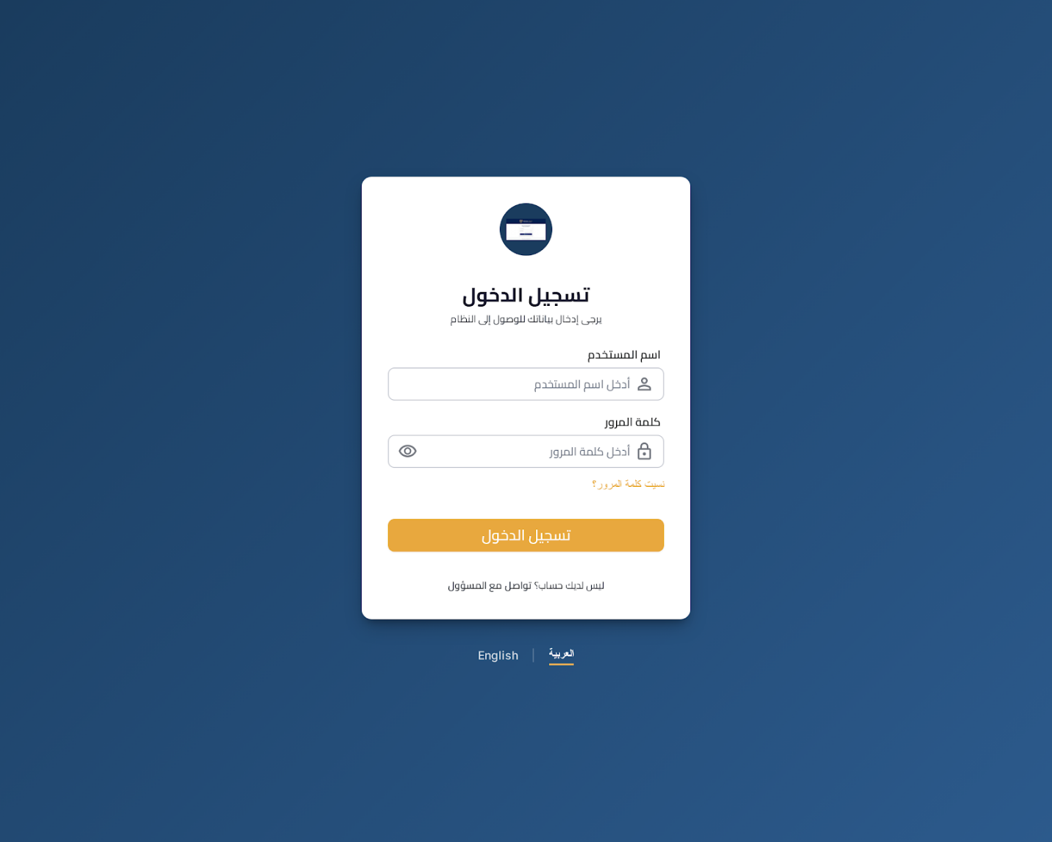Components:
# | Component | Type | Description
1 | Logo | Image | System logo
2 | Title | Text | تسجيل الدخول
3 | Username field | Input | Username input
4 | Password field | Input | Password input with show/hide
5 | Forgot Password link | Link | Forgot password navigation
6 | Login button | Button | Gold login button
7 | Language switcher | Dropdown | Language selection
User Actions:
- Enter username
- Enter password
- Click Login
Validation Rules:
- Username required
- Password required (min 8 characters)
Error States:
- Invalid credentials
- Account locked
- Network error
SC-02: Password Reset Page
User Role: All users
Purpose: Allow users to reset forgotten passwords
Access: Public
Components:
# | Component | Type | Description
1 | Logo | Image | System logo
2 | Title | Text | استعادة كلمة المرور
3 | Subtitle | Text | Subtitle text
4 | Email field | Input | Email input
5 | Send button | Button | Gold send button
6 | Back link | Link | Return to login
User Actions:
- Enter email
- Click Send Reset Link
Validation Rules:
- Email required
- Valid email format

4.2 DASHBOARD SCREENS
SC-03: Admin Dashboard
User Role: Admin
Purpose: System overview and key metrics
Access: Requires authentication and Admin role
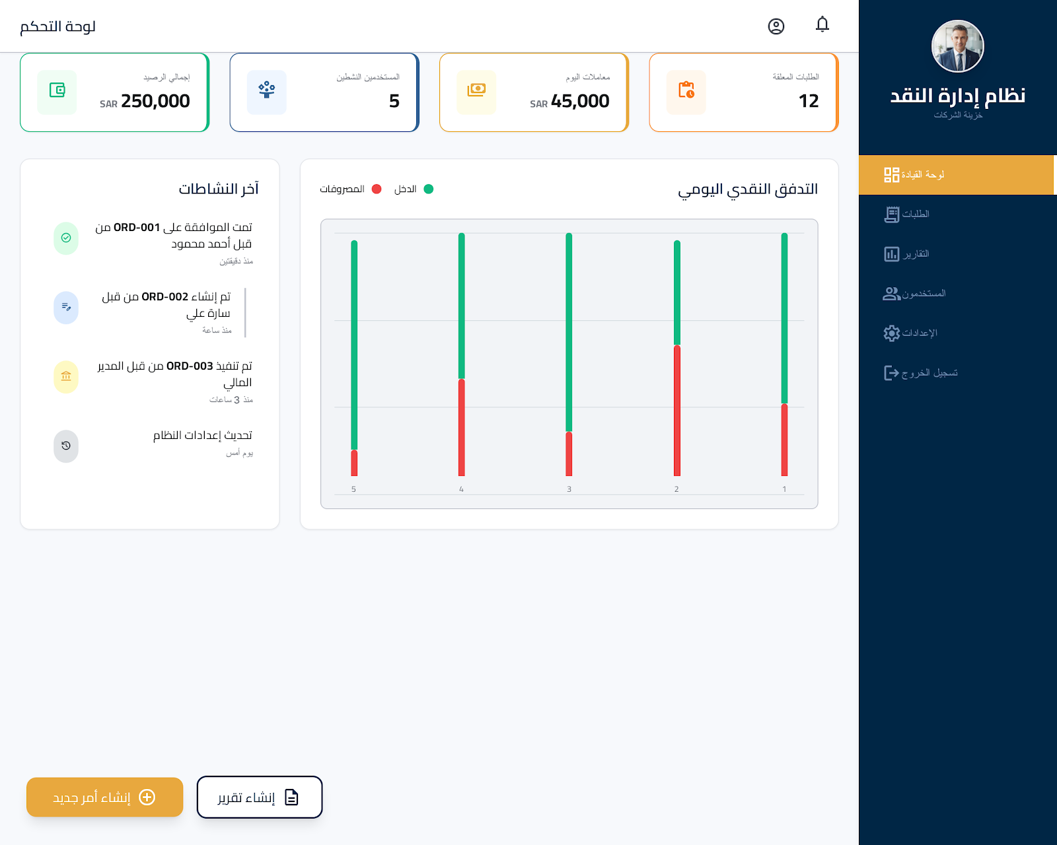
Layout: Top navbar (64px), Left sidebar (240px) dark blue, Main content (24px padding). Sidebar Menu: Dashboard (active), Orders, Reports, Users, Settings, Logout.
Components:
# | Component | Type | Description
1 | KPI Cards (4) | Card | الطلبات المعلقة (12), معاملات اليوم (SAR 45,000), المستخدمين النشطين (5), إجمالي الرصيد (SAR 250,000)
2 | Chart | Chart | Line chart - Daily Cash Flow (Income green, Expenses red)
3 | Recent Activity Feed | List | 3 items with timestamps
4 | Quick Actions | Button | Create Order (gold), Create Report (outline)
User Actions:
- View KPI cards
- Interact with chart
- View recent activity
- Click Quick Action buttons
SC-04: Investor Dashboard
User Role: Investor
Purpose: Financial overview
Access: Requires authentication and Investor role
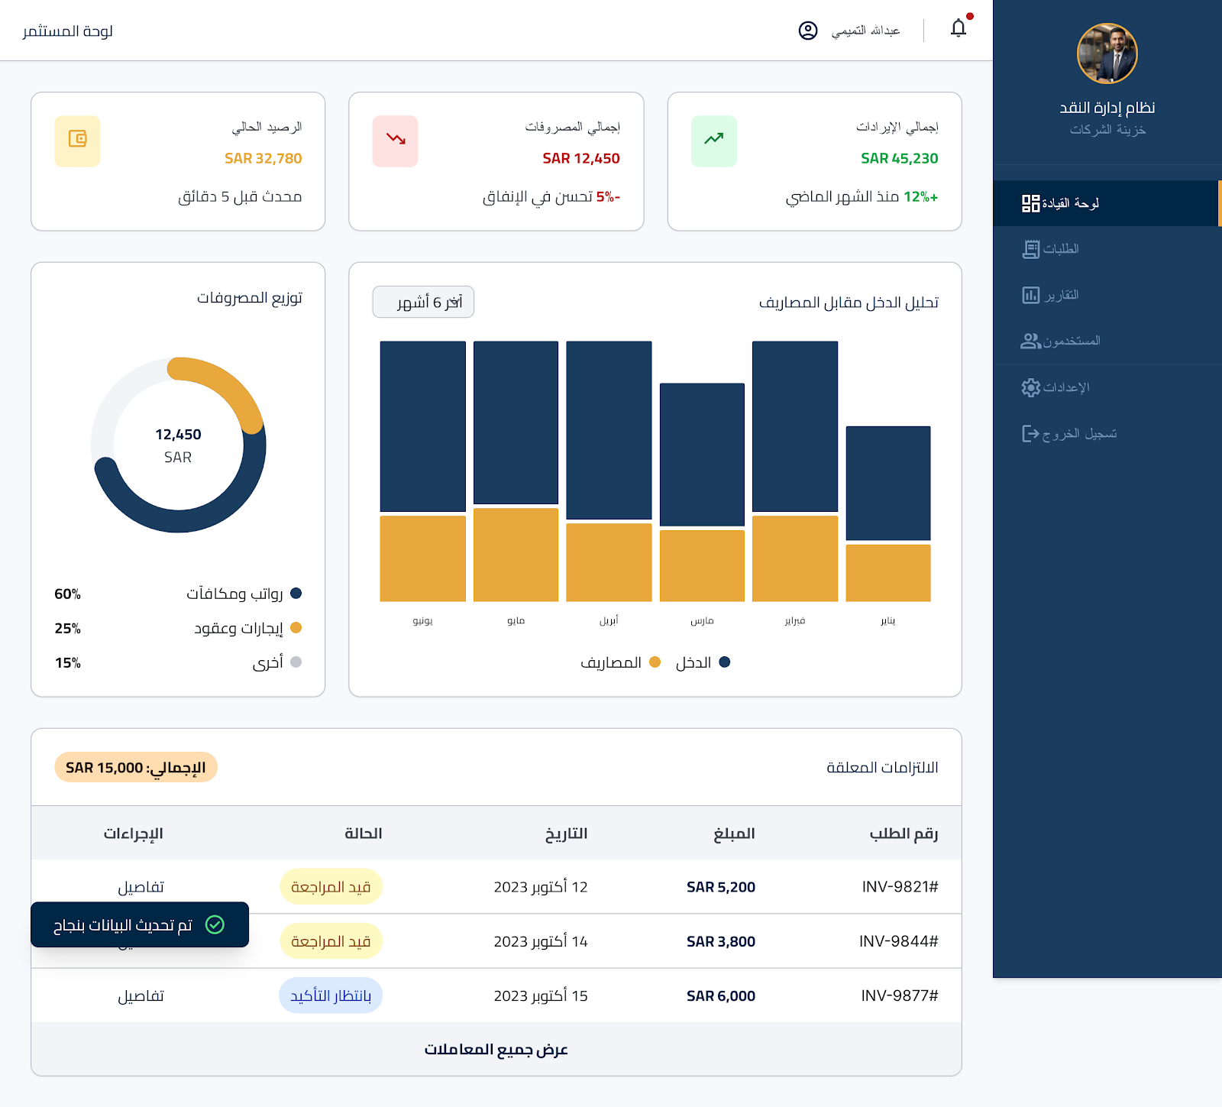
Sidebar Menu: Dashboard (active), Reports, Logout.
Components:
# | Component | Type | Description
1 | KPI Cards (3) | Card | إجمالي الإيرادات (SAR 250,000), إجمالي المصروفات (SAR 180,000), الرصيد الحالي (SAR 70,000)
2 | Charts (2 columns) | Chart | Area chart (Income vs Expenses), Donut chart (Expense breakdown)
3 | Pending Commitments | Table | Order Number, Amount, Date, Status
User Actions:
- View KPI cards
- Interact with charts
- View pending commitments table
SC-05: Finance Manager Dashboard
User Role: Finance Manager
Purpose: Approval queue and operations
Access: Requires authentication and Finance Manager role
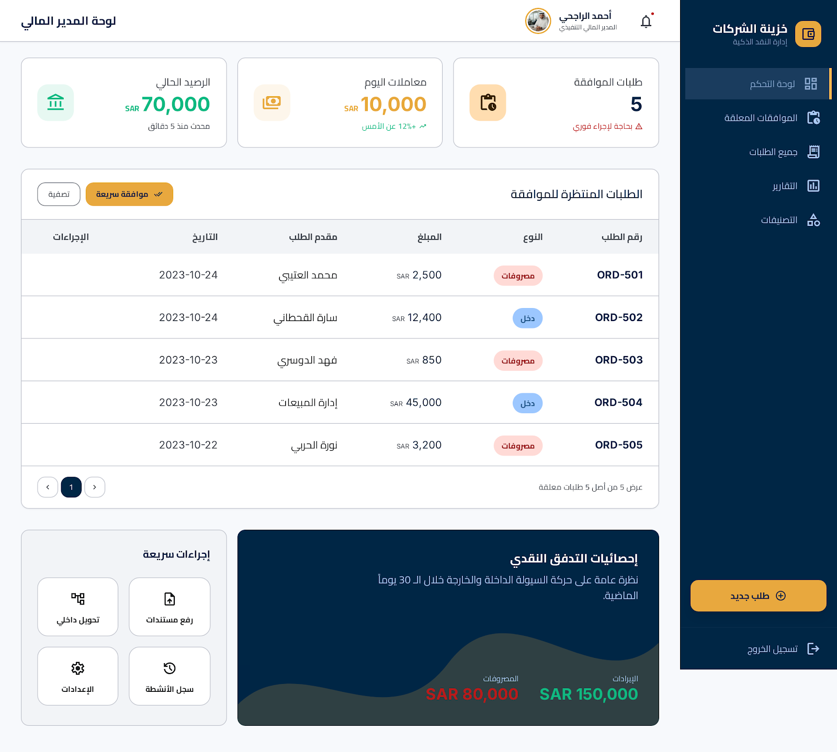
Sidebar Menu: Dashboard (active), Pending Approvals, All Orders, Reports, Categories, Logout.
Components:
# | Component | Type | Description
1 | KPI Cards (3) | Card | طلبات الموافقة (5), معاملات اليوم (SAR 10,000), الرصيد الحالي (SAR 70,000)
2 | Pending Approvals | Table | Approve/Reject buttons
3 | Quick Actions | Button | Quick Approve (gold), Create Order (outline)
User Actions:
- View KPI cards
- Review pending approvals table
- Click Approve/Reject buttons
- Click Quick Action buttons
SC-06: Employee Dashboard
User Role: Employee
Purpose: Personal orders and tasks
Access: Requires authentication and Employee role

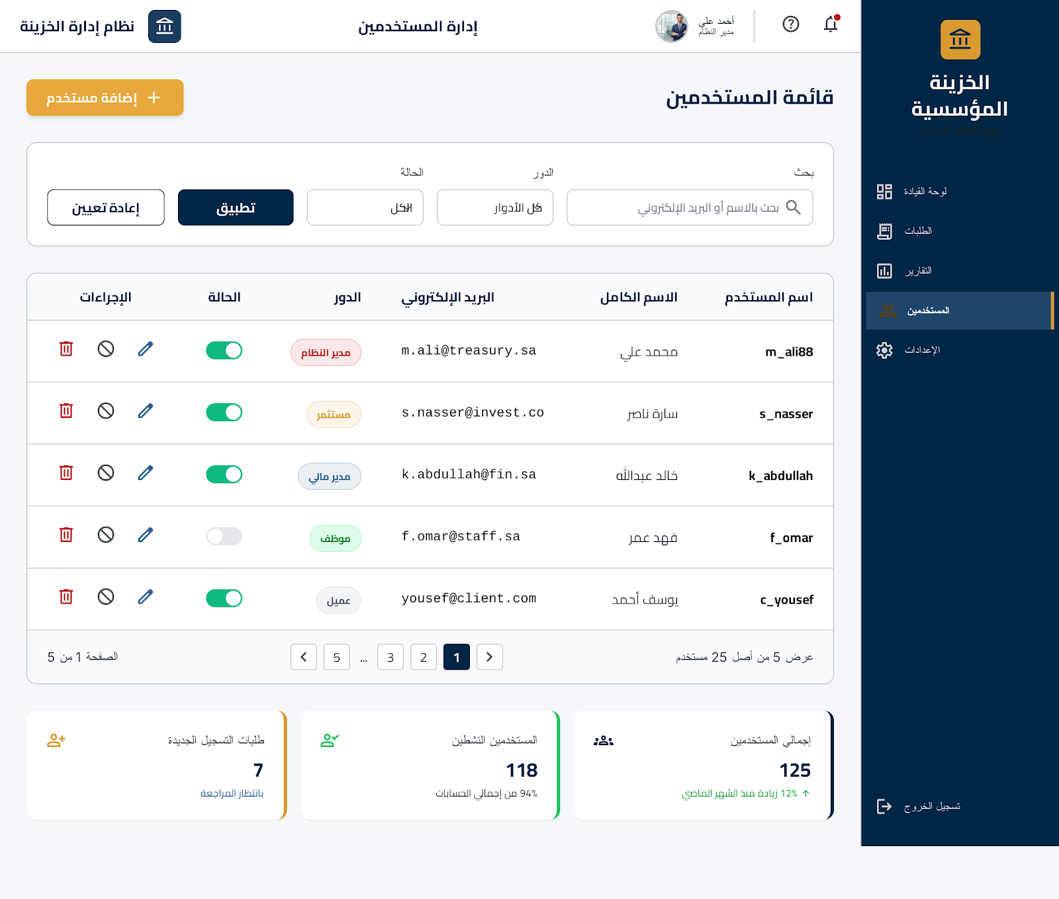Sidebar Menu: Dashboard (active), My Orders, Upload Document, Logout.
Components:
# | Component | Type | Description
1 | Personal Stats (2) | Card | طلباتي المعلقة (3), طلباتي المنفذة (15)
2 | Recent Orders | Table | Status colors
3 | Notifications | List | Icons and timestamps
4 | Quick Actions | Button | New Order (gold), Upload Document (outline)
User Actions:
- View personal stats
- View recent orders table
- View notifications
- Click Quick Action buttons

4.3 USER MANAGEMENT SCREENS
SC-07: User List
User Role: Admin
Purpose: View and manage all system users
Access: Requires authentication and Admin role
Sidebar Menu: Dashboard, Orders, Reports, Users (active), Settings, Logout.
Components:
# | Component | Type | Description
1 | Page Header | Text/Button | Title "إدارة المستخدمين", [+ Add User] button (gold)
2 | Filters | Input/Dropdown/Button | Search, Role dropdown, Status dropdown, Apply/Reset buttons
3 | Users Table | Table | Username, Full Name, Email, Role (badge), Status (toggle), Actions (Edit/Disable/Delete)
User Actions:
- Use search and filters
- Click Add User button
- Toggle user status
- Click Edit, Disable, or Delete actions
Role Badge Colors: Admin (red), Investor (gold), Finance Manager (blue), Employee (green), Client (gray).
SC-08: Create/Edit User
User Role: Admin
Purpose: Add new users or edit existing ones
Access: Requires authentication and Admin role

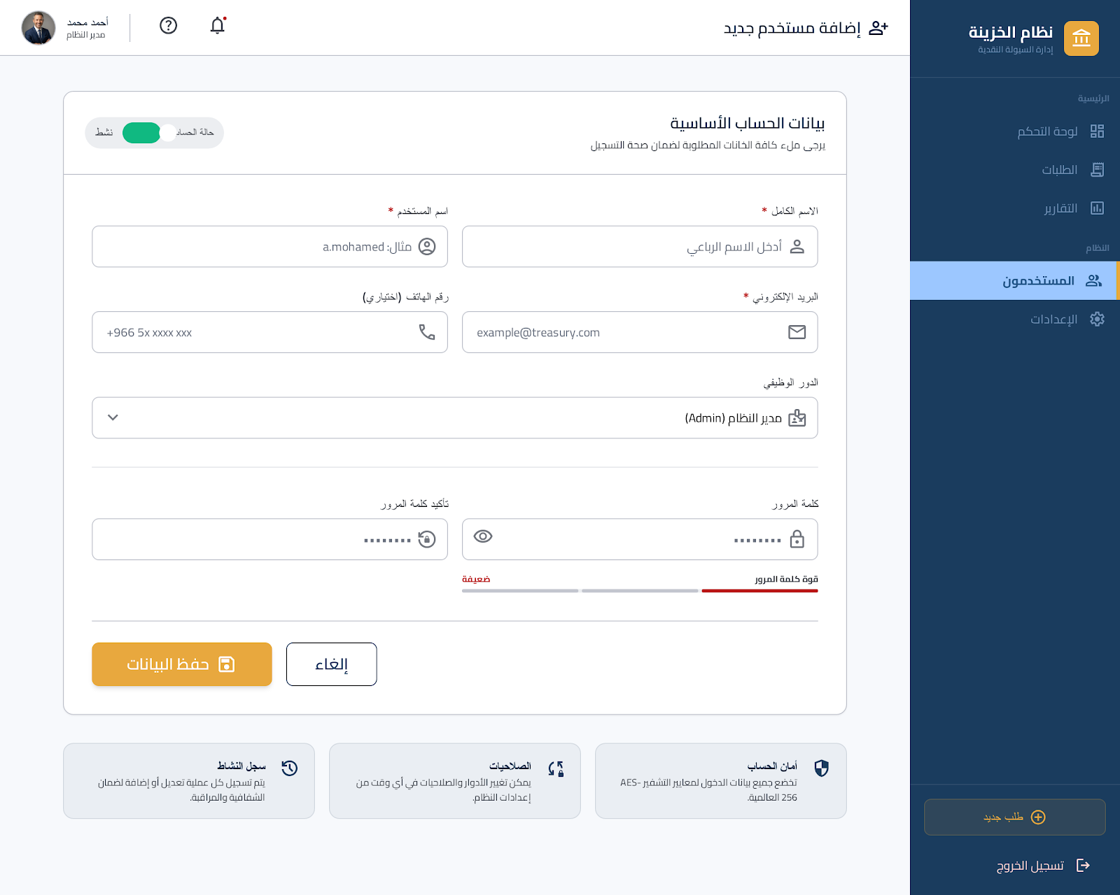Components:
# | Component | Type | Description
1 | Form Fields | Input/Dropdown/Toggle | Full Name, Username, Email, Phone, Role dropdown, Password (with strength indicator), Confirm Password, Status toggle
2 | Actions | Button | Save (gold), Cancel (outline)
User Actions:
- Fill in form fields
- Click Save or Cancel
SC-09: Role Management
User Role: Admin
Purpose: Define and manage user roles and permissions
Access: Requires authentication and Admin role

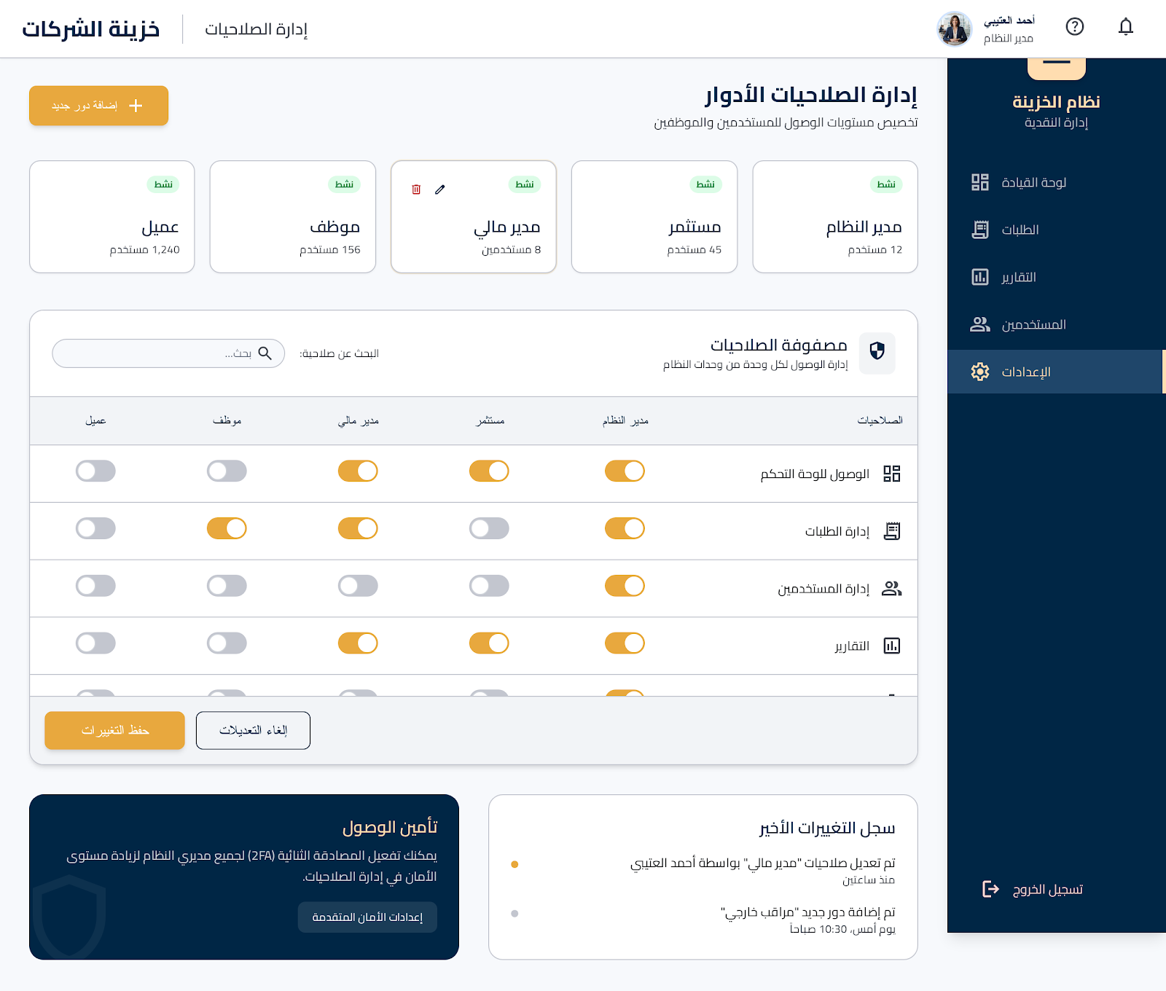Sidebar Menu: Dashboard, Orders, Reports, Users, Settings (active), Logout.
Components:
# | Component | Type | Description
1 | Page Header | Text/Button | Title "إدارة الصلاحيات", [+ Add Role] button (gold)
2 | Roles List | Card | Role name, Users count, Status, Actions
3 | Permission Matrix | Table | Permissions (Dashboard, Orders, Users, Reports, Settings) and roles (Admin, Investor, Finance Manager, Employee, Client) with toggle switches
4 | Actions | Button | Save Changes (gold)
User Actions:
- Click Add Role button
- Toggle permissions in matrix
- Click Save Changes

4.4 ORDER MANAGEMENT SCREENS
SC-10: Create Order
User Role: Employee, Finance Manager
Purpose: Create new income or expense orders
Access: Requires authentication and 'create_orders' permission

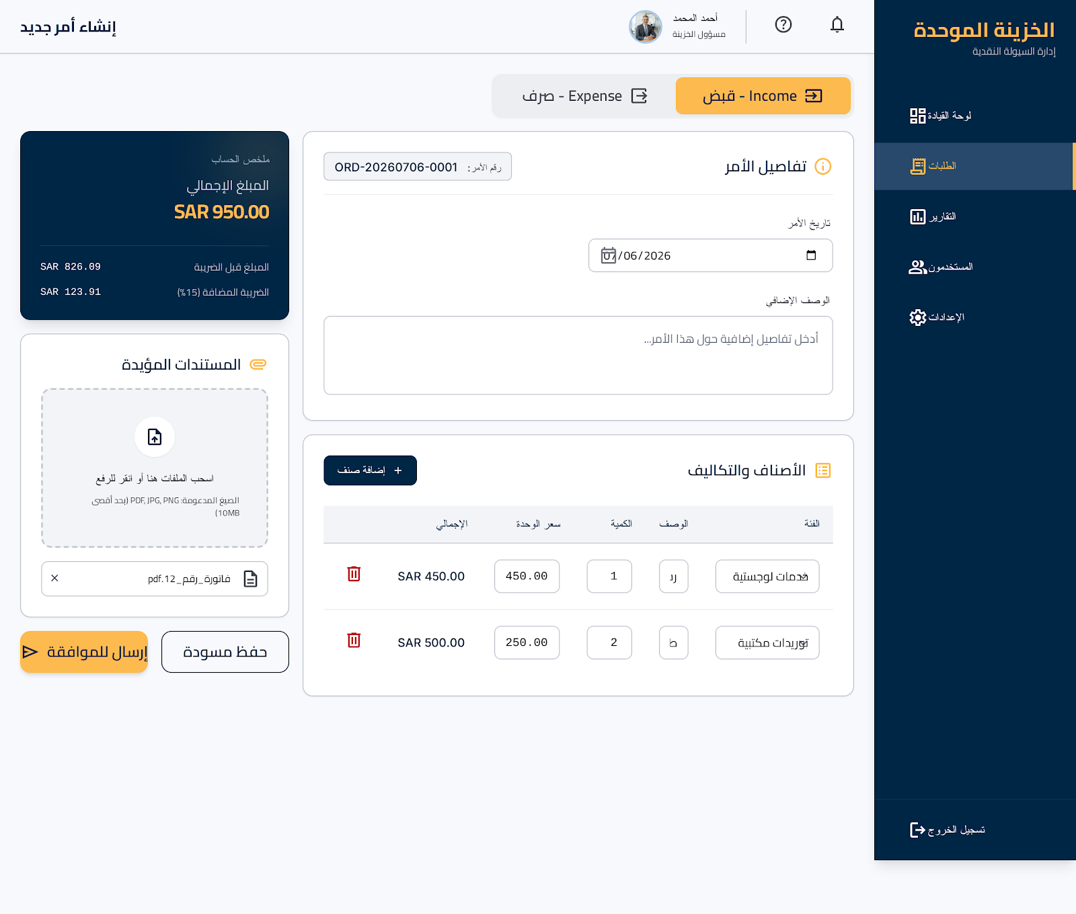Sidebar Menu: Dashboard, Orders (active), Reports, Users, Settings, Logout.
Components:
# | Component | Type | Description
1 | Order Type | Tabs | Income/Expense tabs (gold when active)
2 | Order Details | Input/Picker/Textarea | Order Number (auto), Order Date (picker), Description (textarea)
3 | Items Section | Table/Button | Table (Category dropdown, Description, Quantity, Unit Price, Amount auto-calculated), [+ Add Item] button
4 | Total | Text | Auto-calculated, large, bold, gold
5 | Documents | Upload | Drag-and-drop zone, Uploaded files list with status
6 | Actions | Button | Save Draft (outline), Submit for Approval (gold)
User Actions:
- Select Order Type (Income/Expense)
- Fill Order Details
- Add Items to table
- Upload Documents
- Click Save Draft or Submit for Approval
SC-11: Order List
User Role: All (with permissions)
Purpose: View and filter all orders
Access: Requires authentication

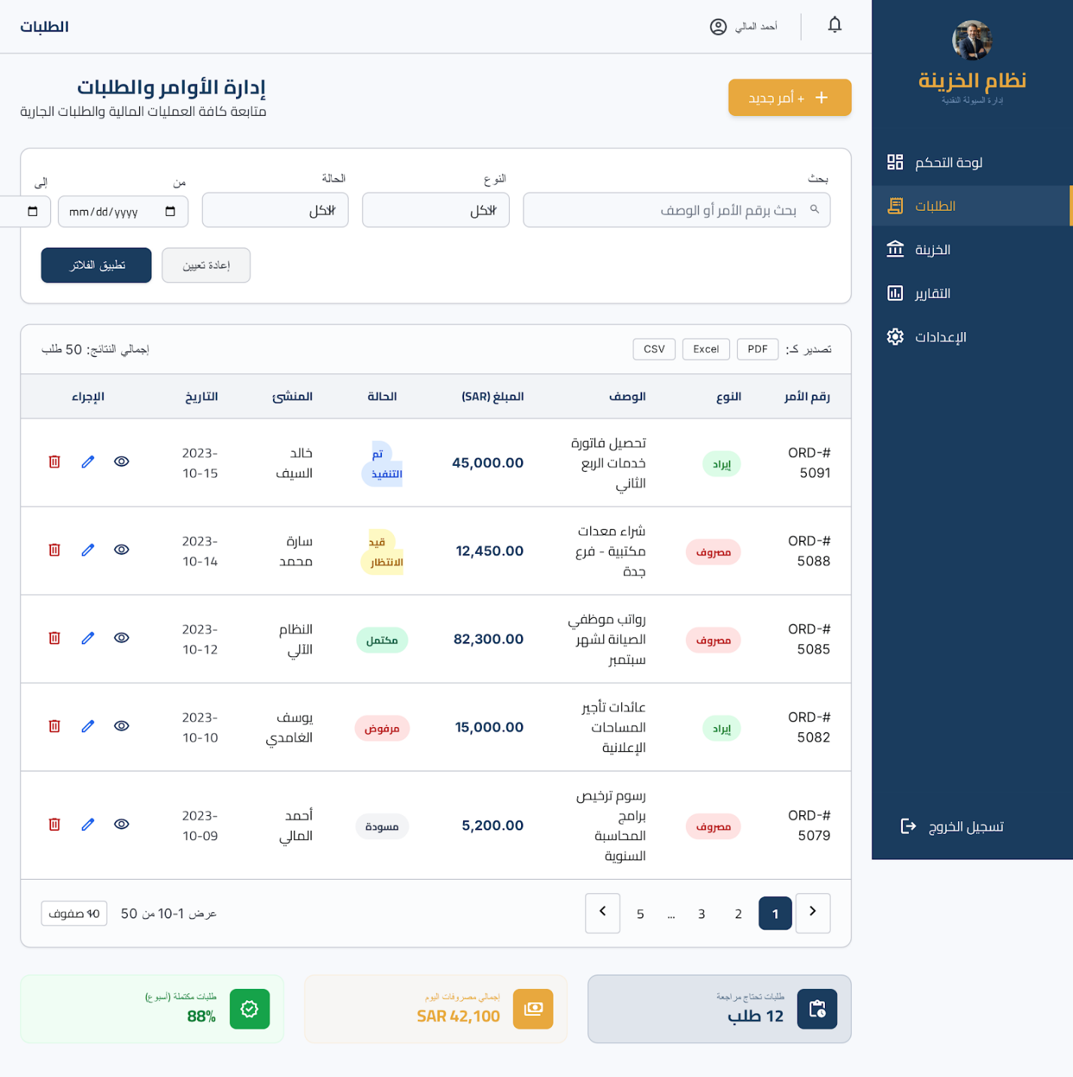Sidebar Menu: Dashboard, Orders (active), Reports, Users, Settings, Logout.
Components:
# | Component | Type | Description
1 | Page Header | Text/Button | Title "الطلبات", [+ New Order] button (gold)
2 | Filters | Input/Dropdown/Button | Search, Type dropdown, Status dropdown, Date Range, Apply/Reset buttons
3 | Orders Table | Table | Order Number, Type (badge), Description, Amount, Status (badge), Created By, Date, Actions
4 | Export | Button | PDF, Excel, CSV buttons
5 | Pagination | Text/Button | Showing 1-10 of 50, Page 1 of 5
User Actions:
- Use search and filters
- Click New Order button
- Click row actions (Edit, View, etc.)
- Click Export buttons
- Navigate pagination
Status Badge Colors: Draft (gray), Pending (yellow), Approved (green), Rejected (red), Executed (blue), Completed (dark green).
SC-12: Order Details
User Role: All (with permissions)
Purpose: View complete order information
Access: Requires authentication

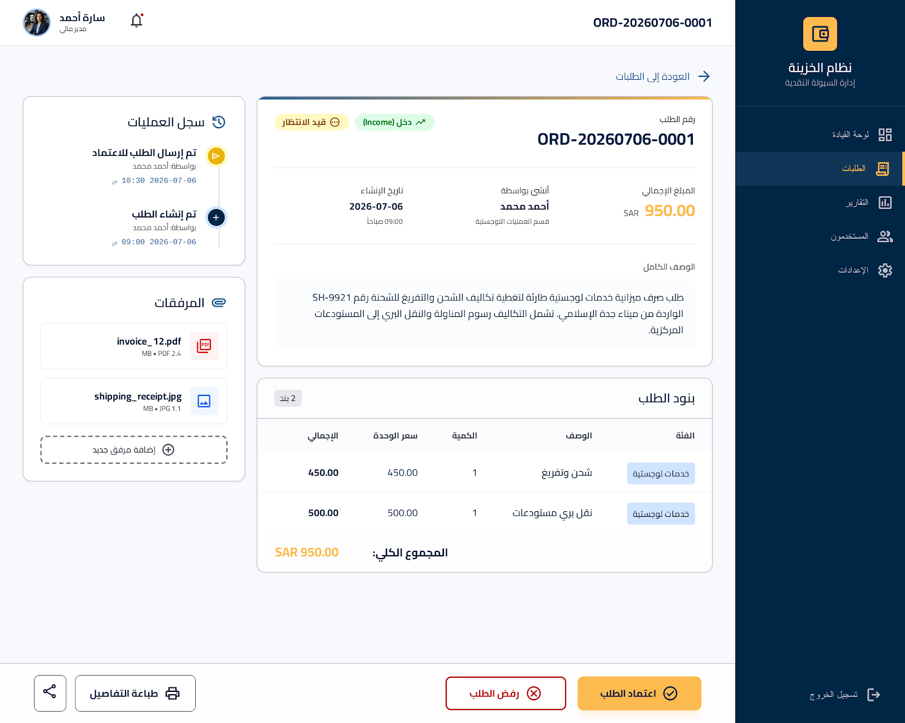Sidebar Menu: Dashboard, Orders (active), Reports, Users, Settings, Logout.
Components:
# | Component | Type | Description
1 | Back Button | Link | ← Back to Orders
2 | Order Summary | Text/Badge | Number, Type badge, Status badge, Amount (gold), Created By, Date, Description
3 | Approval Info | Text | Status, Approved By, Date, Rejection Reason
4 | Items | Table | Category, Description, Quantity, Unit Price, Amount
5 | Documents | File | Files with Download/Preview buttons
6 | Timeline | List | Created → Submitted → Approved → Executed
7 | Actions | Button | Edit, Submit, Approve, Reject, Execute, Print, Delete (based on status)
User Actions:
- Click Back button
- View Order Summary
- Review Approval Info
- View Items table
- Preview/Download documents
- Click action buttons based on status
SC-13: Approve/Reject Order
User Role: Finance Manager
Purpose: Review and approve/reject pending orders
Access: Requires authentication and Finance Manager role

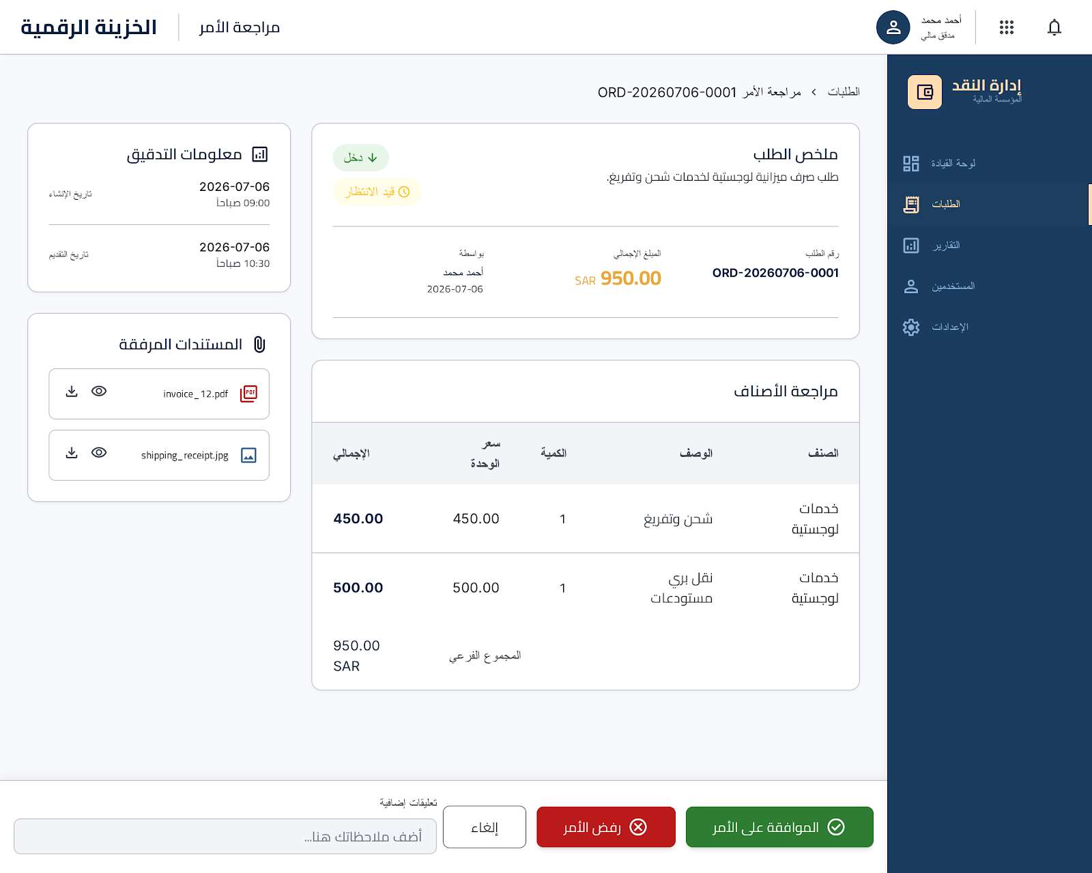Sidebar Menu: Dashboard, Pending Approvals (active), All Orders, Reports, Categories, Logout.
Components:
# | Component | Type | Description
1 | Order Summary | Text/Badge | Number, Type badge, Status, Amount, Created By, Description
2 | Items Review | Table | Items table
3 | Documents Review | Preview/Download | Preview/Download
4 | Approval Action | Textarea/Button | Comments textarea, Approve (green), Reject (red), Cancel (outline)
5 | Audit Info | Text | Created, Submitted timestamps
User Actions:
- Review Order Summary
- Review Items table
- Preview/Download documents
- Enter comments
- Click Approve, Reject, or Cancel

4.5 DOCUMENT MANAGEMENT SCREENS
SC-14: Upload Document
User Role: Employee, Finance Manager
Purpose: Attach documents to orders
Access: Requires authentication and 'upload_documents' permission

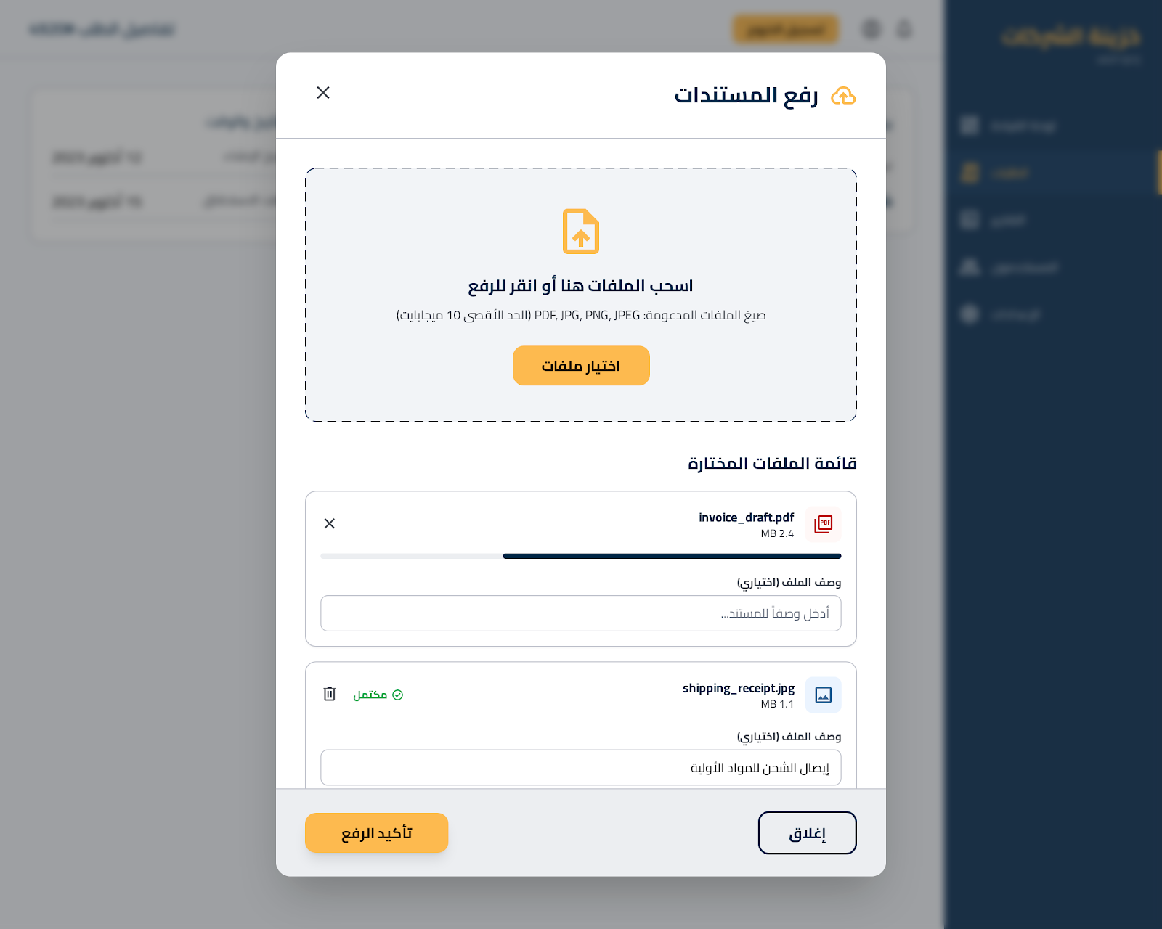Components:
# | Component | Type | Description
1 | Upload Area | Upload | Drag-and-drop zone, Cloud icon, "Drag files here or click to upload", Supported formats (PDF, JPG, PNG, Max 10MB), Select Files button (gold)
2 | Uploaded Files List | List | File icon, Name, Size, Status (Uploading/Uploaded/Failed), Remove button
3 | Description | Input | Optional description field
4 | Close | Button | Close button
User Actions:
- Drag and drop files or click Select Files
- View uploaded files list
- Remove files if needed
- Enter optional description
- Close the modal

4.6 REPORTS SCREENS
SC-15: Report List
User Role: Admin, Investor, Finance Manager
Purpose: View all available reports
Access: Requires authentication and 'view_reports' permission

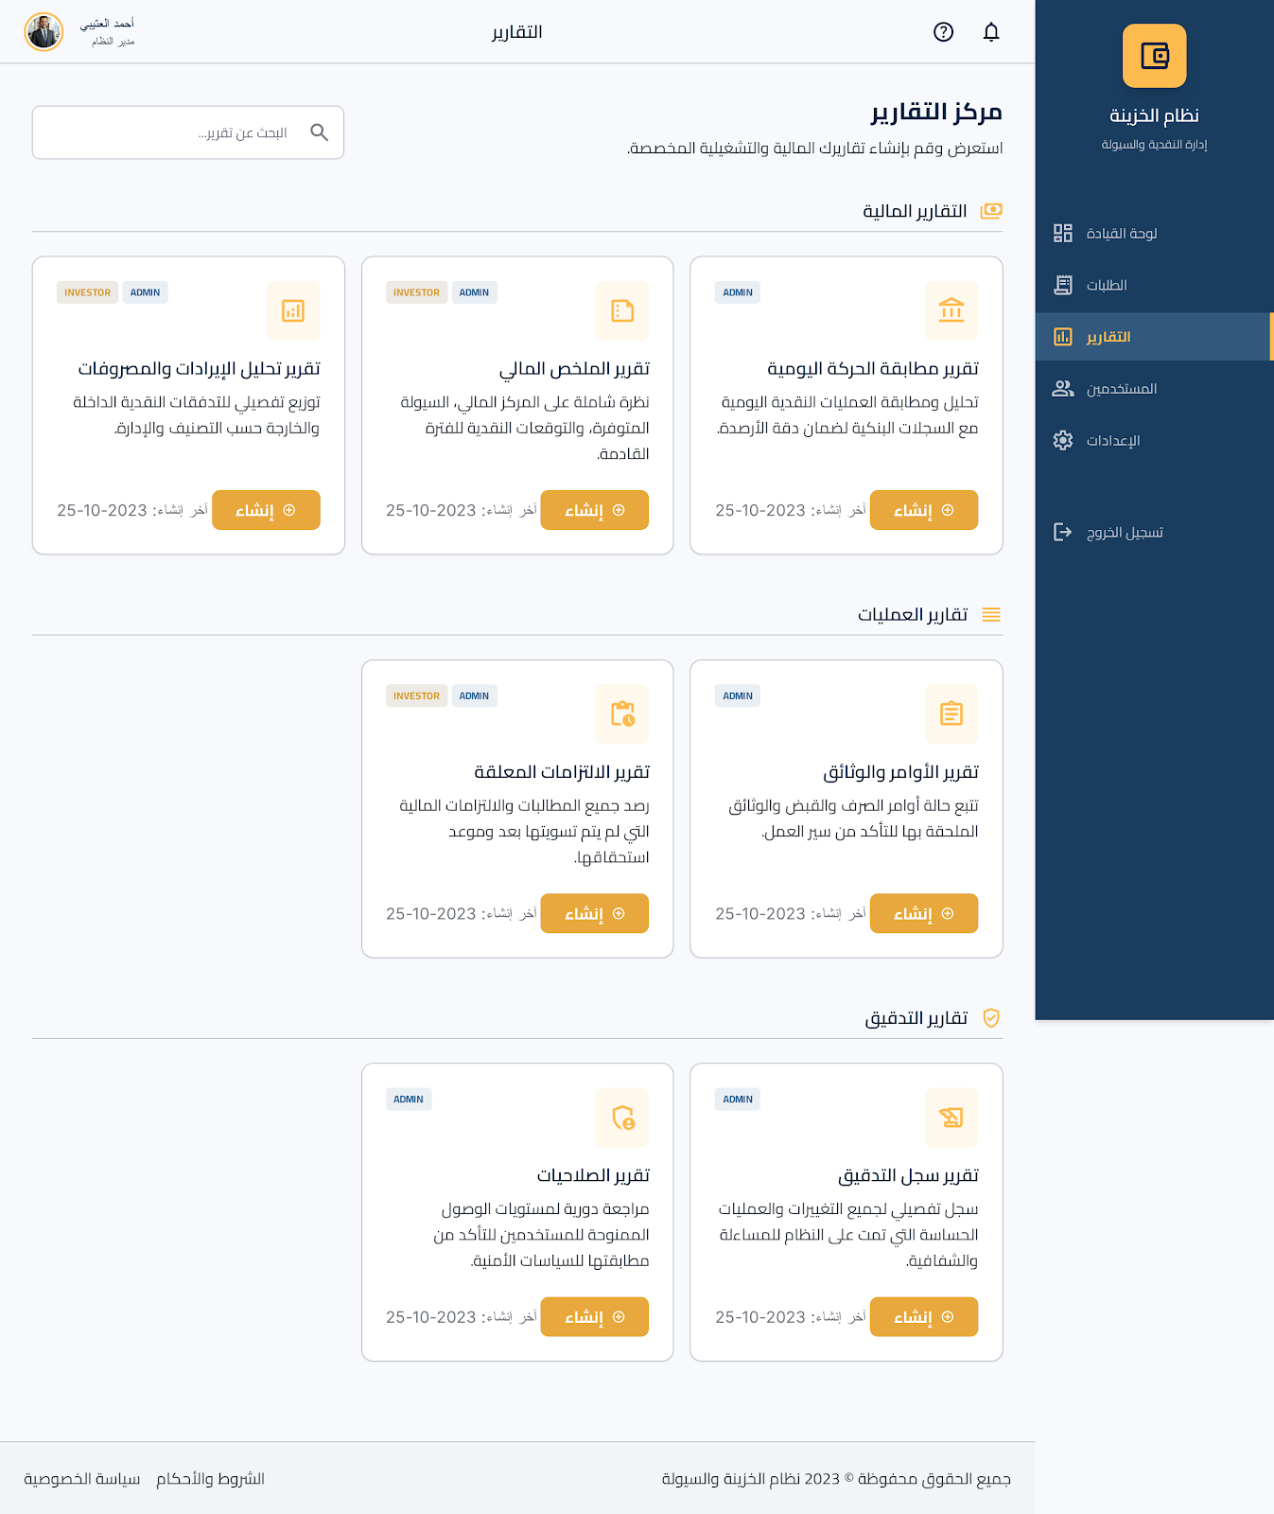Sidebar Menu: Dashboard, Orders, Reports (active), Users, Settings, Logout.
Components:
# | Component | Type | Description
1 | Page Header | Text | Title "التقارير"
2 | Financial Reports | Card | Daily Movement Reconciliation, Financial Summary, Income/Expense Analysis
3 | Operations Reports | Card | Orders & Document Status, Pending Commitments
4 | Audit Reports | Card | Audit Log, User Permissions
User Actions:
- Click Generate button on a report card
- View last generated date
SC-16: Generate Report
User Role: Admin, Investor, Finance Manager
Purpose: Generate reports with specific filters
Access: Requires authentication and 'generate_reports' permission

Sidebar Menu: Dashboard, Orders, Reports (active), Users, Settings, Logout.
Components:
# | Component | Type | Description
1 | Report Name | Text | Large, bold
2 | Filters | Input/Dropdown | Date Range (From/To), Order Type dropdown, Status dropdown, Created By dropdown (Admin only)
3 | Output Format | Radio | PDF/Excel/CSV radio buttons
4 | Scheduling | Checkbox/Dropdown | Checkbox for recurring, Frequency dropdown (Daily/Weekly/Monthly)
5 | Actions | Button | Generate Report (gold), Cancel (outline)
User Actions:
- Set filters
- Select output format
- Optionally enable scheduling
- Click Generate Report or Cancel
SC-17: View Report
User Role: Admin, Investor, Finance Manager
Purpose: View generated reports
Access: Requires authentication and 'view_reports' permission

Sidebar Menu: Dashboard, Orders, Reports (active), Users, Settings, Logout.
Components:
# | Component | Type | Description
1 | Report Header | Text | Name, Generation Date/Time, Period
2 | Action Buttons | Button | Download PDF, Export Excel, Print, Email Report
3 | Report Content | Summary/Chart/Table | Summary Section, Charts Section, Data Table
4 | Footer | Text | Generated By [User] on [Date/Time], System name
User Actions:
- View report header
- Click Download PDF, Export Excel, Print, or Email Report
- View report content

4.7 SETTINGS SCREENS
SC-18: Company Settings
User Role: Admin
Purpose: Configure company information and system settings
Access: Requires authentication and Admin role

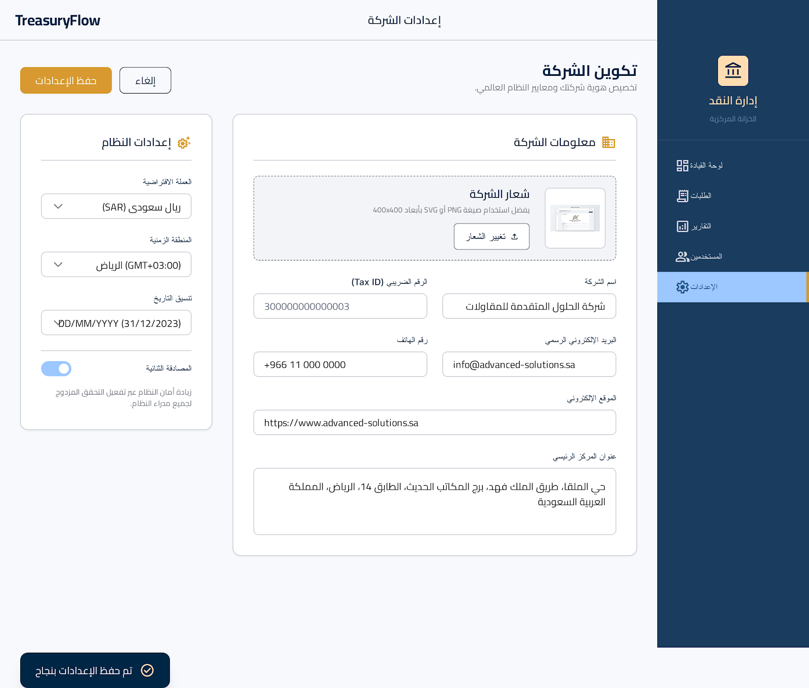Sidebar Menu: Dashboard, Orders, Reports, Users, Settings (active), Logout.
Components:
# | Component | Type | Description
1 | Company Information (Card) | Input/Upload | Name, Logo upload with preview, Address, Phone, Email, Website, Tax ID
2 | System Settings (Card) | Dropdown | Currency dropdown (SAR/USD/EUR), Timezone dropdown (Asia/Riyadh/UTC), Date Format dropdown (dd/mm/yyyy/mm/dd/yyyy)
3 | Actions | Button | Save Settings (gold), Cancel (outline)
User Actions:
- Fill Company Information
- Select System Settings
- Click Save Settings or Cancel
SC-19: Category Management
User Role: Admin
Purpose: Manage income and expense categories
Access: Requires authentication and Admin role

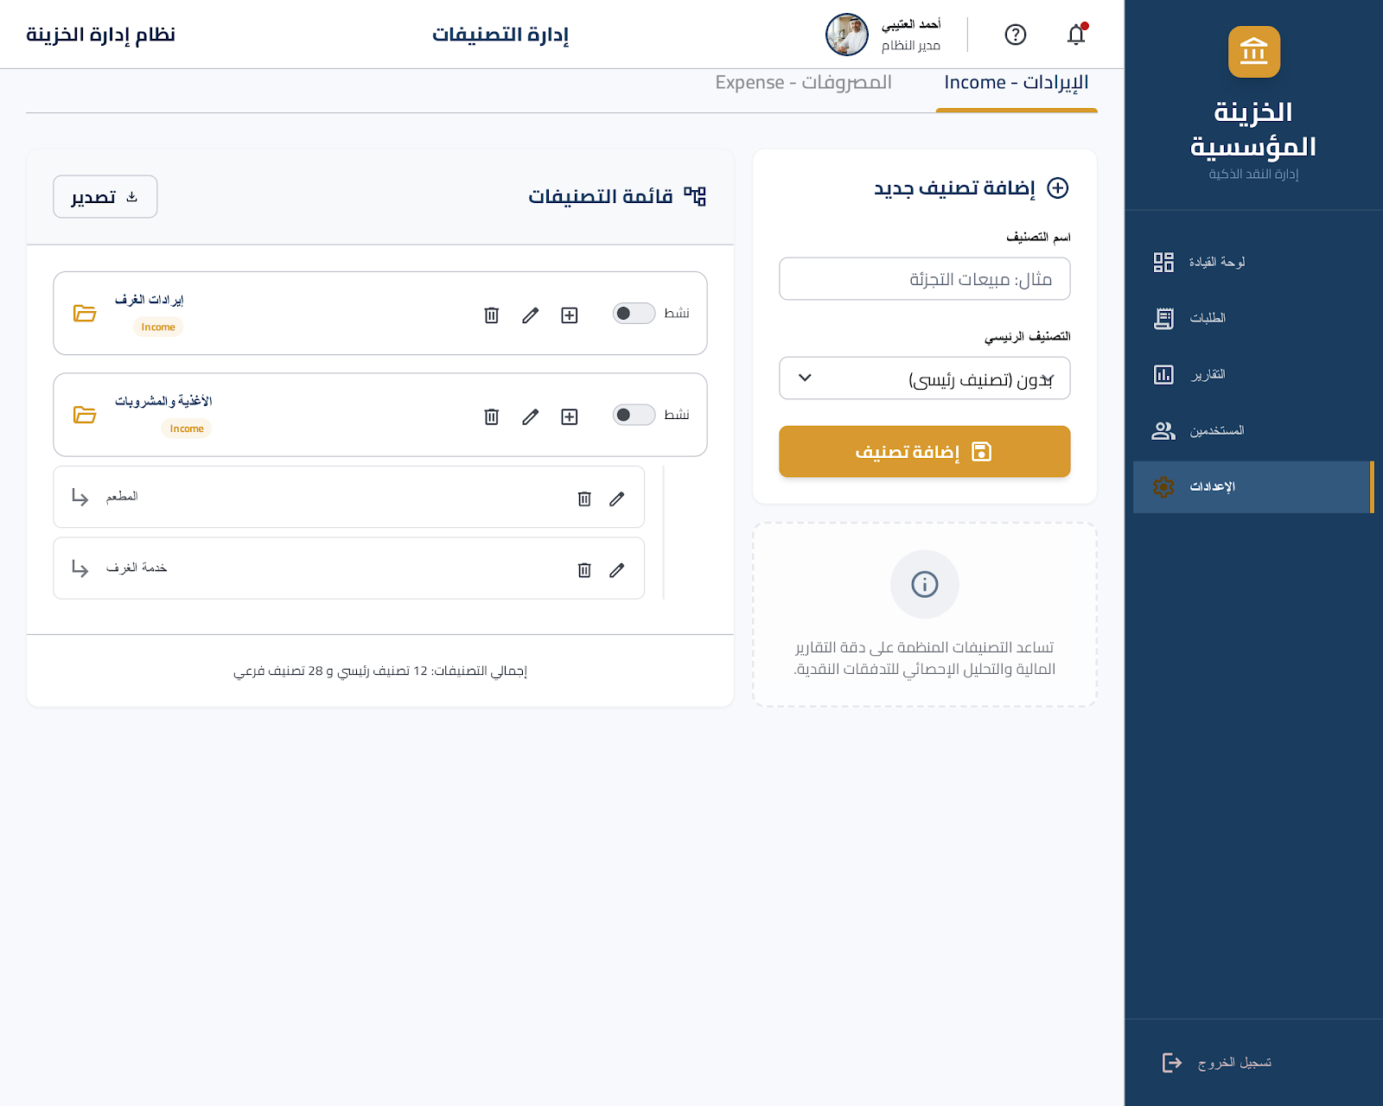Sidebar Menu: Dashboard, Orders, Reports, Users, Settings (active), Logout.
Components:
# | Component | Type | Description
1 | Tabs
2 | Add Category | Input/Dropdown/Button | Name input, Parent Category dropdown, Add button (gold)
3 | Category List | Tree View | Tree view with indentation, Name, Type badge, Status toggle, Actions (Edit/Delete/Add Subcategory)
4 | Export | Button | Export button (outline)
User Actions:
- Switch between Income and Expense tabs
- Enter category name and select parent
- Click Add button
- Edit, Delete, or Add Subcategory to categories
- Click Export button

4.8 CLIENT SCREEN
SC-20: Client Dashboard
User Role: Client
Purpose: View personal transactions and receipts
Access: Requires authentication and Client role

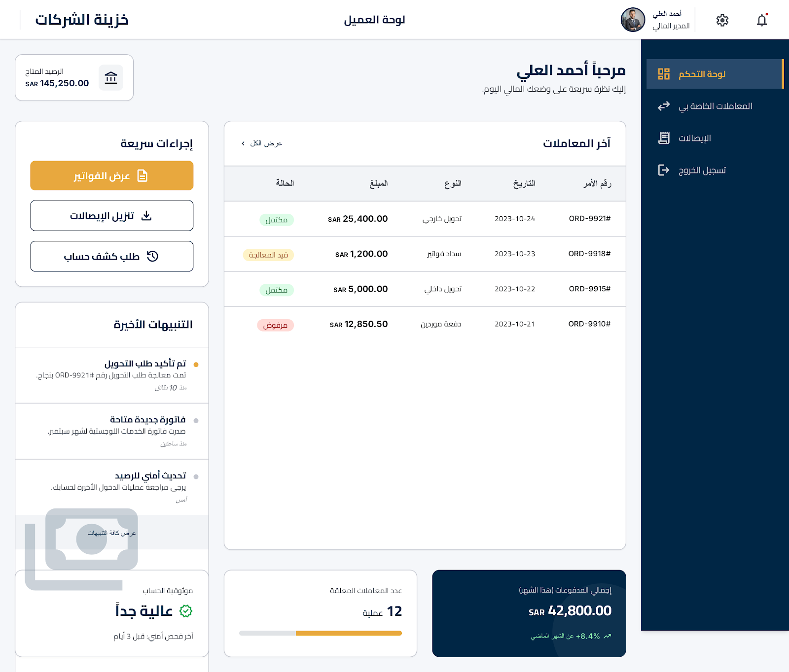Sidebar Menu: Dashboard (active), My Transactions, Receipts, Logout.
Components:
# | Component | Type | Description
1 | Welcome | Text | مرحباً [Client Name]
2 | Recent Transactions | Table | Date, Type, Amount, Status badge, Order Number, View All link
3 | Quick Actions | Button | View Invoices (gold), Download Receipts (outline), Request Statement (outline)
4 | Notifications | List | List with timestamps
User Actions:
- View Welcome message
- View Recent Transactions table
- Click View All link
- Click Quick Action buttons
- View Notifications

5. Responsive Design Considerations

5.1 Desktop View (1440x900)
- Sidebar always visible, 240px width
- Content full width with 24px padding
- Tables full width, all columns visible
- Cards 3-4 columns per row

5.2 Tablet View (768x1024)
- Sidebar collapsible (hamburger menu)
- Content full width with 16px padding
- Tables horizontal scroll
- Cards 2 columns per row

5.3 Mobile View (375x812)
- Sidebar hidden, accessible via hamburger menu
- Content full width with 12px padding
- Tables card view instead of table
- Cards 1 column, stacked
- Buttons full width

