Image Processing in Frequency Domain

Introduction
In general, an image is represented as an array of pixels but it can also be represented as a sum of a number of sine waves of different frequencies, amplitudes and directions, known as Fourier representation or representation in Frequency domain. The parameters specifying the sine waves in Frequency domain are known as Fourier coefficients. There are some image processing activities that can be performed more efficiently by transforming an input image into a frequency domain. An image is converted into frequency domain by applying an image transform. An image transform separates components of an image according to their frequency so that the required processing can be done on these components. This process is analogous to the concept of a prism that separates a light ray into various color components. A number of image transforms are available, such as the Fourier transform, discrete cosine transform, Haar transform and Hough transform. After converting the image into frequency domain, appropriate processing is done and the inverse transformation is subsequently applied in order to get the final image (Fig. 5.1).
Frequency-domain techniques are based on the convolution theorem. Let in spatial domain, an image f(x, y) is operated on by a linear operator in order to get the processed image g(x,y), i.e.,
g(x, y) = f (x, y) ∗ h(x, y) (5.1)

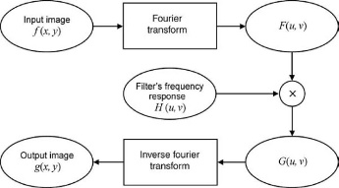
Fig. 5.1. Image processing in frequency-domain.

According to convolution theorem, corresponding to Eq. 5.1, the following relation holds in frequency-domain:
G(u, v) = F (u, v) H (u, v) (5.2)
where G(u,v), F(u,v), and H(u,v) are the Fourier transforms corresponding to g (x,y), f(x,y), and h(x,y), respectively. This multiplication of two Fourier transforms is done point by point and therefore the dimensions of both the transforms should be equal. If the size of both transforms is not equal, then padding needs to be done before convolution. The convolution kernel H (u, v) has to be selected as per the requirement, such that the desired operation is performed.
Many image processing operations can be expressed in the form of frequency domain operations. The filter function in spatial domain can be implemented by corresponding frequency domain filters. This can be observed in Fig. 5.2, in which two frequency filters are given which correspond to spatial domain filters.
In image processing, an image is stored in spatial domain. Therefore, in order to perform processing on an image in the transform domain, initially the image has to be converted into transform domain then an algorithm is applied in the transform
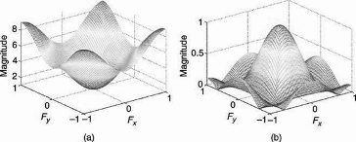
Fig. 5.2. Frequency-domain filters (a) A low-pass frequency domain filter equivalent to a 3 × 3 average filter in the spatial domain; (b) A high-pass frequency domain filter equivalent to a 3 × 3 composite Laplacian sharpening filter in the spatial domain.

domain in order to perform the required image processing, and eventually the inverse transformation is applied in order to get the image in spatial domain. Figure 5.3 shows an image and its corresponding Fourier spectrum.
The steps to be performed in frequency domain filtering are given below
(Fig. 5.4):
Step 1: Apply the Fourier Transform in order to convert the image into a 2D frequency-domain.
Step 2: Apply the appropriate frequency domain filter.
Step 3: Apply the inverse Fourier Transform in order to convert the image into
spatial domain.
In MATLAB®, the two-dimensional Fourier Transform of an image and its inverse can be obtained using functions fft2 and ifft2, respectively. The two- dimensional Fourier Transform is shifted in such a way that the zero-frequency component coincides with the center of the figure for visualization purposes. This
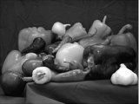
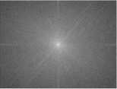
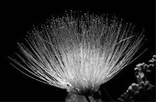
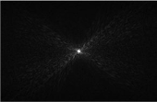

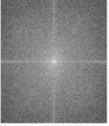

(a) (b)
Fig. 5.3. (a) Images; (b) Fourier spectrum corresponding to the images in (a).
Original image corresponding to upper left image reprinted with permission of The MathWorks, Inc.

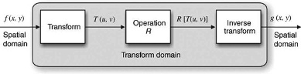
Fig. 5.4. Processing in frequency domain.

can be done using the fftshift function in MATLAB. To shift the Fourier transform back to its position, the ifftshift function is used in MATLAB.

