

Cost Data Collection

PROMOTioN – Progress on Meshed HVDC Offshore Transmission Networks

Mail info@promotion-offshore.net

Web www.promotion-offshore.net

This result is part of a project that has received funding form the European Union’s Horizon 2020 research and innovation programme under grant agreement No 691714.

Publicity reflects the author’s view and the EU is not liable of any use made of the information in this report.

# Document info sheet

|  |  |
| --- | --- |
| **Document Name:** | Cost Data Collection v2.1 |
| **Responsible partner:** | DNV GL |
| **Work Package**: | WP 12 |
| **Work Package leader:** |  |
| **Task:** | Cost Data Collection |
| **Task lead:** | Yongtao Yang, Remco Bal |

## Distribution list

## Approvals

|  |  |  |
| --- | --- | --- |
|  | Name | Company |
| Validated by: |  |  |
| Task leader: |  |  |
| WP Leader: |  |  |

## Document history

|  |  |  |  |
| --- | --- | --- | --- |
| Version | Date | Main modification | Author |
| 1.0 | 30 Mary 2018 |  |  |
| 2.0 | 19 Nov 2019 |  |  |
| 2.1 | 28.Nov.2019 |  |  |

|  |  |  |  |  |
| --- | --- | --- | --- | --- |
| WP Number | WP Title | Person months | Start month | End month |
|  |  |  |  |  |

|  |  |  |  |  |
| --- | --- | --- | --- | --- |
| Deliverable Number | Deliverable Title | Type | Dissemination level | Due Date |
|  |  |  |  |  |

# List of Contributors

Work Package and deliverable involve a large number of partners and contributors. The names of the partners, who contributed to the present deliverable, are presented in the following table.

|  |  |
| --- | --- |
| Partner | NAme |
| SGI | Serge Poullain, Léo Dalmar |
| University of Aberdeen | Dragan Jovcic, Ali Jamshidi Far |
| RWTH | Philipp Ruffing |
| TenneT | Michiel de Schepper, John Moore, Pim Foppele |
| EnergiNet | Walid El-Khatib, Stig Sørensen, Antje Orths, Henrik Thomsen |
| UPV | Ramon Blasco-Gimenez |
| RTE | Jean-Baptiste Curis, Simon Deschanvres |
| SOW | Andreas Wagner |
| Carbon Trust | Oliver Houlden, Andrew Johnson |
| DNV GL | Yongtao Yang, Marie Rustad, Remco Bal, Paul Raats, Cornelis Plet |

# List of Abbreiviations

|  |  |
| --- | --- |
| Acronym | Full NAme |
| AC | Alternating Current |
| HVDC | High Voltage Direct Current |
| VSC | Voltage Source Converter |
| MMC | Modular Multilevel Converter |
| HB | Half Bridge |
| FB | Full Bridge |
| DRU | Diode Rectifier Unit |
| MOG | Meshed Offshore Grid |
| DCCB | HVDC Circuit Breaker |

Content

Document info sheet ii

Distribution list ii

Approvals ii

Document history ii

List of Contributors iii

List of Abbreiviations iv

1 Introduction 7

1.1 Background and objective 7

1.2 Scope of work (overalL) 7

1.3 Data availability 9

2 Cost data analysis 11

2.1 Data collection 11

2.1.1 Cables 12

2.1.2 Converter stations 14

2.1.3 Platform 20

2.1.4 AC Transformers 23

2.1.5 AC circuit breakers 23

2.1.6 DC Circuit breakers 24

2.1.7 DC Grid control centre 26

2.1.8 Island Cost 27

2.1.9 OPEX Cost 27

2.2 Data validation 30

2.2.1 Methodology 30

2.2.2 Step 1: Collecting information about realized and contracted projects 30

2.2.3 Step 2: estimate cost of contracted projects 31

2.2.4 Step 3: Compare contracted cost with estimated cost 31

2.3 Results 33

2.3.1 HVDC offshore wind projects 33

2.3.2 Interconnector projects 37

2.3.3 Conclusion of the validation 41

2.4 Data verification 42

3 Learning curves and cost saving potential 43

3.1 Cost saving potential for HVDC Platforms 43

4 Conclusions 46

5 Disclaimers 47

6 Bibliography 48

# Introduction

## Background and objective

Within PROMOTioN there are several work packages that need cost and price figures as input for analysis and modelling. This kind of business information appears not immediately available to the work package members.

Within the design of Meshed Offshore Grids (MOG), HVDC technology is used. The technology for meshed HVDC grid is still under active development and the major components or subsystems are available as “customized design” rather than off-the-shelf products. In addition, several critical components are either missing or only available as proto-type. currently not ready available as common products in a commercial marketplace. Besides this, the market for HVDC grid components can be labelled as a somewhat ‘private market’ in which it is difficult to get reliable price and cost figures. Market parties keep business information to themselves. This is because of competitive advantage reasons but also because of international regulation which prohibits price agreements by market actors (cartels). This is not different to the market of (HV)AC grid components but due to its market maturity it is easier to acquire reliable cost and price information for AC components. For HVDC projects however many components are bought from one supplier as a turn key solution. The market for HVDC grid components/subsystems appears still to be immature and has only recently seen an increase in demand.

In a professional attempt to provide the work packages with useful cost and price information for HVDC grid components, a project effort has been deployed: the ‘Cost Data Collection’. The aim is to deliver cost figures with a margin of plus or minus 30%, which is common in cost engineering studies. Since the summer of 2017 DNV GL headed a small team that has executed an approach to provide the best cost/price estimates possible.

This document, also named ‘Cost Data Collection’, comprises data collection (from public and companies’ sources), analysis and validation. In the current version <*version 2.1*> no verification is incorporated from any HVDC component/system supplier. This report elaborates on the steps that are taken and present the results.

The current document is the result of the Cost Data Collection effort and is not a formal standalone deliverable, but forms part of the work package 12 and provides cost data to WP12.2. Content-wise, the cost/price data will also provide inputs to WP4.5 “Cost Benefit Analysis of DC Protection Systems”. The objective is to have reliable cost/price estimates for the installations that together build a MOG. These include all connections and offshore installations.

## Scope of work (overalL)

This analysis focuses on the work of PROMOTioN on Meshed Offshore Grids (MOG). By inter-connecting offshore wind farms with several onshore systems, this MOG could be able to combine the development of far shore offshore wind energy with the exchange of power between different countries. In Figure 1 an example of an offshore connection from the onshore substation to the wind turbine is illustrated schematically. In the graph the scope of this cost analysis has been shown with the blue square.

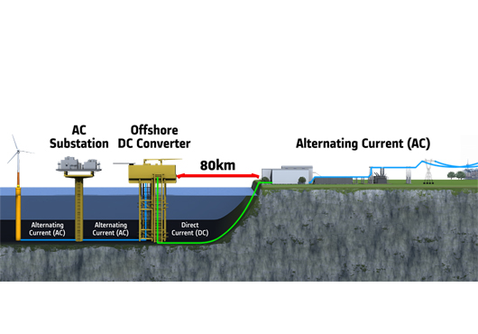

Figure 1 Example of an offshore connection with the cost analysis scope in the blue square

The list of cost items for the cost data collection are based on the requirements for two work packages (WP4 and WP12) within PROMOTioN, more specifically:

1. Task 4.5, cost-benefit analysis of the DC Grid protection solutions, led by SGI
2. Task 12.2, To develop a ‘Optimal Scenario’, led by Tractebel.

The components that are used and for which cost data is needed are stated in Table 1 and are the result of an information request from these work packages. The selection of the cost items as listed in Table 1 is the results of a balanced consideration of both economic and technical importance. For instance, the cost of AC Circuit Breakers is not significant as compared with the other cost items; however ACCB will be studied as an alternative to DCCB in task 4.5 and thus their cost should be included in the comprehensive cost benefit analysis.

Table 1 List of components

|  |  |
| --- | --- |
| HVDC grid component | Detailed List |
| Converter station | Offshore / onshore, half bridge MMC VSC, full bridge MMC VSC, DRU |
| Cables | HVDC, HVAC, Submarine, Underground |
| HVAC Transformers | HVAC Transformers |
| Offshore platforms | AC or DC, different designs (jacket, Jack-up and semi-submersible) |
| DC Breaking Devices | Hybrid DCCB, Mechanical DCCB |
| AC Breaking Devices | AC Circuit Breakers |
| Centralized DC Grid Control Centre | Hardware (control room, computers and communication devices), software (SCADA system, control algorithm, high-level function etc) |
| Island Cost |  |

The item “Centralized Grid Control Centre” [1] in Table 1 is a relatively new concept - it does not exist in any commissioned or on-going HVDC projects: none of those projects consists of meshed HVDC grid and there is no need for such control centre. Similar to the Control Centre for onshore TSOs, it is envisaged that the “Grid Control Centre” will provide the following functionalities for the MOG:

1. Energy Management System (EMS)
2. SCADA for the DC Grid
3. Wide Area Measurement System (WAMS) if necessary

For each category of components, the following procurement cost items are included in the cost data [2]:

* 1. Direct material cost
  2. Labour cost
  3. R&D cost
  4. Profit Margin
  5. Installation cost

Besides procurement costs an estimate of operational cost (OPEX) has been added as a percentage of CAPEX.

The following factors are excluded from the cost data:

1. **Price fluctuations due to short term supply and demand variations**: It is expected that during the large-scale deployment of MOG in the period of 2030-2050, the market will be sufficiently developed and certain significant market barriers[1] can be removed. The construction of a Meshed Offshore Grid in the form of individual projects is assumed to be reasonably well spread in time, and the technology and service providers/vendors have sufficient time and confidence to develop their capacity. Therefore, there should be no substantial market fluctuations due to the rising demand for the relevant technology and services, thus a normal market situation for cost estimations is assumed. More specifically, it is expected that the manufacturers charge the owners based on the underlying cost plus a profit margin.
2. **Project and location specific cost**-**driving factors:** the cost data will be used for the whole project portfolio of a future MOG in the Northern Seas, which consists of many separate projects. The cost of each project will be impacted by certain specific cost drivers such as required ancillary services, redundancy level[2], the scope of service contract, ambient temperatures, water depth and cable routing. Those specific factors for various subsystems in a MOG will not be considered on a detailed project-by-project basis, instead they will be considered on an average level.
3. **Price index:** for this analysis we have indexed all costs to 2017 figures.

## Data availability

As discussed in the introduction of this document, data availability is a major issue. The reason that currently no or little cost data is sufficiently available is due to a number of reasons:

1. Technological innovation: the need to foresee/adapt to technological development. Very often the HVDC suppliers are in the front line of technology development; they have the best insight on the cost drivers of various components and subsystems in the MOG, both the mature/existing components and the components under development
2. Competitive: suppliers do not like to release pricing information and give their competitors insight into their information
3. Regulatory: suppliers also worry that the participation in cost data collection efforts can be viewed as collusion or cartel forming
4. Quality and lack of consistencies of the cost data from the public domain: the vendors usually send out press release on their recently awarded projects, where they indicate the contract price and scope in a rather vague manner.

Due to the limited amount of available data, there is a need for this analysis. In addition to the limited availability of data, the reliability of the limited available data is an issue. Therefore, the various combined sources used in this analysis have been verified by means of cross-checking.

# Cost data analysis

This analysis has been done in the following steps:

Figure 2 Main work flow of the cost data collection

As there is limited information and the information has to be accepted within the consortium, these steps are defined:

1. **Data collection**: Data is collected from public, scientific and DNV GL internal sources. In case there is no information available, bottom up approaches are used to define cost figures based on other components.
2. **Data validation**: The results of the model are validated through public sources of existing projects. These projects include offshore wind connections and interconnections.
3. **Data verification**: The results of the analysis are checked with vendors. This is done by confidential interviews in which the vendors give generic feedback on the figures.

## Data collection

As stated in [2], the methodology for cost data collection has been different depending on the type of components:

1. **Mature products**, such as cables, HB VSC HVDC converter stations and AC transformers. The underlying technologies have been developed continuously over the past couples of decades, the products have been deployed in a significant number of projects worldwide, and there are several vendors competing in the market. For this category of products, the cost data will be collected through publicly available sources (literature, published contract values) and augmented with in-house data from the TSOs.
2. **Products are under development, but other products exist with similar functionalities and configurations:**  DRU and full-bridge VSC converters belong to this group. Full-bridge (FB) VSC converters are similar to half-bridge VSC in both configuration and functionality[3], hence a cost model will be built of FB VSC using HB VSC as reference base. Similarly, the cost of DRU will be based on the cost of a LCC converter station.
3. **Relatively new and unique products which are still under development:** Those products are not yet available in the market and there are very few or no commercial projects with such products, it is therefore not possible to establish the cost data through historical data. Furthermore, due to the unique feature of those products, it is also difficult to establish the cost model by evaluating the cost data of similar products. A “bottom-up” approach will be used to obtain the direct material cost. The other cost items will be estimated as additional percentages of the direct material cost. This applies mainly to DCCBs with different solutions.

### Cables

The cost data of HVAC and HVDC cables are mainly collected based on discussion and inputs with the TSOs and data provided by [3]. The costs listed below include both the procurement cost and the project overhead cost which usually are born by the owners of the projects. Some data points were not defined by the discussions with TSOs and have therefore been interpolated. As the figures from

Table 2 and Table 3 come from TSOs these figures include overhead costs for the project owner. For the data validation in section 2.2, the overhead cost (defined as 30-35% of the total cost) is deducted in order to have a fair comparison. No distinction has been made in the type of cable technology used, i.e. the insulation material (mass-impregnated paper or XLPE) and conductor material (copper or aluminum).

Table 2 Cost Data of HVAC cables

|  |  |  |  |  |
| --- | --- | --- | --- | --- |
| **Voltage (kV)** | **Rating (MVA)** | **Cost (M€/km) – Including installation** | | |
| Submarine cables (10/90) [4] | Submarine cables (0/100) [5] | Underground Cables |
| **150** | 100 | 1,50 | 1,40 | 2,30 |
| 200 | 1,50 | 1,40 | 2,40 |
| 300 | 1,50 | 1,40 | 2,50 |
| **220** | 200 | 1,60 | 1,50 | 2,60 |
| 300 | 1,70 | 1,55 | 2,65 |
| 400 | 1,85 | 1,75 | 2,70 |
| **400** | 400 | 1,90 | 1,75 | 2,90 |
| 500 | 2,10 | 1,95 | 3,00 |
| 600 | 2,40 | 2,25 | 3,05 |

Table 3 Cost Data of HVDC cables

|  |  |  |  |  |
| --- | --- | --- | --- | --- |
| Voltage (kV) | Rating of the pair (MW) | Cost (M€/km) – Including installation, for two poles | | |
| Submarine cables (10/90) | Submarine cables (0/100) | Underground Cables |
| ±320 | 700 | 1,70 | 1,65 | 2,15 |
| 900 | 1,95 | 1,85 | 2,50 |
| 1200 | 2,10 | 1,95 | 2,55 |
| ±525 | 1000 | 2,05 | 1,95 | 2,30 |
| 1400 | 2,25 | 2,15 | 2,55 |
| 1600 | 2,35 | 2,25 | 2,65 |
| 2000 | 2,55 | 2,45 | 2,80 |

### Converter stations

The converter costs are estimated based on publicly available information and scientific papers [4] [3] [5] [6]. The public information consists of reports from similar projects funded by TSOs and/or governmental organizations [4] [3] [5]. The scientific data consists of similar analyses such as [7].

Cost drivers of HVDC converter stations:

1. Power rating
2. Voltage level
3. Onshore/offshore
4. Technology
5. Configuration

***The capital and rental cost of land for onshore HVDC converter stations:***

The capital and rental cost of land for the onshore HVDC converter stations depend on the location of site and the footprint of the converter station. It is reasonable to assume that the converter stations are in flat, barren land with relatively easy site access. To have a first order estimate for such cost, we take a +/-525 kV, 1200 MW VSC converter station as example:

1. According to [8], such a converter station will have a footprint of 100mx150m, thus the total area is 150000 m2
2. The average land price from [9] gives a range of 1958 EUR to 63000 EUR per hectare for arable land in different EU member states in 2016. This price will result in a land capital cost range of 30 kEUR to 1 mEUR for the converter station mentioned above.
3. However, we should be aware that barren land is priced at a much lower level than the arable land. The Norwegian environment Agency has a price comparison of arable and barren land, where the arable land is more than 10 times more expensive than the barren land [10]. If we count other usage possible for the barren land (e.g. forest, recreation), we can put the factor as 5 instead of 10.
4. Combining the data above, the land cost will be less than 200k EUR for the converter station in discussion given it is located in barren land.

The capital cost of about 100 kEUR will be almost negligible as compared with the overall capital cost of the HVDC converter station, which is in the level of hundred million euros. Similarly, we can assume that the annual rental price of the land will be a relatively small amount. Therefore we suggest that in the rest of the report we do not explicitly calculate the capital and rental cost of onshore converter station, but rather assume that they are included implicitly in the CAPEX and OPEX of the converter station.

#### Half-bridge VSC Converter station

Data for HB VSC was mainly found in publicly available sources [4] [3] [5] [6]. These sources combined have resulted in the following procurement cost data:

Table 4 Procurement cost of HB MMC HVDC single converter stations [3] [5] [4] [11]

| Voltage (kV) | Rating (MW) | Cost (M€) | | | |
| --- | --- | --- | --- | --- | --- |
| Onshore | | Offshore (excluding platform and installation) | |
| HB MMC VSC Low value | HB MMC VSC High value | HB MMC VSC Low value | HB MMC VSC High value |
| ±320 | 700 | 85 | 105 | 85 | 105 |
| 800 | 95 | 110 | 95 | 110 |
| 900 | 100 | 120 | 100 | 120 |
| 1200 | 125 | 145 | 125 | 145 |
| ±525 | 1000 | 140 | 165 | 140 | 160 |
| 1200 | 165 | 185 | 165 | 185 |
| 1400 | 185 | 210 | 185 | 210 |
| 1600 | 205 | 235 | 205 | 235 |
| 2000 | 240 | 285 | 240 | 285 |

It is worth mentioning the following details:

***Impact of voltage level****:* most of the cost data provided in the sources are applicable for the DC voltage level of ±320 kV, particularly in [7] and [12]. To develop the cost for ±525 kV HB VSC converter stations, we adapted the methodology suggested in [6]. The cost of a ±525 kV converter will be 30% higher than a ±320 kV converter with identical power rating, the cost increase is mainly caused by “upgrades to power electronics voltage ratings, greater equipment insulation size, and larger space requirements to meet increased electrical clearances”. The estimated increase of cost level (30%) is confirmed by our validation study results in the later sections.

***Impact of converter configuration***: so far the majority of the awarded HB VSC projects chose the symmetric monopole configuration, therefore we can assume that the cost data from various sources are mainly based on the symmetric monopole configuration. With the increase of power rating and voltage levels and requirement for higher redundancy in the HVDC projects, it is foreseeable that some projects might adapt configurations such as rigid monopole or bipole. We expect that the change from symmetric monopole to bipole will incur higher cost for the converter stations in terms of more and non-standard transformers, additional switchgears, electrodes, and related controllers. We are not able to find any reliable indication on the impact of this variation and therefore not include such impact in our cost data.

***Impact of onshore/offshore****:* we did not find reliable sources on the cost difference between onshore and offshore converters. Here the same cost data for the onshore and offshore converters with identical power rating and voltage level is used. However, onshore cost data include installation cost, whereas offshore cost does not. The installation cost of offshore HVDC converter station is normally included as a part of the whole platform installation cost.

#### Full-bridgE VSC converter station

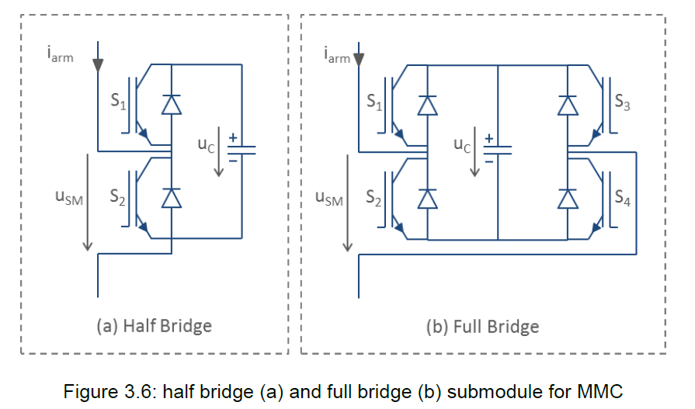As mentioned in the earlier sections, the FB VSC technology is a relatively recent development and only one project has been awarded [13]. The diagram in Figure 3 shows the difference of submodules of HB VSC and FB VSC. There are two IGBTs within each submodule for HB VSC. Whereas for FB VSC each submodule includes four IGBTs.

Figure 3 Half bridge and full bridge submodule for MMC

The advantage of a FB VSC module over a HB VSC is the ability to block fault currents in case of a DC grid fault and the ability to operate at low or reversed voltages, at the cost of increased capex and losses. For matters of clarity, we chose to establish the cost estimate of a 100% FB VSC using the following approach:

1. Use the cost data of a HB VSC with identical power rating and voltage level as a base.
2. Investigate the difference of the two converters in terms of number of power electronic components, dimension of converter transformers, number and dimension of passive components (such as capacitors.)
3. Establish the cost difference between HB VSC and FB VSC based on material cost difference

As an example, we compare the major component list of an HB VSC converter station and an FB VSC converter station, both with power rating at 2000 MW and DC voltage ±525 kV. Based on the principal design made by RWTH Aachen [14],

* The HB VSC converter consists of: 2292 units of IGBT modules I1 (4.5 kV, 1.5 kA) and 1146 pieces of Module Capacitor C1 with a capacitance of 7.6 mF
* The FB VSC converter consists of: 5136 units of IGBT modules I2 (4.5 kV, 1.2 kA) and 1284 pieces of Module Capacitor C2 with a capacitance of 6.8 mF
* If we assume that
  + the costs of IGBT I1 and I2 are proportional to their current rating, i.e. Cost_I2 = Cost_I1*(1.2/1.5),
  + the costs of module capacitors C1 and C2 are proportional to their capacitance, i.e. Cost_C2 = Cost_C1*(6.8/7.6)
* The cost of valve systems for the mentioned HB VSC and FB VSC converters can be compared in the table below:

|  |  |  |
| --- | --- | --- |
| Cost Comparison | HB VSC | FB VSC |
| IGBT | 2292*Cost_I1 | 5136*Cost_I2 = 1.80*(2292*Cost_I1) |
| Module Capacitor | 1146*Cost_C1 | 1284*Cost_C2 = 1.00*(1146*Cost_C1) |

We can draw the conclusion that for an FB VSC the cost of IGBT is 80-90% higher than the IGBT cost of HB VSC, the cost of module capacitors will be almost the same. It is also reasonable to expect that the control and protection system will be more expensive (e.g. 30%) for HB VSC due to the increased number of IGBTs. In Table 5, we compare the cost breakdown of HB VSC converter stations [12] with those of the FB VSC converter stations, and we can estimate that Cost of FB VSC is 30-35% higher than HB VSC with identical power rating and voltage level**Error! Reference source not found.**.

Table 5 Breakdown of HVDC converter costs (HB VSC vs FB VSC)

|  |  |  |
| --- | --- | --- |
|  | Breakdown per component ( HB VSC 2000MW total investment cost as 100%) | |
| Key Compoenents | HB VSC 2000 MW | FB VSC 2000 MW |
| Valve Groups | 30.50 % | 58% (=30.5%*1.9) |
| Control-protection-command | 9 % | 12% (=9%*1.3) |
| Converter transformer | 20 % | 20 % |
| AC&DC switchyard, filtering, auxiliaries | 4 % | 4 % |
| Civil works | 22 % | 22 % |
| Project engineering administraction | 15 % | 15 % |
| Total | 100.00 % | 131.00 % |

#### DRU Converter stataion

The DRU converter station [15] has a modular design, where each DRU module operates on a 12-pulse configuration. As shown in Figure 4, each individual DRU module has a power rating of 200 MW, rated AC voltage of 66kV and rated DC voltage of 106.7kV. Two such DRU modules will be installed per offshore platform. For a typical 1200 MW offshore wind connection, the system consists of three offshore platforms. The DRU modules will be connected in series to provide the +/-320 kV DC voltage, as illustrated in Figure 5. Note it is also possible to place several DRUs in a single offshore platform if it is more cost effective than three platforms.



Figure 4 Structure of a DRU module [15]

In a similar way to the Full Bridge MMC converter, the cost of DRU converter station[6] can be established by comparing station with LCC HVDC converter with identical power rating and voltage level [16] using the following steps:

* Use thyristor-based LCC HVDC converter station as reference.
* Thyristor will be cost 1.5-2 times as much as diode with identical dimension[7]
* DRU Transformer will be cheaper (no need for tap changer), assumed to cause 20% cost reduction.
* Smaller AC Filter for DRU as compared with LCC, which will result in a cost saving of about 50%.
* Strongly reduced control functionality of DRU, the DRU is essentially a passive device with very few controllable items. We expect the cost saving to be 50% as compared with the LCC for the part of control and protection systems.



Figure 5 Structure of a 1200 MW DRU system [15]

Using the cost breakdown of LCC HVDC converter stations [12], the items listed above will result in around 20-30% cost reduction for DRU as compared with LCC HVDC as illustrated in Table 6. Note the cost listed above covers only the DRU converter station itself, not the offshore platform supporting the DRU converter station.

Table 6 Breakdown of HVDC converter costs (LCC vs DRU)

|  |  |  |
| --- | --- | --- |
|  | Breakdown per component LCC 400MW total investment cost as 100%) | |
| Key Compoenents | LCC 400 MW | DRU 400 MW |
| Valve Groups | 21.00 % | 11.5% (=21%*0.5) |
| Control-protection-command | 8 % | 4% (=8%*0.5) |
| Converter transformer | 22 % | 17%(=22%*0.8) |
| AC&DC switchyard, filtering, auxiliaries | 18 % | 9%(=18%*.5) |
| Civil works | 14 % | 14 % |
| Project engineering administraction | 17 % | 17 % |
| Total | 100.00 % | 72.50 % |

A 400 MW LCC HVDC converter station will cost about 45.1 MEUR [3], so a 400 MW DRU HVDC converter station will cost about 31.6 – 36.1 MEUR. The weight of a 400 MW DRU HVDC converter station will be about 3000 ton. The volume of such a DRU HVDC converter station will be about 20% [17] of a corresponding VSC HVDC converter[8][9].

A unique characteristic of the DRU solution is the modular arrangement: normally a single offshore platform with two DRUs can provide the power rating of 400 MW. To supplied higher power rating, multiple offshore platforms will be needed. In such a way, the individual platform will be of same size and thus avoid the large size offshore platforms.



Figure 6 Layouts of offshore wind power plants connected via VSC HVDC (left) and DRU HVDC.

The cost reduction of the DRU converter as compared with VSC HVDC converter (as shown in the summary table in the next section) is substantial but the overall DRU solution will bring in additional cost reduction [17]. The modular design of DRU makes it possible to build multiple smaller offshore platforms instead of large single converter platforms which are known to be expensive; the DRU solution further eliminates the need for collector grid AC offshore substations as the collector cables are directly connected to the DRU platforms as shown in Figure 6.

#### Summary of HVDC Converter Station Cost

The cost data of HVDC converter stations for different power and voltage ratings are summarized in Table 7:

1. The costs of FB MMC VSC converter are calculated by a 30-35% cost rise from the cost of HB MMC VSC converter with the same power and voltage rating.
2. The costs of DRU converters of 800MW, 1200MW, 1600MW and 2000MW rating are obtained by multiplying the estimated cost of 400 MW DRU converter in 2.1.2.3 with factor of 2, 3, 4 and 5, respectively. Note due to the modular characteristics, the DC voltage of such DRU system will consequently increase with an interval of ±106.7 kV, as shown in the last column of Table 7 and in the footnotes. It is also important to note that so far only the 1200MW@±320kV configuration has been proposed by the relevant vendor, other combinations of power and voltage ratings should be further verified.

Table 7: Summary of HVDC Converter Station Cost

| **Voltage (kV)** | **Rating (MW)** | **Cost (M€)** | | | | |
| --- | --- | --- | --- | --- | --- | --- |
| **Onshore** | | **Offshore (excluding platform)** | | |
| **HB MMC VSC** | **FB MMC VSC** | **HB MMC VSC** | **FB MMC VSC** | **DRU** |
| **±320** | 700 | 85-105 | 110-140 | 85-105 | 110-140 | NA |
| 800 | 95-110 | 125-150 | 95-110 | 125-150 | 63-72[10] |
| 900 | 100-120 | 130-160 | 100-120 | 130-160 | NA |
| 1200 | 125-145 | 160-195 | 125-145 | 160-195 | 95-108[11] |
| **±525** | 1000 | 140-165 | 180-220 | 142-160 | 180-220 | NA |
| 1200 | 165-185 | 215-250 | 165-185 | 215-250 | NA |
| 1400 | 185-210 | 240-285 | 185-210 | 240-285 | NA |
| 1600 | 205-235 | 265-315 | 205-235 | 265-315 | 126-144[12] |
| 2000 | 240-285 | 310-385 | 240-285 | 310-385 | 157-180[13] |

### Platform

In Figure 7 a picture of a HVDC platform is given to illustrate the terminology used in the cost figures below. When referring to the cost of a platform, substructure and topside (excluding converter station) is included.

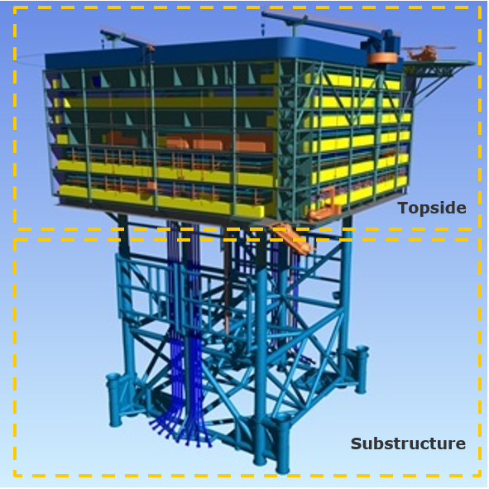

Figure 7 HVDC Platform

The cost data for Platforms was found in the sources as stated and are listed in Table 8 and Table 9. Currently the prices are as stated in the table, but as discussed later in this report these are expected to decline.

Table 8 HVAC Offshore Platforms [3] [5]. Can host a transformer of the given rating (MVA), circuit breakers and cable connection point.

|  |  |  |
| --- | --- | --- |
| Voltage (kV) | Rating (MVA) | Cost (M€) – Including installation |
| 150 | 200 | 35-50 |
| 300 | 35-50 |
| 220 | 300 | 40-60 |
| 400 | 40-60 |

The survey from offshore wind developers indicate that the future design will likely omit the intermate AC platform as shown in the left side of Figure 6, instead the 66 kV collector cables will be connected to the AC busbar of the offshore HVDC converter station.

Table 9 HVDC Offshore Platforms [3] [5]

| Voltage (kV) | Rating (MVA) | Cost (M€) – Including installation |
| --- | --- | --- |
| ±320 | 700 | 305-390 |
| 900[14] | 345-490 |
| 1200 | 380-640 |
| ±525 | 1000 | 355-540 |
| 1400 | 405-735 |
| 1600 | 435-835 |
| 2000 | 595-1030 |

A cost interval is given for each power rating. Which part of the interval that should be used for cost calculations is dependent on different cost drivers for platforms:

* **Platform design**. The type of platform design will impact the platform cost. There are three main types of platform design; jacket, jack-up and semi-submersible. Jacket is expected to be in the lower range of the cost interval, while jack-up and semi-submersible design are more expensive.
* **Topside weight**. The topside weight is expected to be almost linear with the power rating and is covered through the power rating in the tables above. [15]
* **Water depth**. The platform cost will increase with the water depth; a taller substructure is needed for deeper water.
* **Geological condition on the seabed.** More complex seabed increase the installation cost.
* **Weather conditions**. Higher wind- and/or wave load will increase the need for a stronger and heavier substructure.
* **Installation concept** [18]. The transportation and installation cost will differ depending on the installation concept.
* *Heavy lift*. The lifting capacity of the crane vessel is the main constraint associated with heavy lift installation; large topsides must be installed as prefabricated topside modules and assembled in the field. The availability of heavy lift vessels is limited to only a finite number. The vessels are expensive and waiting for one could cause significant project delays.
* *Float-over*. Float-over installation concept exceeds the maximum capacity of heavy lift vessels and allows platform topsides to be installed as one integrated package without a crane vessel. Hence, an integrated topside can be completed onshore, which reduces the substantial costs of doing commissioning offshore. Float-over techniques also open up the market to contractors which do not have access to crane vessels, hence providing additional competition during tender phase.
* **Degree of additional equipment and facilities installed**. Additional equipment/facilities, e.g. living quarter, helicopter deck, diesel generators and cranes on the platform, will impact the topside weight and hence the substructure weight of a platform.

### AC Transformers

The cost data of AC Transformers[16] were provided by a TSO to be used within PROMOTioN, these are listed in **Error! Reference source not found.**. It should be noted that the cost data do not include the installation costs of the AC transformers.

Table 10 AC transformer cost data (European TSOs)

|  |  |  |
| --- | --- | --- |
| Voltage (kV) | Rating (MVA) | Cost excluding installation (M€) |
| 150/66 | 250 | 2.0 - 2.4 |
| 220/66 | 250 | 2.1 - 2.6 |
| 220/150 | 300 | 2.2 - 2.7 |
| 400 | 2.6 - 3.2 |
| 600 | 3.8 - 4.6 |
| 420/150 | 600 | 4.5 - 5.5 |
| 900 | 6.1 - 7.4 |
| 1200 | 7.7 - 9.4 |

### AC circuit breakers

The cost data of AC circuit breakers come from discussions with TSOs. The cost data in Table 11 are associated with ACCBs with a relatively lower breaking current (40 kA instead of 63 kA), which is compatible as the fault current levels with the offshore AC grids are often lower than the onshore AC grid. It was difficult to find more data points than this, however the Circuit Breakers are only a small portion of the total cost of an offshore DC connection.

Table 11 AC circuit breakers cost data (European TSOs)

|  |  |
| --- | --- |
| Voltage (kV) | Cost (M€) – Including installation |
| 150 | 0.030 |
| 170 | 0.042 |
| 420 | 0.1167 |

### DC Circuit breakers

DC circuit breakers (CBs) are essential building blocks for DC grids as they are key components of many protection strategies (selective and non-selective) in the scope of PROMOTioN project. Although semiconductor-based DC breakers easily overcome the limitations in operation speed, they generate large transfer losses typically in the range of 30% of the losses of a voltage source converter station. That is why alternative topologies - mechanical DCCB and hybrid DCCB- were investigated here. The WP6 deliverables D6.1 [19] and D6.2 [20] produced models for hybrid and mechanical DCCB respectively. However, the modelling did not consider size, weight and costing of the DCCB units. The objective of WP 4.5 is to consider the costs for various protection options for DC grids while WP12 seeks to evaluate costs in analysing options for DC grid deployment. In order to develop cost model and carry out cost-benefit analysis, it was necessary to understand in depth the structure of high voltage DCCBs and the cost sensitivity to change in various input parameters, hence the approach presented in next section.

It is important to note that all outputs are computed for a single pole DCCB unit. For 2-pole applications, two of those units should be considered. WP 4.5 produced parametric models for the estimate of both hybrid DCCB and mechanical DCCB CAPEX [21], where the technical report from University of Aberdeen provided the basis for cost modelling. The model input parameters are detailed in Table 12.

Table 12 Cost model input parameters

|  |  |
| --- | --- |
| Nominal pole to ground DC voltage | U |
| Transient Interruption Voltage (TIV) peak value (Maximum voltage between the two terminals during the breaking process) | UbrM |
| Maximum DC breaking current | IbrM |
| Maximum DC permanent / operating current | In |
| Breaker opening time at maximum DC breaking current (Time from breaker trip signal to current diversion to energy dissipators) | To |
| Maximum Energy Dissipation  (Maximum electromagnetic energy that can be dissipated during one cycle of the breaking process) | E |
| Current limiting DC reactor | Ldc |

A general breakdown of DCCB costs is shown on Figure 8 including operational costs in addition to capital costs. The capital costs (CAPEX) can be split into:

* **Direct costs** that can be themselves split into **material costs** (procurement of equipment and associated auxiliaries) and **labor costs** (relating to assembly, testing).
* **Indirect costs** relating toR&D and production investments, industrial and commercial structures.
* **Installation & commissioning costs**.

Regarding operational costs (OPEX), it is assumed that the annual value is:

* 2% of the CAPEX for offshore DCCBs
* 0.7% of the CAPEX for onshore DCCBs

The OPEX percentage values are assumed to be the same as for AC/DC converter stations.

Figure 8: DCCB cost breakdown

The estimate of CAPEX is based on the following approach. For a given set of input parameters (see Table 12):

* Step 1: a list of all components in the DCCB is established based on electrical design rules ( [22]);
* Step 2: the total **material costs**, the **total volume** and the **total weight** of the DCCB are derived by aggregation of the unitary costs, volume and weight of components.
* Step 3: **labor manufacturing costs**, **indirect costs**, **installation and commissioning costs** are derived by applying empirical costing rules from HVDC projects return on experience.

Additionally an extra cost corresponding to the cost incurred to the offshore platform and depending on DCCB total weight and volume, is computed to complete the CAPEX model of DCCBs. For more details about cost assumptions, please refer to DCCB cost models report ( [21]). CAPEX values for the DCCB corresponding to different system set-ups are provided in Table 13, where all the DCCBs are capable of Open-Close-Open (OCO) opening cycle and bi-directional operations. The cost of DCCBs with single Open (O) opening cycle and / or uni-directional operation will be lower, please refer to [21] for such cost data.

Table 13 Summary of DCCB CAPEX

| Nominal DC Voltage (kV)[17] | Breaking current (kA) | CAPEX Cost (M€) | | | | | |
| --- | --- | --- | --- | --- | --- | --- | --- |
| Hybrid DCCB[18] | | Mechanic DCCB[19] | | | |
| High diserpated energy[20] | | Low diserpated energy[21] | |
| Onshore | Offshore | Onshore | Offshore | Onshore | Offshore |
| 320 | 16 | 14.0 | 18.0 | 4.7 | 10.4 | 2.7 | 5.9 |
| 32 | 25.9 | 29.9 | 6.2 | 11.9 | 4.2 | 7.3 |
| 525 | 16 | 23.7 | 31.7 | 8.0 | 14.9 | 4.7 | 10.5 |
| 32 | 44.6 | 52.6 | 10.5 | 20.2 | 7.3 | 13.0 |

### DC Grid control centre

As described in [1], so far most of the HVDC projects are point to point, where the control functions are covered by the individual converter stations. However with meshed grid, there is a need for centralized grid control.

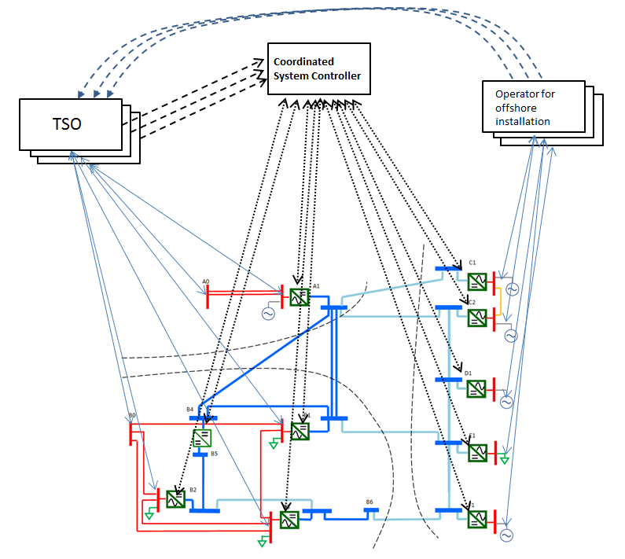

Figure 9 Illustrative diagram of DC Grid Control Centre [1]

It is difficult to predict the actual cost of a DC Grid Control Centre for the MOG, as there has almost no experience for DC Grid Control Centre. However we would use the onshore TSO control centre as reference values, the control function and algorithm might be more complicated for the DC grid. On the other hand, the onshore AC grid control centre tends to have more substations and power plants to control/dispatch, whereas the grid control centre will have fewer converter stations to be controlled.

The DC Grid Control Centre is also expected to be operated by a team of operation staff, which should be included in the Operational Cost (OPEX) of the Grid Control Centre.

Discussion should be carried out with TSOs on their experience of Control Centre, some of the publically available sources indicate that such a grid control center costs between 12 MEUR to 22 MEUR.

### Island Cost

This part of work just started, we expect the following process to establish the cost estimate for the islands:

1. Request location info for the Energy Hub from Task 12.2, where the deployment plan is studied.
2. Request from the Energy Hub Consortium to provide cost of island for the location specified in step #1.

### OPEX Cost

The OPEX cost for the major components of an HVDC system is given in Table 14. The OPEX cost is given as an average percent value of the total procurement cost for each component. The data is provided by [4], where a triple estimate is given for the OPEX cost; the mode value is given in the table below.

Table 14 OPEX cost given in percentage (%) of the unit cost for the equipment [4]

|  |  |  |  |  |  |  |  |  |  |
| --- | --- | --- | --- | --- | --- | --- | --- | --- | --- |
| Component | AC/DC Converter Station | | Cable | | AC Transformer | | HVDC Offshore Platform | HVDC Circuit Breaker | |
|  | Onshore | Offshore | Submarine | Underground | Onshore | Offshore |  | Onshore | Offshore |
| OPEX cost given in % of the unit cost for the equipment | 0,70% | 2,00% | 2,50% | 0,05% | 0,15% | 0,15% | 2,00% | 0.70% | 2.00% |

The total OpEx cost, including onshore and offshore assets, is approximately 2-2.5% of the total CapEx. OpEx cost for HVDC systems include periodic maintenance of equipment which typically includes the following tasks:

* Scheduled maintenance of the foundations and structure, which includes periodic inspections of:
  + The scour protection or the scour development of the foundations
  + The cathodic protection system
  + The marine growth and guano
  + The splash zone and NDT inspections
  + Conditions of the paint at the boat landing, platform and topside of the substation
  + Conditions and safety inspections of all ladders, deck cranes, davit cranes, hoists, fall-arrest systems, walkways, auxiliary platforms, railings and hatchways
* Scheduled maintenance of the topside and electrical equipment, which includes periodic inspections of:
* The drinking water and sewage system, the fire detection and extinction system, the sea water and cooling system, heating, ventilation, air condition system, emergency power system, fuel tanks, helicopter landing deck, accommodation facilities, communication system, oil pans and waste oil collection containers
* SCADA, CCTV and lighting system
* Intrusive inspections of GIS switchgear bays, transformers, transformers’ cooling systems, reactors, reactors’ cooling systems, rectifier modules, rectifier modules’ cooling systems; earthing and auxiliary transformers
* Non-Intrusive inspections of: GIS switchgear bays, transformers, transformers’ cooling systems, reactors, reactors’ cooling systems, rectifier modules, rectifier modules’ cooling systems; earthing and auxiliary transformers
* Scheduled maintenance of the electrical equipment at the onshore substation, which includes periodic inspections of:
* The fire detection and extinction system, the cooling system, heating, ventilation, air condition system, emergency power system, fuel tanks, communication system, oil pans and waste oil collection containers
* SCADA, CCTV and lighting system
* Intrusive inspections of: AIS or GIS switchgear bays, transformers, transformers’ cooling systems, reactors, reactors’ cooling systems, rectifier modules, rectifier modules’ cooling systems, earthing and auxiliary transformers
* Non-Intrusive inspections of: GIS switchgear bays, transformers, transformers’ cooling systems, reactors, reactors’ cooling systems, rectifier modules, rectifier modules’ cooling systems, earthing and auxiliary transformers
* Scheduled maintenance of the export cable:
  + Regular subsea surveys (typically undertaken in years 1, 2, 5, 10, 15 and 20) to assess whether the subsea cable remains fully buried. The frequency of these surveys depends on the mobility of the sea bed along its route. The surveys are typically undertaken using a survey vessel with ROV and crew. It is possible that the survey vessel could also be used to remotely survey the scour development at the base of the structure, reducing the cost of the scour protection survey
  + Monitoring of the export cable used to identify the location of any faults. This monitoring should include the ability to monitor both strain related and thermal events within the subsea cable, for example through (but not limited to) optical time-domain reflectometry and distributed temperature sensing methods respectively
  + In the event of damage to the subsea cable, provision of all labour, supervision of labour, spare parts, consumables, tools, equipment and transport required in accordance with good industry practice.

Costs typically included in OpEx are labour, spare parts, consumables, FMEA, KPI analysis, supply and accommodation vessels, crew transfer vessels or helicopter costs if applicable, travel expenses for staff and overnight accommodation, waste disposal, management and execution costs.

## Data validation

### Methodology

In 2.1, cost estimates are provided for each of the components relevant for HVDC offshore wind projects and HVDC interconnector projects. The aim of this section is to check how good the cost data fits with contracted projects. The methodology follows three steps, which are described in more detail below:

1. Collect information about contracted cost and design parameters for contracted HVDC offshore wind projects and HVDC interconnector projects
2. Estimate the cost of contracted projects with design parameters from 1) and cost estimates from the data collection in 2.1 as input
3. Compare contracted cost from 1) with estimated cost from 2)

### Step 1: Collecting information about realized and contracted projects

The validation study started by collecting data for all contracted European interconnector projects and offshore HVDC wind projects. The following information was collected:

* Contract year
* Power
* Topside weight and substructure weight
* Water depth
* DC Voltage
* Cable length
  + Submarine cable
  + Land cable
* Contract value(s) - since realized cost information is not available contract values have been used
* Converter technology (HB/FB) and configuration (Symmetrical monopole/bipole)

Data was in most cases found using public sources. Finding information was in some cases challenging, as the information found in the public domain is often scarce or even contradictory. When possible, contract values were extracted from the suppliers’ press releases and then index adjusted to 2017 numbers.

At the start of the offshore wind market, the offshore HVDC wind projects were awarded as turnkey contracts to one supplier. More recently, most offshore HVDC wind projects have however been awarded in two contracts, one to the cable supplier and one to the supplier of platform and converter station. Hence, for the offshore HVDC wind projects, the data available for the cable part and for platform and converter combined is adequate. However, to know the exact cost split between platform and converter station has been a challenge and is the reason why contract values in Table 15 is not split between platform and converter.

The HVDC interconnector projects have often been awarded in two or three contracts, one contract for the converter stations and one or two contract(s) for the cable part. Hence, for the interconnector projects, the exact cost split between cables and converter stations is in most cases known.

### Step 2: estimate cost of contracted projects

The cost of the contracted projects is estimated with design parameters from previous step (Table 15 and Table 16) and cost estimates from the data collection in 2.1 as input. An example for one of the projects is given below to make the methodology clear:

Figure 10 : Methodology for estimating sum of contracted projects. Note, the factor of 1.4 is line with the 30-35% overhead cost mentioned in 2.1.1: 1/1.4 ~= (1-0.3)

### Step 3: Compare contracted cost with estimated cost

In step 1 the actual contract sum is provided and in step 2 the contract sum is estimated using the cost data from 2.1. The aim with this section is to assess the accuracy of fit by comparing these two values. The comparison is split into the following three groups, where the actual contract sum from step 1 is compared to the estimated contract sum from step 2 for each of the groups:

1. Cable
2. Converter station and offshore platform
3. Total

In testing cost figures against realized cost data, a deviation of 30% is often regarded as acceptable in cost data analyses. When validating the cost data from 2.1 by comparing the estimated values of projects to actual contract values, a deviation of 30% will be used to conclude whether the cost tables seem to be sufficiently accurate to be used for cost estimation of the relevant component.

## Results

***Disclaimer:*** *the contract values used in this section are based exclusively on publicly announced data, which can deviate substantially with actual contract values and therefore the content of this* ***Section 2.3*** *does not guarantee any completeness and correctness with regards to the used contract values. The asset owners of some of the studied projects within the PROMOTioN consortium have been approached for comments, but they generally refrained to verify the contract values due to NDA concerns. The results obtained in the validation study should be interpreted in an average and aggregated manner, it is NOT recommended to rely on the comparisons results of individual project.*

*DNVGL, her bodies and employees are not responsible for any incorrectness of the contract values used in this Chapter 2.3 and do not accept any liability for direct or indirect loss due to the use of these contract values.*

### HVDC offshore wind projects

The table below shows the data collected for the validation study.

Table 15 A summary of the techno-economic parameters for HVDC offshore wind projects indexed to 2017 euro’s

|  | Information | | | | Weight (tonnes) | | Line Length (km) | | Contracted Cost (MEUR) | | | Source |
| --- | --- | --- | --- | --- | --- | --- | --- | --- | --- | --- | --- | --- |
|  | Contract Year | Power | DC voltage | Water Depth | Topside | Substructure | Sea Cable (km) | Land Cable (km) | Cable | Converters and Platform | Total |  |
| Proj 1 | 2010 | 800 | ±300 | 40 | 10746 | 5797 | 125 | 75 | 269 | 269 | 537 | [23] [24] |
| Proj 2 | 2014 | 900 | ±320 | 40 |  |  | 130 | 30 | 253 | 1010 | 1263 | [25] [26] |
| Proj 4 | 2010 | 800 | ±320 | - | 12191 | 7115 | 75 | 90 | 222[22] | 51122 | 733 | [27] |
| Proj 5 | 2011 | 916 | ±320 | 29 |  |  | 45 | 90 | 18823 | 530[23] | 718 | [28] |
| Proj 6 | 2013 | 900 | ±320 | 30 | 16280 | 12220 | 80 | 80 | 350 | 650[24] | 100024 | [29] [24] |
| Proj 7 | 2017 | 900 | ±320 | - |  |  | 45 | 45 | 100 | 750[25] | 85025 | [30] [31] [32] |
| Proj 13 | 2011 | 864 | ±320 | 40 | 12617 | 11033 | 160 | 45 | 285 | 530[26] | 81626 | [33] [24] |
| Proj 8 | 2010 | 576 | ±250 | 26 | 10074 | 6391 | 85 | 45 | 161 | 376 | 537 | [34] [24] |
| Proj 9 | 2011 | 690 | ±320 | 24 | 10600 | 5000 | 85 | 46 | 204 | 35724 | 56124 | [35] [24] |

**It should be noted that all projects listed in the above table are half-bridge VSC systems (of different valve technologies such as cascaded two level and modular multi-level) in symmetrical monopole configuration.**

**The contract value for cables, the value for converter and platform combined, and the total value were estimated for each of the HVDC offshore wind projects using the methodology given in** Figure 10. Both a low and a high estimate was calculated. These sums were then validated by comparing them against the contracted values given in Table 15. The results are given in the figures below, where the projects are sorted from left to right based on the date of contract year. The percentage above the columns shows the amount by which the estimated value differs from the contract value.

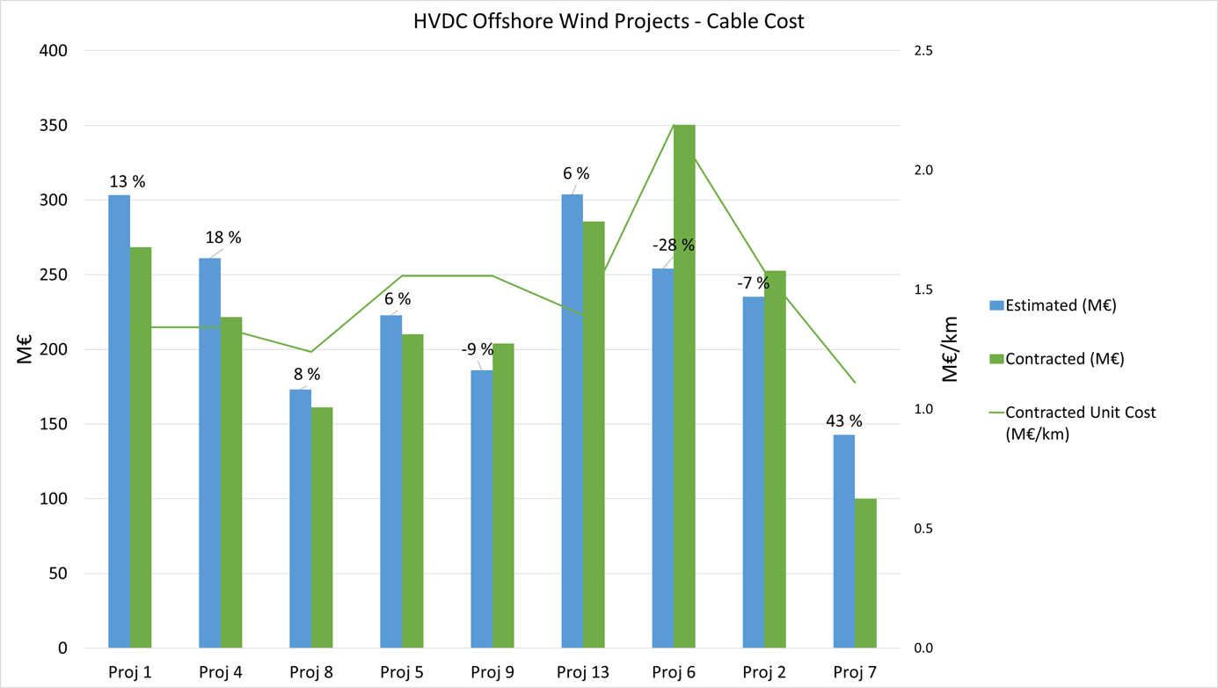

Figure 12 HVDC Offshore Wind Projects – Cable Cost

From Figure 12 it is observed that except from one project , all projects deviate from contract values with less than 30%, and it could hence be concluded that the cable cost model given in 2.1.1 is accurate enough to be used for cost estimation of cables for HVDC offshore wind projects. From Figure 12, it can also be observed that the contracted unit cost (M€/km) is stable except Proj 6 and Proj 7; indicating a mature market and hence limited potential for future increase or decrease in the price of HVDC cables.

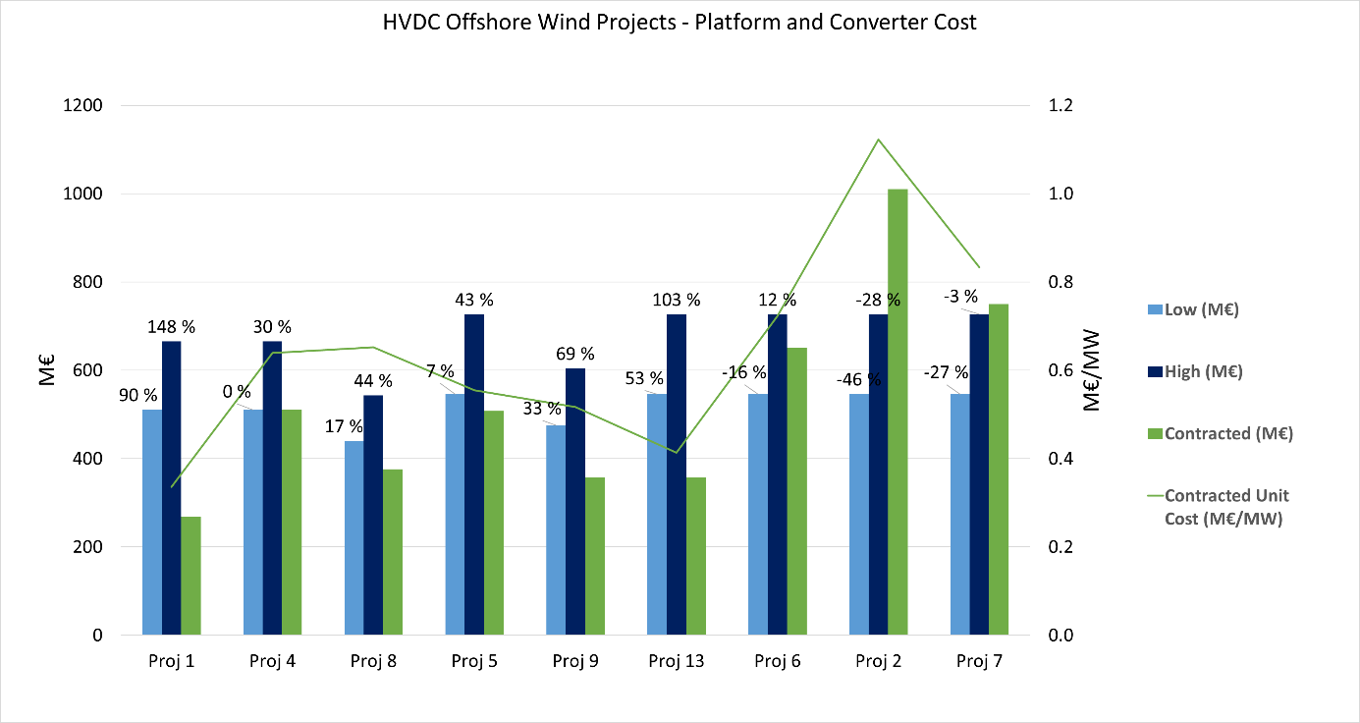

Figure 13 HVDC Offshore Wind Projects - Platform and Converter Cost

For platform and converter, the estimated sum seems to be greater than contract sum for the early projects, while the opposite trend is dominating for later projects. It is also observed that the contract unit cost (M€/MW) is not stable. Both observations reflect fluctuating contract values and is most likely explained by an immature market for offshore converter stations and platforms. The average deviation between estimated value and contract value is less using the low estimate (26%) than the high estimate (45%), and the low value should therefore be used when estimating cost of HVDC platform and converter. It should however be noted that the cost data provided to calculate cost of platform and converter, given in 2.1.2 and 2.1.3, should be treated with caution as the market is not mature and as the price level has not stabilized yet.

Further discussion of the assumed reasons for fluctuation prices and of the validity of the cost model for platform and converter is given in 2.3.3.

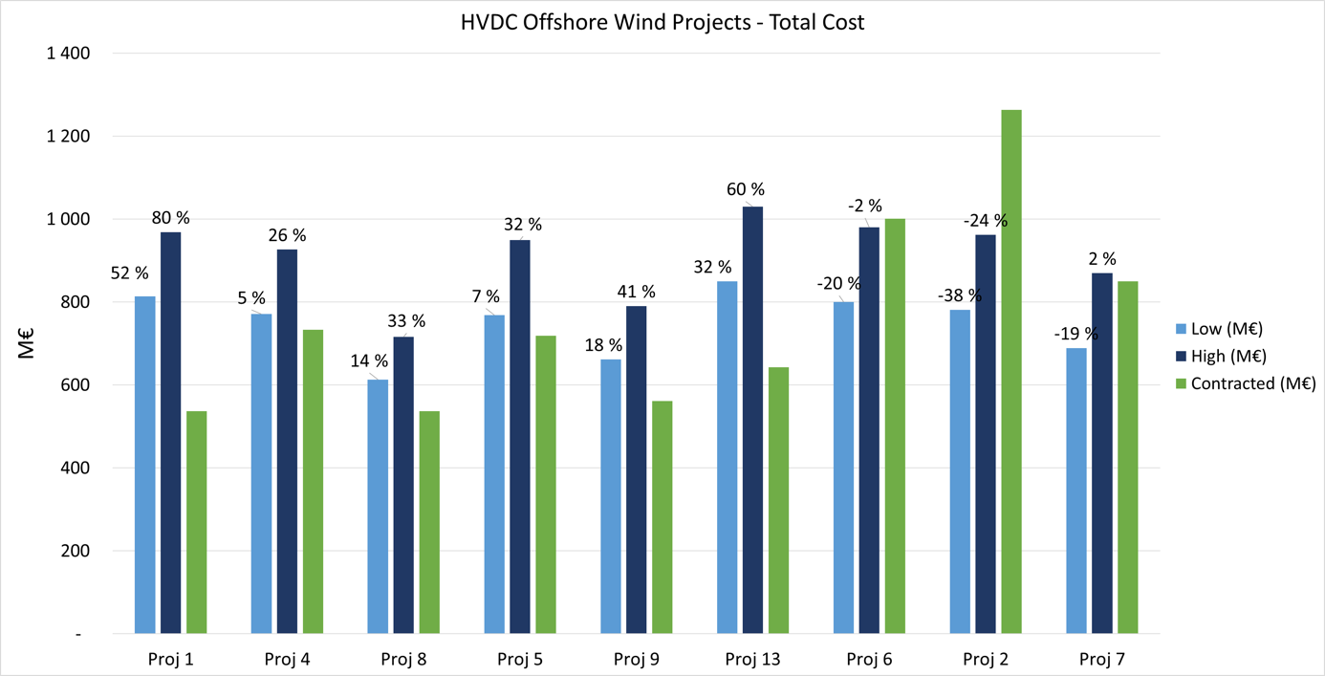

Figure 14 HVDC Offshore Wind Projects - Total Cost

Comparison of the estimated total cost and the contracted total cost also reflects the mature market for HVDC cables and the immature market for platforms and converter stations. Both observations are previously discussed in this section.

### Interconnector projects

The table below shows the data collected for the validation study.

Table 16 A summary of the techno-economic parameters of HVDC interconnector projects.

|  |  |  |  |  |  |  |  |  |  |  |  |
| --- | --- | --- | --- | --- | --- | --- | --- | --- | --- | --- | --- |
|  | Information | | |  |  | Line Length | | Contracted cost | | | Source |
|  | Contract Year | Power | DC Voltage | Technology | Configuration | Sea Cable | Land Cable | Cable | Converters | Total |  |
| Proj 10[27] | 2015 | 1400 | ±525 | HB | Bipolar | 516 | 107 | 890[28] | 490 | 1380 | [36] [37] [38] [39] |
| Proj 11 | 2015 | 1400 | ±525 | HB | Bipolar | 720 | 7 | 920 | 423 | 1344 | [40] [41] [42] |
| Proj 3 | 2016 | 700 | ±320 | HB | Monopole | 300 | 26 | 261 | 179 | 443 | [43] [44] |
| Proj 14 | 2017 | 1400 | ±525 | HB | Bipolar | 620 | 140 | 950[29] | 35029 | 130029 | [45] |
| Proj 12 | 2012 | 700 | ±525 | HB | Monopole | 137 | 102 | 127 | 133 | 260 | [46] [47] [48] |

The contract value for cables, converter stations and the total sum were estimated for each of the HVDC interconnector projects using the methodology described in Figure 11. Both a low and a high estimate was calculated. These sums were then validated by comparing them against the contracted values given in Table 16. The results are given in the figures below, where the projects are sorted from left to right based on the date of contract year. The percentage above the columns shows the amount by which the estimated value differs from the contract value.

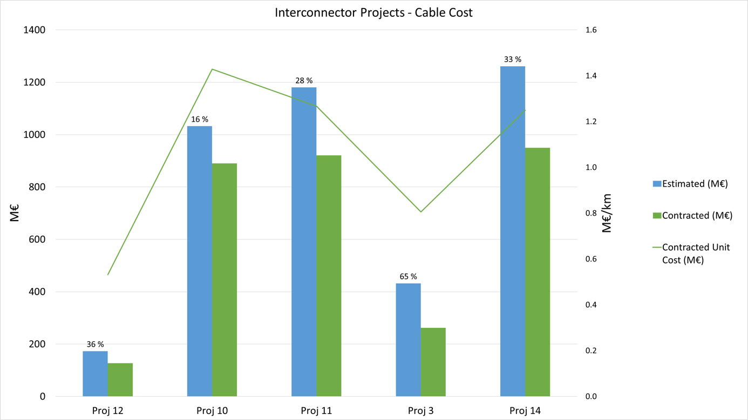

Figure 15 Interconnector Projects – Cable Cost

From Figure 15 it is observed that the deviation between estimated cable cost and contracted cable cost is greater than 30% for 3 out of 5 projects; indicating that the fit of the cost models provided in 2.1.1 do not show a high level of accuracy when applied for estimation of interconnector cable cost. When comparing Figure 15 Interconnector Projects – Cable Cost to Figure 12 HVDC Offshore Wind Projects – Cable Cost, it is observed that the cost figures for cables makes up a better fit for offshore HVDC wind projects than for interconnector projects. The observation could indicate that the cost model provided in this report does not take scale advantages due to longer cables for interconnector projects into account and that two different models should be developed for offshore HVDC wind projects and interconnector projects. A more detailed discussion of this is given in 2.3.3.

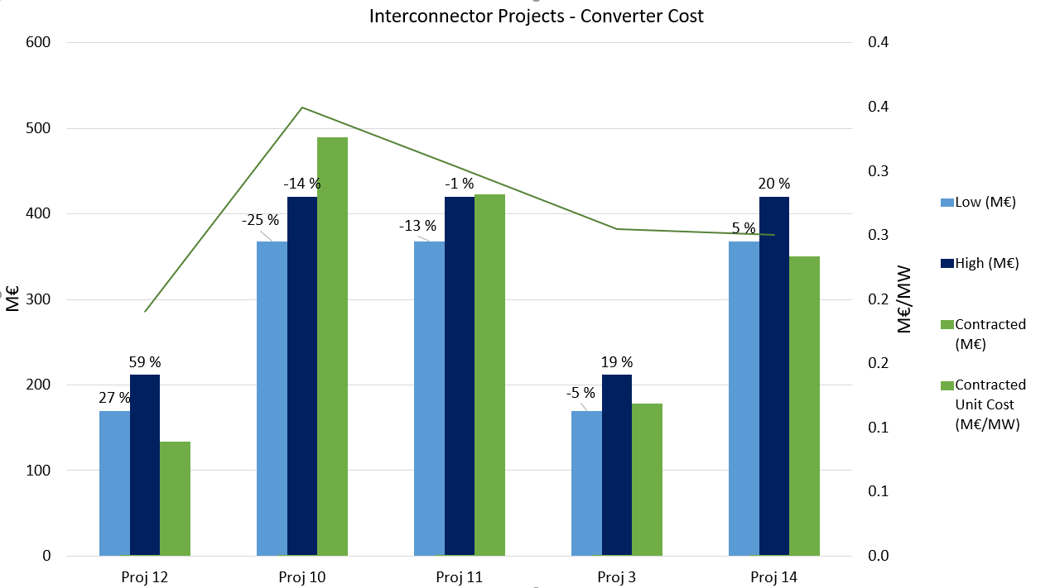

Figure 16 Interconnector Projects – Converter Cost

The accuracy of the model for converter cost is quite good and the low value makes up the best fit with an average deviation between estimated cost and contracted cost of 15%. The low value from 2.1.2 should therefore be applied when estimating the converter station cost in future interconnector projects. The reason why the fit is better and more stable for interconnector projects than for offshore HVDC wind projects, is that the interconnector projects do not include any offshore installation, neither platform nor converter, and hence products and installation are to a greater extent known to the vendors. The market for onshore converters could be regarded as mature, and the cost saving potential is most likely less than for offshore converter station and platform (Figure 13).

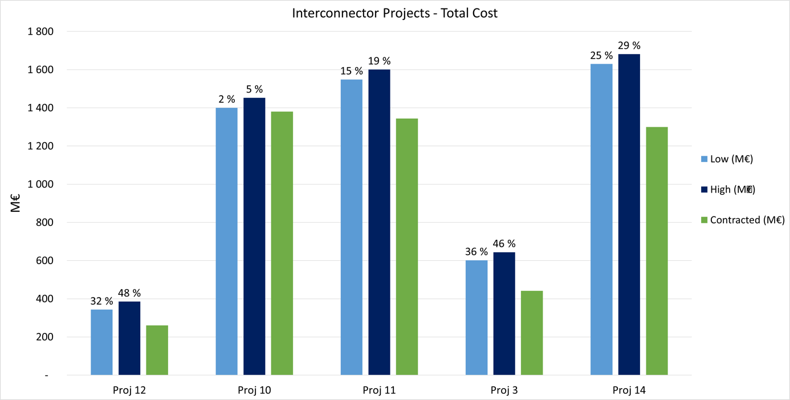

Figure 17 Interconnector Projects – Total Cost

Comparison of the estimated total cost and the contracted total cost in Figure 17 reflects the observations from Figure 15 and Figure 16.

### Conclusion of the validation

To conclude on the degree to which the cost model provided in this report fits contracted projects, the average difference (in absolute value) between estimated value and contract value is analyzed. The result is given in Table 17.

Table 17 Illustration of the average difference (in absolute value) between estimated value and contract value

|  |  |  |  |  |  |
| --- | --- | --- | --- | --- | --- |
|  | Cable | Converter and (Platform) | | Total | |
|  | Average difference between estimated value and contract value | Average difference between estimated low value and contract value | Average difference between estimated high value and contract value | Average difference between estimated low value and contract value | Average difference between estimated high value and contract value |
| HVDC offshore wind projects (all) | 17% | 26% | 45% | 20% | 30% |
| Interconnector projects (all) | 36% | 15% | 23% | 22% | 30% |

Table 17 shows a quite good fit between the estimated values and the contract values. As a 30% deviation is commonly regarded as acceptable for cost data analyses, the authors of this report claim that the cost data provided in 2.1 shows an overall good fit with the contracted projects.

There are two exceptions that are already mentioned and should be further addressed:

* The estimated high value for converter and platform for HVDC offshore wind projects (45%)
* The estimated value for the cable part of interconnector projects (36%)

**HVDC offshore wind projects - platform and converter**   
As addressed in 2.3, observations from Figure 13 reflect fluctuating contract values which is most likely explained by an immature market for offshore converter stations and platforms. One of the reasons could be that vendors still have limited experience with delivering offshore HVDC solutions and that fluctuating realized cost from previous projects affects contracted cost of new projects. Both Siemens and ABB have reported additional costs for some of their projects, which is interpreted to be as much as 25% - 50% [49]. It is not unlikely, that such cost overruns have affected how vendors have chosen to price later projects and could explain why the cost/MW increases substantially for later projects as observed in Figure 13. The market is still immature, and as vendors gain experience, the cost/MW is expected to stabilize.

As the market is immature, it could also be discussed whether the technology is mature. Vendors have claimed that there is a potential to cut the weight of HVDC platforms. A discussion of the weight- and cost saving potential for HVDC platforms is given in Chapter 3.

The cost estimates provided in this report for platforms and converters for HVDC offshore wind projects should be treated with caution as the market is not mature and as the price level has not stabilized yet. Due to an immature market with unstable prices for offshore HVDC platform and converter, the authors of this report recommend that the cost estimates for platform and converter are reviewed within a few years.

**Interconnector projects - Cable**  
An interesting observation is that contracted cable cost/km is lower for interconnector projects (1,06 M€/km) compared to HVDC offshore wind projects (1,37 M€/km). As discussed in 2.2, this observation is most likely explained by a longer cable for interconnector projects and hence scale advantages.

Table 17 shows a clear tendency that the cost model for cables gives a better fit for HVDC offshore wind projects than for interconnector projects. This indicates that different cost models for cables should be developed for these two different types of projects. The authors of this report recommend that future work should be done to provide more accurate cost estimates for interconnector cables. For now, when making use of the cost data provided in this report, it should be kept in mind that the contract sum for interconnector cables is, on average, approximately 75% of the value estimated by using the cost data provided in this report.

## Data verification

In the previous steps, cost data has been collected and then validated. Based on the validation study, some preliminary conclusions on the cost model’s accuracy of fit were drawn and provided in the previous section. The next step is to discuss and receive feedback from vendors in order to verify the cost data and the conclusions made.

# Learning curves and cost saving potential

The cost development of HVDC equipment is dependent on whether business continues as usual or whether one can achieve a planned concept with a coordinated approach among partners and vendors. In a planned concept, the projects are reasonably spread in time, and vendors and partners cooperate with each other to achieve the optimal solutions and technology. A planned concept with a coordinated approach, compared to the “business as usual” scenario, is assumed to drive down cost especially due to the following reasons:

* By spreading the projects in time, one will secure good capacity among vendors and hence favourable competition.
* Will facilitate learning curves among vendors as they get time to bring learning from a set of projects to the next set of projects.
* Will increase the opportunity to standardise specifications and hence support standard interchangeable products. This gives manufacturers the opportunity to focus on innovation and on driving costs down. An uncoordinated approach will lead to less standardisation, which means that suppliers are likely to be less innovative and that HVDC projects remain complex and expensive.

Learning curves will most likely drive down cost for all the costliest HVDC components, including platform, converter station and cables. In the following subchapter, the cost saving potential for HVDC platforms is addressed more in detail.

## Cost saving potential for HVDC Platforms

Both researchers and vendors have claimed that there are significant cost-saving opportunities available for the offshore wind market. The weight of some of the HVDC platforms exceeds 20 000 tonnes and according to ABB there is a potential to cut the weight by as much as 50% [50]. Part of the potential to cut weight is related to the weight of the converter station, but could it also exist a weight saving potential in applying more efficient platform design? As the horizon for the meshed grid for Europe stretches towards 2050, cost estimates cannot be discussed without discussing how the future price level in the market for offshore wind is likely develop.

The greatest potential to reduce cost is assumed to be related to the offshore components of the HVDC projects, where especially offshore platforms is a significant cost driver that the current active vendors in the HVDC market have limited experience with. A possible assumption is that the potential to reduce cost for HVDC platforms relates to the platforms being over dimensioned and heavier than they should be. To check this assumption, DNV GL has done a comparison of the platform dimensions in the conventional oil platform market and in the HVDC offshore market. As most of the HVDC platforms have jacket design, the focus of the analysis was on this design.

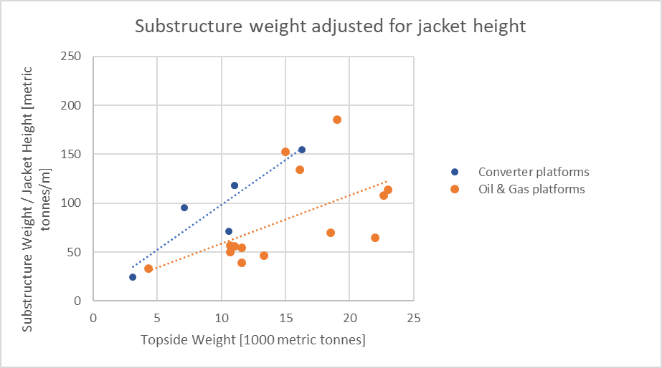First, the assumption that substructure weight of a platform is highly dependent on topside weight, was tested and confirmed. Further, the substructure weight of platforms with jacket design in the offshore oil sector was compared with substructure weight of platforms with jacket design in the offshore wind sector. As conventional oil platforms are designed for deeper water, the substructure weight was adjusted for jacket height. The result is given in the figure below:

A comparison of the two regression lines shows that, for equivalent topside weight, substructure weight of jacket platforms tends to be higher in the offshore wind industry compared to the substructure weight of jacket platforms in the Oil & Gas industry. The result could indicate that platforms in the offshore wind industry are over-engineered and heavier than they should be. This could in turn indicate that the market for HVDC platforms is immature and that there is a double potential to cut cost for offshore converter platforms; first to reduce the converter weight and then to make the substructure design more efficient.

When discussing the potential to reducing HVDC platform weight, it should be kept in mind that there are some differences in topside design between Oil and Gas platforms and HVDC platforms that can explain part of the difference in the graph above:

* HVDC platforms do not have a modular design like platforms in the Oil & Gas sector. This implies a higher wind load for HVDC platforms as they do not have gaps between the modules. Higher wind load increase the need for a stronger and heavier substructure.
* The weight distribution of HVDC platforms is uneven compared to Oil & Gas platforms, increasing the need for stronger and heavier substructures.

# Conclusions

Within this analysis publicly available cost figures of HV grid components have been gathered and compared with each other. These figures have been used as input for calculations of costs of HVDC projects. The outcome of the model has been compared with existing projects and showed that for most projects the outcome is within a margin of 30%. Concluding on this is that the input figures are within the margin and can be used for further analysis.

Several sources seem to have reliable figures which could be used as input and have resulted in these results. It must be noted however that there are only several sources and the figures are estimates. This can be used as input for R&D purposes only and as the market matures it is recommended to update these figures in the coming years. Both for interconnections and for wind farm connections the model has delivered mostly results within margin. This analysis can therefore be used as input and for future cost analysis.

Besides finding current cost figures for analysis, potential savings have been identified. As the HVDC market is currently not mature there is a cost savings potential. For offshore platforms, it was found that the current HVDC platform costs are higher than oil & gas platforms of similar design. The analysis that is performed shows saving potentials based on weight and water depth. As the market is expected to mature and parts of the MOG will be installed in several years this has to be considered for future price projections.

As an extra check discussions with vendors are planned. The outcome of these discussions will be used to define the final figures and will result in more reliable figures. This is planned to be finished in June.

# Disclaimers

This document can be used as background material and provision of direction for discussions regarding the costs, reliability and availability of components for Meshed Offshore Grid systems and the limitations and conditions of participation in these discussions for the purpose of its participation in the PROMOTioN project. All such contributions should be considered indicative and generic for the purpose of R&D studies only and do not relate to any specific project. Neither can the document be relied on for budgeting or investment decisions or other in connection with individual projects.

This analysis is performed with limited available data from the market. Publicly available sources, including research papers, as well as know-how and discussions with stakeholders are used to identify figures. However, they will necessarily remain preliminary and indicative, as all parameters have not been accessed, and conclusive data from actual projects have only to a limited extent been publicly available.

The parameters given for the cost analysis and studies are intended for research and development only, and are to be used as an indicative basis for further studies on how these parameters can impact the design of an offshore HVDC grid.

The suppliers of HVDC systems and/or components in the project have not had a common discussion regarding these parameters, and they are not a result of ongoing projects or tenders. They are derived from data collected by the Independent Partner from a collection of more or less reliable sources, and presented as estimates and averages. No data collected by the Independent Partner has been shared between the suppliers. Costs for HVDC systems vary, largely depending (for example) on local limitations and laws, costs of resources, requirements of functionality, availability and reliability. In no way should any data within this document be seen as a price list or to represent any recommended or anticipated investment or budgeting basis, resale price or any final commercial production costs.

# Bibliography

|  |  |
| --- | --- |
| [1] | CIGRE WG B4.58, "CONTROL METHODOLOGIES FOR DIRECT VOLTAGE AND POWER FLOW IN A MESHED HVDC GRID," CIGRE, Paris, 2017. |
| [2] | Yongtao Yang et al., *Assumption for cost data collection in PROMOTioN,* 2018. |
| [3] | National Grid, "Electricity Ten Year Statement - 2013," National Grid, 2013. |
| [4] | A. Flament, P. Joseph, G. Gerdes, L. Rehfeldt, A. Behrens, A. Dimitrova, F. Genoese, I. Gajic, M. Jafar, N. Tidemand, Y. Yang, J. Jansen, F. Nieuwenhout and K. Veum, "NorthSeaGrid - Offshore Electricity Grid Implementation in the North Sea: Final Report," 2015. |
| [5] | National Grid, "Electricity Ten Year Statement - 2015," National Grid, 2015. |
| [6] | WECC, "CAPITAL COSTS FOR TRANSMISSION," Western Electricity Coordinating Council, 2014. |
| [7] | H. e. al., "Review of investment model cost parameters for VSC HVDC transmission infrastructure," Electric Power Systems Research, 2017. |
| [8] | ABB, "HVDC@Light - It's time to connect," 2012. [Online]. Available: https://new.abb.com/docs/default-source/ewea-doc/hvdc-light.pdf. [Accessed 29 August 2018]. |
| [9] | Eurostat, "Land prices vary considerably between and within Member States - Agriculture land prices and rents," April 2018. [Online]. Available: https://ec.europa.eu/eurostat/documents/2995521/8756523/5-21032018-AP-EN.pdf/b1d0ffd3-f75b-40cc-b53f-f22f68d541df. [Accessed 28 August 2018]. |
| [10] | Norwegian Environment Agency, «Fastsetting av pris,» 14 August 2017. [Internett]. Available: http://www.miljodirektoratet.no/no/Tema/For-offentlig-sektor/Sikring-og-forvaltning-av-friluftslivsomrader/Sikring-av-friluftslivsomrader/Sikring-av-friluftslivsomrader---fra-planlegging-til-gjennomforing/6-Fastsetting-av-pris/. [Funnet 28 August 2018]. |
| [11] | P. Hartel, T. K. Vrana, T. Hennig, M. v. Bonin, E. J. Wiggelinkhuizen and F. D. Nieuwenhout, "Review of Investment Model Cost Parameters," *Electric Power Systems Research,* no. June, 2017. |
| [12] | A. Vafeas; T. Pagano; E. Peirano, "e-HIGHWAY 2050," European Comission, 2014. |
| [13] | Siemens, "Ultranet - Siemens presents new technology for converter stations," To be compelted., 8 December 2015. [Online]. Available: https://www.siemens.com/press/pool/de/pressemitteilungen/2015/energymanagement/PR2015120086EMEN.pdf. [Accessed 30 Aug 2018]. |
| [14] | P. Ruffing, *PROMOTioN - MMC HVDC Converter Station Design for CBA,* 2017. |
| [15] | "Deliverable 2.1: Grid topology and model specification," Progress on Meshed HVDC Offshore Transmission Networks (PROMOTION), 2017. |
| [16] | R. Blasco-Gimenez, *Email correspondance concering cost data of DRU,* 2017. |
| [17] | Siemens, "Siemens presents new DC grid connection for offshore wind farms," Siemens, 19 10 2015. [Online]. Available: https://www.siemens.com/press/pool/de/events/2015/energymanagement/2015-10-dc-grid/presentation-dc-grid-e.pdf. [Accessed 30 05 2018]. |
| [18] | P. S. Bjørheim, 2015. [Online]. Available: https://brage.bibsys.no/xmlui/bitstream/handle/11250/302334/Bjoerheim_Per_Steinar.pdf?sequence=3. |
| [19] | PROMOTioN, "D6.1 - Develop system level model for hybrid DCCB". |
| [20] | PROMOTioN, "D6.2 - Develop system level model for mechanical DCCB". |
| [21] | PROMOTioN, "DCCB cost models". |
| [22] | PROMOTioN, "WP 4.5 - Cost benefit analysis - Components breakdown parametric model for DC circuit breakers". |
| [23] | Siemens, "Siemens.com," 11 June 2010. [Online]. Available: https://www.siemens.com/press/pool/de/pressemitteilungen/2010/power_transmission/EPT201006085e.pdf. [Accessed 25 April 2018]. |
| [24] | Prysmian Group, "Company Presentation," 27 November 2013. [Online]. Available: https://www.prysmiangroup.com/sites/default/files/PrysmianGroup%20Company%20Presentation_SRI%20Exane%20Conference%2027.11.2013.pdf. [Accessed 25 April 2018]. |
| [25] | Siemens, "Hauptversammlung der Siemens AG," 27 January 2015. [Online]. Available: https://www.siemens.com/press/pool/de/events/2015/corporate/2015-Q1/2015-HV-rede-kaeser.pdf. [Accessed 25 April 2018]. |
| [26] | Prysmian Group, "Prysmian secures BorWin3 Project worth in excess of EUR 250 M," 15 April 2014. [Online]. Available: https://www.prysmiangroup.com/en/en_2014-BorWin3.html. [Accessed 15 April 2018]. |
| [27] | ABB, "ABB wins order for offshore wind power connection worth around $ 700 million," 16 July 2010. [Online]. Available: http://www04.abb.com/global/seitp/seitp202.nsf/0/2cc3b5489562daa4c12577620036b92d/$file/10_29_DolWin_e.pdf. [Accessed 25 April 2018]. |
| [28] | ABB, "ABB wins $1 billion order for offshore wind power connection," 2 August 2011. [Online]. Available: http://www04.abb.com/global/seitp/seitp202.nsf/0/b84d5ce77c21527dc12578e0001a3db4/$file/11_50_DolWin.pdf. [Accessed 25 April 2018]. |
| [29] | Alstom, "Offshore wind energy: TenneT awards “DolWin3”project to Alstom, marking next step in Germany’s energy turnaround," 26 February 2013. [Online]. Available: http://www.alstom.com/press-centre/2013/2/offshore-wind-energy-tennet-awards-dolwin3project-to-alstom-marking-next-step-in-germanys-energy-turnaround/. [Accessed 25 April 2018]. |
| [30] | Nexans, "NEXANS SUPPLIES 320 KV CABLES FOR “DOLWIN6” OFFSHORE DC LINK TO TENNET," 17 July 2017. [Online]. Available: https://www.nexans.no/Corporate/2017/1707%2017_Nexans_DolWin6_GB.pdf. [Accessed 25 April 2018]. |
| [31] | Siemens, "Siemens receives major order from TenneT for DolWin6 offshore grid connection," 17 July 2017. [Online]. Available: https://www.siemens.com/press/pool/de/pressemitteilungen/2017/energymanagement/PR2017070370EMEN.pdf. [Accessed 25 April 2018]. |
| [32] | Promotion, "Offshore grid connection: 15 percent cost reduction in the tender for DolWin6," 20 July 2017. [Online]. Available: https://www.promotion-offshore.net/news_events/news/detail/offshore-grid-connection-15-percent-cost-reduction-in-the-tender-for-dolwin6/. [Accessed 25 April 2018]. |
| [33] | Siemens, "Green power from the North Sea: Siemens to install grid link for DanTysk offshore wind farm," 26 January 2011. [Online]. Available: https://www.siemens.com/press/pool/de/pressemitteilungen/2011/power_transmission/EPT201101035e.pdf. [Accessed 25 April 2018]. |
| [34] | Siemens, "Siemens wins another order from transpower for connecting up offshore wind turbines," 16 July 2010. [Online]. Available: https://www.siemens.com/press/pool/de/pressemitteilungen/2010/power_transmission/EPT201007106e.pdf. [Accessed 25 April 2018]. |
| [35] | Siemens, "Siemens brings HelWin cluster windfarm on line," 02 August 2011. [Online]. Available: https://www.siemens.com/press/en/pressrelease/?press=/en/pressrelease/2011/power_transmission/ept201108091.htm&content[]=ET&content[]=EM. [Accessed 25 April 2018]. |
| [36] | TenneT, "NordLink: Contract signed for subsea cable," 03 March 2015. [Online]. Available: https://www.tennet.eu/news/detail/nordlink-contract-signed-for-subsea-cable/. [Accessed 25 April 2018]. |
| [37] | Nexans, "NordLink contract is signed," 25 March 2015. [Online]. Available: https://www.nexans.no/eservice/Norway-en/navigatepub_0_-34301/NordLink_HVDC_interconnector_between_Norway_and_Ge.html. [Accessed 25 April 2018]. |
| [38] | ABB, "ABB wins $900 million order to connect Norwegian and German power grids," 19 March 2015. [Online]. Available: http://www02.abb.com/global/abbzh/abbzh251.nsf!OpenDatabase&db=/global/abbzh/abbzh250.nsf&v=553E&e=us&url=/global/seitp/seitp202.nsf/0/8893AFCD95434D02C1257E0D003AF5A4!OpenDocument. [Accessed 25 April 2018]. |
| [39] | TenneT, "NordLink," 2018. [Online]. Available: https://www.tennet.eu/our-grid/international-connections/nordlink/. [Accessed 25 April 2018]. |
| [40] | ABB, "ABB wins $450 million order for Norway-UK HVDC interconnection," 14 July 2015. [Online]. Available: http://www.abb.com/cawp/seitp202/992f3a8e32ca36c1c1257e8200234aa1.aspx. [Accessed 25 April 2018]. |
| [41] | Prysmian Group, "Prysmian, new contract worth around 550 MEuro," 14 July 2015. [Online]. Available: https://www.prysmiangroup.com/sites/default/files/corporate/media/downloads/pdf/press-releases/PR_Prysmian-Group_14_07_2015_nsn_ENG.pdf. [Accessed 25 April 2018]. |
| [42] | Nexans, "NSN Link will interconnect Nordic and British energy markets with the world’s longest subsea power link incorporating Nexans’ HVDC cable technology," 14 July 2015. [Online]. Available: https://www.nexans.no/eservice/navigation/NavigationPublication.nx?navigationId=325309&publicationId=-34542. [Accessed 25 April 2018]. |
| [43] | Siemens, "Siemens wins order for HVDC link between Denmark and Holland," 01 February 2016. [Online]. Available: https://www.siemens.com/press/en/pressrelease/?press=/en/pressrelease/2016/energymanagement/pr2016020137emen.htm&content[]=EM. [Accessed 25 April 2018]. |
| [44] | Prysmian Group, "Contract worth around € 250 M for a submarine power cable link between the Netherlands and Denmark," 01 February 2016. [Online]. Available: https://www.prysmiangroup.com/en/en_2016_PR-Cobra.html. [Accessed 25 April 2018]. |
| [45] | EU-supply, "Contract Notice - utilities," 13 January 2017. [Online]. Available: https://eu.eu-supply.com/ctm/Supplier/PublicTenders/ViewNotice/184718. [Accessed 25 April 2018]. |
| [46] | Nexans, "Nexans wins 87 million Euro contract for Skagerrak 4 subsea HVDC power cable between Denmark and Norway," 7 January 2011. [Online]. Available: https://www.nexans.ch/eservice/Switzerland-en/navigatepub_151106_-28751/Nexans_wins_87_million_Euro_contract_for_Skagerrak.html. [Accessed 25 April 2018]. |
| [47] | Prysmian Group, "Prysmian, new contract worth over € 40 million from Energinet.dk to supply a 500 kV cable system for the Skagerrak 4 HVDC link between Norway and Denmark.," 01 July 2011. [Online]. Available: https://www.prysmiangroup.com/en/en_2011_news003.html. [Accessed 25 April 2018]. |
| [48] | ABB, "ABB wins $180 million order for Norway-Denmark power transmission link," 6 April 2011. [Online]. Available: http://www.abb.com/cawp/seitp202/a9c12f4db03090a74825786a000e9446.aspx. [Accessed 25 April 2018]. |
| [49] | GGSC, "Beschleunigungs- und Kosten-senkungspotenziale bei HGÜ-Offshore-Netzanbindungsprojekten," June 2016. [Online]. Available: https://www.offshore-stiftung.de/sites/offshorelink.de/files/documents/Optimierungspotenziale%20Offshore-HG%C3%9C-Projekte_final.pdf. [Accessed 26 April 2016]. |
| [50] | ABB, "Offshore grid technology challenges: a European Research and Innovation Agenda," 2015. [Online]. Available: https://ec.europa.eu/energy/sites/ener/files/documents/4.3%20Callavik%20ABB%20offshore%20grid%20integration%20Brussels%2020150528%20rev00.pdf. |
| [51] | ABB, "ABB.com," 18 September 2007. [Online]. Available: http://www.abb.com/cawp/seitp202/98b8128e95e94127c125735a003203e3.aspx . [Accessed 25 April 2018]. |
| [52] | Windfair.net, "ABB wins $900 million order to connect Norwegian and German power grids," 03 March 2015. [Online]. Available: http://w3.windfair.net/wind-energy/news/17895-abb-wins-900-million-order-to-connect-norwegian-and-german-power-grids. [Accessed 25 April 2018]. |
| [53] | Semikron, "Products and Shop," [Online]. Available: http://shop.semikron.com/Products-and-Shop/Product-Groups/Thyristor-Diode-Modules/voltVal2200/currVal6/. [Accessed 30 May 2018]. |
| [54] | ABB, "Self-installing platforms for offshore HVDC projects," Unknown. [Online]. Available: http://www04.abb.com/global/gbabb/gbabb901.nsf!OpenDatabase&db=/global/gbabb/gbabb905.nsf&v=F4A&e=us&url=/global/seitp/seitp202.nsf/0/1393082CFC73C61544257C290068C33D!OpenDocument. |
| [55] | PROMOTioN, "Cost data collection". |

1. Such as the current supporting scheme for renewables where OWPP only gets subsidies if it is connected to the national power grid where the OWPP located.
2. IT should be noted that different grid topology will result in different level of redundancy, for example, meshed grid will have higher redundancy level than the point-to-point connection. New emerging concepts, such as the ‘‘North Sea Wind Power Hub‘‘ will likely bring additional level of redundancy.
3. It is worth noting that a FB VSC is capable of block fault currents in case of a DC grid fault and the ability to operate at low or reversed voltages.
4. 10/90 refers to nearshore and far offshore where 10% is near shore and 90% of the cable is far offshore, this column is used for the validation study
5. 0/100 to nearshore and far offshore where 0% is near shore and 100% is far offshore
6. In this document, a DRU converter station include the DRU valves, converter transformers, AC/DC filters and GIS units, similar to FB and HB VSC MMC Converter stations.
7. Based on publicly available sources such as [53]
8. A 400 MW offshore VSC station has a dimension of 50mx33mx22m, whereas a 900MW offshore VSC converter station is about 85mx55mx40m.
9. It should be noted that this significant size/volume reduction is achieved through the use of GIS station. GIS brings other challenges including additional cost.
10. The DC Voltage is ±213.3 kV.
11. The DC Voltage is ±320.0 kV.
12. The DC Voltage is ±426.7 kV.
13. The DC Voltage is ±533.4 kV, this will be relying on the availability of HVDC submarine cable at this voltage rating and DR Units for higher voltage isolation.
14. We have received feedback from the industry that the platform cost is not significantly different between 700 and 900 MW.
15. The weight/power ratio would be different for VSC and for DRU. There may also be difference for FB and HB VSC, although to a less extent.
16. Note the AC transformers should be distinguished with the converter transformers for HVDC converter station, the costs of the later are normally considered part of the costs of converter stations.
17. Transient Interruption Voltage (TIV) peak value Ubrm is 480 kV for nominal voltage 320kV; for nominal voltage 525 kV Ubrm = 840 kV.
18. Breaker opening time at maximum DC breaking current is 2ms for Hybrid DCCB. For DCCB at 320 kV, the dissipiated energy is 10 MJ and the Ldc = 100 mH; for DCCB at 525 kV, E = 16 MJ and Ldc = 160 mH.
19. Breaker opening time at maximum DC breaking current is 8ms for Mechanic DCCB.
20. For the hgih dissipitated energy option, the dissipiated energy is 50 MJ and the Ldc = 200 mH for 320 kV DCCB; the dissipiated energy is 80 MJ and the Ldc = 320 mH for 525 kV DCCB.
21. For the low dissipitated energy option, the dissipiated energy is 5 MJ and the Ldc = 0 mH for 320 kV DCCB; the dissipiated energy is 8 MJ and the Ldc = 0 mH for 525 kV DCCB.
22. Was entirely built by one contractor, and hence only total contract value is available in public domain. Cable cost/km for Borwin 2 (same contract year) is used to estimate the cable sum.
23. Was entirely built by one contractor, and hence only total contract value is available in public domain. Cable cost/km for Sylwin 1 (same contract year) is used to estimate the cable sum.
24. Only contract value for cable part is available in public domain. Total contract value is based on statements by Tennet/Siemens.
25. Only contract value for cable part is available in public domain. Converter and platform cost is assumed based on statement by Siemens about the total order value.
26. Only contract value for cable part is available in public domain. Equal platform and converter cost as for Dolwin 2 is assumed (same contract year and about the same power rating).
27. Part of the cable is overhead line. As this makes up a small part of the total cost, equal cost per km was assumed for overhead line and underground cable when estimating the contract value using cost data from section 2.1.1.
28. When calculating the converter and cable cost of the NordLink project, equal cable cost/km for both Nexans and ABB contract was assumed.
29. Cost numbers are not contracted values, but are extracted from contract notice.