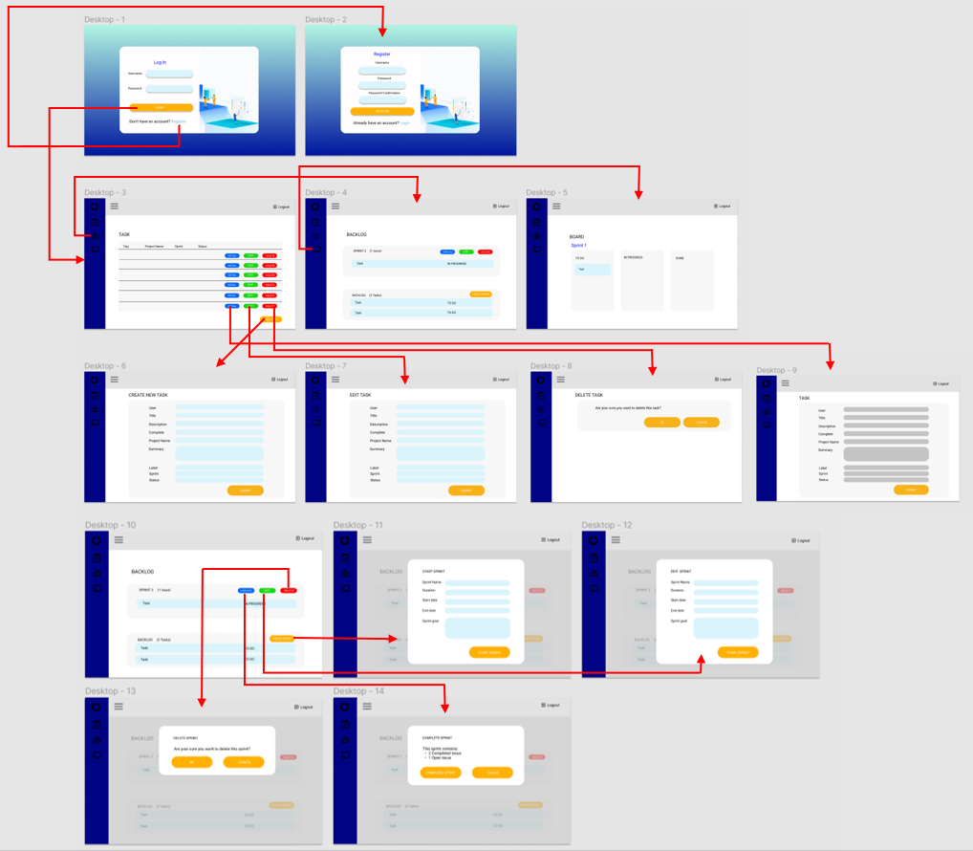

WireFrame

Usability Tasks

|  |  |
| --- | --- |
| Research question | Where are the problem areas on creating a new task? |
| Scenario | Imagine that you need register a new task |
| Task | Starting on the login page, once you have logged in you can see all the tasks registered, then you have a button that says add task, after pressing this button a form appears, and finally you need to press submit to register the task. |
| Inputs (if needed) | User: odasys pass: taskmanager |
| Steps | 1. Enter username 2. Enter password 3. Press the login button 4. After login, press the button add task 5. Field the form 6. Press submit button |
| Success criteria | The new task should be register |

Task 1: Register a new task

|  |  |
| --- | --- |
| Research question | Where are the problem areas on creating a new sprint? |
| Scenario | Imagine that you need register a new sprint |
| Task | Starting on the login page, once you have logged in you can see all the tasks registered, the you don’t have any option to register a new sprint but we have a menu, in the next option of the menu you have the option backlog, in this view exists a button create sprint if I press the button a field appears, finally after pressing start sprint a new sprint is register |
| Inputs (if needed) | User: odasys pass: taskmanager |
| Steps | 1. Enter username 2. Enter password 3. Press the login button 4. After login, press the burger menu backlog 5. Press the button create sprint 6. Field the form 7. Press the button start sprint |
| Success criteria | The new sprint should be register |

Task 2: Register a new sprint

Task 3: Edit a task

|  |  |
| --- | --- |
| Research question | Where are the problem areas on edit a task? |
| Scenario | Imagine that you need edit the information for a task |
| Task | Starting on the login page, once you have logged in you can see all the tasks registered, then you have a button that says edit, after pressing this button a form appears, and finally you need to press submit to save the changes. |
| Inputs (if needed) | User: odasys pass: taskmanager |
| Steps | 1. Enter username 2. Enter password 3. Press the login button 4. After login, press the button edit 5. Field the form 6. Press submit button |
| Success criteria | A task information is edited. |

|  |  |
| --- | --- |
| Research question | Where are the problem areas on creating a new sprint? |
| Scenario | Imagine that you need register a new sprint |
| Task | Starting on the login page, once you have logged in you can see all the tasks registered, the you don’t have any option to register a new sprint but we have a menu, in the next option of the menu you have the option backlog, in this view exists a button edit in each sprint if I press the button a field appears, finally after pressing submit a new sprint is register |
| Inputs (if needed) | User: odasys pass: taskmanager |
| Steps | 1. Enter username 2. Enter password 3. Press the login button 4. After login, press the burger menu backlog 5. Press the button create sprint 6. Field the form 7. Press the button start sprint |
| Success criteria | The sprint should be edited |

Task 4: Edit a sprint

Task 5: Delete a task

|  |  |
| --- | --- |
| Research question | Where are the problem areas on delete a task? |
| Scenario | Imagine that you need delete a task |
| Task | Starting on the login page, once you have logged in you can see all the tasks registered, then you have a button that says delete, after pressing this button a confirmation message appears, and finally you need to press ok to delete the task. |
| Inputs (if needed) | User: odasys pass: taskmanager |
| Steps | 1. Enter username 2. Enter password 3. Press the login button 4. After login, press the button delete 5. Press ok |
| Success criteria | A task should be deleted. |

|  |  |
| --- | --- |
| Research question | Where are the problem areas on delete a sprint? |
| Scenario | Imagine that you need to delete a sprint |
| Task | Starting on the login page, once you have logged in you can see all the tasks registered, the you don’t have any option to register a new sprint but we have a menu, in the next option of the menu you have the option backlog, in this view exists a button delete in each sprint if I press the button a message appears, finally after pressing ok the sprint should be deleted. |
| Inputs (if needed) | User: odasys pass: taskmanager |
| Steps | 1. Enter username 2. Enter password 3. Press the login button 4. After login, press the burger menu backlog 5. Press the button delete 6. Press the button ok |
| Success criteria | The sprint should be deleted |

Task 6: Delete a sprint

Task 7: Check task details

|  |  |
| --- | --- |
| Research question | Where are the problem areas on checking a task? |
| Scenario | Imagine that you need check a task detail |
| Task | Starting on the login page, once you have logged in you can see all the tasks registered, then you have a button that says details, after pressing this button all the task information appears |
| Inputs (if needed) | User: odasys pass: taskmanager |
| Steps | 1. Enter username 2. Enter password 3. Press the login button 4. After login, press the button detail |
| Success criteria | A task should be deleted. |

|  |  |
| --- | --- |
| Research question | Where are the problem areas on checking a sprint? |
| Scenario | Imagine that you need to check a sprint detail |
| Task | Starting on the login page, once you have logged in you can see all the tasks registered, the you don’t have any option to register a new sprint but we have a menu, in the next option of the menu you have the option backlog, in this view exists a button delete in each sprint if I press the button a message appears, finally after pressing ok the sprint should be deleted. |
| Inputs (if needed) | User: odasys pass: taskmanager |
| Steps | 1. Enter username 2. Enter password 3. Press the login button 4. After login, press the burger menu backlog 5. Press the button detail |
| Success criteria | The sprint should be deleted |

Task 8: Check sprint details

