 | 003-Mean  000-NodeApiJwt  Full Mean Example Using JWT

Directory Structure

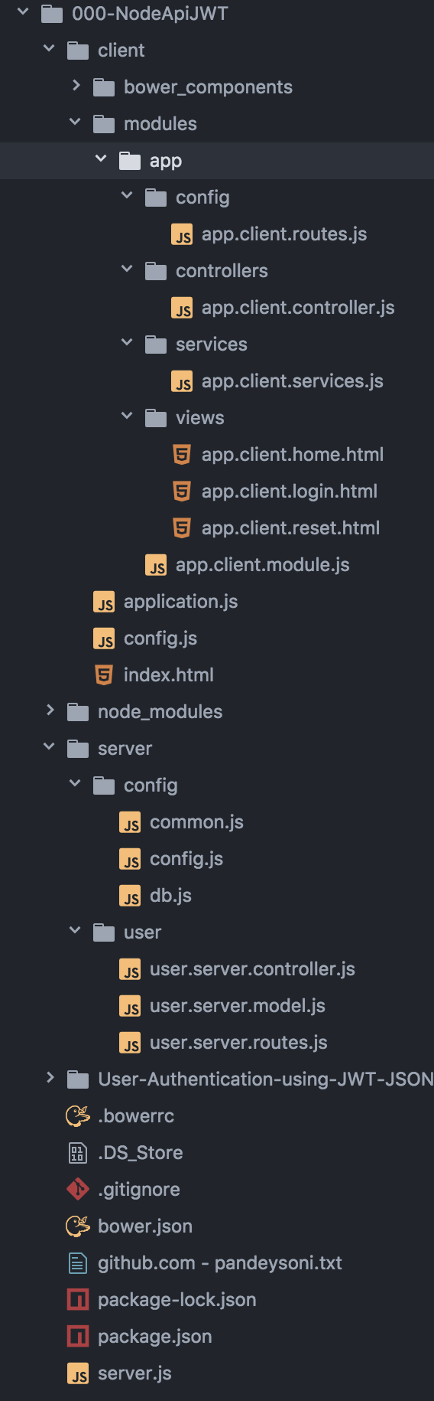
- client
  - bower
  - modules
    - app
      - config
        - app.client.routes.js
      - controllers
        - app.client.controller.js
      - services
        - app.client.services.js
      - views
        - app.client.home.html
        - app.client.login.html
        - app.client.reset.html
      - app.client.module.js
    - application.js
    - config.js
    - index.html
- node_modules
- server
  - config
    - common.js
    - config.js
      - Configuration settings for:
        - server
        - database
        - encryption key
        - email sending
    - db.js
      - Creates the mongoDB connection
      - Creates connection error handlers.
  - user
    - user.server.controller.js
      - Logic for handling all the post requests from the client
        - Uses mongoose Model to connect to mongoDB
        - Uses JWT authentication from client
    - user.server.model.js
      - Mongoose Schema and Model for User
      - Uses Mongoose Static functions to define the model calls to mongoose
    - user.server.routes.js
      - Routes are all the 'post' requests from client pages
        - app.post('/user', User.create);
        - app.post('/login', User.login);
        - app.post('/forgot', User.forgotPassword);
        - app.post('/reset', User.newPassword);
        - app.post('/verifyLink', User.verifyEmail);
      - User is user.server.controller.js
- server.js
  - Creates the express() app.
  - adds app.use(bodyParser....
  - Points 'Static' to client folder
  - Directs all requests to client/index.html: app.get('*',...
  - require('./server/user/user.server.routes')(app);
    - These are all the 'post' requests from client pages

Features

$stateParams
- In html

- in app.config

- in app.controller

Regular Expression - Matching/Validation
- The script here calls for a number only to be used in 'a'.

Params are kinda/ always optional
- Here a is optional and adding a b will be ignored
  - unless you skip a, then b moves to a

The params{a: {value: 1}, b: {value:2} }
- Can set default values that will always be passed.
- Works only with ui-sref

Default params and href vs ui-sref
- Only work with ui-sref
  - -unless you use a slash at the end of the url
    - fifth-msg/5/

Default params and href vs ui-sref using squash
- Default value will be used BECAUSE squash = true

Default params and href vs ui-sref using squash and values
- Default value will be used WHEN squash = true - when url param = squash value

Query Parameters ?
- Will use parameters defined here by default - even if I don't include them in the href or ui-sref.

Query Parameters ? and Array[]
- Define as array and all params will be in an array

zz Code Green
zz Code Grey
zz Code Blue
zz Head 1 Blue
zz Head 1 Green
zz Head 2 Blue
zz Head 2 Green
zz Head 3 Blue
zz Head 3 Green
zz Head 3 Gold
zz italic Black
zz italic Blue
zz italic Green
zz italic lime Green
zz italic Magenta
zz italic Orange
zz italic Red

