
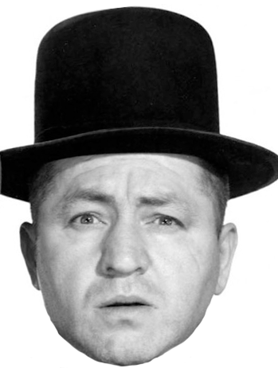
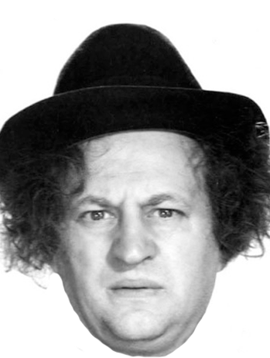
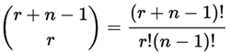
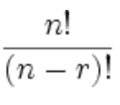
Combinations | Permutations
based on Order and Repetition
Order Doesn't Matter  Repetition Allowed  Only 1 Un-Ordered Set exists  for each combination of  characters.  Formula:  - n = 2 stooges  - r = 3 selections  - 4! / 3! x 1!  - 24 / 6 = 4 Combinations | Order Matters  Repetition Allowed  Many Sets and Orders exists  Formula: n^r  - n = 2 stooges  - r = 3 selections  - 2^3 = 8 Permutations
Repetition Not Allowed  Very Few Un-Ordered Set exists!  Formula:  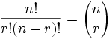  - n = 3 stooges  - r = 2 selections  - 3! / (2! x 1!)  - 6 / (2 x 1) = 3 Combinations | Repetition Not Allowed  Fewer Sets and Orders exists  - n = 3 stooges  - r = 2 selections  - 3! / 1!  - 6 / 1 = 6 Permutations
Order Doesn’t Matter  2 Types:  - Repetition Allowed  - Repetition Not Allowed  1. Repetition Allowed  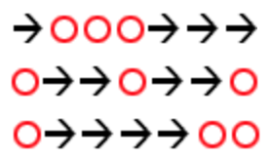  - ex: how many different ways can we arrange arrows and circles?  - Notice that there are always 3 circles (3 scoops of ice cream) and 4 arrows (we need to move 4 times to go from the 1st to 5th container).  - So (being general here) there are r + (n−1) positions, and we want to choose r of them to have circles.  - This is like saying "we have r + (n−1) pool balls and want to choose r of them". In other words it is now like the pool balls question, but with slightly changed numbers. And we can write it like this:  where n is the number of things to choose from,  and we choose r of them repetition allowed,  order doesn't matter.  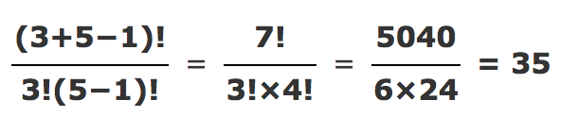  2. Repetition Not Allowed  - ex: Let’s say pool balls 1, 2 and 3 are chosen.  - These are the possibilities:  Order does matter: Order doesn't matter  (Permutation) (Combination)  123  132  213 123  231  312  321  So, permutations have 6 times as many .  Formula:  n!  r!(n − r)!  It is often called "n choose r" (such as "16 choose 3")  And is also known as the Binomial Coefficient. | Order Matters  2 Types:  - Repetition Allowed  - Repetition Not Allowed  1. Repetition Allowed  - ex: Permutation Lock:  - There are 10 numbers to choose from  (0,1,2,3,4,5,6,7,8,9) and we choose 3 of them:  - 10 × 10 × ... (3 times) = 10^3 = 1,000  permutations  n = number of items in the set.  r = times we choose from the set  Formula: n^r  2. Repetition Not Allowed  - ex: what order can 16 pool balls be in?  - After choosing the “14 Ball" we can't choose it again.  - So, our first choice has 16 possibilities  - our next choice has 15 possibilities,  - then 14, 13, 12, 11, ... etc.  16 × 15 × 14 × 13 × ... = 20,922,789,888,000  - But maybe we don't want to choose them all,  just 3 of them, and that is then:  16 × 15 × 14 = 3,360  n = number of items in the set each time  ! = times we choose from the set  Factorial: 3! = 16 × 15 × 14 = 3,360  Formula:  P(16,3) = 3,360  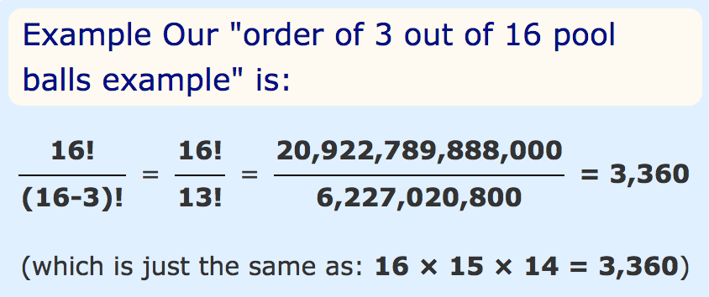

Permutation

