> sp <- read.csv ("C:\\Users\\oonyemenem\\Desktop\\Project_data1.csv")

> sp

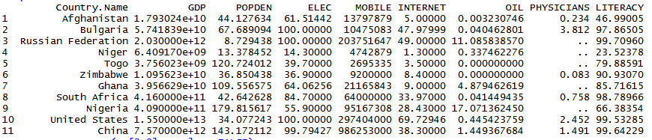> install.packages("magrittr")

Installing package into ‘C:/Users/oonyemenem/Documents/R/win-library/3.3’

(as ‘lib’ is unspecified)

trying URL 'https://cran.rstudio.com/bin/windows/contrib/3.3/magrittr_1.5.zip'

Content type 'application/zip' length 149768 bytes (146 KB)

downloaded 146 KB

package ‘magrittr’ successfully unpacked and MD5 sums checked

The downloaded binary packages are in

C:\Users\oonyemenem\AppData\Local\Temp\Rtmpyk2pQ6\downloaded_packages

> sp$GDP<-as.numeric(sp$GDP)

> sp$POPDEN<-as.numeric(sp$POPDEN)

> sp$ELEC<-as.numeric(sp$ELEC)

> sp$MOBILE<-as.numeric(sp$MOBILE)

> sp$INTERNET<-as.numeric(sp$INTERNET)

> sp$OIL<-as.numeric(sp$OIL)

> sp$PHYSICIANS<-as.numeric(sp$PHYSICIANS)

> sp$LITERACY<-as.numeric(sp$LITERACY)

> sp_pca <- prcomp(sp[2:9], scale = FALSE)

> sp_pca

Standard deviations:

[1] 4.901817e+12 2.345134e+08 5.102124e+01 3.385658e+01 1.396652e+01 7.600555e+00 4.076526e+00 5.672351e-01

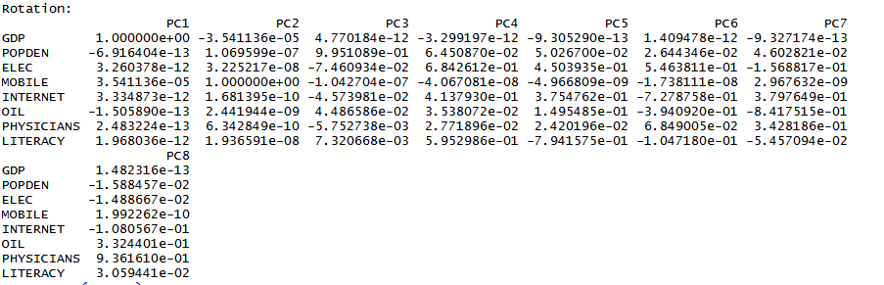

> summary (sp_pca)

Importance of components:

PC1 PC2 PC3 PC4 PC5 PC6 PC7 PC8

Standard deviation 4.902e+12 234513415 51.02 33.86 13.97 7.601 4.077 0.5672

Proportion of Variance 1.000e+00 0 0.00 0.00 0.00 0.000 0.000 0.0000

Cumulative Proportion 1.000e+00 1 1.00 1.00 1.00 1.000 1.000 1.0000

> library(sqldf)

> query1<-'SELECT GDP, POPDEN, ELEC, MOBILE, INTERNET, OIL, PHYSICIANS, LITERACY FROM sp'

> result1<-sqldf(query1);

> cor(result1)

GDP POPDEN ELEC MOBILE INTERNET OIL PHYSICIANS LITERACY

GDP 1.00000000 -0.059711047 0.526606642 0.594931722 0.7104367 -0.129100120 0.53948004 0.380216654

POPDEN -0.05971105 1.000000000 -0.001163217 0.319568237 -0.1067466 0.418687766 -0.09873372 0.094548703

ELEC 0.52660664 -0.001163217 1.000000000 0.513614434 0.8649652 0.083352752 0.68384843 0.754650554

MOBILE 0.59493172 0.319568237 0.513614434 1.000000000 0.4240388 0.003697758 0.37394326 0.370076769

INTERNET 0.71043675 -0.106746628 0.864965232 0.424038762 1.0000000 0.164147550 0.66953367 0.659906120

OIL -0.12910012 0.418687766 0.083352752 0.003697758 0.1641476 1.000000000 -0.45807458 0.003181272

PHYSICIANS 0.53948004 -0.098733722 0.683848432 0.373943256 0.6695337 -0.458074581 1.00000000 0.467408383

LITERACY 0.38021665 0.094548703 0.754650554 0.370076769 0.6599061 0.003181272 0.46740838 1.000000000

> plot(result1)

