Stat 112 D. Small

Example of Regression Analysis: Emergency Calls to the New York Auto Club

The AAA Club of New York provides many services to its members, including travel planning, traffic safety classes and discounts on insurance. The service with the highest profile is its Emergency Road Service (ERS). If a club member’s car breaks down, the member can tell the Club to send out a tow truck for assistance. This service is especially useful in the winter months, when Club members can be stranded with frozen locks, dead batteries, weather induced accidents and spinning tires.

If the weather is very bad, the Club can be overwhelmed with calls. By tracking the weather conditions the Club can divert resources from other Club activities to the ERS for projected peak days. This will lead to better services for Club members and also greatly reduces stress on the Club staff.

Are the numbers of calls the Club will receive in a day predictable from the weather forecast given on the previous day?

We will investigate this with data from the second-half of January in 1993 and 1994. The Club reports the number of ERS calls answered each day as a percentage of the monthly ERS calls (Pcalls). We have also recorded the forecast daily low temperature. The data is in ers.JMP.

The percentage of the January calls for 1/16/93 and 1/17/93 are 3.6% and 2.7% respectively. This suggests that the resources necessary on the 17th would be about 75%=2.7/3.6 of those necessary on the 16th. Thus 25% of those people working for the ERS on the 16th could be reassigned or given a rest day. The advantage of considering percentage of the monthly ERS calls rather than the actual number of ERS calls is that it adjusts for the total level of calls for that month due to the cumulative effects of weather. It is difficult to measure and take into account the cumulative effects of weather.

Step I. Define the question of interest. We would like to be able to make point predictions and make prediction intervals for Pcalls based on the forecast daily low temperature. This will help the Club best allocate its staff based on the forecast daily low temperatures.

Step II. Explore the data using a scatterplot.

Bivariate Fit of Percentage Calls By Forecast Low Temperature
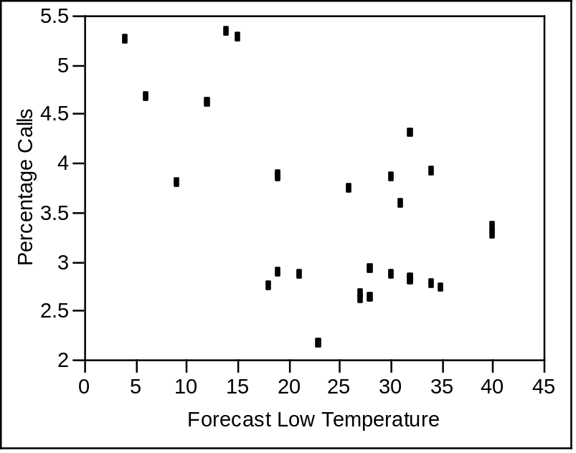

A straight line relationship between E(Y|X) and X appears reasonable. There are no striking outliers in the direction of the scatterplot or influential points. A simple linear regression model appears reasonable to try to model the relationship between Y and X.

Step III. Fit an initial regression model and check the assumptions of the regression model. We try a simple linear regression model.

Bivariate Fit of Percentage Calls By Forecast Low Temperature
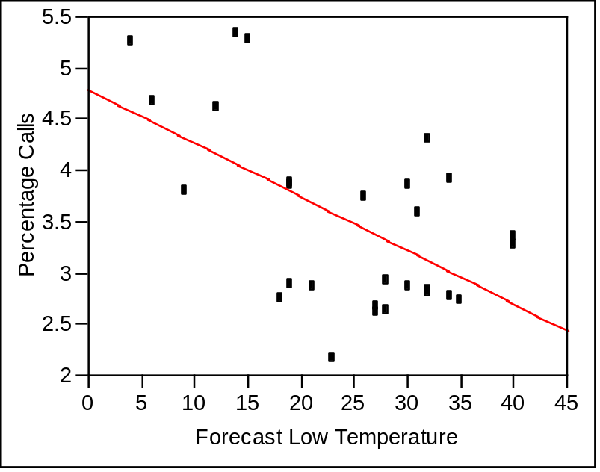


Linear Fit
Percentage Calls = 4.7895287 - 0.0523019 Forecast Low Temperature

Summary of Fit
RSquare | 0.324174
RSquare Adj | 0.29818
Root Mean Square Error | 0.753569
Mean of Response | 3.509999
Observations (or Sum Wgts) | 28

Analysis of Variance
Source | DF | Sum of Squares | Mean Square | F Ratio
Model | 1 | 7.082096 | 7.08210 | 12.4714
Error | 26 | 14.764506 | 0.56787 | Prob > F
C. Total | 27 | 21.846601 |  | 0.0016

Parameter Estimates
Term |  | Estimate | Std Error | t Ratio | Prob>|t|
Intercept |  | 4.7895287 | 0.389303 | 12.30 | <.0001
Forecast Low Temperature |  | -0.052302 | 0.01481 | -3.53 | 0.0016

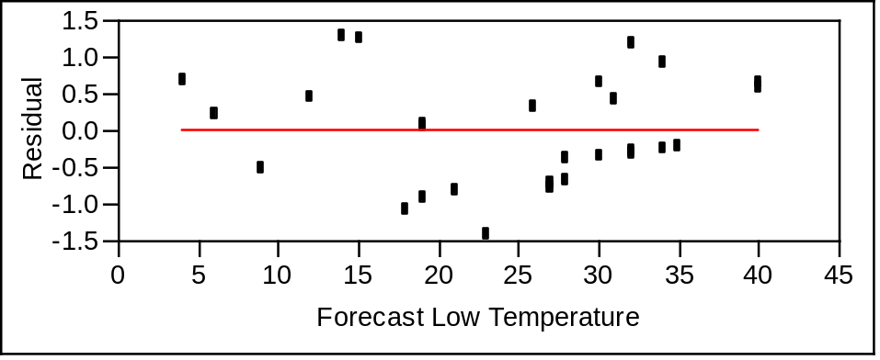

Distributions
Residuals Percentage Calls
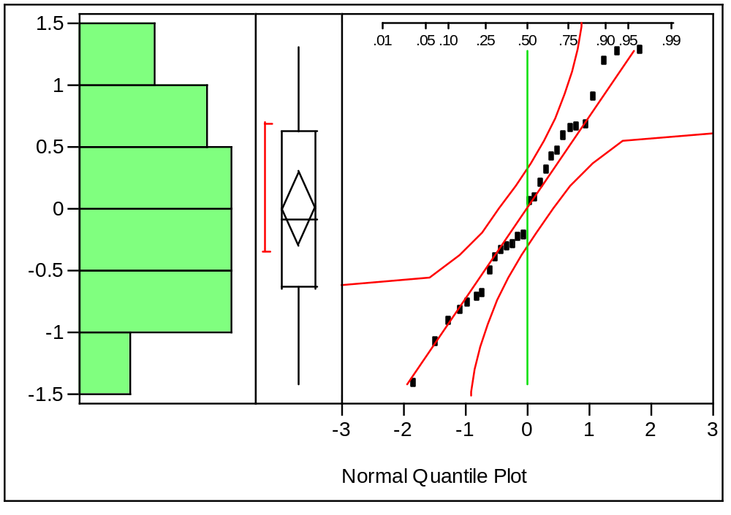

The four assumptions of the simple linear regression model are (1) linearity – the mean of E(Y|X) is a straight line function of X; (2) constant variance – the standard deviation of Y|X is the same for all X; (3) normality – the distribution of Y|X is normal; (4) independence – the observations are all independent.

We check linearity by looking at the residual plot. There is no clear pattern in the mean of the residuals as X changes , so linearity appears reasonable. We also check constant variance by looking at the residual plot. There is no clear pattern in the spread of the residuals as X changes, so constant variance appears reasonable. We check normality by looking at a normal quantile plot of the residuals. All of the points fall within the 95% confidence bands, indicating that normality appears reasonable.

Since this data is taken over time, we can check independence by plotting the residuals versus time. I have created a variable time which is the time order of the observations. Below is a plot of the residuals versus time.

Bivariate Fit of Residuals Percentage Calls By Time
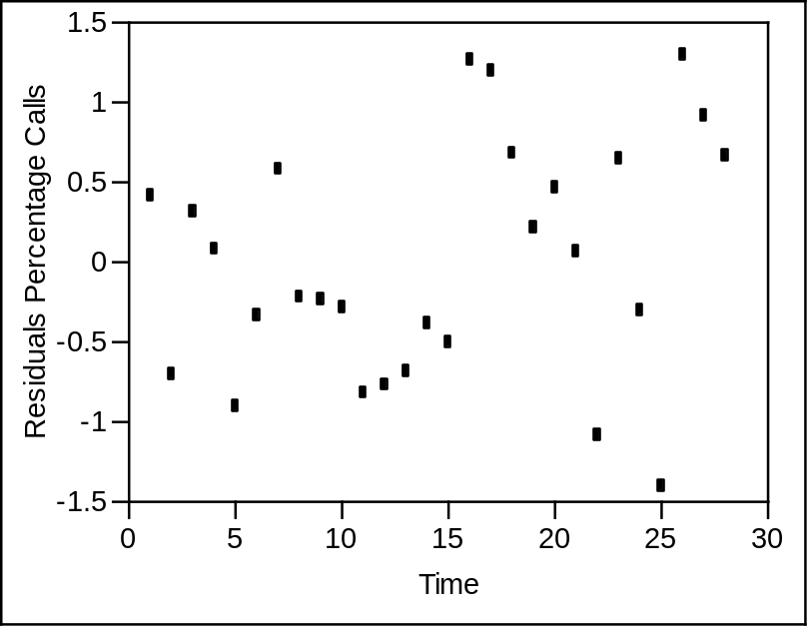

There is no clear pattern in the residuals over time, indicating that independence is a reasonable assumption.

4. Investigate influential points. The following are histograms and boxplots of the Cook’s distances and leverages.

Distributions
Cook's D Influence Calls
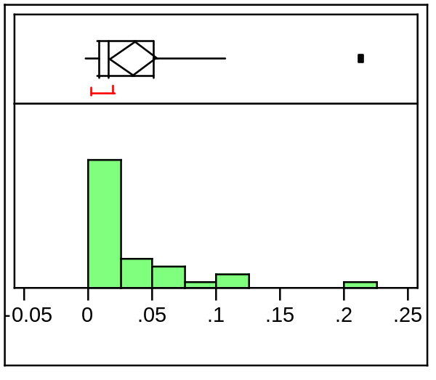

h Calls
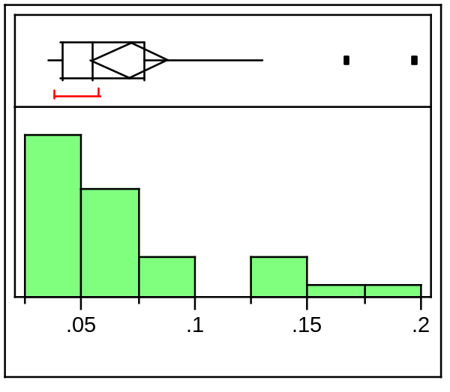
There are no points with high influence (Cook’s Distance over 1). The cutoff for high leverage is (3*2)/n=6/28=0.217. The point with the highest leverage has leverage 0.197 so no point has high leverage.

5. Infer answers to the questions of interest.

The assumptions of the simple linear regression model appear to, by and large, hold and there are no influential points. The question of interest is to predict Pcalls based on daily low temperature and give a prediction interval that is likely to contain the Pcalls for a given day with a daily low temperature of X. These questions are answered by the estimated regression line, which provides the best prediction of Pcalls, and 95% prediction intervals.

Bivariate Fit of Percentage Calls By Forecast Low Temperature
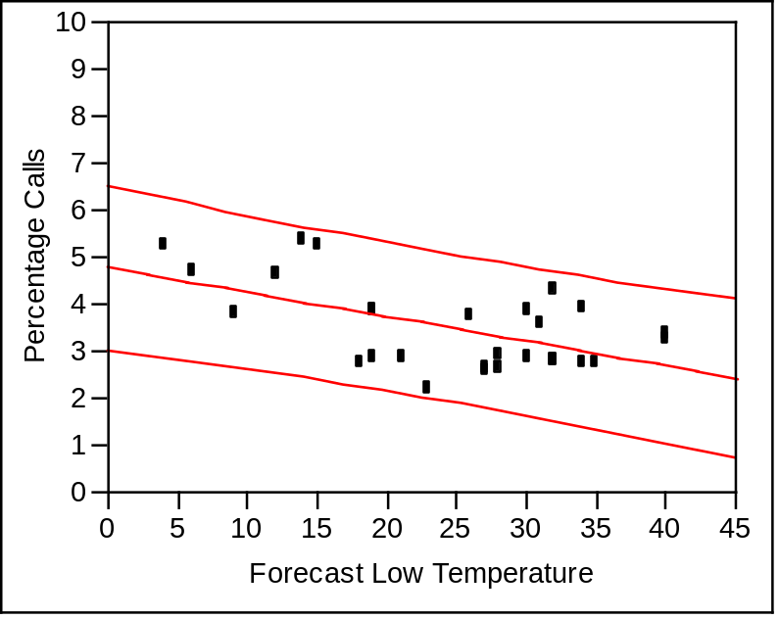

For a day with a forecasted low temperature of 14 degrees, the predicted percentage of calls is 3.95 and the 95% prediction interval is (2.40,5.49). In order to have a good chance of having the appropriate number of staff to meet demand, the club should provide enough staff to meet between 2.4% and 5.49% of the monthly total.

