Here I am going to create a list of elements and their output/inputs:

1. **Proximity sensor module** (remember this is HC-SR04 sensor and AT Tiny bonded together)

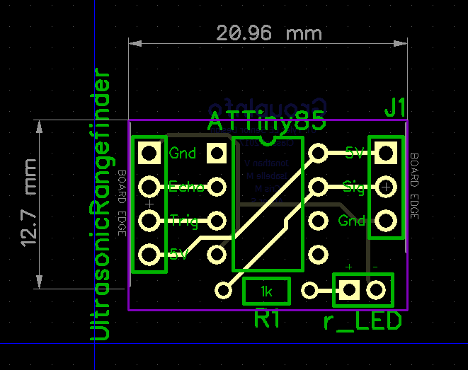

^^ this is the PCB layout for the HC-SR04 sensor on the left, At Tiny in the middle, and input/output on the right

Input: +5 volts, ground

Output: signal from At Tiny carrying info

**\*\*\*\*Also there are supposed to be 5 of these modules\*\*\*\***

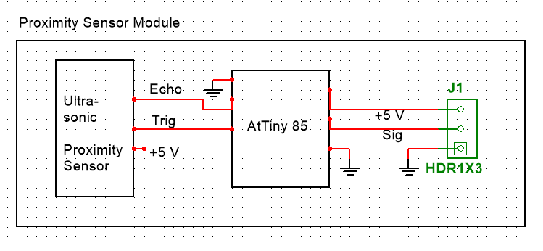

-------------------------------------------------------------------------------------------------------------------

2) **Camera Module** (remember this is the 3 cameras and they multiplexer together)

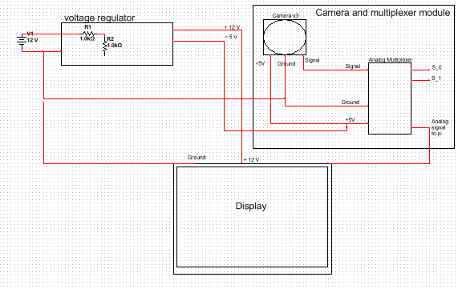

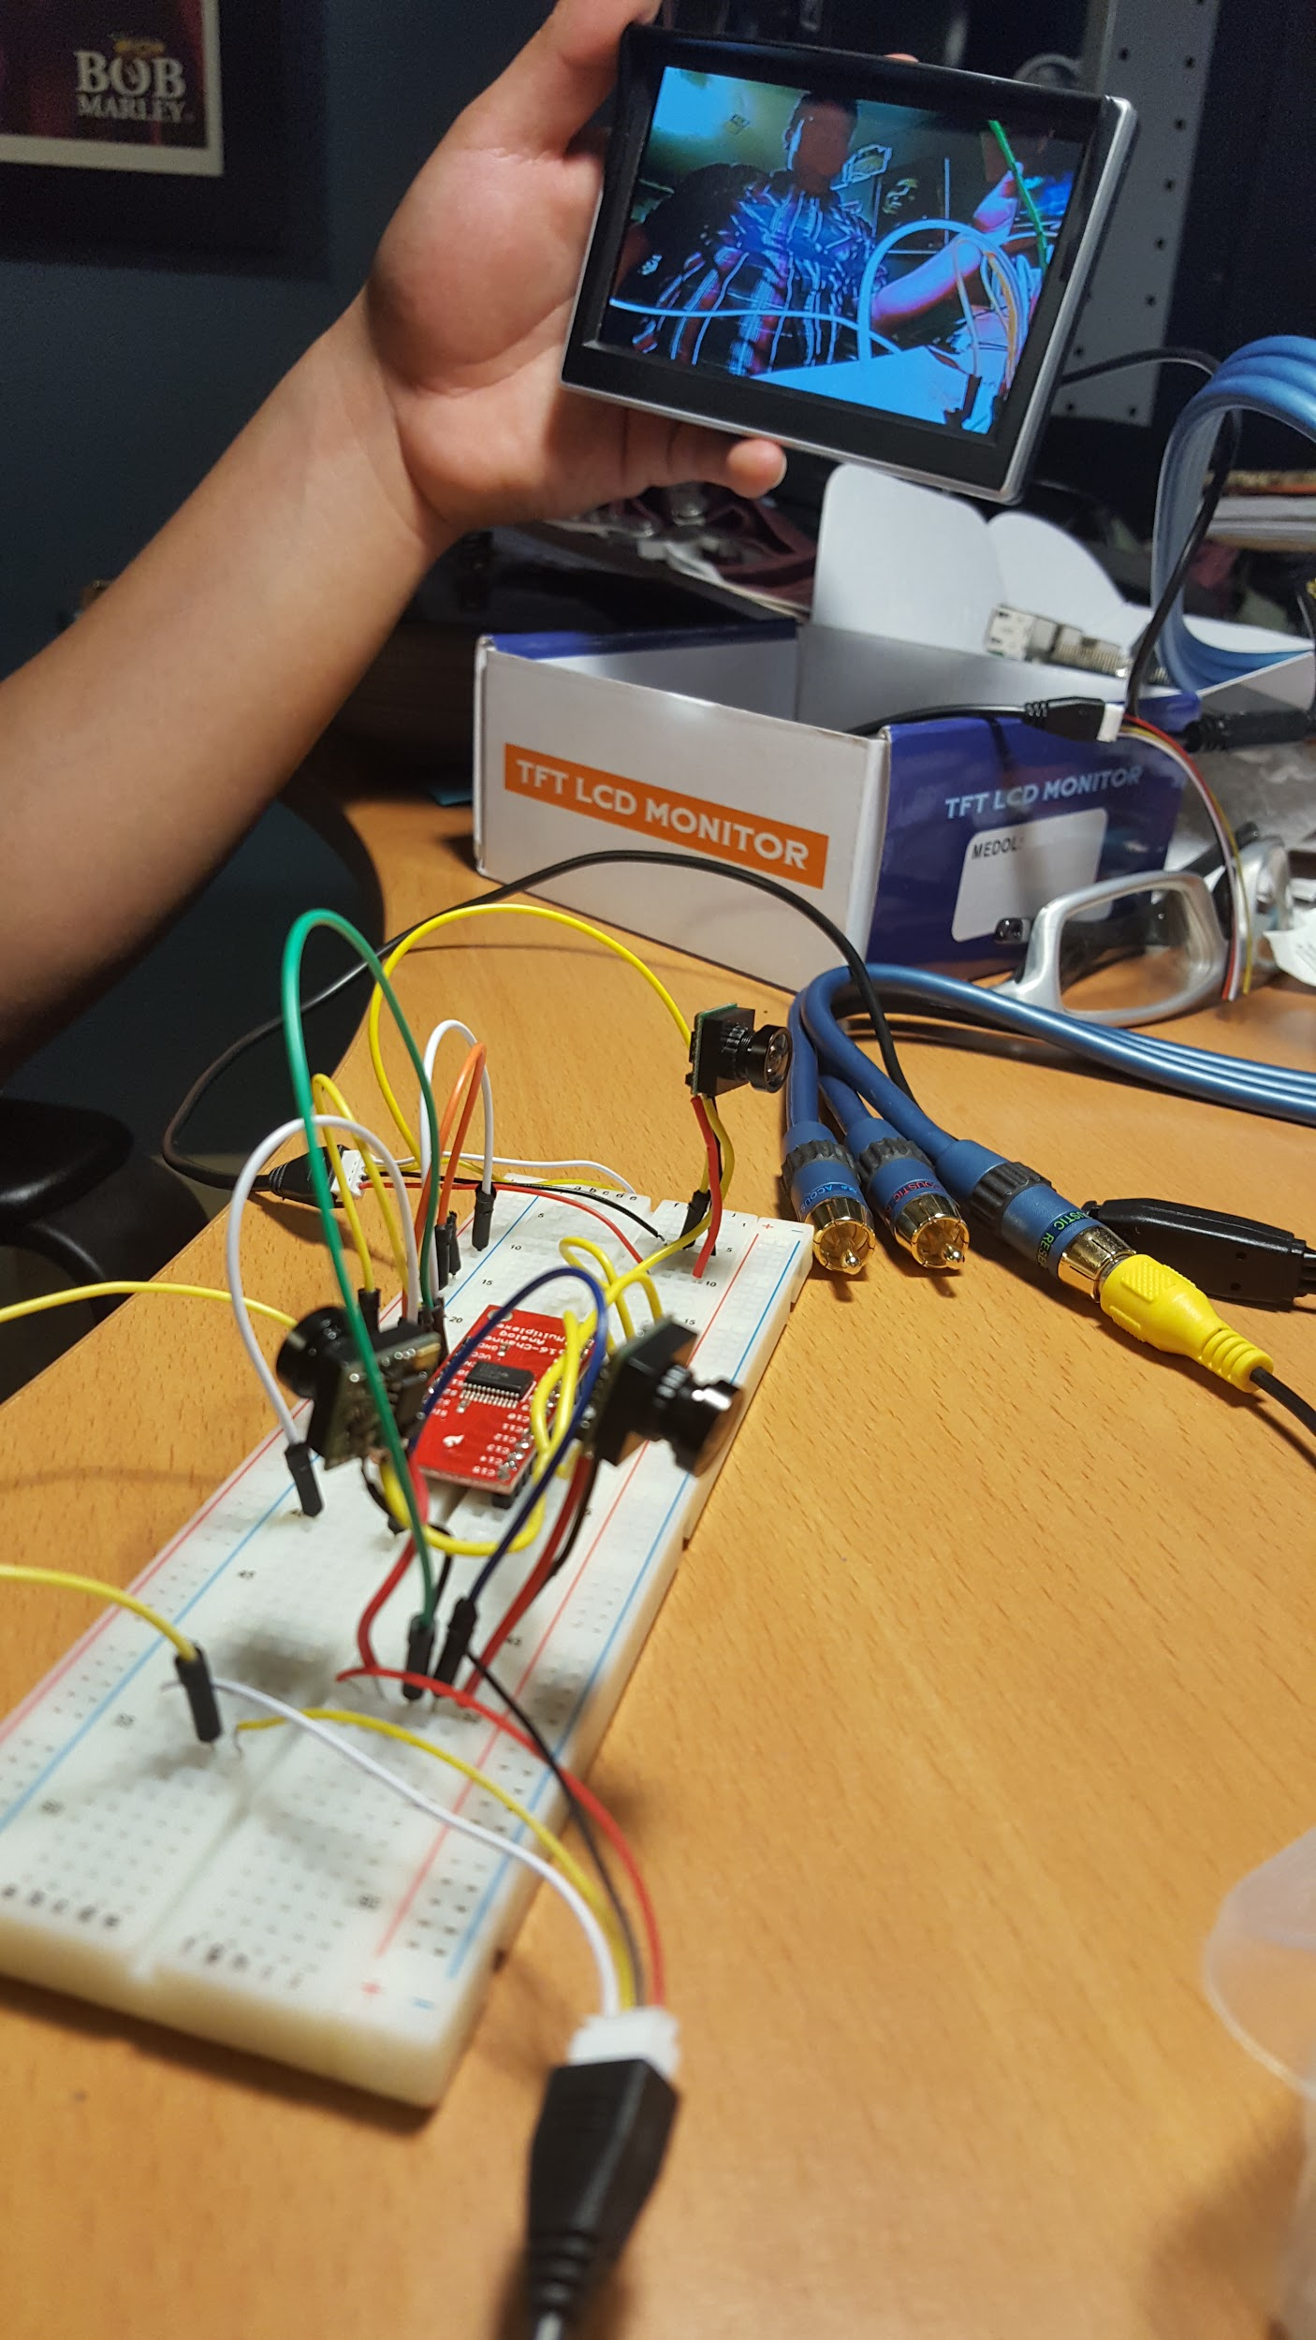

So this part is a little tricky, but I THINK that the plan is to run long wires to the camera mounts into the box with the MUX

That would make MUX box like this:

Inputs: +5volts, Ground, 3 camera lines, analog signal from the PI, S0, S1 from the PI

Outputs: signal wire to the display

00 left cam

01 right cam

10 Back cam

11 GUI

-------------------------------------------------------------------------------------------------------------------

3) **Display module**

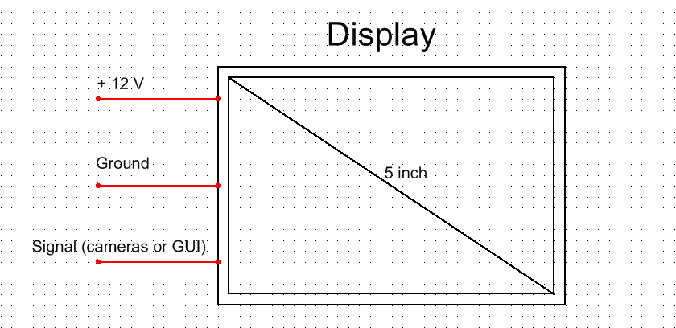

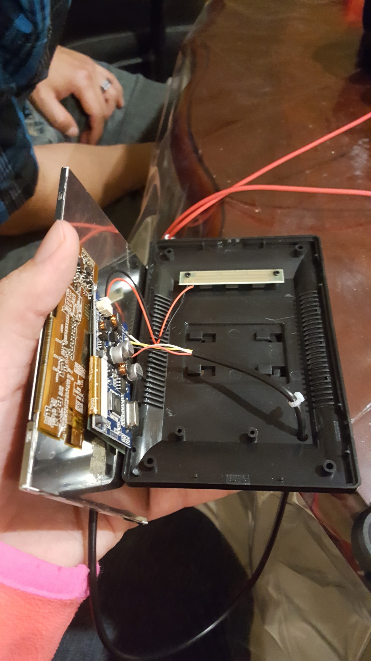

^^need better picture, but that is coming

Inputs: +12 volts, ground, signal to display (either cameras or GUI)

Outputs: ….nothing wired

----------------------------------------------------------------------------------------------------------------------------

4) **Rasberry Pi**

Inputs: AT Tiny signal, bluetooth serial connection, 5 volts, ground

Outputs: S0, S1, analog display signal,

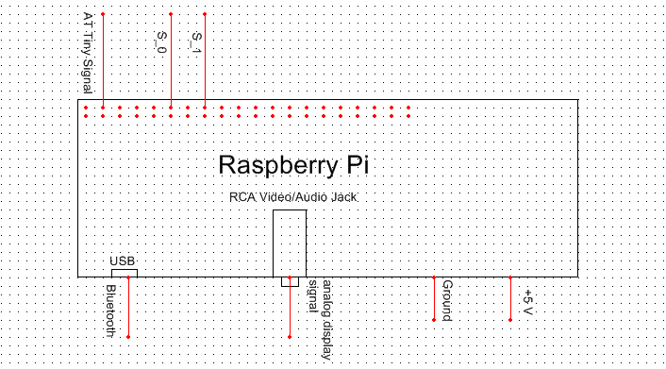

We are still not sure if we will use the USB ports and other functions of the Pi

----------------------------------------------------------------------------------------------------------------------------

**6) voltage regulator:**

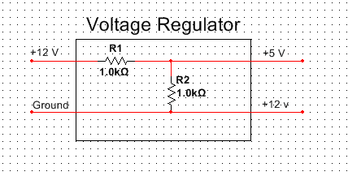

**Input: +12, ground**

**Output: +5, +12**

**?????????? can we run 1 wire with the 5 volts ?????????**

**??????????all 3 cameras on the same 5 volts???????**

**?????????all 5 AT Tiny on the same 5 volts????**

**\*\*\*\*\*in theory we can parallel\*\*\*\***

**----------------------------------------------------------------------------------------------------------------------------**

**5)OBDII module ***NEED MORE INFO HERE\*\*\*\***

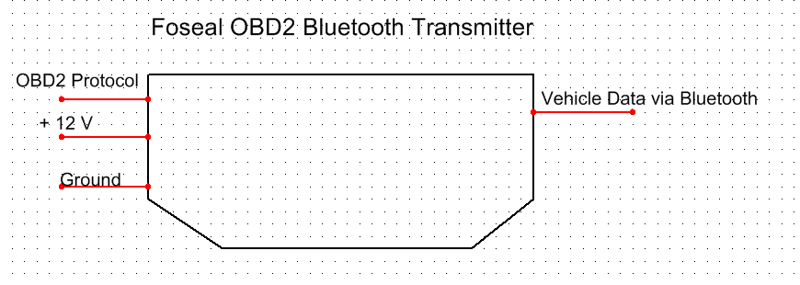

**Input:**

**Output: bluetooth radio signal with info**

<http://python-obd.readthedocs.io/en/latest/>

Dodge RAM protocol:

**SAE J1850 VPW**

We need USB-OBDII cable, as the bluetooth doesn’t seem to function, 10-30 dollars

***note**** this might not be the solution since the problem would still be the same. (Enabling SPP on the pi)

----bluez will install, but serial connection is not forming (with pi zero)

**-----------------------------------------------------------------------------------------------------------------------**

**\*\*\*Start meeting up with all the members\*\*\***

5) Stuff missing from report:

Schematics

Meat of project: a complete comprehensive technical description, architecture, sub-system diagram

Sign off on pictures: (side mirror and camera, prox sensor & LED, schematic of PCB, diagram of whole and sub systems)

Data: (how far away are prox sensors sensing, layout of modules, table of vals for OBDII, calculations, tabulated results)