**There are four types of Queue:**  
  
1. Simple Queue  
2. Circular Queue  
3. Priority Queue  
4. Dequeue (Double Ended Queue)

**1. Simple Queue**

Simple queue defines the simple operation of queue in which insertion occurs at the rear of the list and deletion occurs at the front of the list.  
  
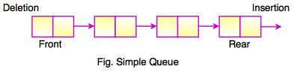

**2. Circular Queue**

* In a circular queue, all nodes are treated as circular. Last node is connected back to the first node.
* Circular queue is also called as**Ring Buffer.**
* It is an abstract data type.
* Circular queue contains a collection of data which allows insertion of data at the end of the queue and deletion of data at the beginning of the queue.

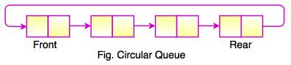  
  
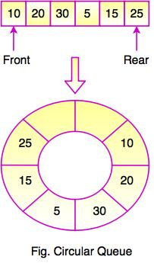  
  
The above figure shows the structure of circular queue. It stores an element in a circular way and performs the operations according to its FIFO structure.

**3. Priority Queue**

* Priority queue contains data items which have some preset priority. While removing an element from a priority queue, the data item with the highest priority is removed first.
* In a priority queue, insertion is performed in the order of arrival and deletion is performed based on the priority.

**4. Dequeue (Double Ended Queue)**

In Double Ended Queue, insert and delete operation can be occur at both ends that is front and rear of the queue.  
  
