**Dijkstra Algorithm-**

* Dijkstra Algorithm is a very famous greedy algorithm.
* It is used for solving the single source shortest path problem.
* It computes the shortest path from one particular source node to all other remaining nodes of the graph.

**Conditions-**

It is important to note the following points regarding Dijkstra Algorithm-

* Dijkstra algorithm works only for connected graphs.
* Dijkstra algorithm works only for those graphs that do not contain any negative weight edge.
* The actual Dijkstra algorithm does not output the shortest paths.
* It only provides the value or cost of the shortest paths.
* By making minor modifications in the actual algorithm, the shortest paths can be easily obtained.
* Dijkstra algorithm works for directed as well as undirected graphs.

**Dijkstra Algorithm-**

1. dist[S] ← 0 // The distance to source vertex is set to 0
2. Π[S] ← NIL // The predecessor of source vertex is set as NIL
3. for all v ∈ V - {S} // For all other vertices
4. do dist[v] ← ∞ // All other distances are set to ∞
5. Π[v] ← NIL // The predecessor of all other vertices is set as NIL
6. S ← ∅ // The set of vertices that have been visited 'S' is initially empty
7. Q ← V // The queue 'Q' initially contains all the vertices
8. while Q ≠ ∅ // While loop executes till the queue is not empty
9. do u ← **mindistance** (Q, dist) // A vertex from Q with the least distance is selected
10. S ← S ∪ {u} // Vertex 'u' is added to 'S' list of vertices that have been visited
11. for all v ∈ neighbors[u] // For all the neighboring vertices of vertex 'u'
12. do if dist[v] > dist[u] + **w**(u,v) // if any new shortest path is discovered
13. then dist[v] ← dist[u] + **w**(u,v) // The new value of the shortest path is selected
14. return dist

**Implementation-**

The implementation of above Dijkstra Algorithm is explained in the following steps-

**Step-01:**

In the first step. two sets are defined-

* One set contains all those vertices which have been included in the shortest path tree.
* In the beginning, this set is empty.
* Other set contains all those vertices which are still left to be included in the shortest path tree.
* In the beginning, this set contains all the vertices of the given graph.

**Step-02:**

For each vertex of the given graph, two variables are defined as-

* Π[v] which denotes the predecessor of vertex ‘v’
* d[v] which denotes the shortest path estimate of vertex ‘v’ from the source vertex.

Initially, the value of these variables is set as-

* The value of variable ‘Π’ for each vertex is set to NIL i.e. Π[v] = NIL
* The value of variable ‘d’ for source vertex is set to 0 i.e. d[S] = 0
* The value of variable ‘d’ for remaining vertices is set to ∞ i.e. d[v] = ∞

**Step-03:**

The following procedure is repeated until all the vertices of the graph are processed-

* Among unprocessed  vertices, a vertex with minimum value of variable ‘d’ is chosen.
* Its outgoing edges are relaxed.
* After relaxing the edges for that vertex, the sets created in step-01 are updated.

**What is Edge Relaxation?**

Consider the edge (a,b) in the following graph-

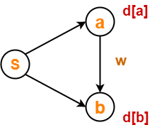

Here, d[a] and d[b] denotes the shortest path estimate for vertices a and b respectively from the source vertex ‘S’.

Now,

If d[a] + w < d[b]

then d[b] = d[a] + w and Π[b] = a

This is called as edge relaxation.

**Time Complexity Analysis-**

**Case-01:**

This case is valid when-

* The given graph G is represented as an adjacency matrix.
* Priority queue Q is represented as an unordered list.

Here,

* A[i,j] stores the information about edge (i,j).
* Time taken for selecting i with the smallest dist is O(V).
* For each neighbor of i, time taken for updating dist[j] is O(1) and there will be maximum V neighbors.
* Time taken for each iteration of the loop is O(V) and one vertex is deleted from Q.
* Thus, total time complexity becomes O(V2).

**Case-02:**

This case is valid when-

* The given graph G is represented as an adjacency list.
* Priority queue Q is represented as a binary heap.

Here,

* With adjacency list representation, all vertices of the graph can be traversed using BFS in O(V+E) time.
* In min heap, operations like extract-min and decrease-key value takes O(logV) time.
* So, overall time complexity becomes O(E+V) x O(logV) which is O((E + V) x logV) = O(ElogV)
* This time complexity can be reduced to O(E+VlogV) using Fibonacci heap.

**PRACTICE PROBLEM BASED ON DIJKSTRA ALGORITHM-**

**Problem-**

Using Dijkstra’s Algorithm, find the shortest distance from source vertex ‘S’ to remaining vertices in the following graph-

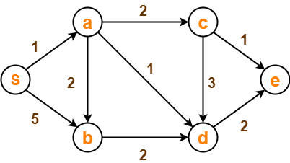

Also, write the order in which the vertices are visited.

**Solution-**

**Step-01:**

The following two sets are created-

* Unvisited set : {S , a , b , c , d , e}
* Visited set     : { }

**Step-02:**

The two variables  Π and d are created for each vertex and initialized as-

* Π[S] = Π[a] = Π[b] = Π[c] = Π[d] = Π[e] = NIL
* d[S] = 0
* d[a] = d[b] = d[c] = d[d] = d[e] = ∞

**Step-03:**

* Vertex ‘S’ is chosen.
* This is because shortest path estimate for vertex ‘S’ is least.
* The outgoing edges of vertex ‘S’ are relaxed.

**Before Edge Relaxation-**

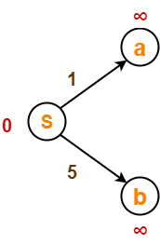

Now,

* d[S] + 1 = 0 + 1 = 1 < ∞

∴ d[a] = 1 and Π[a] = S

* d[S] + 5 = 0 + 5 = 5 < ∞

∴ d[b] = 5 and Π[b] = S

After edge relaxation, our shortest path tree is-

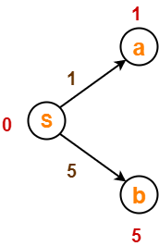

Now, the sets are updated as-

* Unvisited set : {a , b , c , d , e}
* Visited set : {S}

**Step-04:**

* Vertex ‘a’ is chosen.
* This is because shortest path estimate for vertex ‘a’ is least.
* The outgoing edges of vertex ‘a’ are relaxed.

**Before Edge Relaxation-**

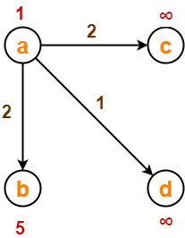

Now,

* d[a] + 2 = 1 + 2 = 3 < ∞

∴ d[c] = 3 and Π[c] = a

* d[a] + 1 = 1 + 1 = 2 < ∞

∴ d[d] = 2 and Π[d] = a

* d[b] + 2 = 1 + 2 = 3 < 5

∴ d[b] = 3 and Π[b] = a

After edge relaxation, our shortest path tree is-

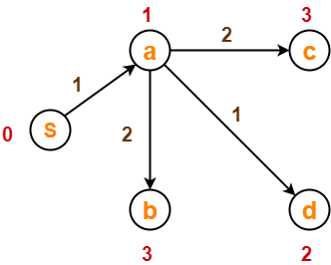

Now, the sets are updated as-

* Unvisited set : {b , c , d , e}
* Visited set : {S , a}

**Step-05:**

* Vertex ‘d’ is chosen.
* This is because shortest path estimate for vertex ‘d’ is least.
* The outgoing edges of vertex ‘d’ are relaxed.

**Before Edge Relaxation-**

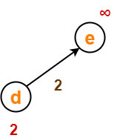

Now,

* d[d] + 2 = 2 + 2 = 4 < ∞

∴ d[e] = 4 and Π[e] = d

After edge relaxation, our shortest path tree is-

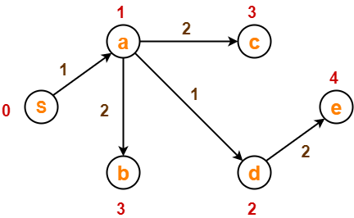

Now, the sets are updated as-

* Unvisited set : {b , c , e}
* Visited set : {S , a , d}

**Step-06:**

* Vertex ‘b’ is chosen.
* This is because shortest path estimate for vertex ‘b’ is least.
* Vertex ‘c’ may also be chosen since for both the vertices, shortest path estimate is least.
* The outgoing edges of vertex ‘b’ are relaxed.

**Before Edge Relaxation-**

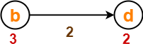

Now,

* d[b] + 2 = 3 + 2 = 5 > 2

∴ No change

After edge relaxation, our shortest path tree remains the same as in Step-05.

Now, the sets are updated as-

* Unvisited set : {c , e}
* Visited set     : {S , a , d , b}

**Step-07:**

* Vertex ‘c’ is chosen.
* This is because shortest path estimate for vertex ‘c’ is least.
* The outgoing edges of vertex ‘c’ are relaxed.

**Before Edge Relaxation-**

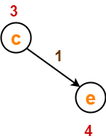

Now,

* d[c] + 1 = 3 + 1 = 4 = 4

∴ No change

After edge relaxation, our shortest path tree remains the same as in Step-05.

Now, the sets are updated as-

* Unvisited set : {e}
* Visited set : {S , a , d , b , c}

**Step-08:**

* Vertex ‘e’ is chosen.
* This is because shortest path estimate for vertex ‘e’ is least.
* The outgoing edges of vertex ‘e’ are relaxed.
* There are no outgoing edges for vertex ‘e’.
* So, our shortest path tree remains the same as in Step-05.

Now, the sets are updated as-

* Unvisited set : { }
* Visited set : {S , a , d , b , c , e}

Now,

* All vertices of the graph are processed.
* Our final shortest path tree is as shown below.
* It represents the shortest path from source vertex ‘S’ to all other remaining vertices.

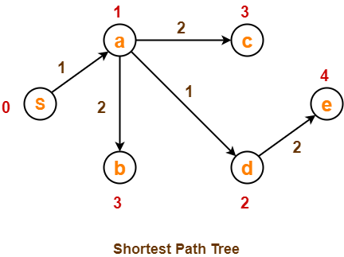

The order in which all the vertices are processed is :

**S , a , d , b , c , e**.