199303069

Hardik Srivastava

Q12

import java.util.Scanner;

public class Main {

public static void main(String args[])

{

Scanner scanner = new Scanner(System.in);

int n = scanner.nextInt();

scanner.close();

int count = 1;

int spaces = 1;

int start = 0;

for (int i = 1; i < (n \* 2); i++) {

for (int spc = n - spaces; spc > 0; spc--) {

System.out.print(" ");

}

if (i < n) {

start = i;

spaces++;

}

else {

start = (n\*2)-i;

spaces--;

}

for (int j = 0; j < count; j++) {

System.out.print(start);

if (j < count / 2) {

start--;

}

else {

start++;

}

}

if (i < n) {

count = count + 2;

}

else {

count = count - 2;

}

System.out.println();

}

}

}

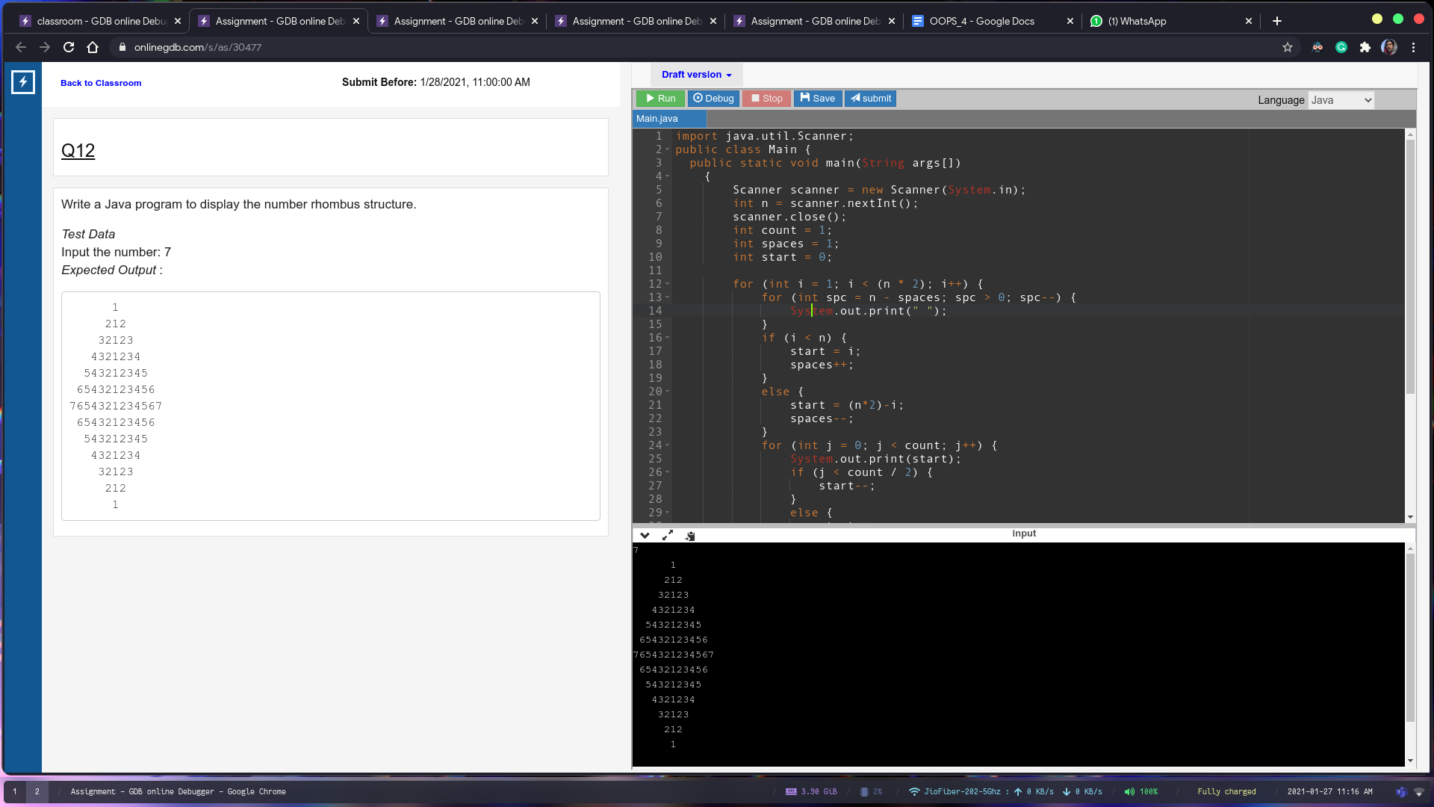

Q13

import java.util.Scanner;

public class Main {

public static void main(String[] args) {

Scanner sc = new Scanner(System.in);

String s = sc.nextLine().trim();

//String s = "thequickbrownfoxxofnworbquickthe";

int max = s.length();

int cur = 1;

String longest = "";

while (cur <= max) {

int i = 0;

while ((i+cur) <= max) {

String check = s.substring(i, i+cur);

if (palindrome(check)) {

//System.out.println(check);

if (check.length() > longest.length()) {

longest = check;

}

}

i++;

}

cur++;

}

System.out.print(longest);

}

private static boolean palindrome(String s) {

String copy = s.trim();

StringBuffer sb = new StringBuffer(s);

sb.reverse();

String ss = sb.toString();

return (ss.equals(s));

}

}

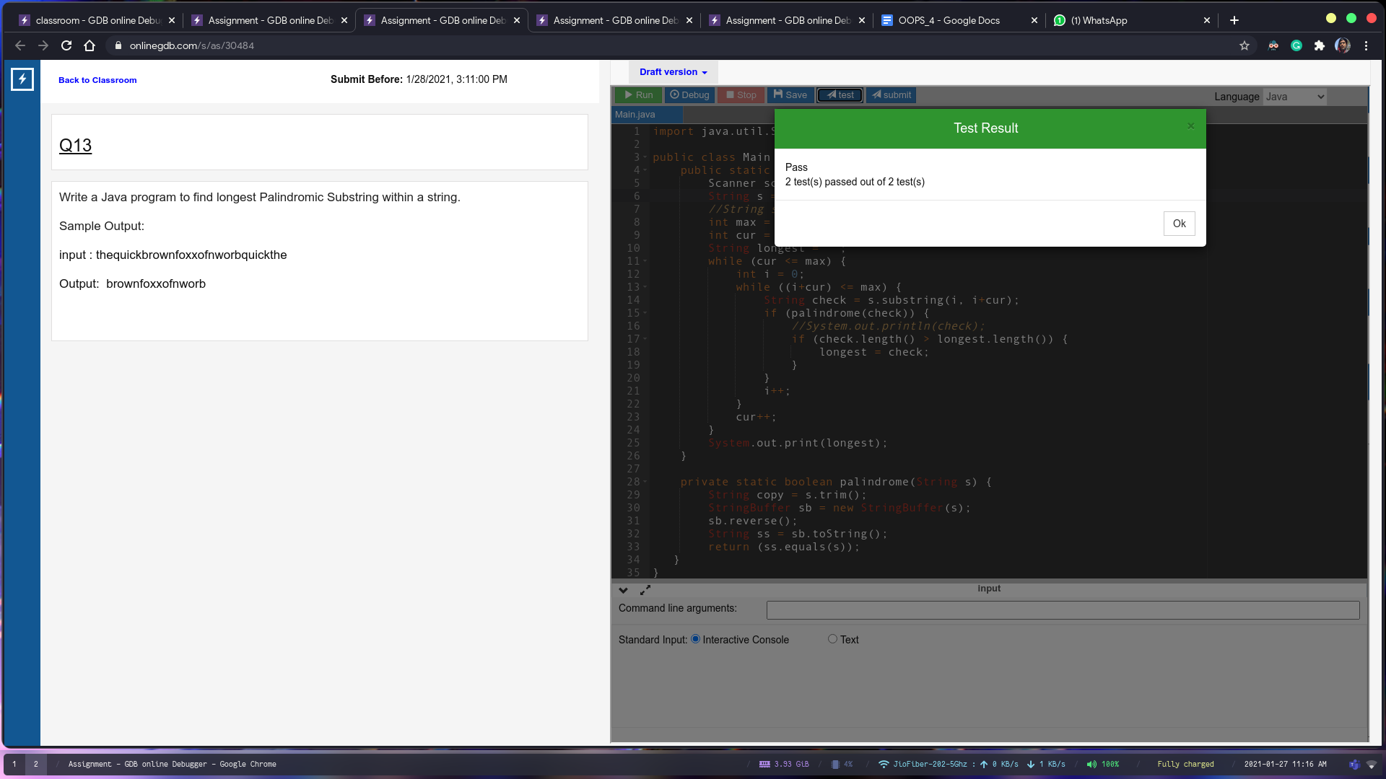

Q14

import java.util.Arrays;

import java.util.Scanner;

public class Main {

public static void main(String[] args) {

String str = new Scanner(System.in).next().trim();

int n = str.length();

int length = str.length();

char[] data = new char[length + 1];

char[] sort = str.toCharArray();

Arrays.sort(sort);

str = new String(sort);

perm(str, data, length - 1, 0);

}

static void perm(String str, char[] data, int last, int index) {

int length = str.length();

for (int i = 0; i < length; i++) {

data[index] = str.charAt(i);

if (index == last) {

//

System.out.println(new String(data));

}

else {

perm(str, data, last, index + 1);

}

}

}

}

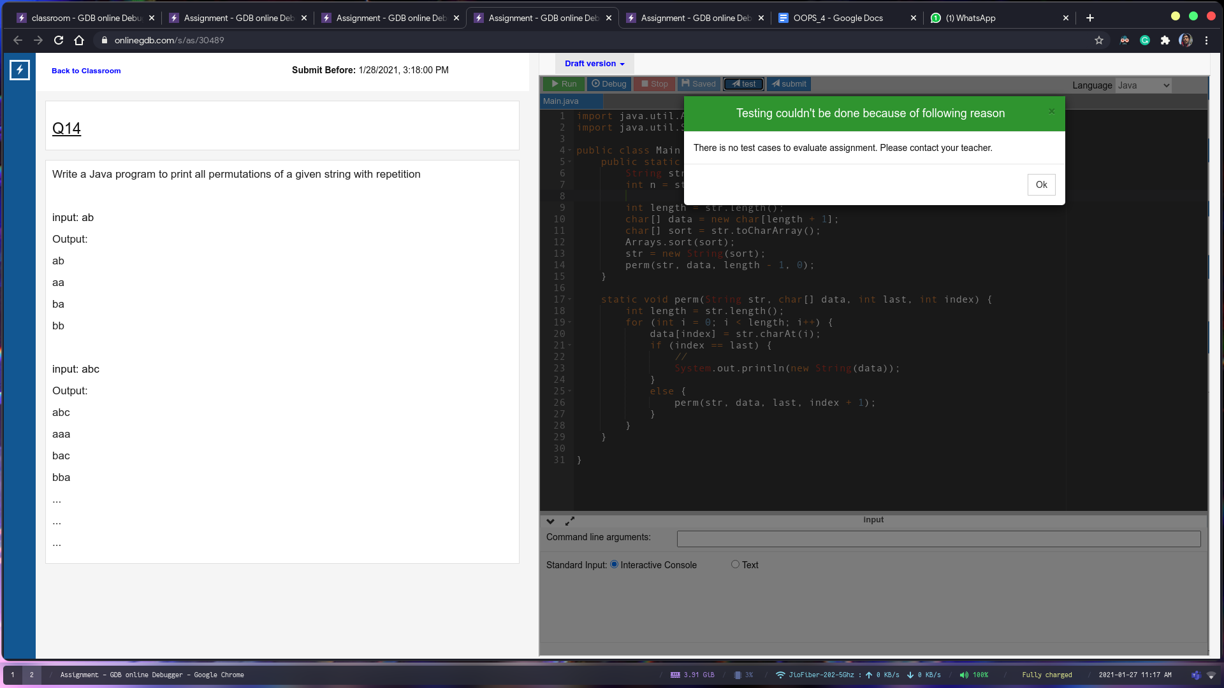

Q15

import java.util.Scanner;

public class Main {

public static void main(String[] args) {

Scanner sc = new Scanner(System.in);

String s = sc.next().trim();

int max = s.length();

int cur = 2;

String longest = "";

while (cur <= max) {

int i = 0;

while ((i+cur) <= max) {

String check = s.substring(i, i+cur);

if (stringRepeating(check)) {

if (check.length() > longest.length()) {

longest = check;

}

}

i++;

}

cur++;

}

System.out.println(longest);

}

private static boolean stringRepeating(String s) {

for (int i = 0; i < s.length(); i++) {

for (int j = i+1; j < s.length(); j++) {

if (s.charAt(i) == s.charAt(j)) {

return false;

}

}

}

return true;

}

}

