**Hardik Srivastava**

**199303069**

**Assignment Question 1 :**

// WAP to print multiple of 2

import java.util.Scanner;

public class Assignment1{

public static void main(String[] args) {

Scanner scanner = new Scanner(System.in);

int n = scanner.nextInt();

System.out.print(n * 2);

scanner.close();

}

}

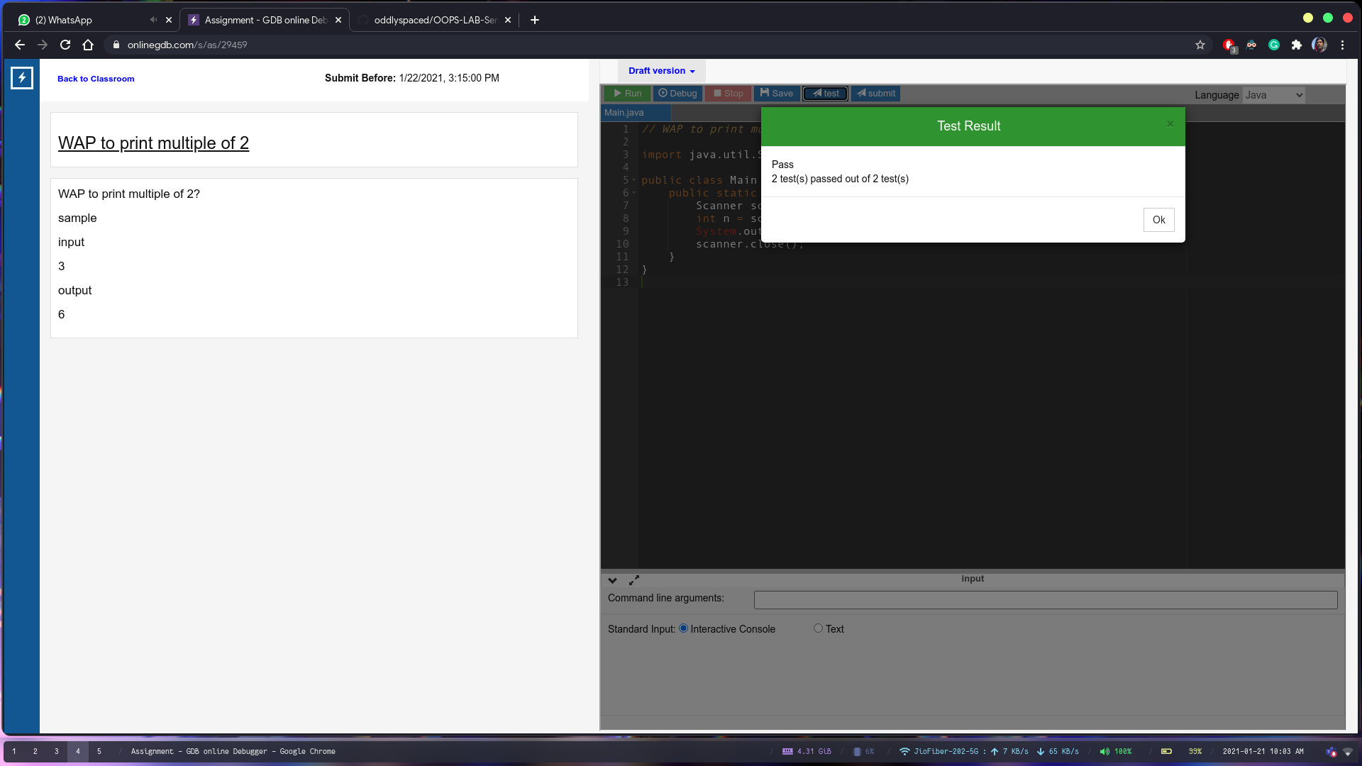

**Assignment Question 2 :**

// WAP to print the multiple of 1,2,3,5,6,7,8 in a series.

import java.util.Scanner;

class Main {

public static void main(String[] args) {

Scanner scanner = new Scanner(System.in);

int n = scanner.nextInt();

int num[] = {1, 2, 3, 5, 6, 7, 8};

for (int i = 0; i < num.length; i++) {

System.out.print(n * num[i] + " ");

}

scanner.close();

}

}

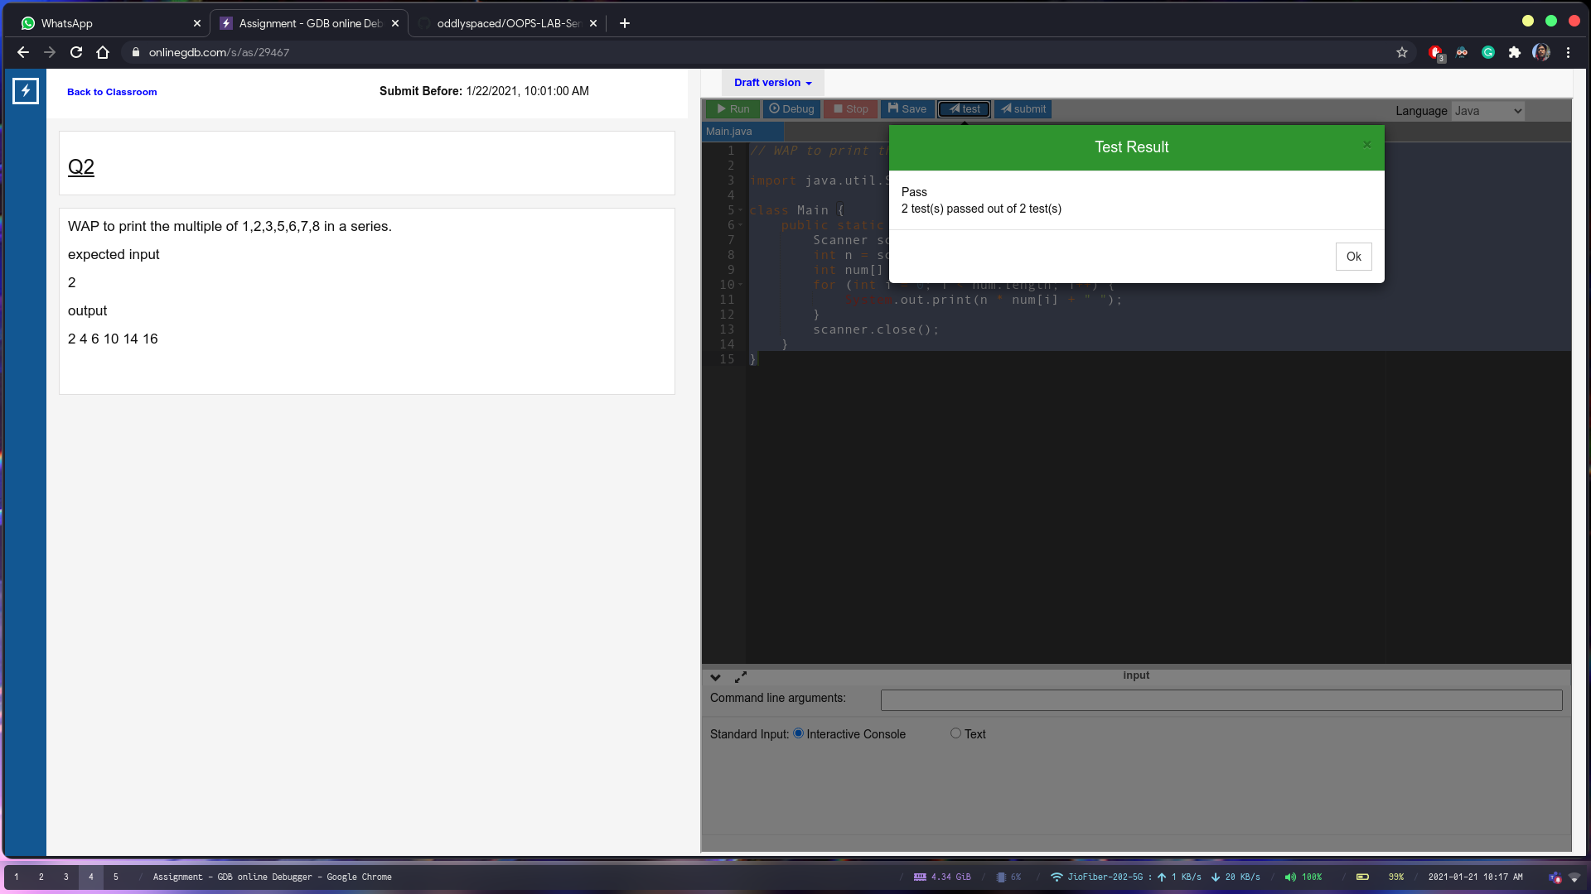

**Assignment Question 3 :**

// Write a function that takes an integer hours and converts it to seconds

import java.util.Scanner;

class Main {

public static void main(String[] args) {

Scanner scanner = new Scanner(System.in);

int hours = scanner.nextInt();

System.out.print(hours * 60 * 60);

scanner.close();

}

}

