199303069

Hardik Srivastava

Q8 :

// Write a Java program to insert an element (specific position) into an array

import java.util.Scanner;

class Main {

public static void main(String[] args) {

Scanner scanner = new Scanner(System.in);

System.out.println("Enter array size: ");

int size = scanner.nextInt() + 1;

int arr[] = new int[size + 1];

System.out.println("Enter values:");

for (int i = 0; i < size-1; i++) {

arr[i] = scanner.nextInt();

}

System.out.println("Inputted Array : ");

for (int i = 0; i < size-1; i++) {

System.out.print(arr[i] + "\t");

}

System.out.println();

System.out.println("Enter value to insert along with index:");

int insValue = scanner.nextInt(), insPos = scanner.nextInt();

if (insPos < 0 || insPos > size - 1) {

System.out.println("Invalid index!");

return;

}

for (int i = size - 1; i > insPos; i--) {

arr[i] = arr[i - 1];

}

arr[insPos] = insValue;

System.out.println("New Array : ");

for (int i = 0; i < size; i++) {

System.out.print(arr[i] + "\t");

}

scanner.close();

}

}

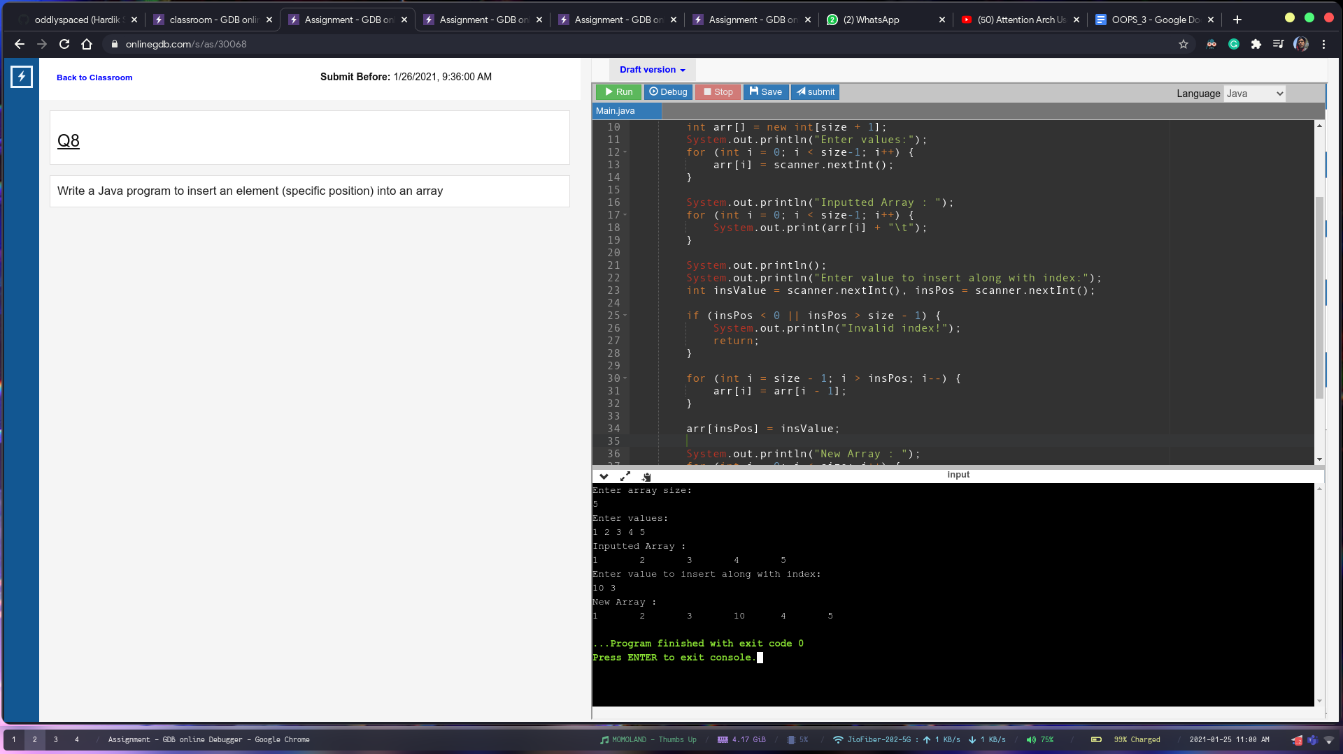

Q9

import java.util.Scanner;

class Main {

public static void main(String[] args) {

Scanner scanner = new Scanner(System.in);

System.out.println("Enter array size: ");

int size = scanner.nextInt();

String[] arr = new String[size];

System.out.println("Enter strings: ");

for (int i = 0; i < size; i++) {

arr[i] = scanner.next();

}

System.out.println("Duplicate values: ");

for (int i = 0; i < size; i++) {

for (int j = i + 1; j < size; j++) {

if (arr[i].equals(arr[j])) {

System.out.println(arr[i]);

}

}

}

scanner.close();

}

}

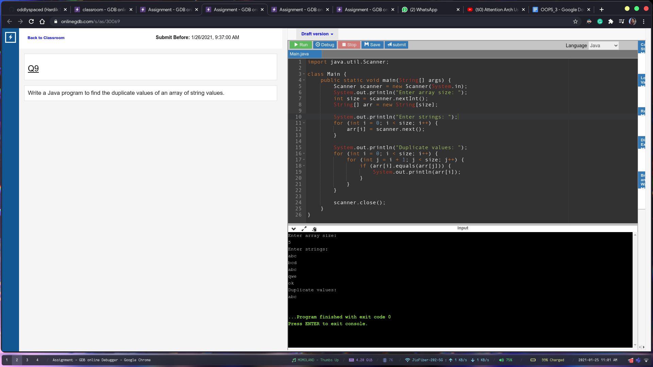

Q10:

import java.util.Scanner;

class Main {

public static void main(String[] args) {

Scanner scanner = new Scanner(System.in);

System.out.println("Enter array size: ");

int size = scanner.nextInt();

int arr[] = new int[size];

System.out.println("Enter values:");

for (int i = 0; i < size; i++) {

arr[i] = scanner.nextInt();

}

System.out.println("Inputted Array : ");

printArray(arr);

rotate(arr);

rotate(arr);

System.out.println("Rotated Array: ");

printArray(arr);

}

private static void printArray(int arr[]) {

for (int i = 0; i < arr.length; i++) {

System.out.print(arr[i] + "\t");

}

System.out.println();

}

private static int[] rotate(int arr[]) {

int size = arr.length;

int last = arr[size - 1];

for (int i = size - 1; i > 0; i--) {

arr[i] = arr[i - 1];

}

arr[0] = last;

return arr;

}

}

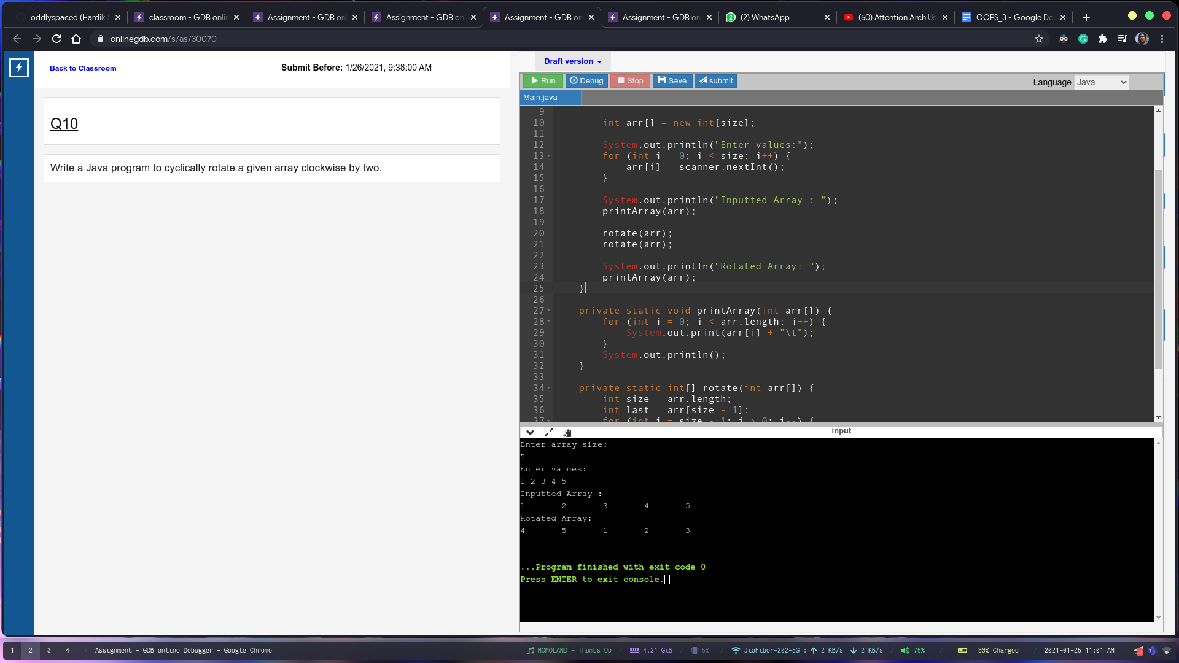

Q11

import java.util.Scanner;

class Main {

public static void main(String[] args) {

Scanner scanner = new Scanner(System.in);

String original = scanner.nextLine();

String repl = scanner.nextLine();

String with = scanner.nextLine();

String newString = original.replaceAll(repl, with);

System.out.println(newString);

}

}

