199303069

Hardik Srivastava

Q35

import java.util.Scanner;

class Main {

public static void main (String[] args) {

Scanner sc = new Scanner(System.in);

int n = sc.nextInt();

int a = 0, b = 1, c = 1;

int sum = 0;

while (true) {

c = a + b;

if (c > n) {

break;

}

if (c%2 == 0) {

sum += c;

}

// System.out.println(c);

a = b;

b = c;

}

System.out.println(sum);

}

}

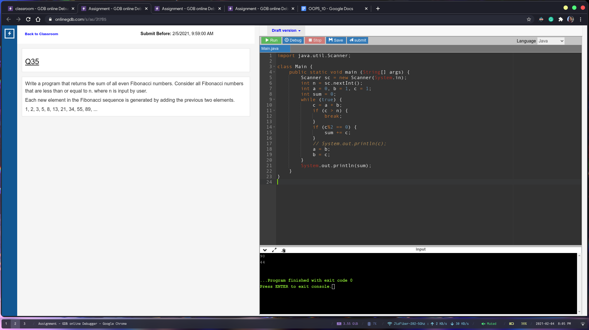

Q36

import java.util.\*;

class Main {

public static void main (String[] args) {

Scanner sc = new Scanner(System.in);

int s1 = sc.nextInt();

ArrayList<Integer> list1 = new ArrayList<Integer>();

for (int i = 0; i < s1; i++) {

list1.add(sc.nextInt());

}

int s2 = sc.nextInt();

ArrayList<Integer> list2 = new ArrayList<Integer>();

for (int i = 0; i < s2; i++) {

list2.add(sc.nextInt());

}

int smaller = (s1 < s2)? s1: s2;

ArrayList<Integer> fin = new ArrayList<Integer>();

for (int i = 0; i < smaller; i++) {

fin.add(list1.get(i) + list2.get(i));

System.out.println(fin.get(i));

}

}

}

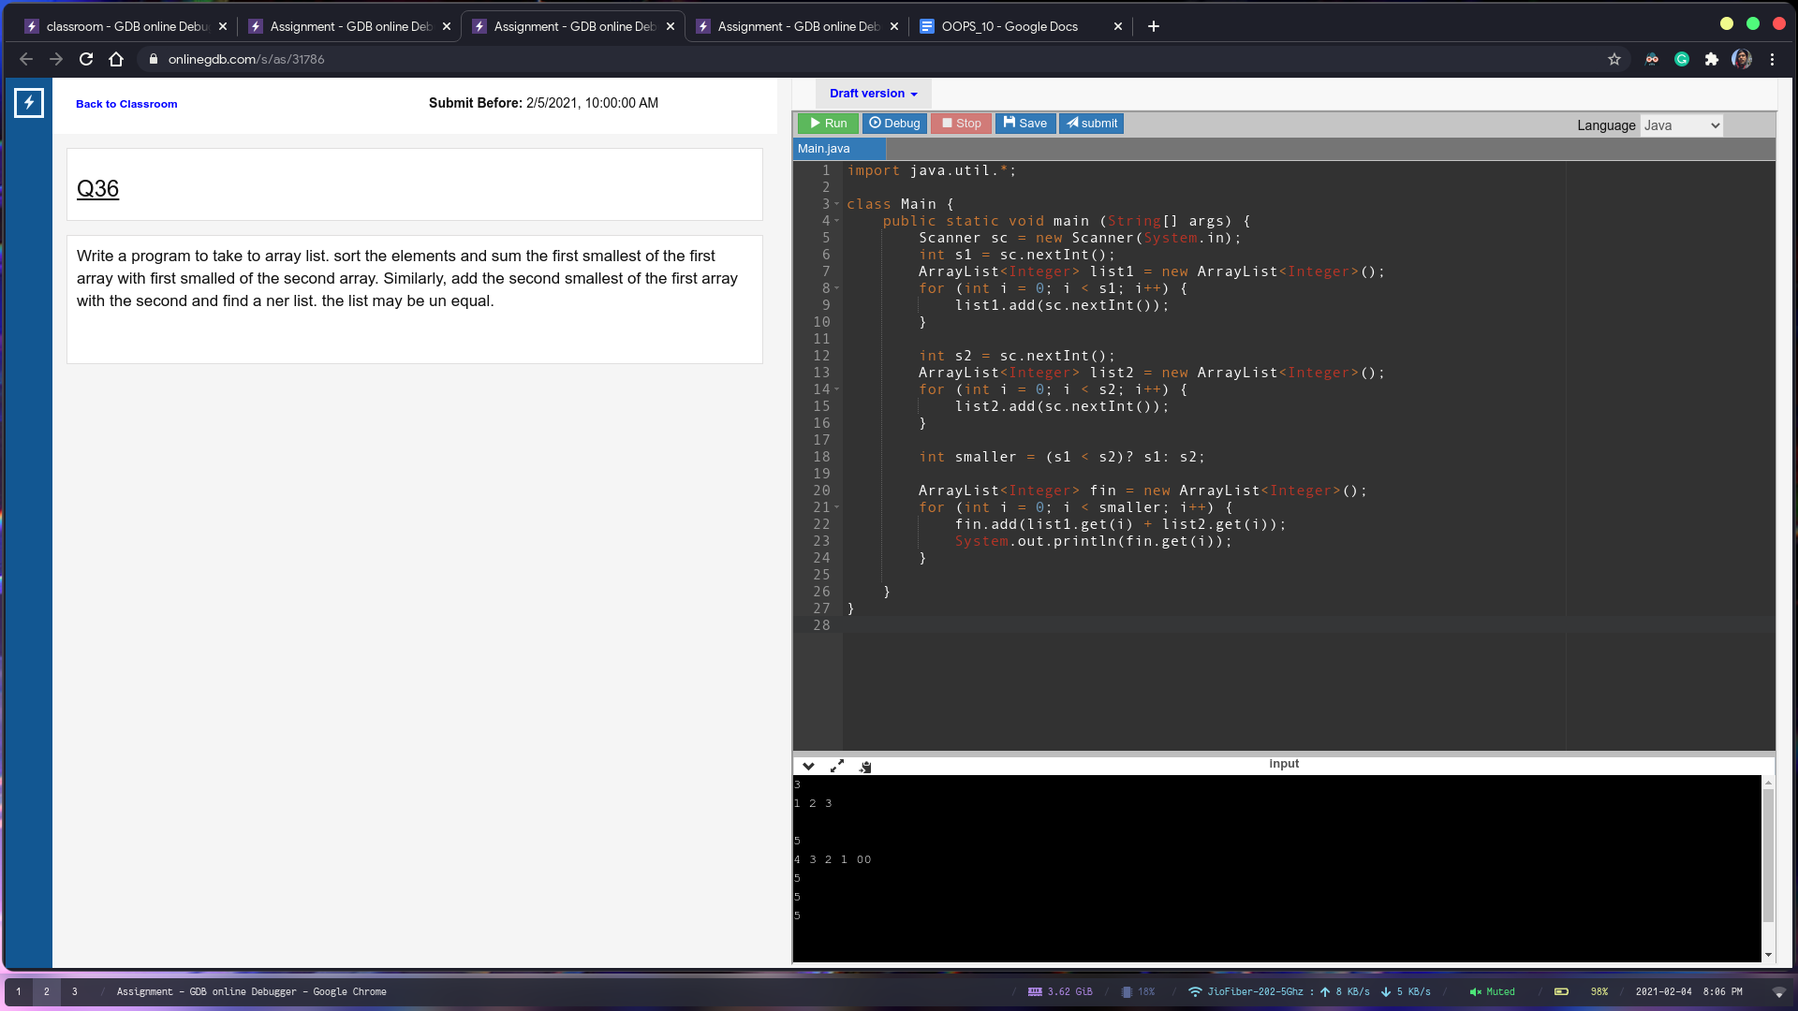

Q37

import java.text.ParseException;

import java.text.SimpleDateFormat;

import java.util.Calendar;

import java.util.Locale;

import java.util.Scanner;

class Main {

public static void main (String[] args) throws ParseException {

Scanner sc = new Scanner(System.in);

String inp = sc.next();

Calendar cal = Calendar.getInstance();

SimpleDateFormat sdf = new SimpleDateFormat("dd-MM-yyyy", Locale.ENGLISH);

cal.setTime(sdf.parse(inp));// all done

cal.add(Calendar.DATE, 14);

SimpleDateFormat sdfDay = new SimpleDateFormat("EEE", Locale.ENGLISH);

System.out.println(sdfDay.format(cal.getTime()));

}

}

