199303069

Hardik Srivastava

Q4

// Write a Java program to find the number of days in a month.

import java.util.Scanner;

class Main {

public static void main(String[] args) {

int[] days = {0, 31, 28, 31, 30, 31, 30, 31, 31, 30, 31, 30, 31};

String[] months = {"", "January", "February", "March", "April", "May", "June", "July", "August", "September", "October", "November", "December"};

Scanner scanner = new Scanner(System.in);

System.out.print("Input a month number: ");

int month = scanner.nextInt();

System.out.println();

System.out.print("Input a year: ");

int year = scanner.nextInt();

System.out.println();

if (((year % 4 == 0) && (year % 100!= 0)) || (year%400 == 0)) {

days[2] = 29;

}

System.out.println(months[month] + " " + year + " has " + days[month] + " days");

scanner.close();

}

}

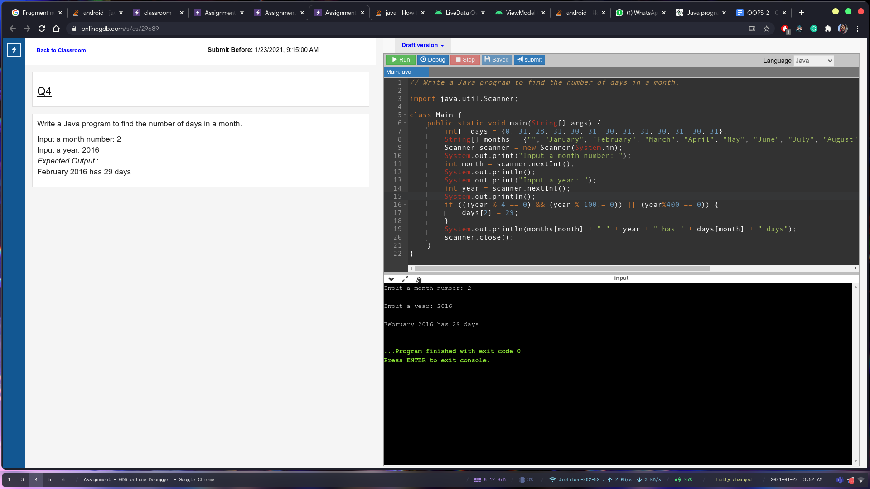

Q5:

// Write a program in Java to print the Floyd's Triangle.

import java.util.Scanner;

class Main {

public static void main(String[] args) {

Scanner scanner = new Scanner(System.in);

int n = scanner.nextInt();

int c = 1;

for (int i = 0; i < n; i++) {

for (int j = 0; j <= i; j++) {

System.out.print(c++ + " ");

}

System.out.println();

}

scanner.close();

}

}

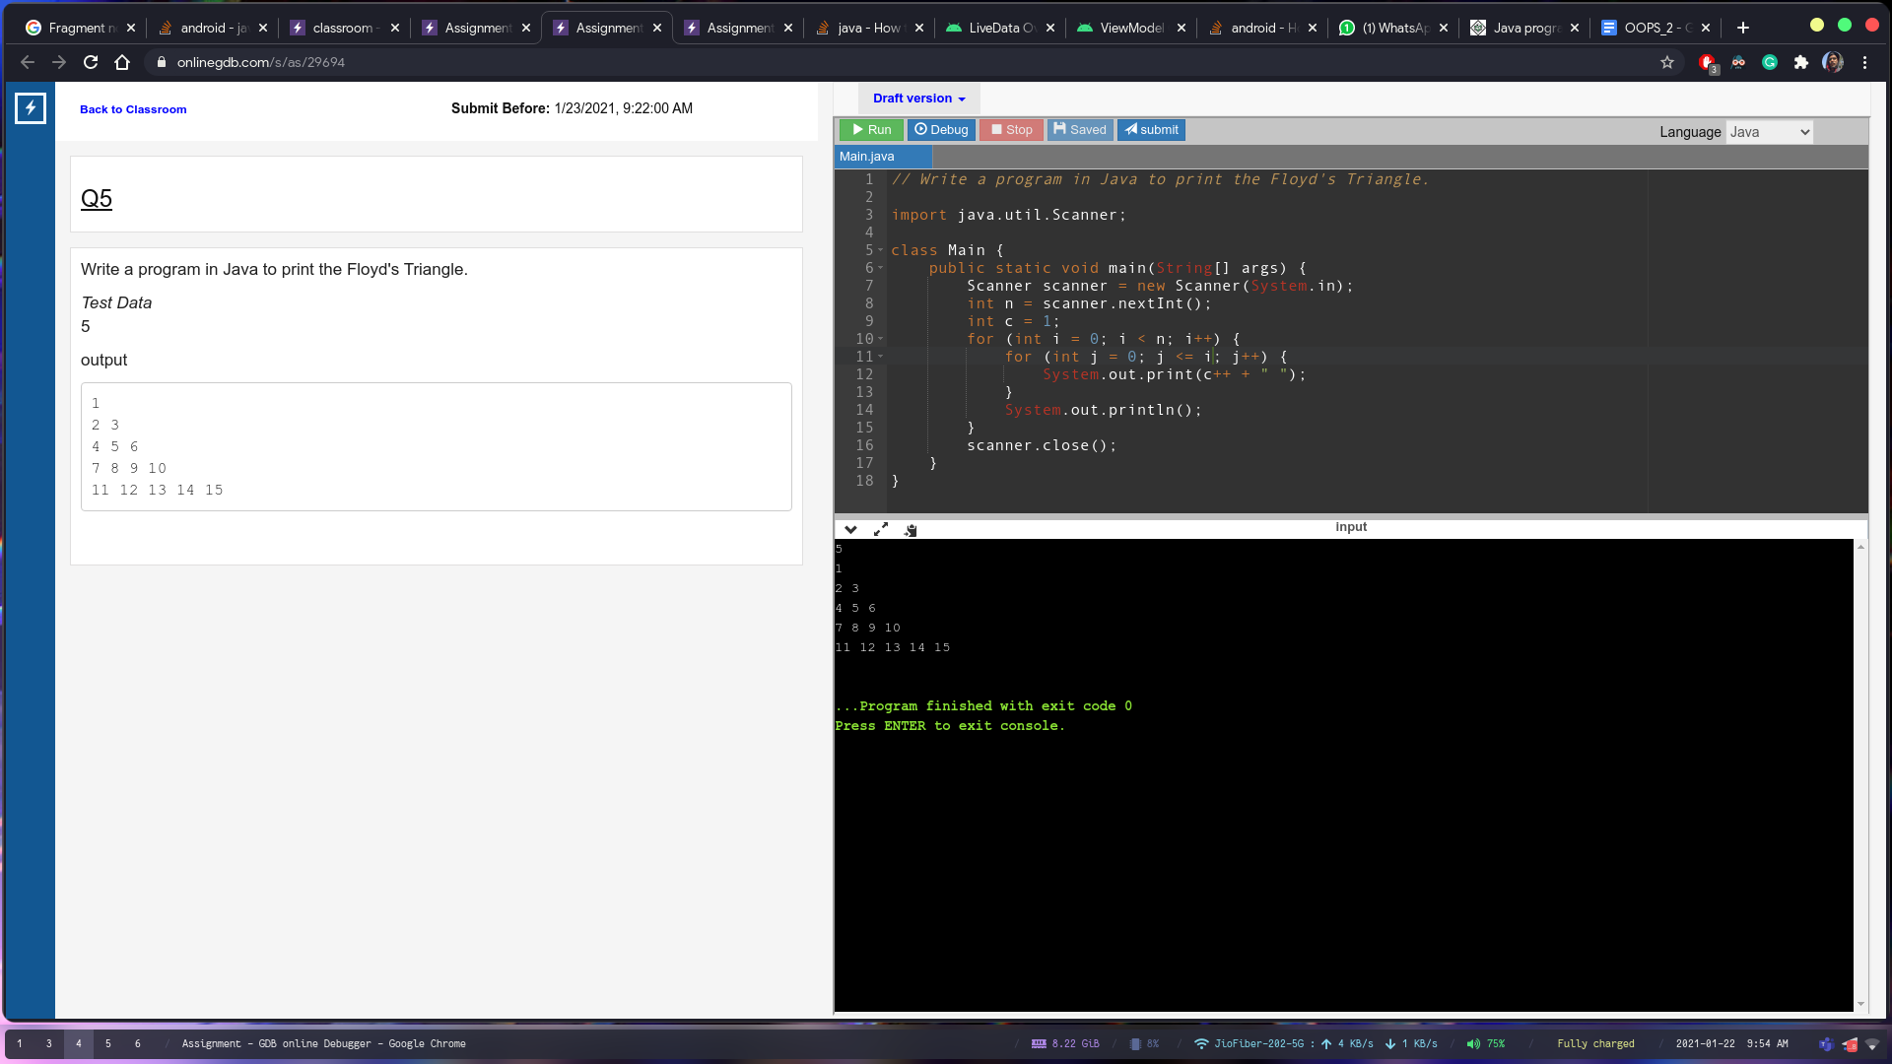

Q6:

// Write a Java program to find the duplicate values of an array of integer values.

import java.util.Scanner;

class Main {

public static void main(String[] args) {

Scanner scanner = new Scanner(System.in);

int size = scanner.nextInt();

int[] arr = new int[size];

for (int i = 0; i < size; i++) {

arr[i] = scanner.nextInt();

}

System.out.println("Duplicate: ");

for (int i = 0; i < size; i++) {

for (int j = i+1; j < size; j++) {

if (arr[i] == arr[j]) {

System.out.println(arr[i]);

}

}

}

scanner.close();

}

}

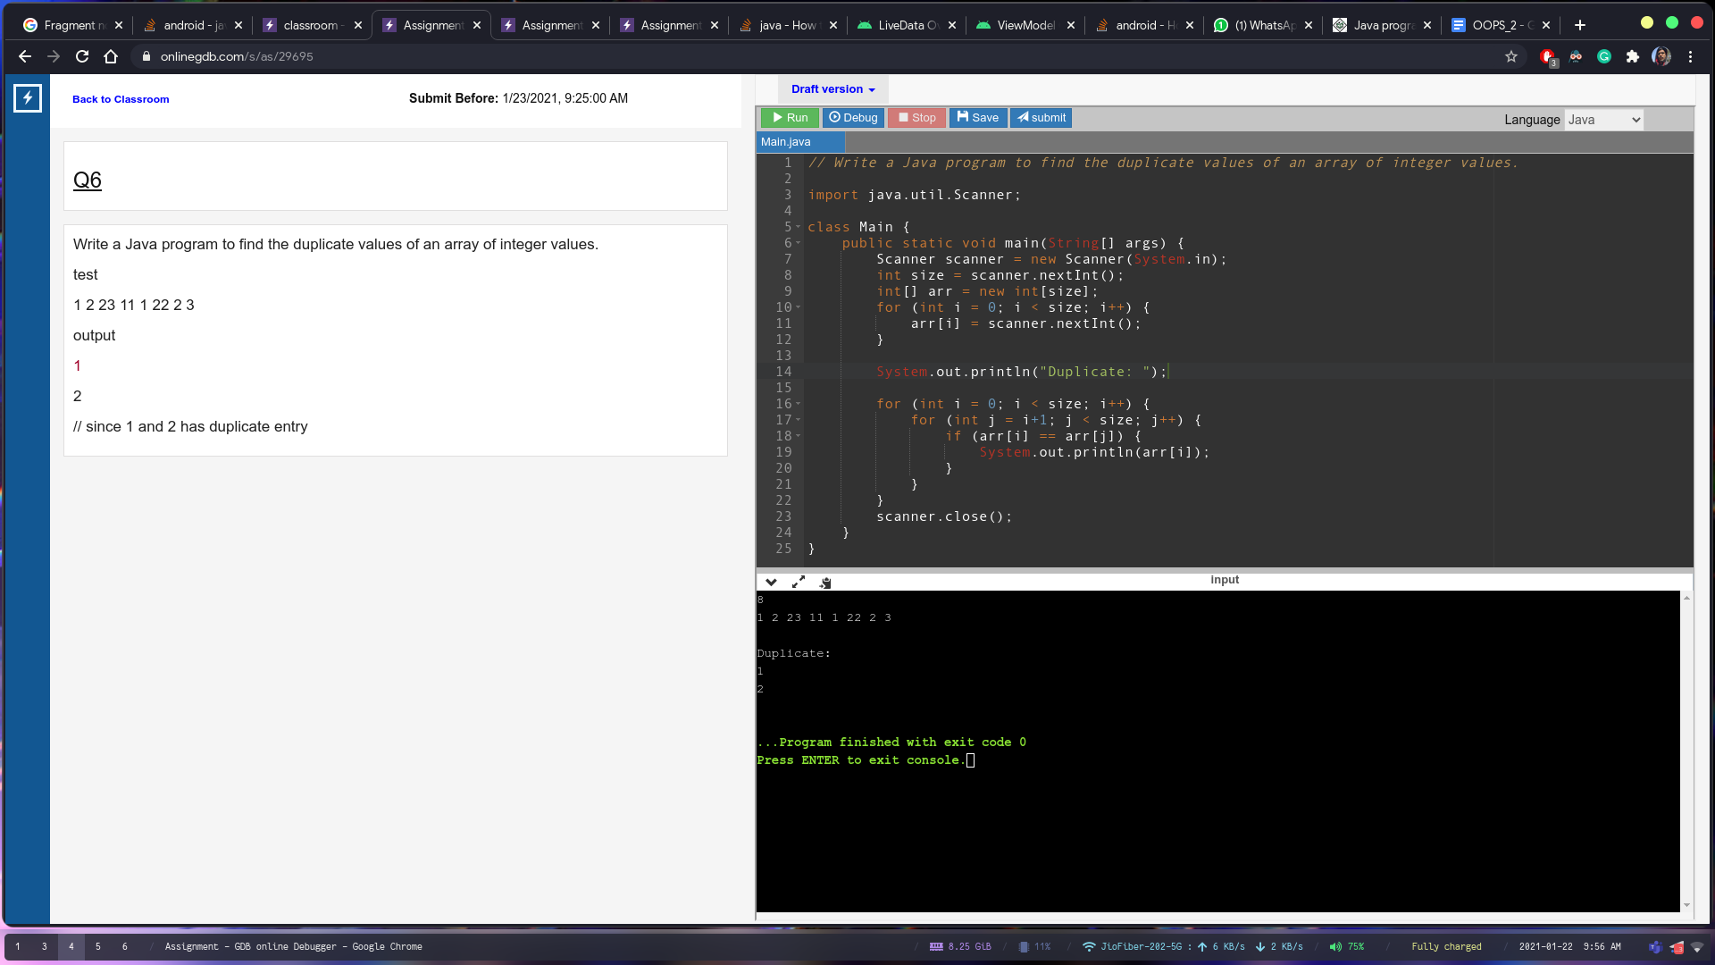

Q7

// Q7

import java.util.Scanner;

import java.lang.\*;

class Main {

public static void main(String[] args) {

Scanner scanner = new Scanner(System.in);

char inp = scanner.next().charAt(0);

scanner.close();

int c = 0;

int a = 1;

char arr[][] = new char[7][6];

for (int i = 0; i < 7; i++) {

for (int j = 0; j < 6; j++) {

arr[i][j] = inp;

for (int k = 0; k < c; k++) {

arr[i][k] = '0';

arr[i][5 - k] = '0';

}

}

c = c + a;

if (c > 2) {

a = -1;

}

for (int j = 0; j < 6; j++) {

System.out.print(arr[i][j]);

}

System.out.println();

}

}

}