199303069

Hardik Srivastava

Q16:

import java.util.ArrayList;

import java.util.Scanner;

class Main {

public static void main(String[] args) {

ArrayList<Integer> list = new ArrayList<Integer>();

Scanner scanner = new Scanner(System.in);

while (scanner.hasNext()) {

int temp = scanner.nextInt();

if (!list.contains(temp)) {

list.add(temp);

}

}

for (int i = 0; i < list.size(); i++) {

System.out.print(list.get(i) + " ");

}

}

}

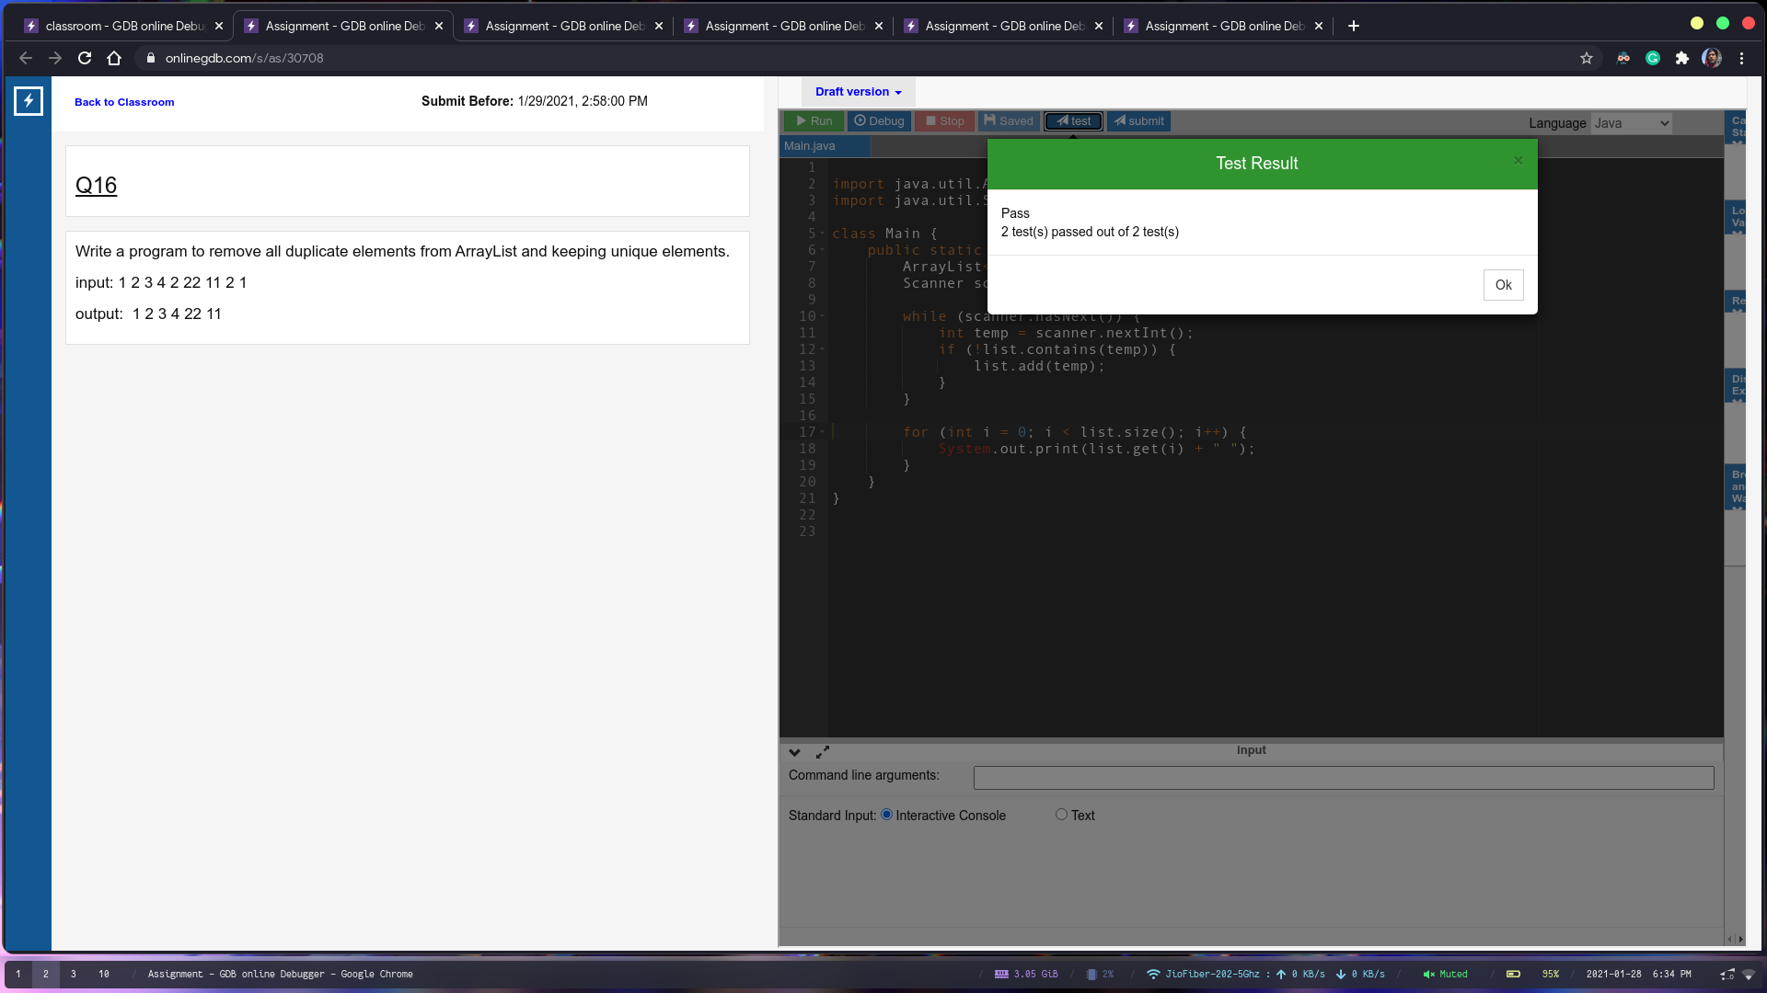

Q17:

import java.util.Scanner;

import java.util.ArrayList;

import java.util.Comparator;

class Main {

public static void main(String[] args) {

ArrayList<Integer> list = new ArrayList<Integer>();

Scanner scanner = new Scanner(System.in);

while (scanner.hasNext()) {

int temp = scanner.nextInt();

list.add(temp);

}

list.sort(Comparator.naturalOrder());

for (int i = 0; i < list.size(); i++) {

System.out.print(list.get(i) + " ");

}

}

}

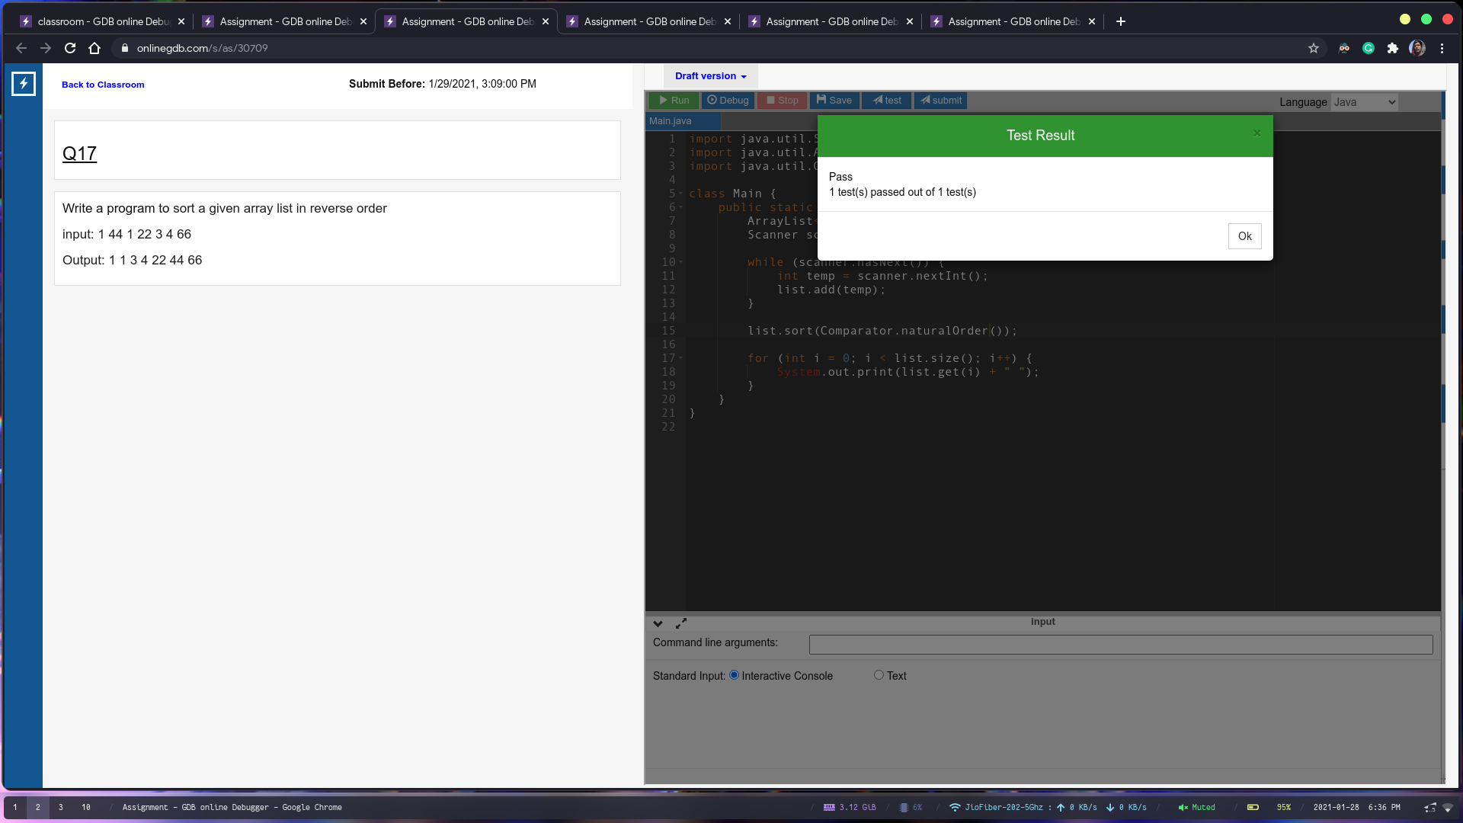

Q18:

import java.util.\*;

class Main {

public static void main(String args[]) {

LinkedList<Integer> list = new LinkedList<Integer>();

list.add(1);

list.add(2);

list.add(3);

list.add(4);

list.add(5);

Scanner sc = new Scanner(System.in);

System.out.println(list);

System.out.println("Enter index and value:");

int i = sc.nextInt();

int v = sc.nextInt();

list.add(i, v);

System.out.println(list);

}

}

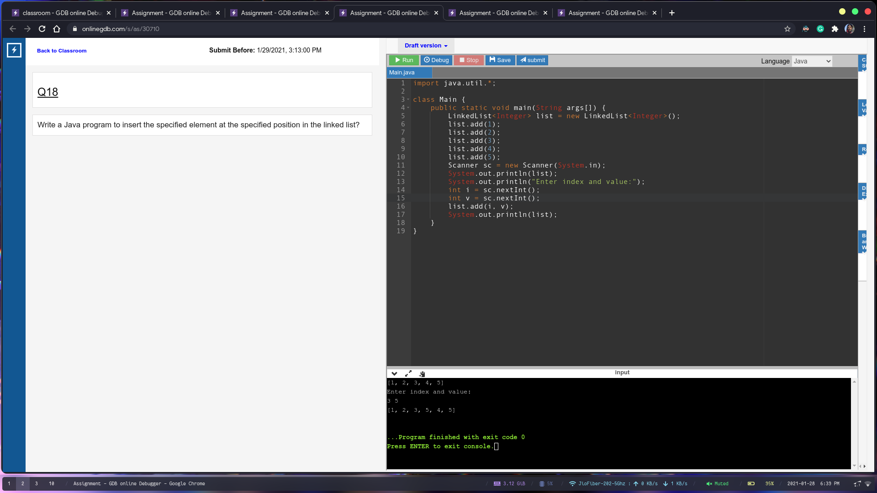

Q19

import java.util.LinkedList;

import java.util.Scanner;

class Main {

public static void main(String[] args) {

LinkedList<Integer> list = new LinkedList<Integer>();

Scanner sc = new Scanner(System.in);

list.add(1);

list.add(2);

list.add(3);

list.add(4);

list.add(5);

System.out.println(list);

LinkedList<Integer> newList = new LinkedList(list);

newList.removeFirst();

newList.removeLast();

System.out.println(newList);

}

}

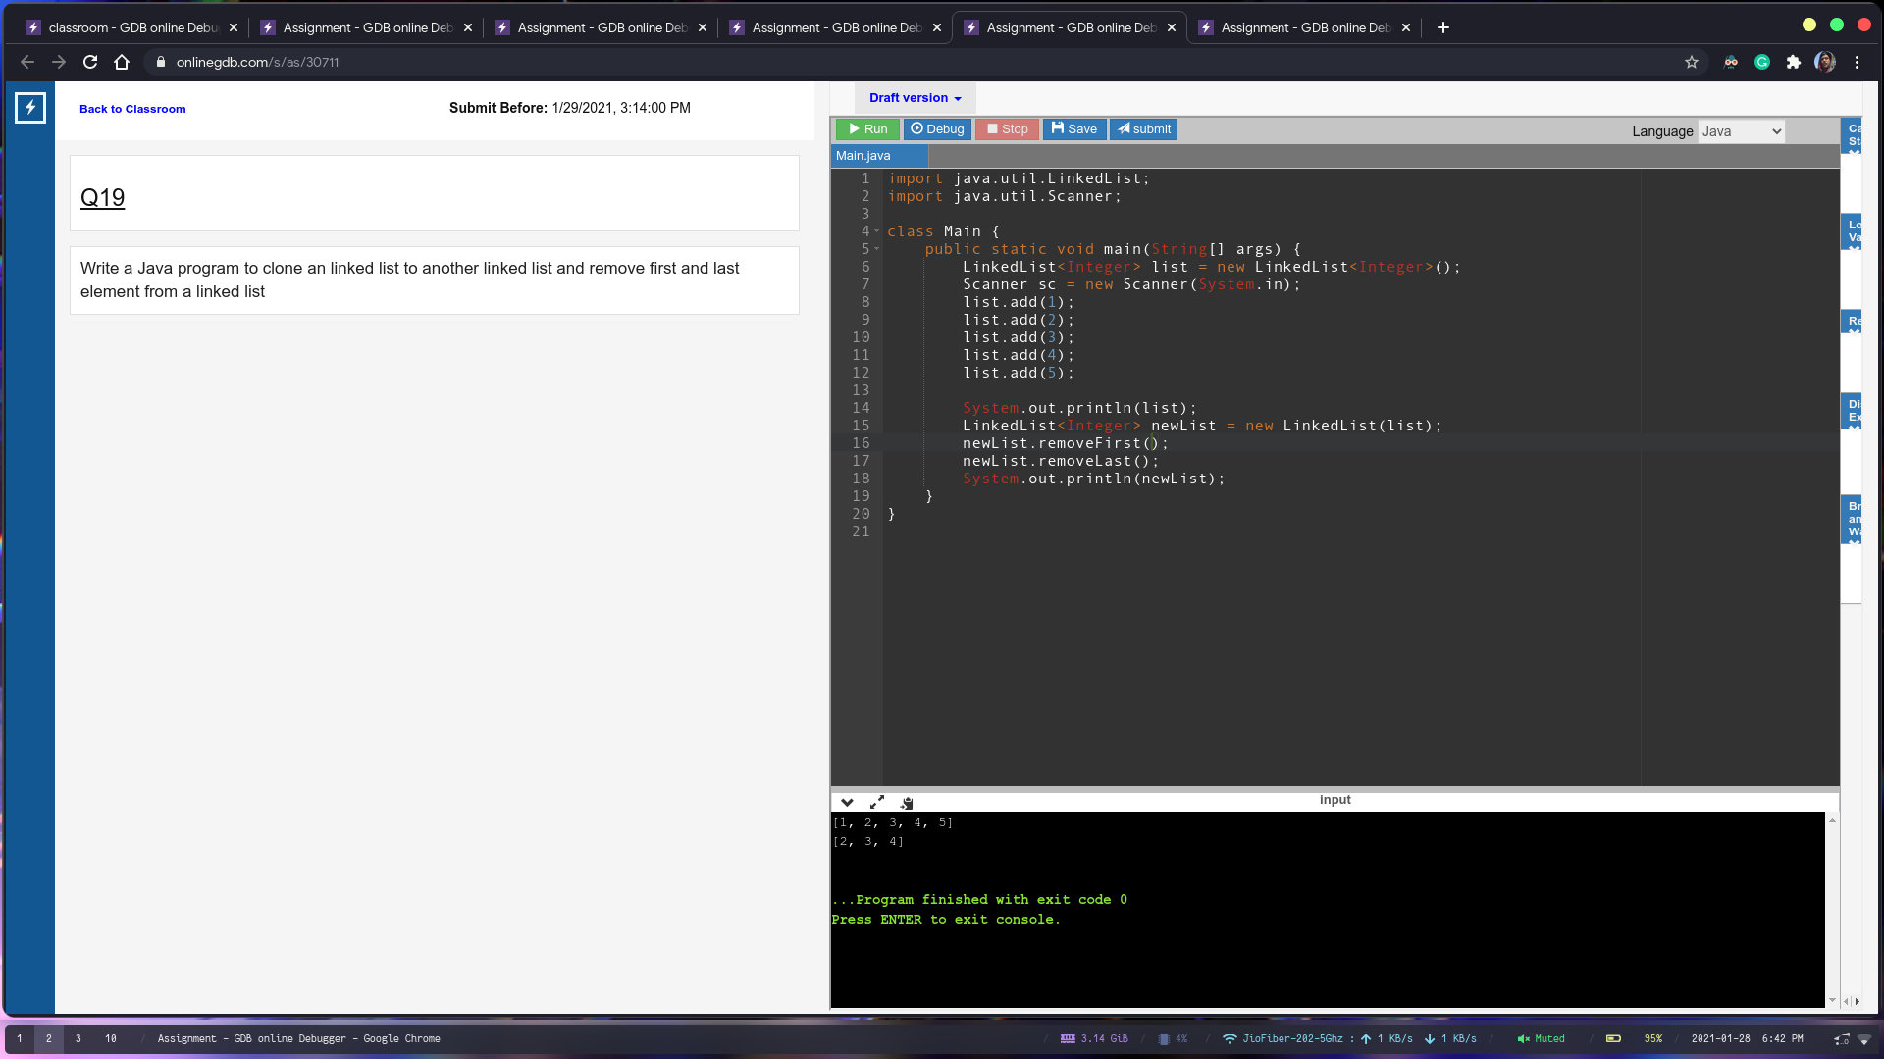

Q20:

import java.util.Scanner;

class Main {

public static void main(String[] args) {

Scanner sc = new Scanner(System.in);

int size = sc.nextInt();

int[] arr = new int[size];

for (int i = 0; i < size; i++) {

arr[i] = sc.nextInt();

}

for(int i = 0; i < size; i++) {

for(int j = 1; j < (size-i); j++) {

if(arr[j-1] > arr[j]) {

int temp = arr[j-1];

arr[j-1] = arr[j];

arr[j] = temp;

}

}

}

for (int i = 0; i < size; i++) {

System.out.print(arr[i] + " ");

}

}

}

