199303069

Hardik Srivastava

Q20:

import java.util.Scanner;

class Main {

public static void main(String[] args) {

Scanner sc = new Scanner(System.in);

int size = sc.nextInt();

int[] arr = new int[size];

for (int i = 0; i < size; i++) {

arr[i] = sc.nextInt();

}

for(int i = 0; i < size; i++) {

for(int j = 1; j < (size-i); j++) {

if(arr[j-1] > arr[j]) {

int temp = arr[j-1];

arr[j-1] = arr[j];

arr[j] = temp;

}

}

}

for (int i = 0; i < size; i++) {

System.out.print(arr[i] + " ");

}

}

}

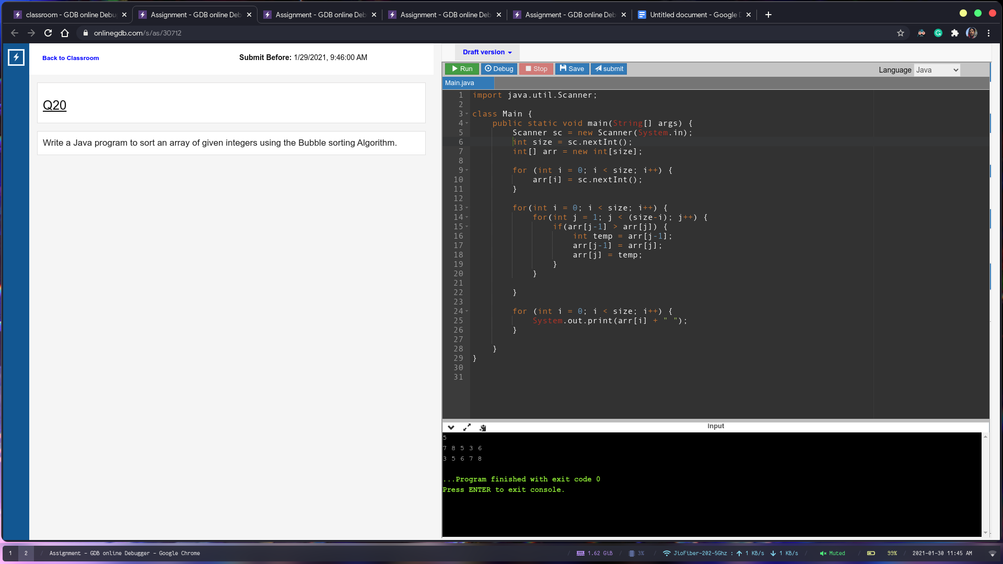

Q21

import java.util.Scanner;

class Main {

private static boolean isCyclic(long N) {

long num = N;

int count = 0;

int digit = (int)(num % 10);

boolean allSame = true;

while (num > 0) {

count++;

if (num % 10 != digit)

allSame = false;

num = num / 10;

}

if (allSame == true)

return false;

if (count % 2 == 0) {

long halfPower = (long)Math.pow(10, count / 2);

long firstHalf = N % halfPower;

long secondHalf = N / halfPower;

if (firstHalf == firstHalf && isCyclic(firstHalf))

return false;

}

num = N;

while (true) {

long rem = num % 10;

long div = num / 10;

num = (long)(Math.pow(10, count - 1)) \* rem + div;

if (num == N)

break;

if (num % N != 0)

return false;

}

return true;

}

public static void main(String[] args) {

Scanner sc = new Scanner(System.in);

long N = sc.nextLong();

sc.close();

if (isCyclic(N))

System.out.print("yes");

else

System.out.print("no");

}

}

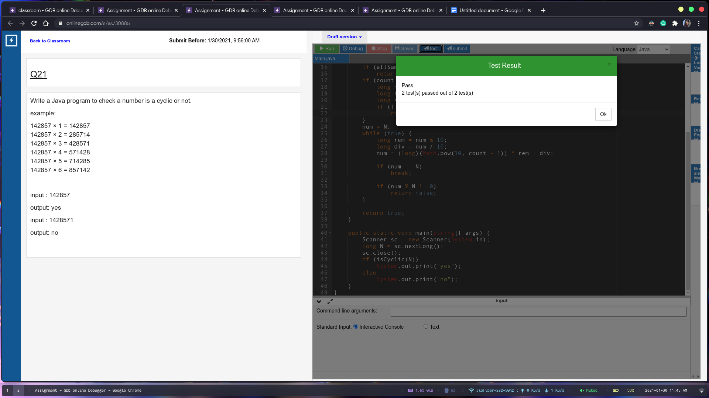

Q22:

import java.util.Scanner;

import java.util.StringTokenizer;

class Main {

public static void main(String[] args) {

Scanner sc = new Scanner(System.in);

String s1 = sc.nextLine().trim();

String s2 = sc.nextLine().trim();

StringTokenizer st = new StringTokenizer(s1);

while (st.hasMoreTokens()) {

if (s2.contains(st.nextToken())) {

System.out.println("true");

return;

}

}

System.out.println("false");

}

}

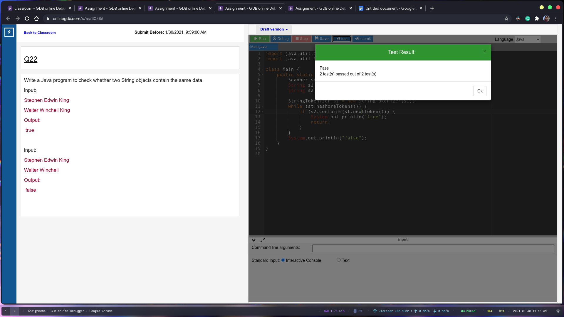

Q23 :

class Animal{

void walk(){

System.out.println("I am walking");

}

}

class Bird extends Animal {

void fly() {

System.out.println("I am flying");

}

void sing() {

System.out.println("I am singing");

}

}

class Solution{

public static void main(String[] args){

Bird bird = new Bird();

bird.walk();

bird.fly();

bird.sing();

}

}

public class Main {

public static void main(String[] args) {

new Solution().main(new String[1]);

}

}

