199303069

Hardik Srivastava

Q24

class Sports{

String getName() {

return "Generic Sports";

}

void getNumberOfTeamMembers() {

System.out.println("Each team has n players in " + getName());

}

}

class Soccer extends Sports{

@Override

String getName(){

return "Soccer Class";

}

@Override

void getNumberOfTeamMembers() {

System.out.println( "Each team has 11 players in " + getName() );

}

}

class Main {

public static void main (String[] args) {

Soccer soccer = new Soccer();

soccer.getNumberOfTeamMembers();

}

}

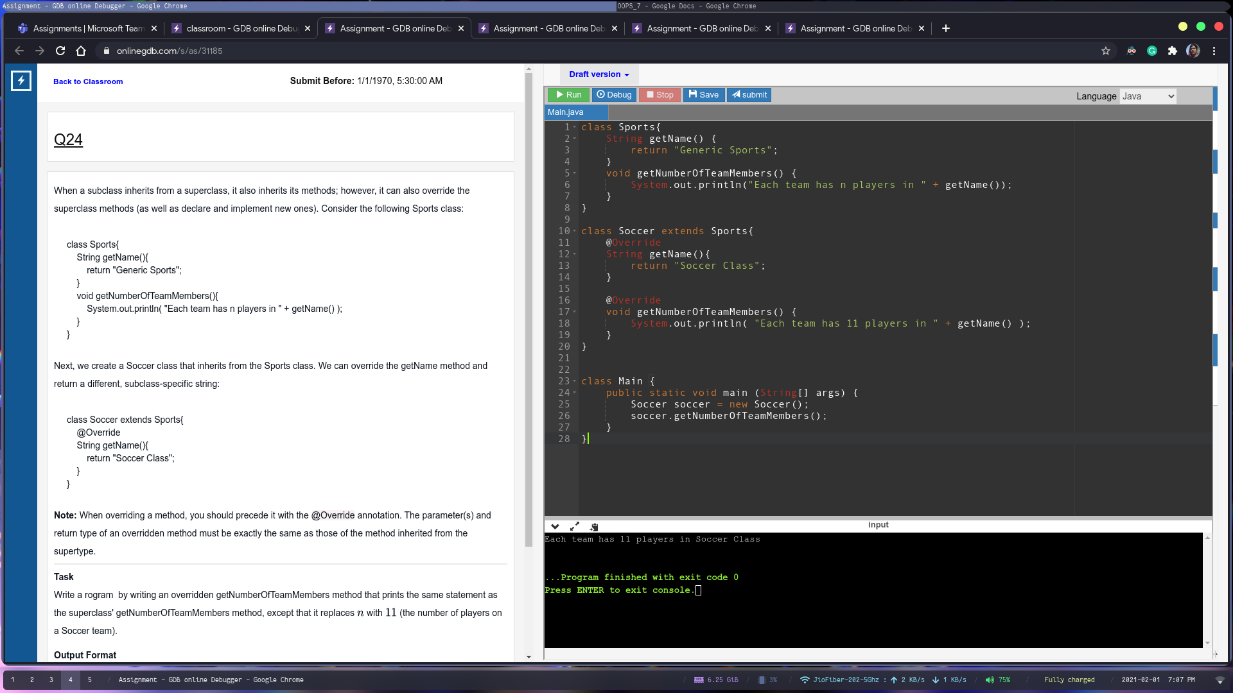

Q25

import java.util.Scanner;

class Main {

public static void main (String[] args) {

Scanner sc = new Scanner(System.in);

int a1 = sc.nextInt();

int a2 = sc.nextInt();

int a3 = 180 - (a1 + a2);

int[] angles = new int[3];

angles[0] = larger(a1, larger(a2, a3));

angles[2] = smaller(a1, smaller(a2, a3));

angles[1] = (a1 + a2 + a3) - angles[0] - angles[2];

if (angles[0] == 90) {

System.out.println("Right angled triangle");

}

else if (angles[0] < 90) {

System.out.println("Acute angled triangle");

}

else {

System.out.println("Obtuse angled triangle");

}

}

private static int larger(int a, int b) {

if (a > b) {

return a;

}

else {

return b;

}

}

private static int smaller(int a, int b) {

if (a < b) {

return a;

}

else {

return b;

}

}

}

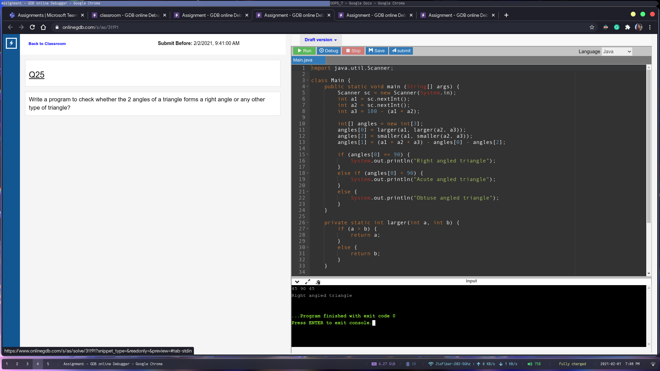

Q26

import java.util.Scanner;

class Main {

public static void main(String[] args) {

Scanner sc = new Scanner(System.in);

int n = sc.nextInt();

String s = n + "";

int arr[] = new int[s.length()];

for (int i = 0; i < s.length(); i++) {

int t = n % 10;

n = n / 10;

arr[i] = t;

}

for (int i = 0; i < s.length(); i++) {

for (int j = 1; j < (s.length() - i); j++) {

if (arr[j - 1] > arr[j]) {

int temp = arr[j - 1];

arr[j - 1] = arr[j];

arr[j] = temp;

}

}

}

for (int i = 0; i < s.length(); i++) {

System.out.print(arr[i]);

}

}

}

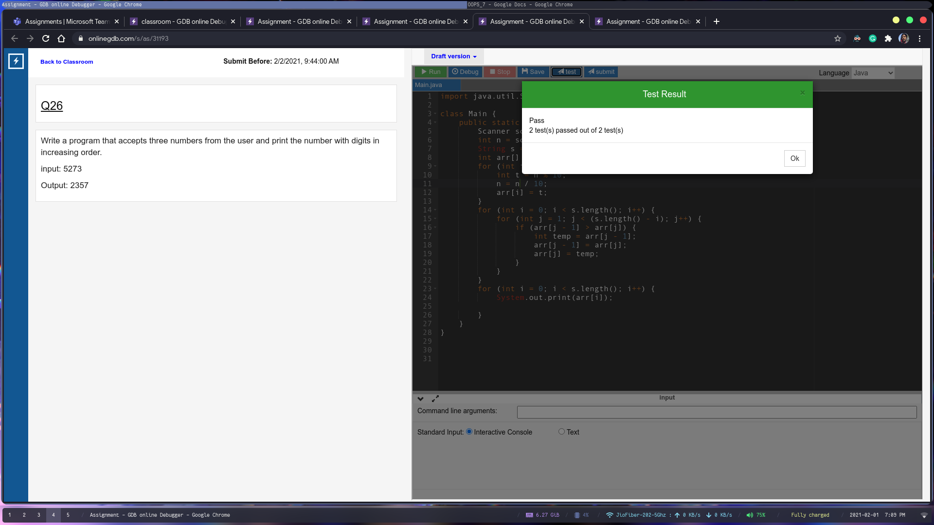

Q27

import java.util.Scanner;

class Main {

public static void main (String[] args) {

sum("12345678");

}

private static void sum(String s) {

if (s.length() == 0) {

return;

}

if (s.length() == 1) {

return;

}

int d1 = Integer.parseInt(s.charAt(0) + "");

int d2 = Integer.parseInt(s.charAt(s.length() - 1) + "");

System.out.println(d1 + " + " + d2 + " = " + (d1 + d2));

sum(s.substring(1, s.length() -1 ));

}

}

