199303069

Hardik Srivastava

Q28

class Main {

public static void main (String[] args) {

for (int i = 1; i <= 50; i++) {

System.out.print(calc(i) + "\t");

if (i % 10 == 0) {

System.out.println();

}

}

}

private static int calc(int n) {

int v = ((3\*n\*n) - n)/2;

return v;

}

}

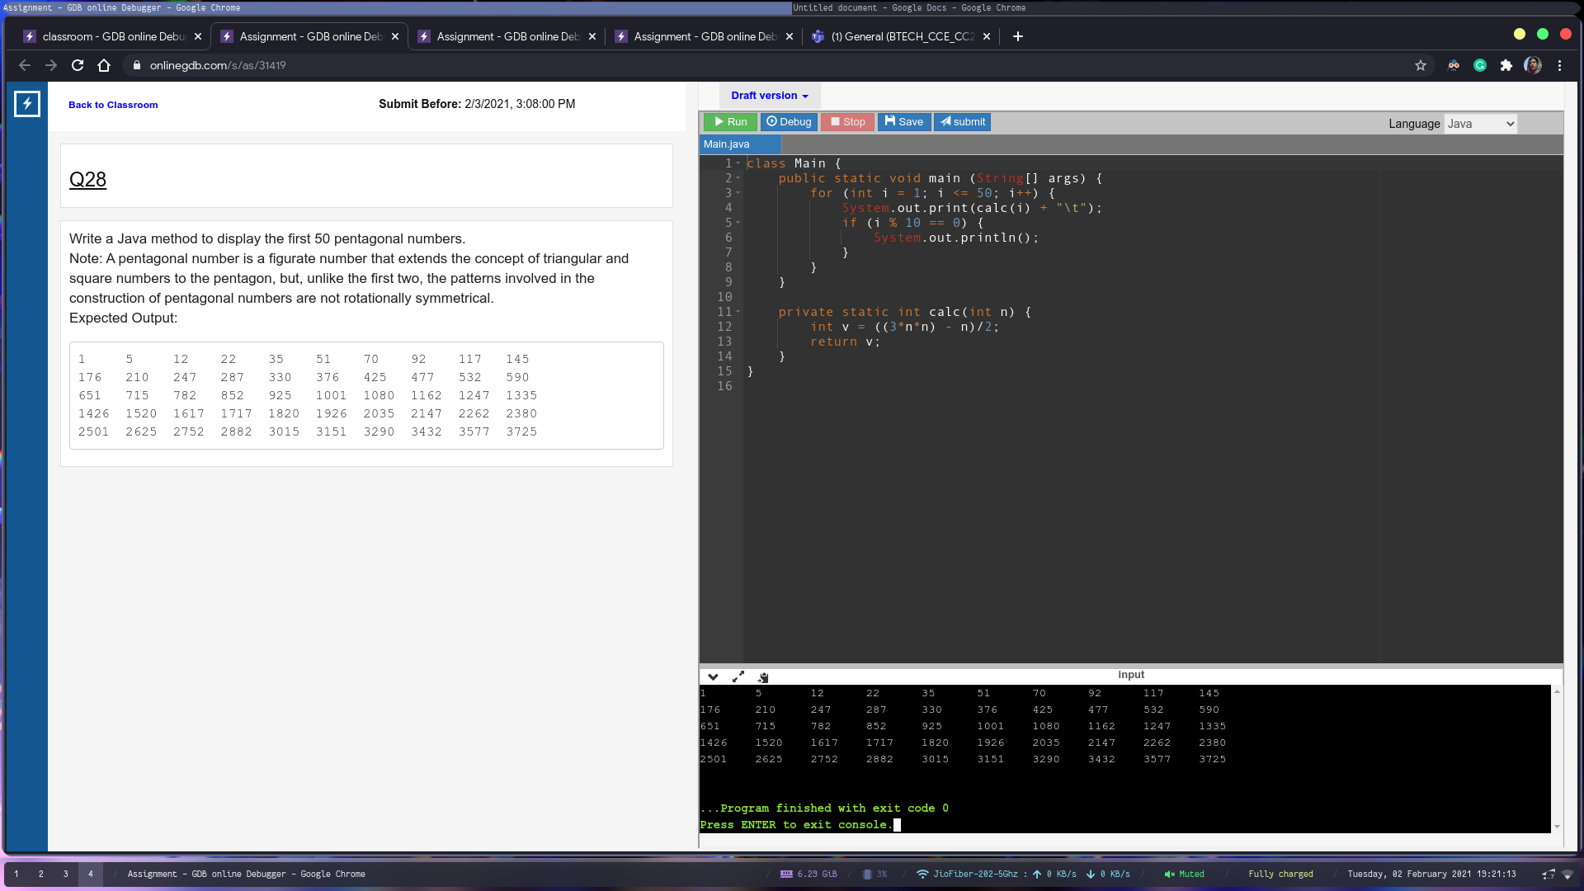

Q29

class Main {

public static void main (String[] args) {

if (isValid("hellohello32")) {

System.out.println("Valid");

}

}

private static boolean isValid(String s) {

if (s.length() < 10) {

return false;

}

String valid = "abcdefghijklmnopqrstuvwxyz0123456789";

String digits = "0123456789";

int digitCount = 0;

for (int i = 0; i < s.length(); i++) {

char c = s.charAt(i);

c = Character.toLowerCase(c);

if (digits.indexOf(c) != -1) {

digitCount++;

}

if (valid.indexOf(c) == -1) {

return false;

}

}

if (digitCount < 2) {

return false;

}

return true;

}

}

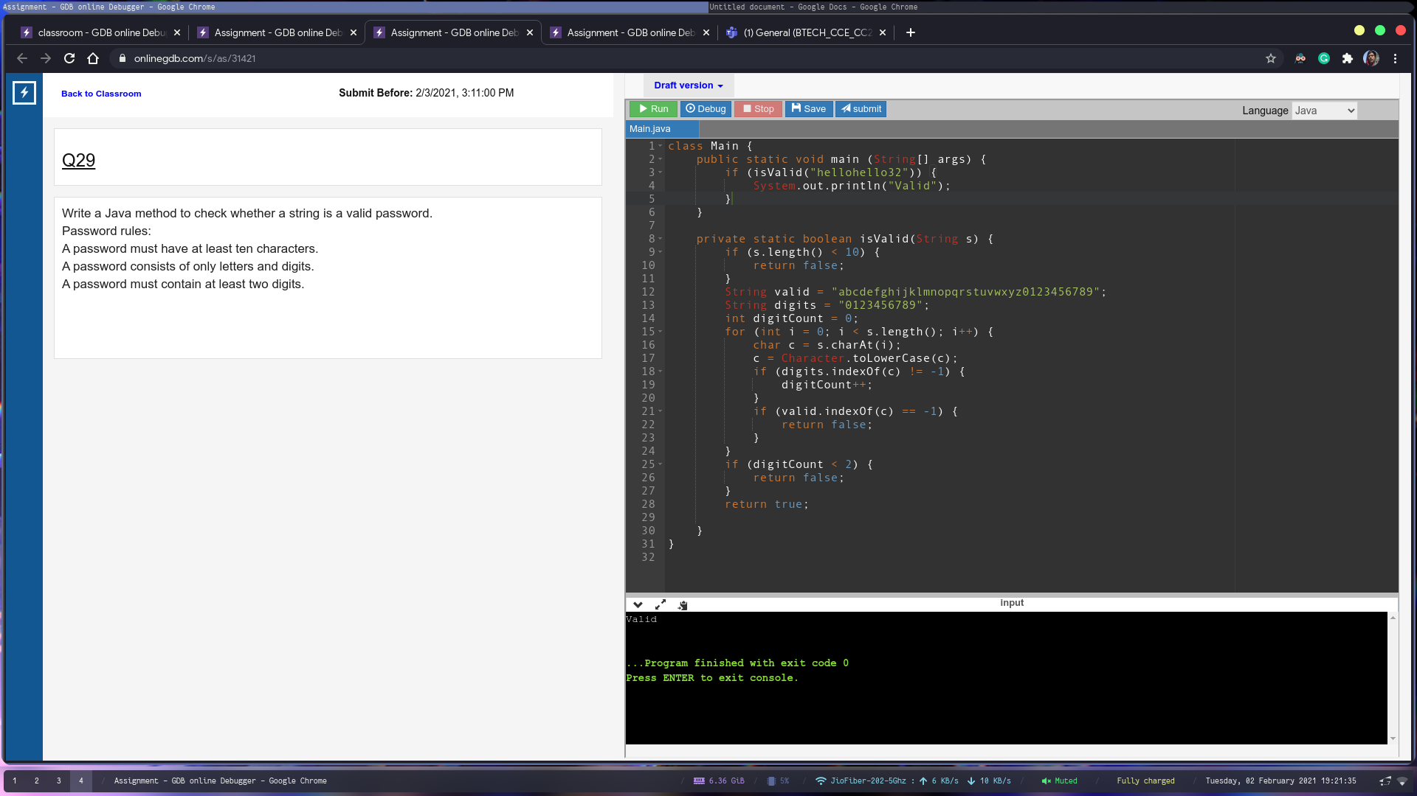

Q30

import java.util.Scanner;

class Main {

public static void main (String[] args) {

Scanner sc = new Scanner(System.in);

int side = sc.nextInt();

int len = sc.nextInt();

double area = (5.0 / 2) \* side \* len;

System.out.println(area);

}

}

