199303069

Hardik Srivastava

Q31

import java.util.Scanner;

class Main {

public static void main (String[] args) {

Scanner sc = new Scanner(System.in);

int n = sc.nextInt();

for (int i = 2; i < n; i++) {

if (n%i == 0 && isPrime(i)) {

System.out.println(i);

}

}

}

private static boolean isPrime(int n) {

for (int i = 2; i < n; i++) {

if (n%i == 0) {

return false;

}

}

return true;

}

}

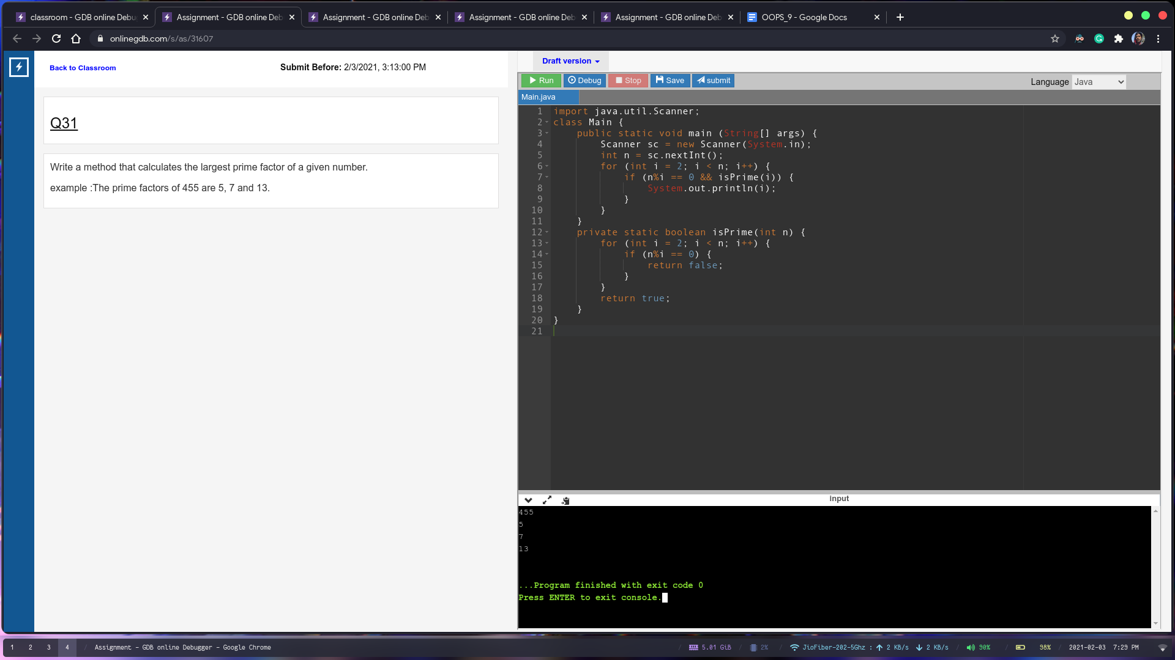

Q32

class Main {

public static void main (String[] args) {

System.out.println(getNumberSmallBags(101, 1, 502));

}

private static Integer getNumberSmallBags(Integer big, Integer small, Integer goal) {

int result = -1;

if (big \* 5 >= goal) {

if (small >= goal % 5)

result = goal % 5;

}

else {

if (small >= goal - big \* 5) {

result = goal - big \* 5;

}

}

return result;

}

}

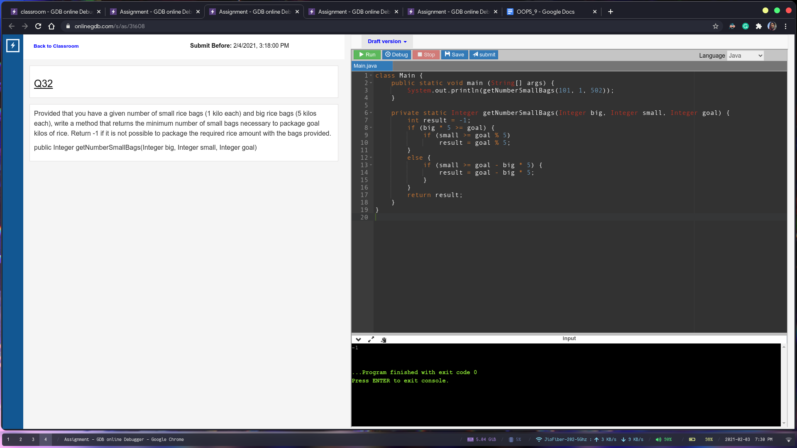

Q33

import java.util.\*;

class Main {

public static void main (String[] args) {

ArrayList<String> list = new ArrayList<String>();

list.add("abc");

list.add("Abc");

list.add("ab");

ArrayList<String> custom = check(list);

for (int i = 0; i < custom.size(); i++) {

System.out.println(custom.get(i));

}

}

private static ArrayList<String> check(ArrayList<String> list) {

ArrayList<String> custom = new ArrayList<String>();

for (int i = 0; i < list.size(); i++) {

if (list.get(i).length() == 3 && list.get(i).charAt(0) == 'a') {

custom.add(list.get(i));

}

}

return custom;

}

}

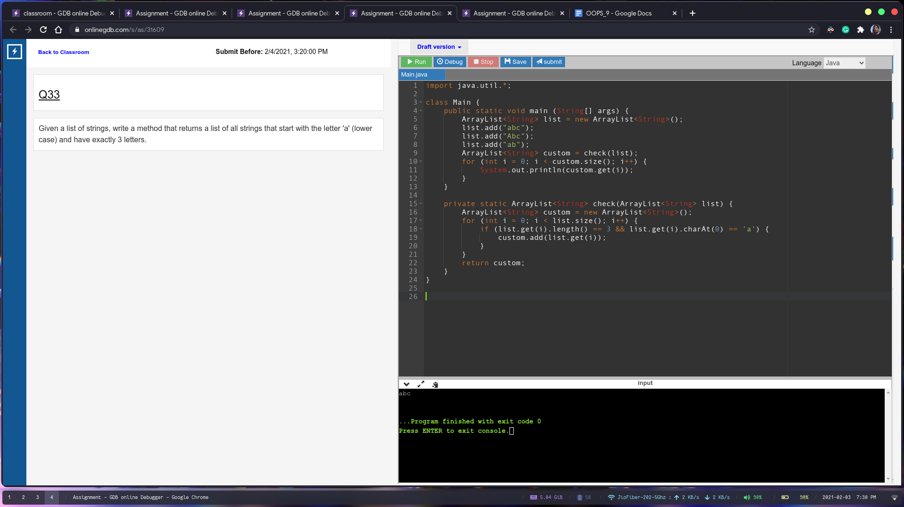

Q34

import java.util.\*;

class Main {

public static void main (String[] args) {

ArrayList<String> list = new ArrayList<String>();

list.add("abc");

list.add("Abc");

list.add("ab");

ArrayList<String> custom = check(list);

for (int i = 0; i < custom.size(); i++) {

System.out.println(custom.get(i));

}

}

private static ArrayList<String> check(ArrayList<String> list) {

ArrayList<String> custom = new ArrayList<String>();

for (int i = 0; i < list.size(); i++) {

if (list.get(i).length() == 3 && list.get(i).charAt(0) == 'a') {

custom.add(list.get(i));

}

}

return custom;

}

}

