199303069

Hardik Srivastava

Q1

import java.util.Scanner;

public class Main {

public static void main(String[] args) {

Scanner scanner = new Scanner(System.in);

double[] sgpa = new double[6];

double total = 0;

for (int i = 0; i < sgpa.length; i++) {

sgpa[i] = scanner.nextDouble();

total += sgpa[i];

if (sgpa[i] < 0 || sgpa[i] > 10) {

System.out.println("-1");

return;

}

}

total = total/6.0;

if (total >= 6) {

System.out.println("1");

}

else {

System.out.println("0");

}

}

}

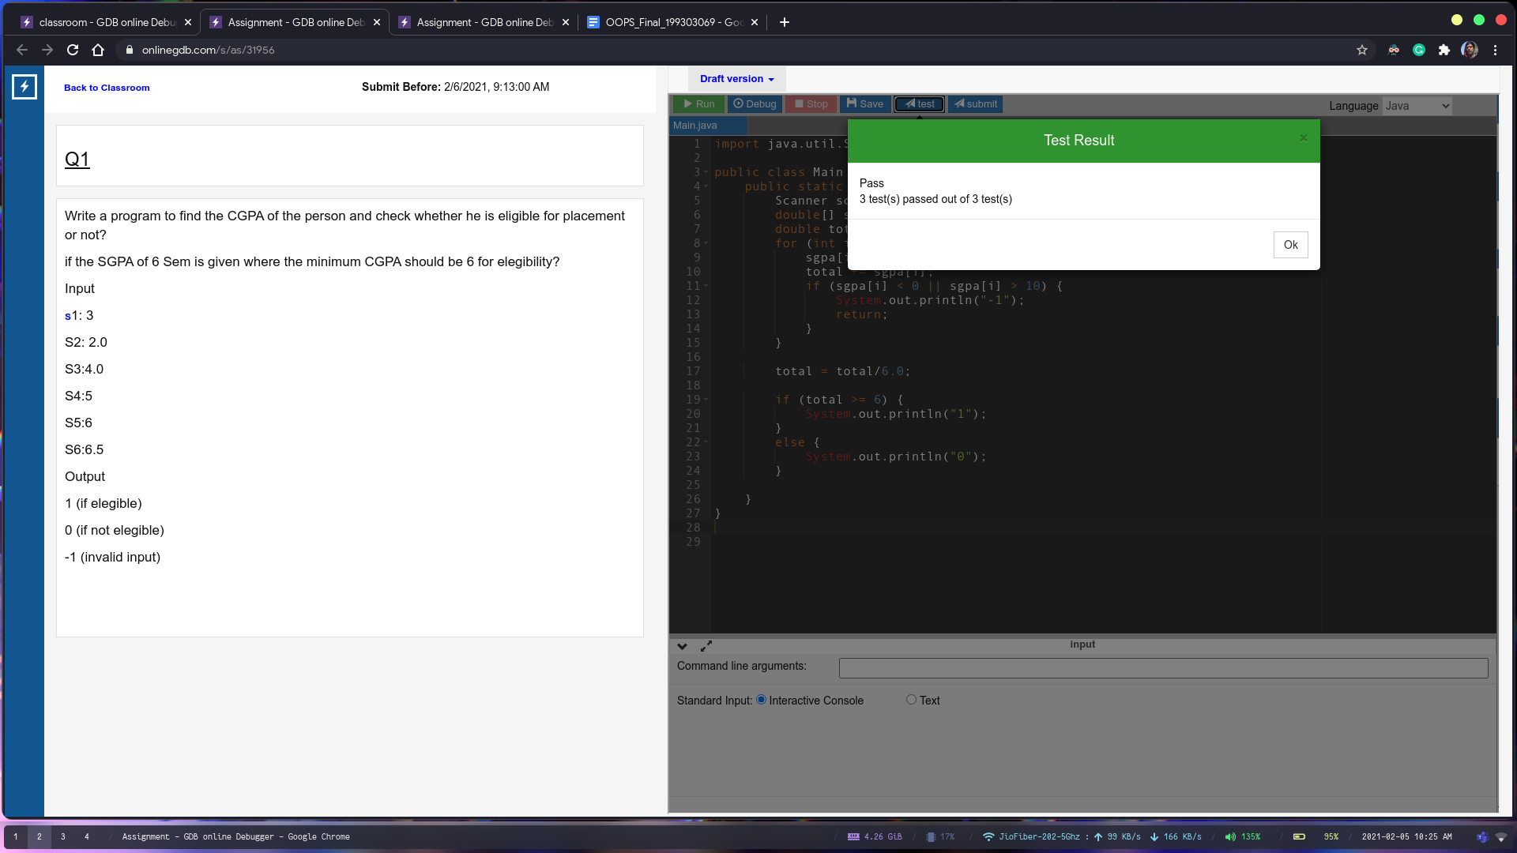

Q2

import java.util.Scanner;

public class Main {

public static void main(String[] args) {

Scanner scanner = new Scanner(System.in);

String input1 = scanner.next();

String input2 = scanner.next();

String smaller = (input1.length() < input2.length())? input1 : input2;

String match = "0";

int max = smaller.length();

int cur = 2;

while (cur <= max) {

int i = 0;

while ((i+cur) <= max) {

String check = smaller.substring(i, i+cur);

if (input1.contains(check) && input2.contains(check) && check.length() > match.length()) {

match = check;

}

i++;

}

cur++;

}

System.out.println(match);

}

}

