Note: This was the version by Nathan and Yigit for the first design doc project milestone, and was given to me (David) in DOC format. This is post-conversion, pre-editing, and saved only for archival and future design purposes.

Battlestar
Documentation

Team 11
David Gay
Scott Gunther
Yigit Katkici
Nathan Osborn

April 22, 2012
unaccepted Revision 0.1
Table of Contents
Change Log 3
Executive Overview 4
Audience 5
Assumptions 6
Gantt Chart 7
Program Overview 8
UML Diagram 11
Screenshots 12
Protocols 13
TODO 16
To do: 16
Done: 17
Issues 18
License 19

Change Log
Preferrably, changes are referenced through the git repo log on GitHub. However, this project also requires that we maintain this change log, especially since most team members don't know git. This log lists significant project changes.

Commit history: https://github.com/oddshocks/battlestar/commits/master/

Member | Date | Message | Version
David Gay | April 11, 2012 | Created repo | Design
David Gay | April 17, 2012 | Created design doc | Design
Nathan Osborn | April 19, 2012 | Edited design doc | Design
Yigit Katkici | April 22, 2012 | Edited document / finalize | Design

Executive Overview

This project is a two player turn based game on the popular TV show Battlestar Galactica. One player represents the human race, the other represents the Cylons (human created beings bent on destroying the human race). The Cylons have launched an attack on the humans and destroyed all 12 of the remaining human colonies. Earth is the remaining colony, so the goal of the human player is to reach Earth safely. The goal of the Cylon’s is to destroy all humans. This turn based game features 2 fields of play. The first is a galaxy map that each player moves their ships over. Once two of the player’s ships overlap on a territory, it switches to the second field of play. This field of play pits players ships against each other in a chess like format. The winner of this battle gets control of the territory, and the loser’s ship is destroyed. VIP’s are placed by each team on ships of their choosing, and if all of a team’s VIP’s are destroyed, that team loses. Besides this, other events can occur outside of either player’s control. These random events give one player an extra edge, giving a little spontaneity to the game.

Audience

You who should be reading this should be some interested programmers wondering how we went about designing this game!! Hopefully the language in this document is of sufficient skill level, and by reading this you get a good feel for how we did our project. We plan to have an audience who are actual Battle Star Galactica Fans but anyone who are able to read the instructions can learn and play this game.

Assumptions

It is likely that we need to grasp all aspects of the game before going ahead to create it in our program. For this purpose we made sketches onto papers to create the game in real life. That gave us the levitation to make right assumptions and actually made us understand how the game works.

Since the game is going to be multiplayer, we needed to add network functionality. This required us to implement a server and a client. Client would send information after each turn and the server would crunch those numbers and put the pieces in right parts or start the battle sequence if necessary.

Another assumption we can make is that a player who just opened this game will have no idea where to begin or how to play the game. We will include a how to document that will be accessible through our menu that will explain rules and perks of the game.

Gantt Chart

The project file is also uploaded with this file.
Battle Star Project.mpp

Program Overview

Project parameter Interface
- Contains Port number constants, used by Client and Server
- Contains window frame width and height
- Contains random number constant
Client
- Main method
  - Detects any player name and port number from start game interface
- Client constructor
  - Create GUI for game board, chat, and player tracks
  - Thread started for writing and reading objects to server
- getVariables method
  - return variables in 3 seconds to user when game started
- ButtonListener class
  - Implements action listener for buttons on the game board items
- StartGameButtonListener
  - Action listener for “start game button”
- ChatListener
  - Create listener for chat button and starts chat thread class
- FileListener class
  - Accepts action event from file menus
Server
- Main method
  - Detects any command line arguments and run the server
- MatchingGameServer constructor
  - Accepts all clients connection and start ClientHandler thread class
  - Creates GUI interface
- randomNumbers
  - generates random numbers, such as dice rolls and places of the player pieces at the beginning of the game.
- getRandomNumbers
  - accessor to get random numbers array
- FileListener
  - Generates action listener for file menu items
  - Run actionPerformed method to run action event for each menu item
- ClientHandler
  - Threads for clients
  - Run object input and output stream for reading and writing messages
- setLogFile
  - set log file in the txt file where server starts and runs

UML Diagram

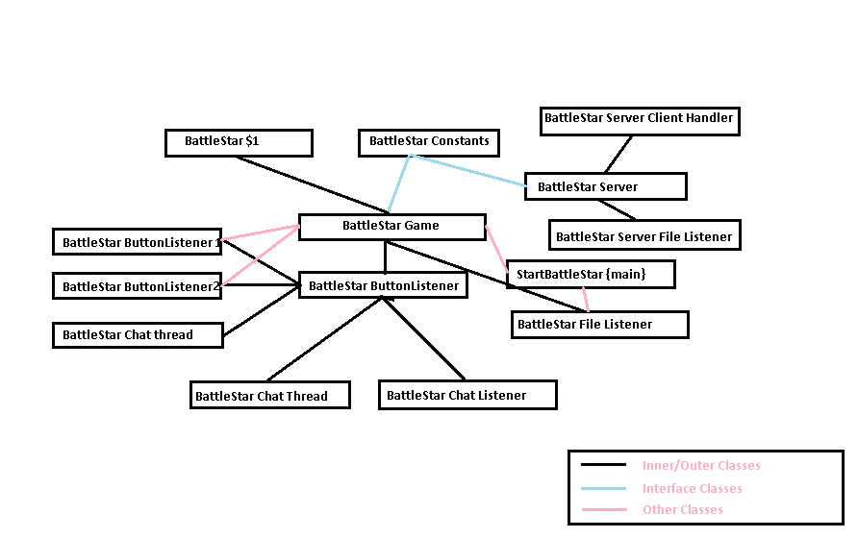

Screenshots
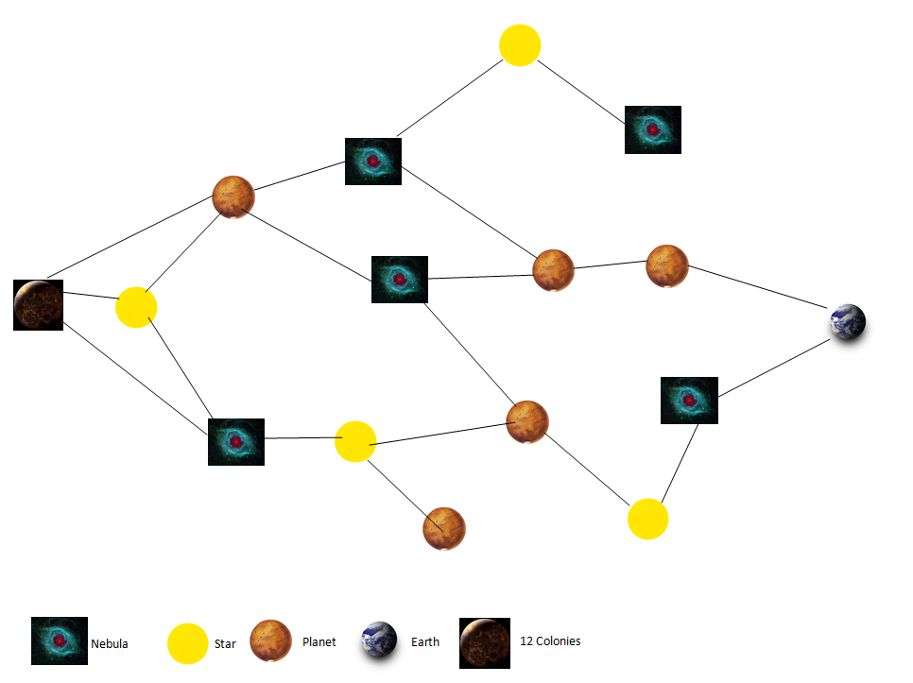

We would like to implement view as the Main Graphical interface and add functionality using mouse actions. Once the player selects his own player we might implement an action which would light the next step so that the player would be aware of his choices. Just to accomplish the requirements of the project we might implement a fight scene which just involves consecutive dice rolls and make it work for the fight. Then we can work on our dual board concept once it is accomplished so that we do not run out time.

Protocols

IP address: IP addresses include any ip address using during communication, multiple clients and servers IP address.
Port number: 16789 is the port number both clients and server use
Protocol interface code for both client and server:
Constant interface for the game
The constant interface will include the number for each planet on the GUI. It will also include the frame width, height, font sizes, font numbers and other constants involving other communication options. Chat thread is created also to listen messages from server simultaneously.

Client / Server Interaction
Here are some details about the Client/Server interaction and how the communication will be established for before and after each move.
Client | Communication | Server
 |  | Startup
Waits for client to connect
Accept connection
Client connection | Connection, no data → | Waits for client to connect  Accept connection
Client reads data and store random numbers | ← <Necessary Info> | Server sends random numbers
Client sends player name | < Necessary Info >→ | Server accepts and adds it into list
Client reads “start” keyword and start to game | ← < Necessary Info > | Server sends “start” message to all connected clients if there is multiple clients.
Client sends message | < Necessary Info >→ | Server accepts message from client and returns this message to all connected clients
Client receives <message> | ← < Necessary Info to [all] client(s)> | Server sends message to client(s)
Client still sending message to server | <message>→ | Server accepts this message
Client still sending message to server | ← <message to all clients> | Server returns this message
Client stops connection to server | ← <over information to all clients> | Server sends message

Data

As starters the project consists of 4 java class files, start matching game, matching, and server log and score file.

StartBattleStar: getting server IP address and player name
BattleStar: creating GUI with game board, chat part, and statically information
BattleStarServer: creating server connection using 16789 port number and keep players tracking for log, player list, and top score
GameConstant: the interface of game constants shared both client and server files.
Serverlog.txt: keep logging in txt file in the same folder with server
Score.txt: tracking players’ scores for the future time.

ServerSocket and Socket connection is used with 16789 port number and any IP address where server installs.

TODO

To do:
- Creating GUI interface based on the design discussed with group members
- Working on the chat communication to embed it into the project
- Creating server interface to create socket connection with clients
- Keeping track of player lists, scores, and displaying sort of score in both client and server lobby
- Creating all shared constants for both client and server in separate interfaces
- Creating entrance of the game to get server IP address and player name

Done:
- Implemented the Chat screen.(Week 4)
- Laid out the rules and finished the game design (Week 5)
- Made a to do list for gameplay and GUI (Week 5)
- Created the design document and project file (Week 5)

Issues

See the issue tracker for bugs, enhancements, feature requests, and the like.

Issue tracker: https://github.com/oddshocks/battlestar/issues

In order to minimize the issues that we can face we started implementing classes with full design and architecture from the beginning. We started as small as possible and laid out future plans of the projects. As we start as atomic as possible problems we face are minimized and we deal with each problem as they come so they do not outgrow our programming abilities.

License

We haven't quite discussed the license yet. Since we're using GitHub, it is assumed that everyone's cool with open source. Leaning toward GNU GPL in the interest of education and freedom.

