Práctica 1: Análisis de Eficiencia de Algoritmos
Curso 2016-2017
Jesús Miguel Jaldo Ruiz
Alberto Ortega Ruiz
Patricia Retamero
Pablo Rey Pedrosa
Juan Manuel Salcedo Serrado

1.INTRODUCCIÓN
De cara al cumplimiento de los objetivos marcados para esta práctica se desarrollará el cálculo de la eficiencia empírica e híbrida para el análisis de los siguientes algoritmos:
- Burbuja.
- Inserción.
- Selección.
- Mergesort.
- Quicksort.
- Heapsort.
- Floyd.
- Fibonacci.
Se ejecutarán versiones de dichos algoritmos en los lenguajes C++ y Python.

2.CARACTERÍSTICAS DEL ORDENADOR USADO
Procesador: Intel(R) Core(TM) i5-4210U CPU @ 1.70GHz x4
Memoria: 8GB
Sistema Operativo: Fedora 24

3.ALGORITMOS DE ORDENACIÓN

3.1.EFICIENCIA O(n²)
Los algoritmos a estudiar en este apartado son: burbuja, inserción y selección.

Eficiencia empírica
Tablas de resultados
Tamaño | Burbuja (C++) | Inserción (C++) | Selección (C++)
1000 | 0.000879541 | 0.000540269 | 0.000553594
10000 | 0.143727 | 0.0568834 | 0.0385964
20000 | 0.655584 | 0.226457 | 0.151688
35000 | 2.13808 | 0.689446 | 0.460826
50000 | 4.43309 | 1.39916 | 0.93838
60000 | 6.44763 | 2.0176 | 1.34969
70000 | 8.76553 | 2.77507 | 1.83878
80000 | 11.4739 | 3.62353 | 2.39648
90000 | 14.49 | 4.58403 | 3.03055
99000 | 17.5868 | 5.52892 | 3.70871

Tamaño | Burbuja (Python) | Inserción (Python) | Selección (Python)
1000 | 0.0649600028992 | 0.0473279953003 | 0.0228400230408
10000 | 6.5684299469 | 5.05886292458 | 2.46224498749
20000 | 26.516505003 | 20.1673858166 | 10.3445651531
35000 | 82.3514251709 | 62.5369391441 | 33.9319210052
50000 | 172.346644163 | 126.830260992 | 71.7569289207
60000 | 254.888651133 | 184.649797916 | 114.514564991
70000 | 354.585552931 | 251.304101944 | 162.101373911
80000 | 500.905437231 | 329.282088995 | 235.244632959
90000 | 620.622777939 | 419.442105055 | 298.314745903
99000 | 767.95497489 | 511.34738493 | 398.60297513

Gráficas de eficiencia empírica(primero C++ y después Python)
- Burbuja
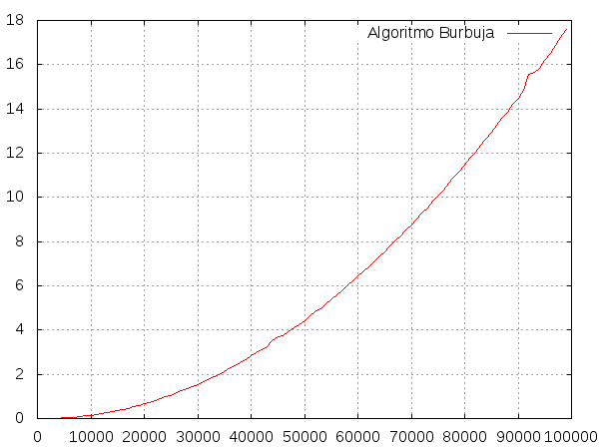
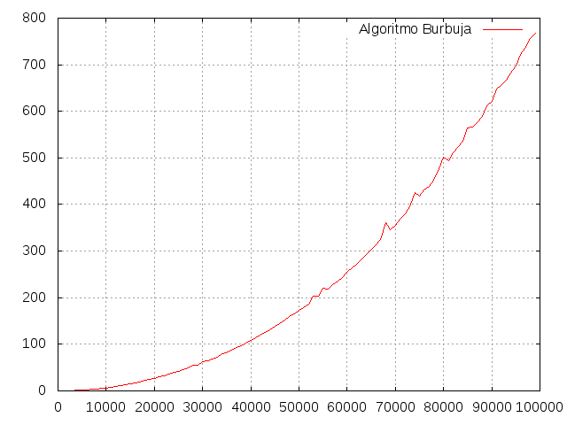

- Inserción
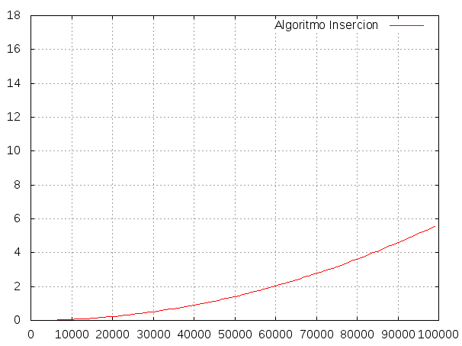
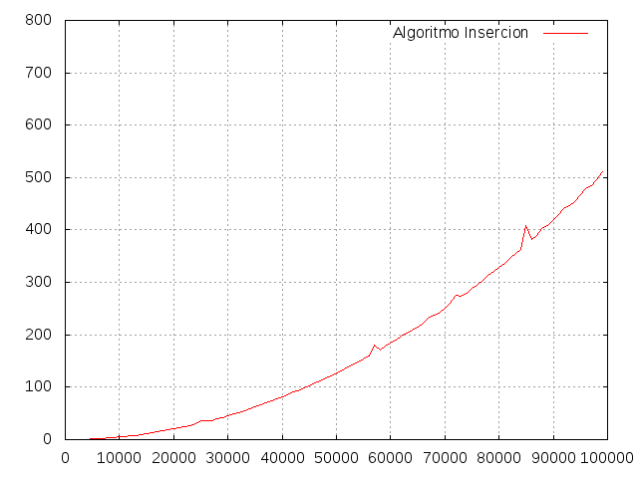

- Selección
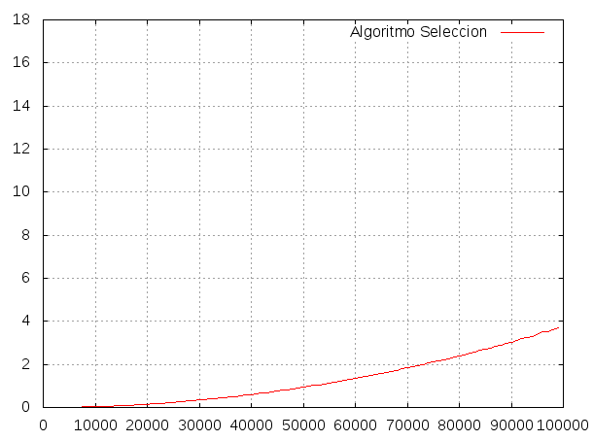

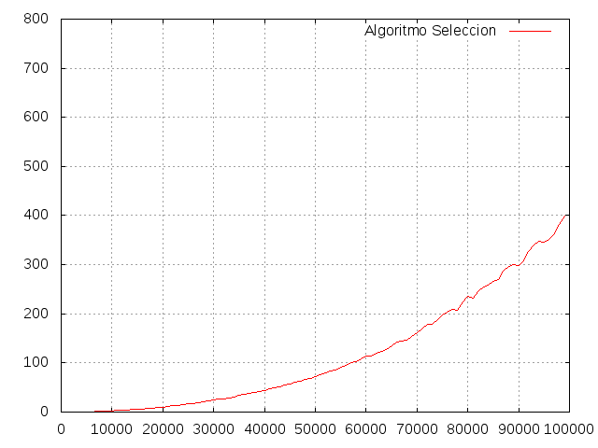

- Comparación
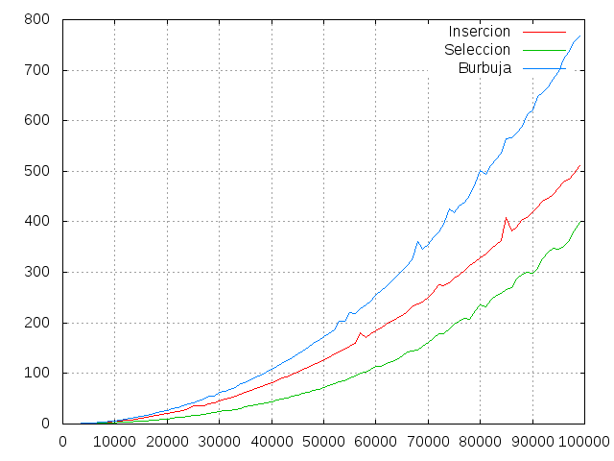
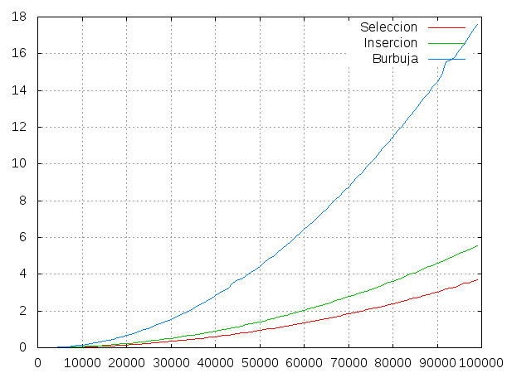

Eficiencia híbrida
Ajustes de las funciones(primero C++ y después Python):
- Burbuja, f(x) = a0*x*x+a1*x+a2
Final set of parameters Asymptotic Standard Error
======================= ==========================
a0 = 1.81597e-09 +/- 6.228e-12 (0.343%)
a1 = -1.52099e-06 +/- 6.428e-07 (42.26%)
a2 = -0.0247509 +/- 0.01393 (56.27%)
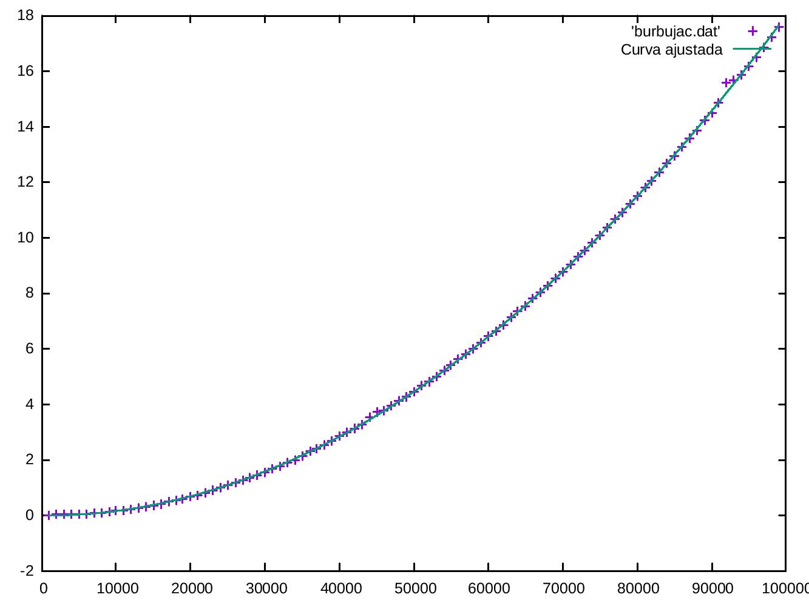

Final set of parameters Asymptotic Standard Error
======================= ==========================
a0 = 8.8213e-08 +/- 7.789e-10 (0.883%)
a1 = -0.00112098 +/- 8.04e-05 (7.172%)
a2 = 10.0479 +/- 1.742 (17.33%)

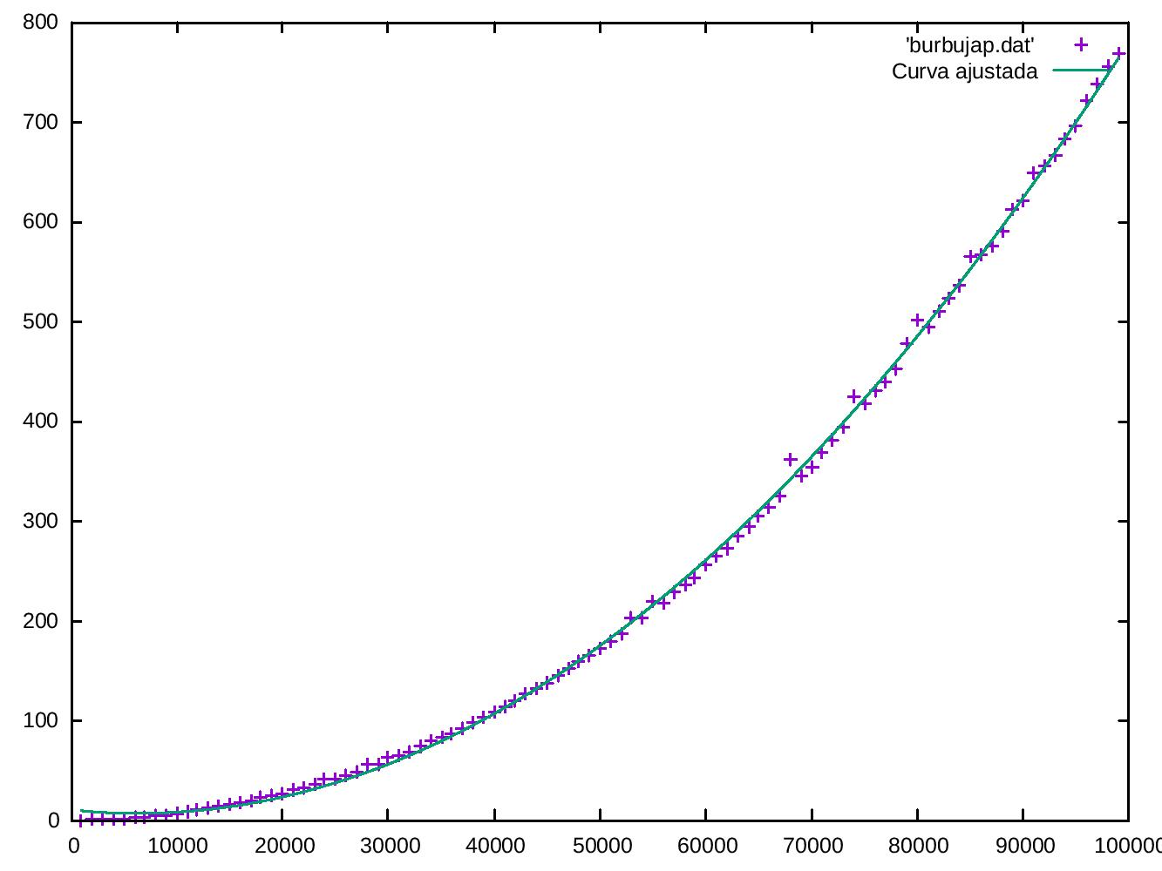

- Inserción, f(x) = a0*x*x+a1*x+a2

Final set of parameters Asymptotic Standard Error
======================= ==========================
a0 = 5.70499e-10 +/- 1.285e-12 (0.2253%)
a1 = -4.40932e-07 +/- 1.326e-07 (30.08%)
a2 = 0.00488587 +/- 0.002874 (58.81%)
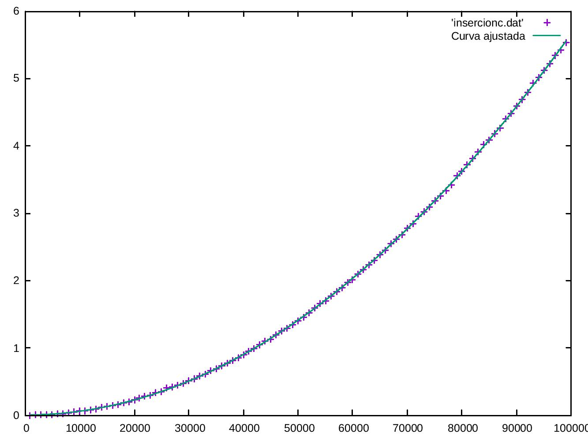

Final set of parameters Asymptotic Standard Error
======================= ==========================
a0 = 5.28341e-08 +/- 5.785e-10 (1.095%)
a1 = -0.000100087 +/- 5.97e-05 (59.65%)
a2 = 0.990415 +/- 1.293 (130.6%)
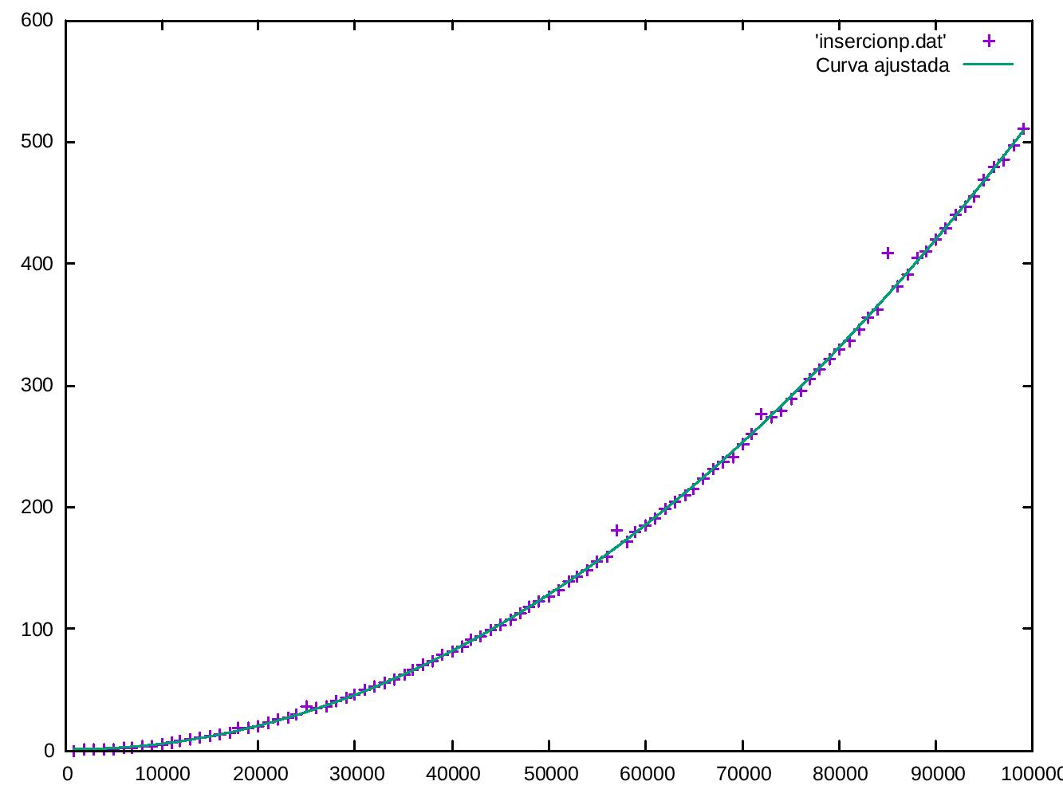
- Selección,f(x) = a0*x*x+a1*x+a2

Final set of parameters Asymptotic Standard Error
======================= ==========================
a0 = 3.77302e-10 +/- 1.081e-12 (0.2866%)
a1 = -2.00618e-07 +/- 1.116e-07 (55.63%)
a2 = 0.00424519 +/- 0.002418 (56.95%)
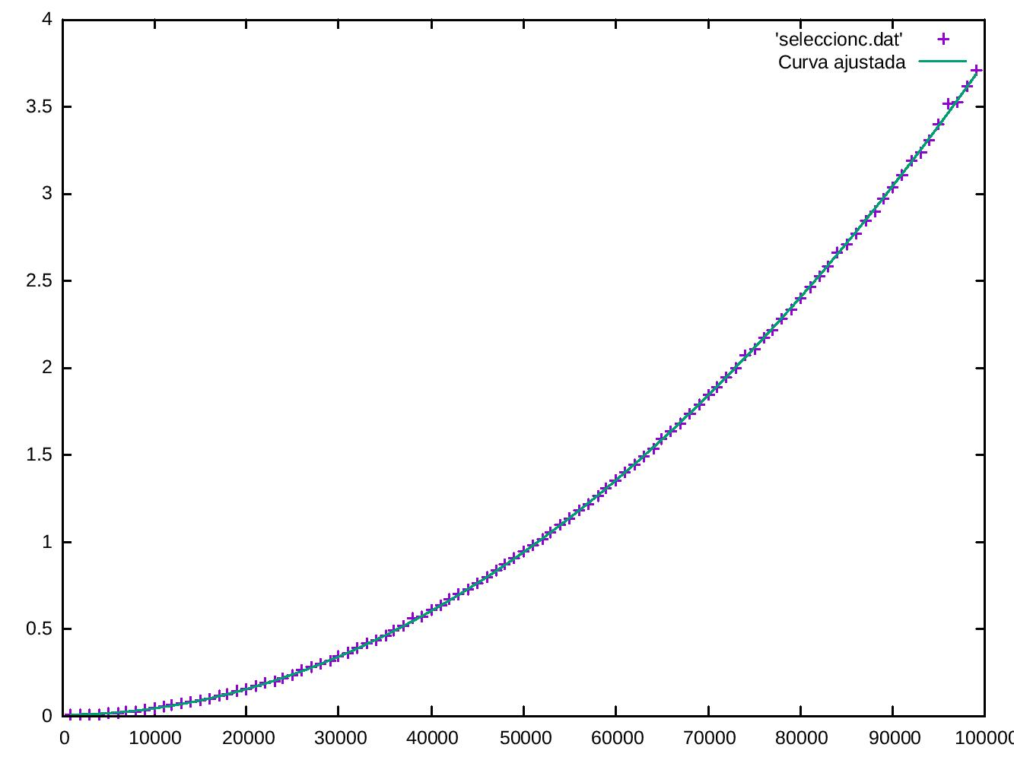

Final set of parameters Asymptotic Standard Error
======================= ==========================
a0 = 5.09563e-08 +/- 7.634e-10 (1.498%)
a1 = -0.00133427 +/- 7.88e-05 (5.906%)
a2 = 12.3991 +/- 1.707 (13.77%)

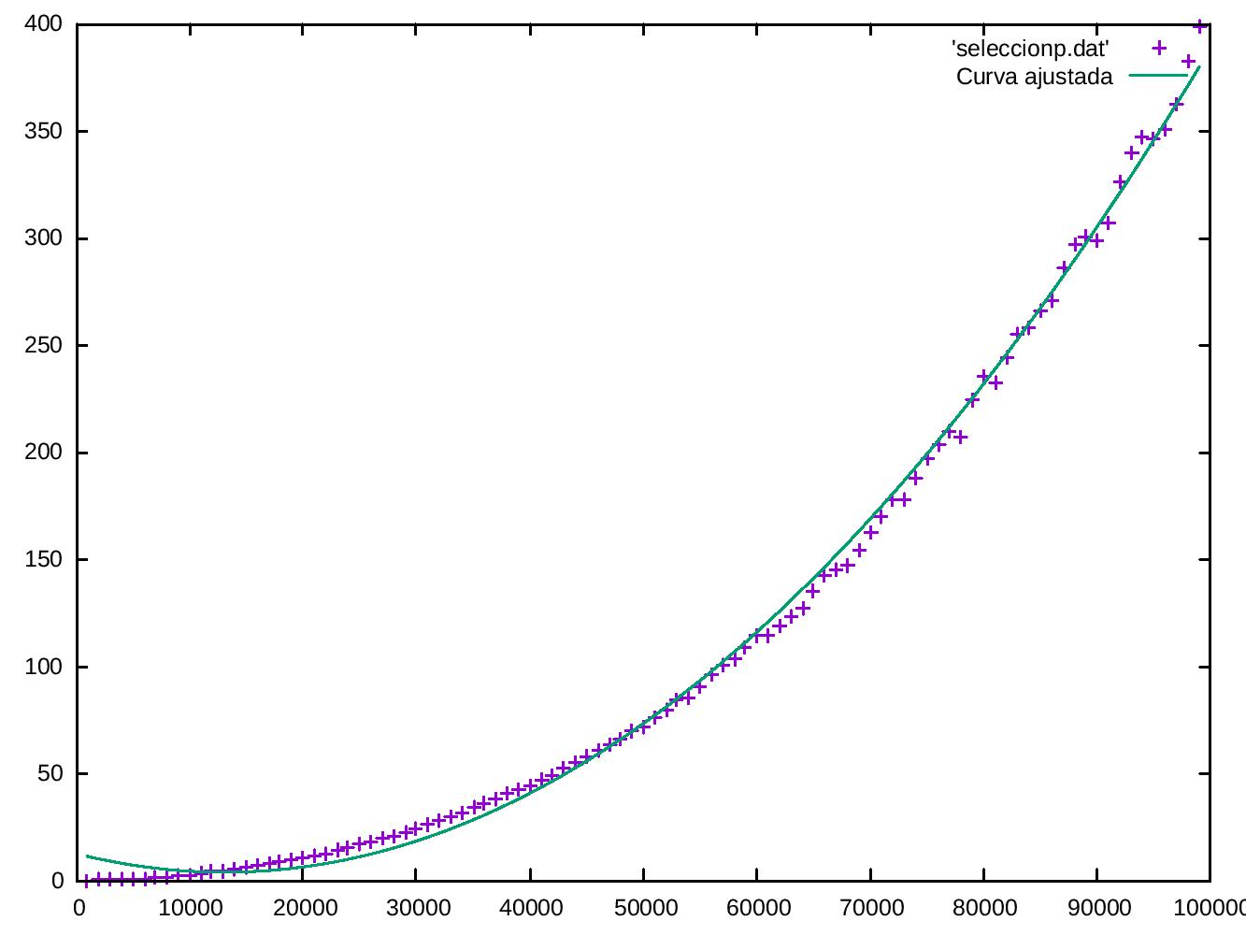

3.2.EFICIENCIA O(n log n)
Los algoritmos a estudiar en este apartado son: mergesort, quicksort, heapsort.

Eficiencia empírica

Tablas de resultados
Tamaño | Mergesort(C++) | Quicksort(C++) | Heapsort(C++)
1000 | 8.6181e-05 | 6.3762e-05 | 0.000172567
10000 | 0.000936577 | 0.000684618 | 0.00157897
20000 | 0.00197736 | 0.00138921 | 0.00201405
35000 | 0.00345 | 0.00249703 | 0.00319122
50000 | 0.00566141 | 0.00362944 | 0.00564161
60000 | 0.00598736 | 0.00455255 | 0.00681114
70000 | 0.00722908 | 0.00518491 | 0.00808251
80000 | 0.00870208 | 0.00603832 | 0.00935919
90000 | 0.0103219 | 0.00697616 | 0.0107161
99000 | 0.0116134 | 0.00759317 | 0.0119418

Tamaño | Mergesort(Python) | Quicksort(Python) | Heapsort(Python)
1000 | 0.00393104553223 | 0.00788998603821 | 0.00400590896606
10000 | 0.0526428222656 | 0.132952213287 | 0.0444979667664
20000 | 0.109836816788 | 0.391301870346 | 0.0925769805908
35000 | 0.185222148895 | 0.455076932907 | 0.176299095154
50000 | 0.336151123047 | 0.77449798584 | 0.261458158493
60000 | 0.320370912552 | 0.909179925919 | 0.31378698349
70000 | 0.39608001709 | 1.04434084892 | 0.629143953323
80000 | 0.508186817169 | 1.17782497406 | 0.438916921616
90000 | 0.614493131638 | 1.50136518478 | 0.494750022888
99000 | 0.731216907501 | 1.70011091232 | 0.545054912567

Gráficas de eficiencia empírica(primero C++ y después Python)
- Mergesort
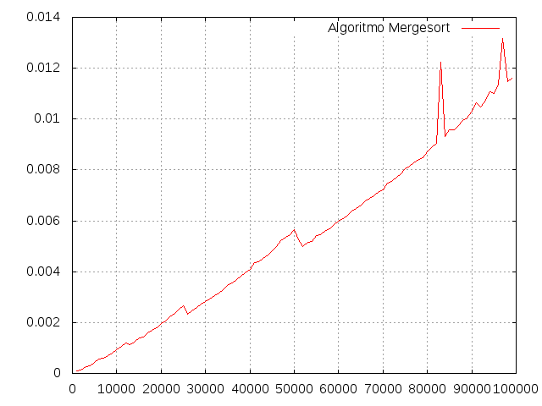
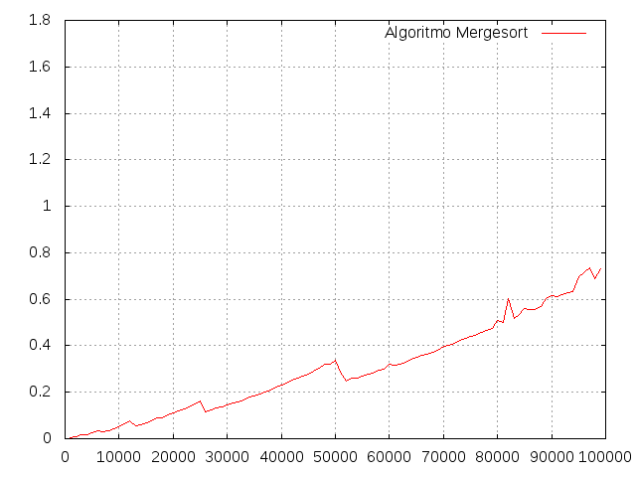

- Quicksort
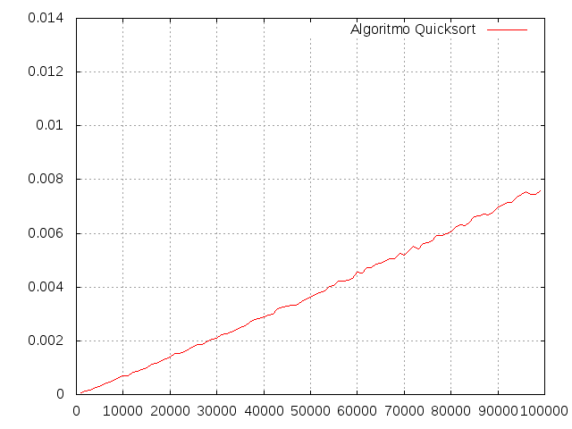
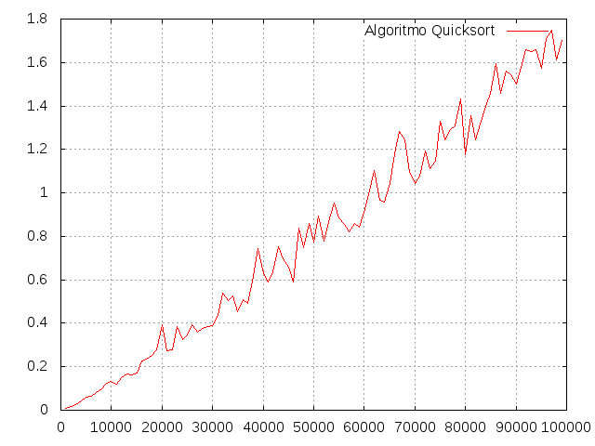

- Heapsort
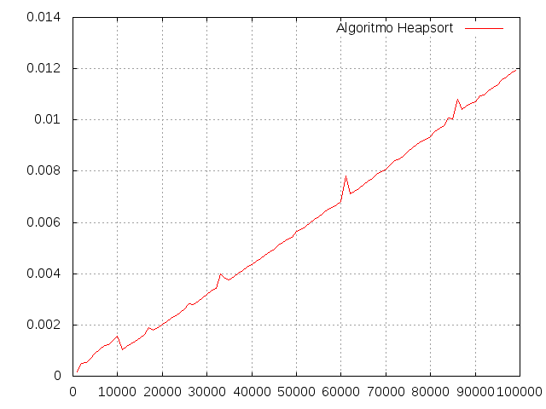
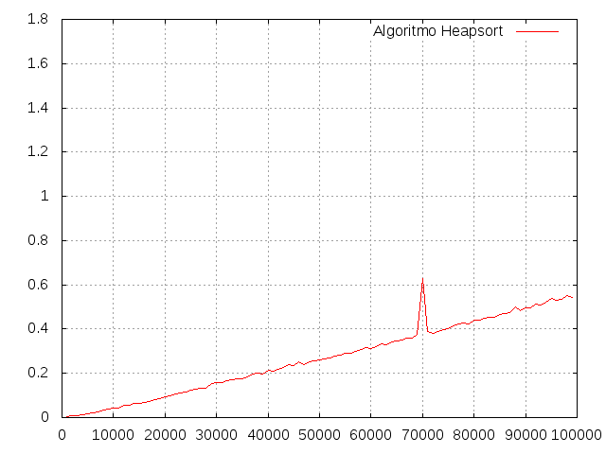

- Comparaciones
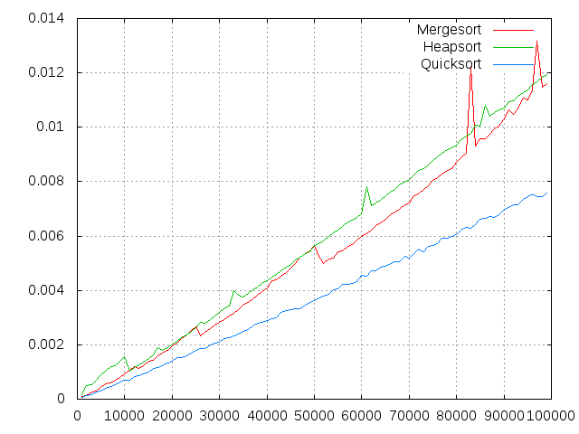
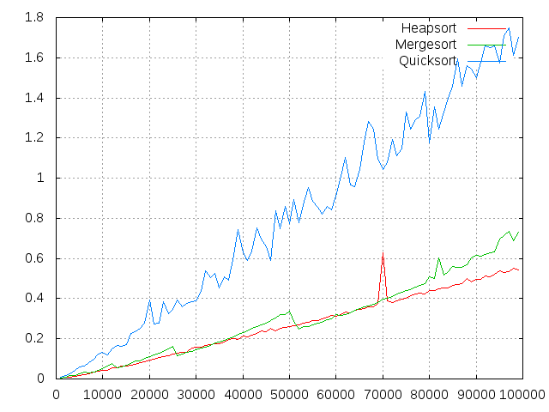

Eficiencia híbrida
Ajustes de las funciones(primero C++ y después Python):

- Mergesort, f(x) = a0*x*(log(x)/log(2))
Final set of parameters Asymptotic Standard Error
======================= ==========================
a0 = 6.81417e-09 +/- 5.09e-11 (0.747%)
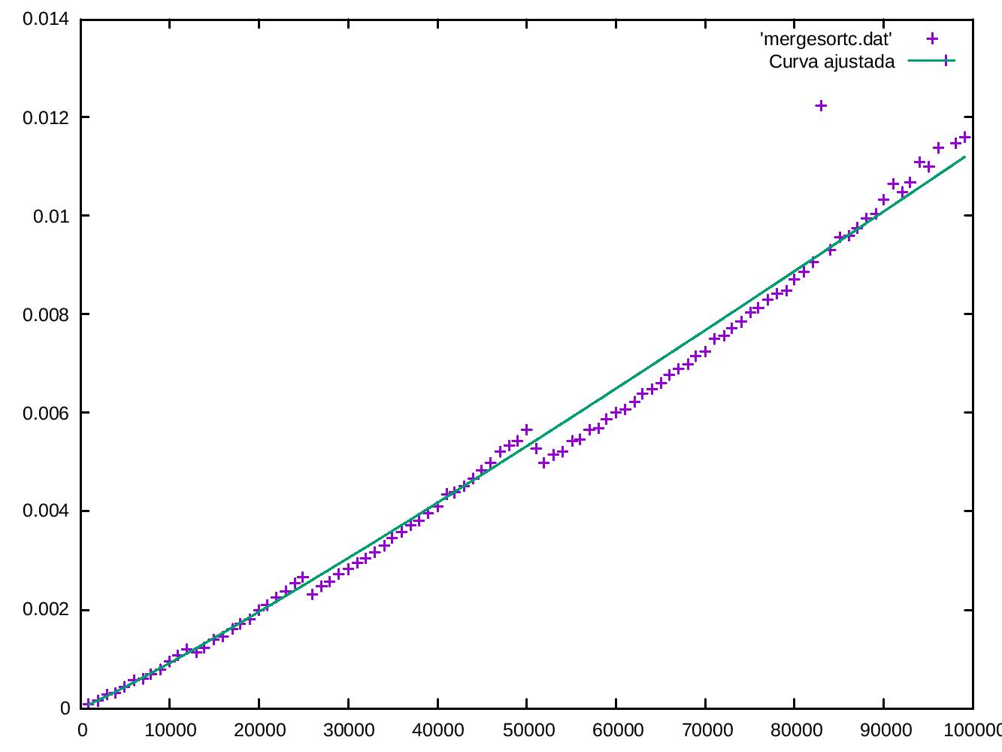

Final set of parameters Asymptotic Standard Error
======================= ==========================
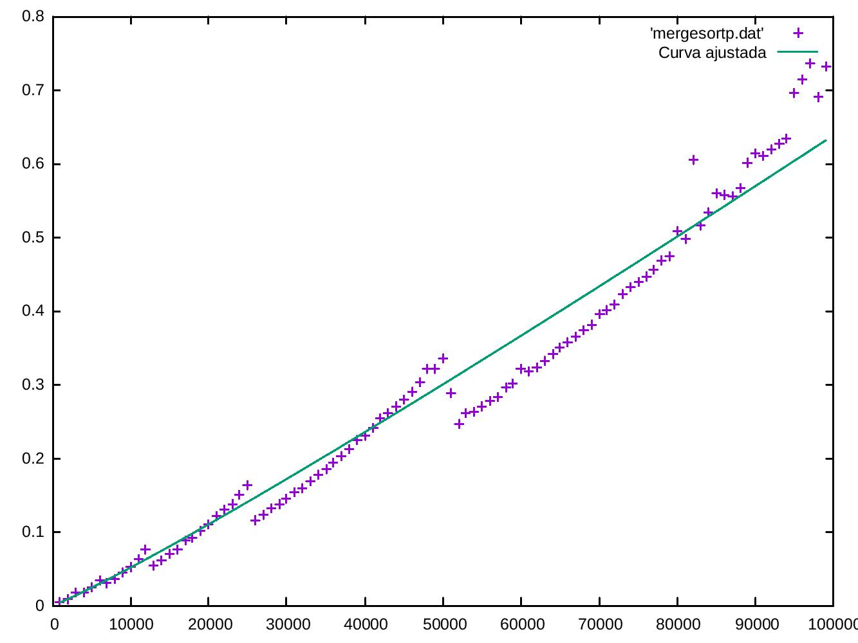
a0 = 3.84371e-07 +/- 4.137e-09 (1.076%)

- Quicksort, f(x) = a0*x*(log(x)/log(2))

Final set of parameters Asymptotic Standard Error
======================= ==========================
a0 = 4.69096e-09 +/- 6.188e-12 (0.1319%)
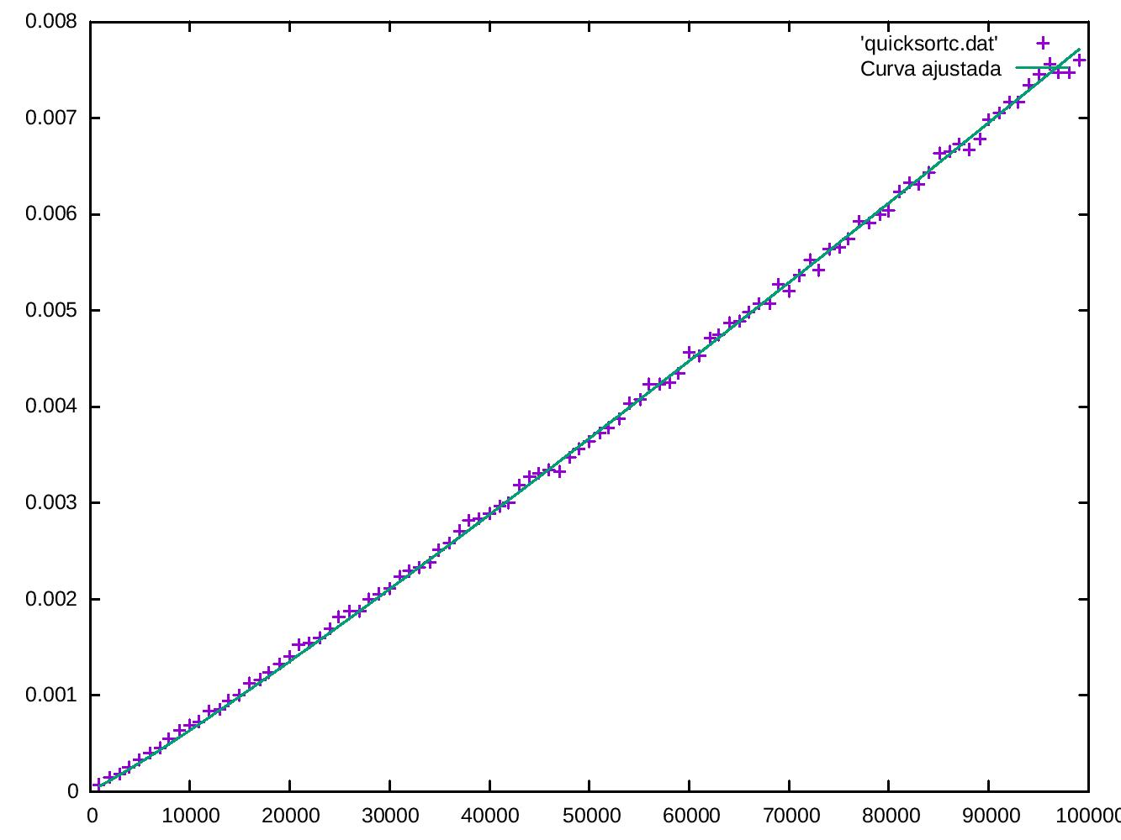

Final set of parameters Asymptotic Standard Error
======================= ==========================
a0 = 1.02733e-06 +/- 7.217e-09 (0.7025%)
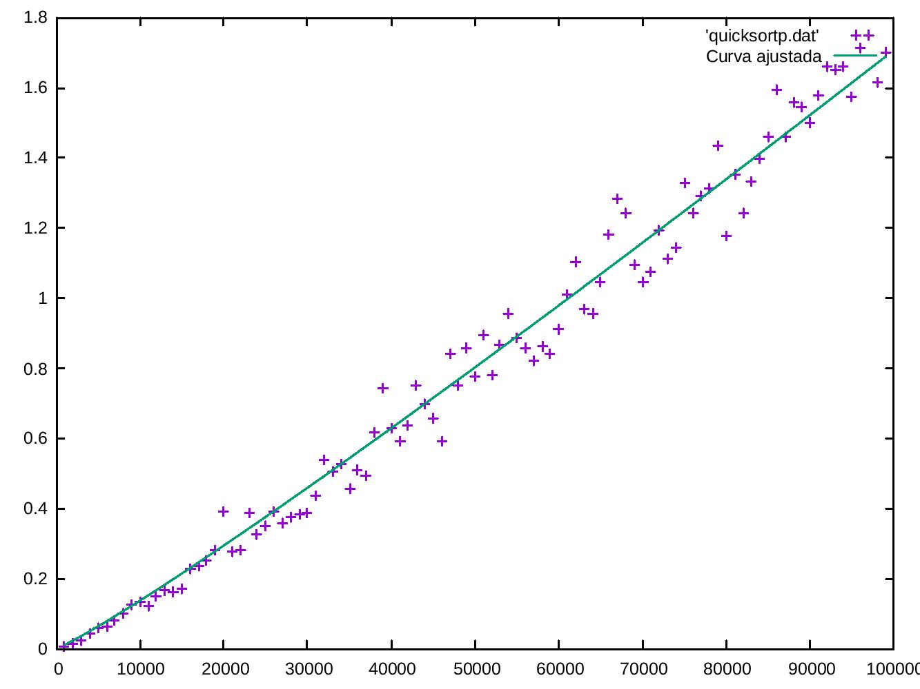

- Heapsort, f(x) = a0*x*(log(x)/log(2))

Final set of parameters Asymptotic Standard Error
======================= ==========================
a0 = 7.25048e-09 +/- 2.016e-11 (0.278%)
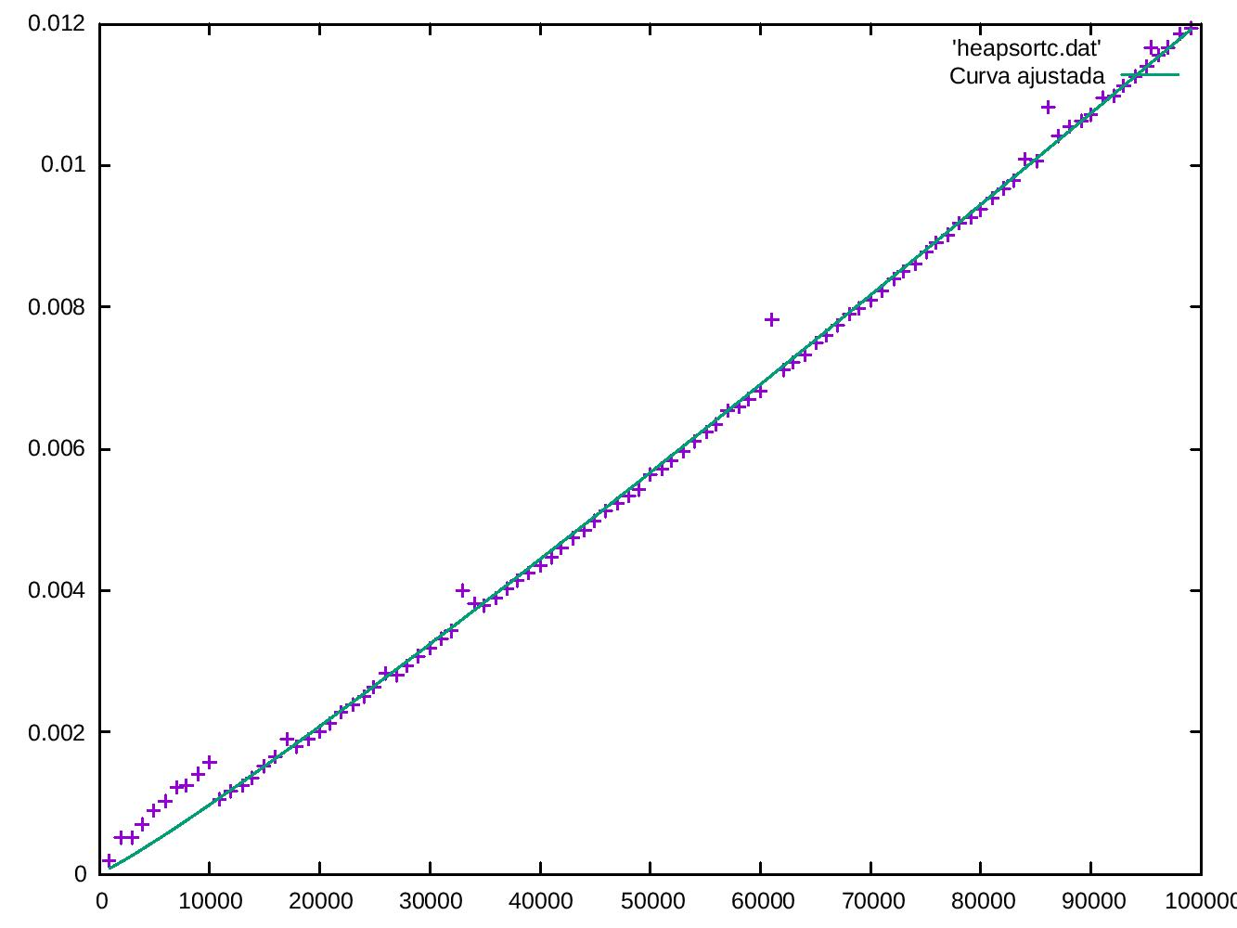

Final set of parameters Asymptotic Standard Error
======================= ==========================
a0 = 3.38096e-07 +/- 2.785e-09 (0.8238%)

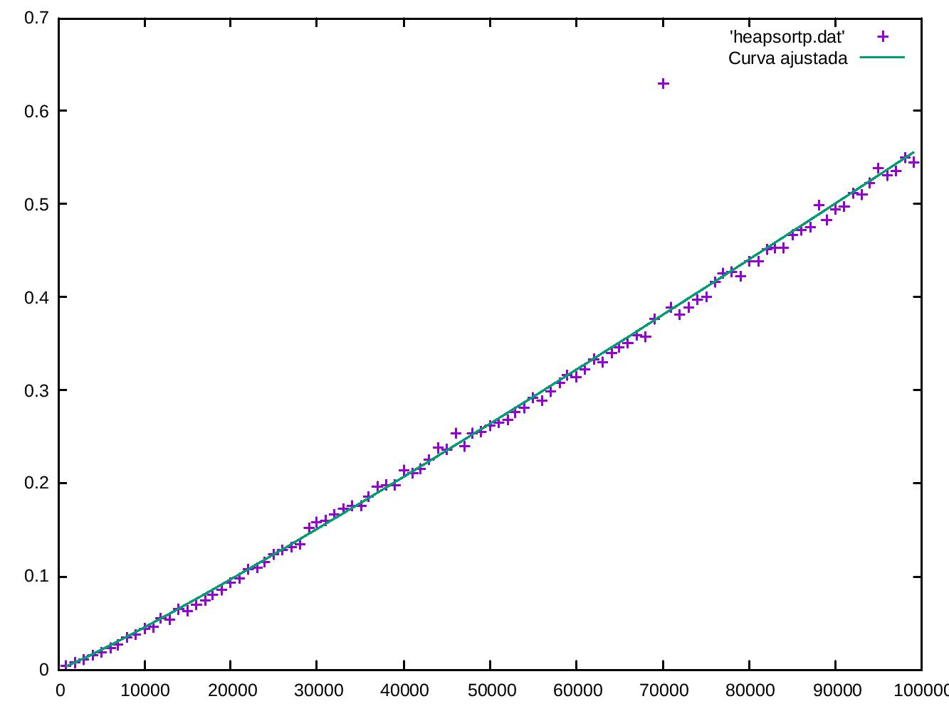

4.ALGORITMO DE FLOYD O(n³)

Eficiencia empírica
Tablas de resultados
Tamaño | C++ | Python
10 | 1.482e-06 | 0.00023889541626
50 | 0.000155283 | 0.0250079631805
100 | 0.00126338 | 0.201648950577
150 | 0.0038006 | 0.668588876724
200 | 0.00894525 | 1.57522082329
250 | 0.0173707 | 3.17275905609
300 | 0.029572 | 5.39323401451
350 | 0.0459378 | 8.4226899147
400 | 0.0684161 | 12.6614019871
490 | 0.125531 | 23.5752220154

Gráficas de eficiencia empírica(primero en C++ y después en Python)
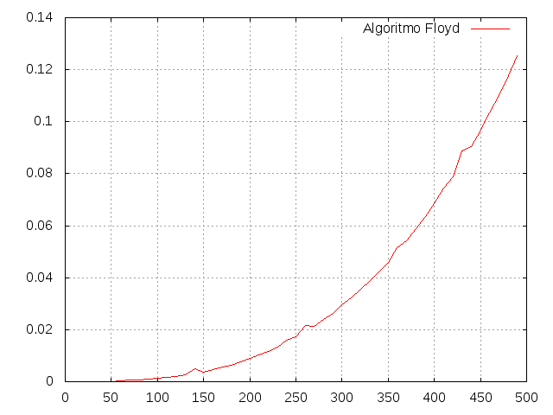
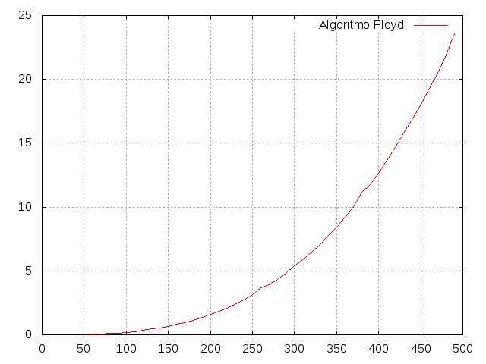

Eficiencia híbrida
Ajustes de la función (primero C++ y después Python):

- f(x) = a0*x*x*x+a1*x*x+a2*x+a3

Final set of parameters Asymptotic Standard Error
======================= ==========================
a0 = 1.03039e-09 +/- 5.024e-11 (4.876%)
a1 = 1.25205e-08 +/- 3.819e-08 (305%)
a2 = 2.20194e-06 +/- 8.263e-06 (375.2%)
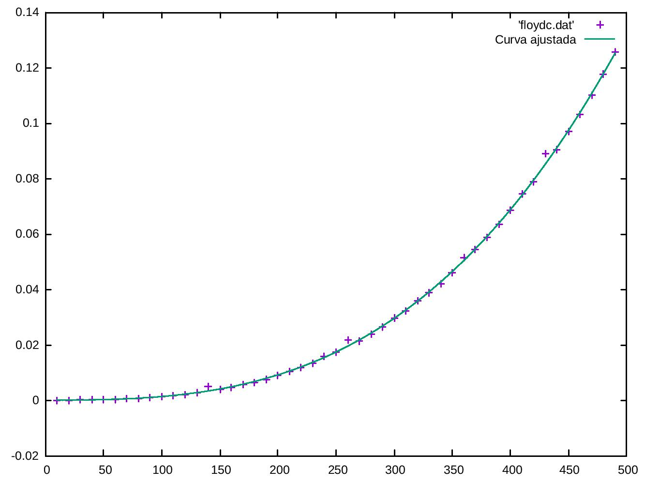
a3 = -5.94601e-05 +/- 0.0004819 (810.4%)
Final set of parameters Asymptotic Standard Error
======================= ==========================
a0 = 2.01341e-07 +/- 4.523e-09 (2.246%)
a1 = -2.33625e-06 +/- 3.438e-06 (147.2%)
a2 = 0.000513157 +/- 0.0007438 (145%)
a3 = -0.0193231 +/- 0.04338 (224.5%)

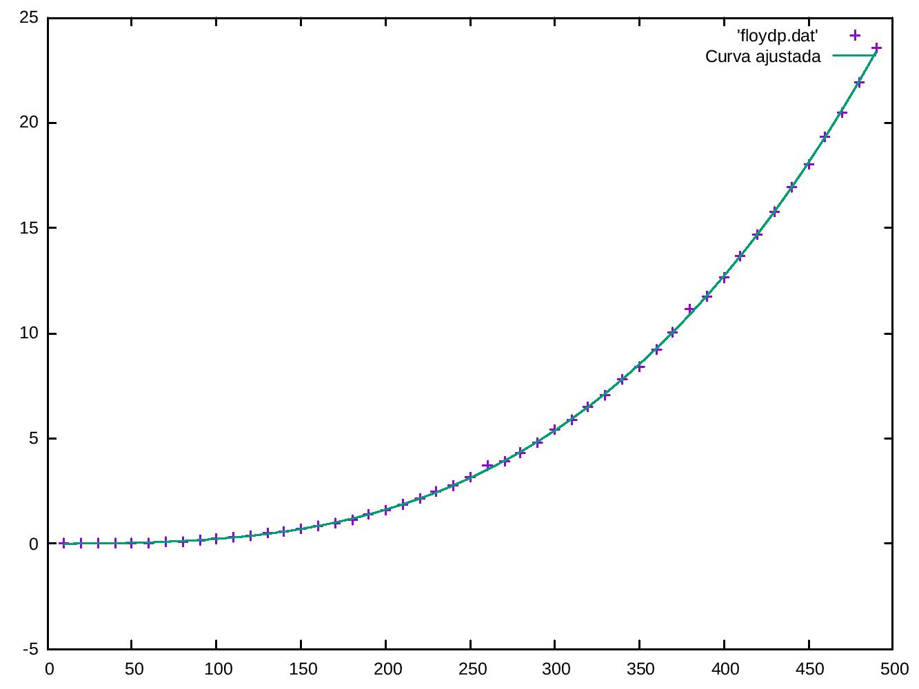

5.ALGORITMO DE FIBONACCI O(( 1+ 2 5 ) n ))

Eficiencia empírica
Tamaño | C++ | Python
10 | 6e-07 | 4.29153442383e-05
12 | 1.345e-06 | 6.103515625e-05
14 | 2.403e-06 | 0.000149965286255
18 | 1.3105e-05 | 0.000962972640991
22 | 8.5968e-05 | 0.00855493545532
26 | 0.000588946 | 0.0450170040131
30 | 0.00421234 | 0.312088012695
34 | 0.0275747 | 2.11239099503
36 | 0.0723397 | 5.6723511219
38 | 0.196365 | 14.4997828007
40 | 0.499014 | 37.7748119831
42 | 1.29192 | 101.042599916
44 | 3.37255 | 265.218493938
46 | 8.85076 | 681.166821957
48 | 23.2206 | 1777.12923694

Gráficas de eficiencia empírica (primero en C++ y luego en Python)
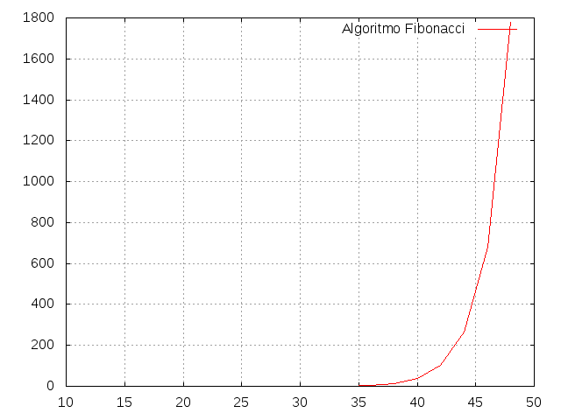
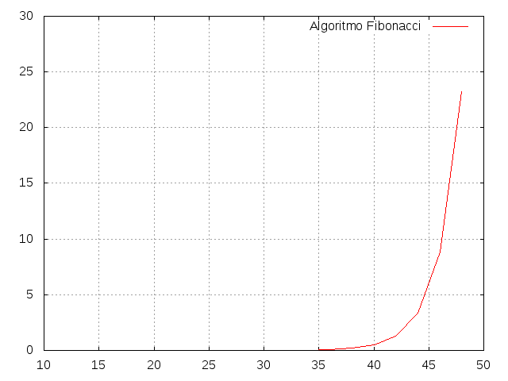

Eficiencia híbrida
Ajustes de la función (primero C++ y después Python):
- f(x)=a0*((1+sqrt(5))/2)**x

Final set of parameters Asymptotic Standard Error
======================= ==========================
a0 = 2.15932e-09 +/- 4.813e-13 (0.02229%)
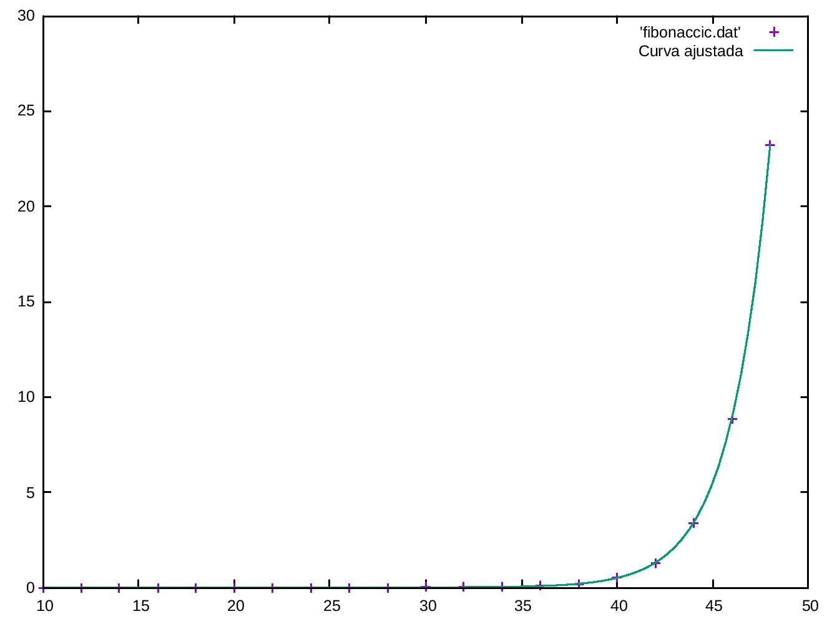

Final set of parameters Asymptotic Standard Error
======================= ==========================
a0 = 1.65464e-07 +/- 1.277e-10 (0.07715%)
