**Software Project Management - Exercise 2**

Submitted By: Lital Levy, Shir Bruchim and Oded Rosiansky

**1. System architecture**

The diagram is in the following link:

<https://cacoo.com/diagrams/qGmobGfW6xuOCqvl/edit?sampleId=official-1492341>

**2. Data Tables:**

in the ERD below or in the following link:

<https://s28.postimg.org/ih12edfwd/mpo_erd.png>

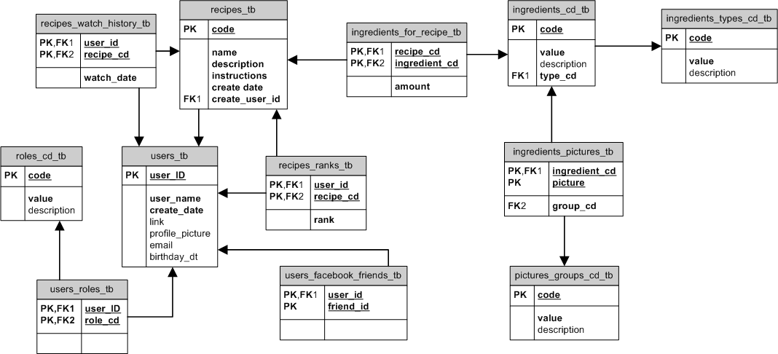

**3. Technologies**

**Programming Languages:**

JavaScript

Python

JSX

**Developers tools:**

Brackets - an open source code editor for web development

PyCharm - an IDE used for python in order to build the crawler

SciPy - the most useful package for machine learning in Python

**Technologies and Libraries:**

React.js - an open-source JavaScript library for data rendered as HTML

React Native - A framework for building native apps with React

Node.js - an open-source, server-side Javascript technology

Express.js - an open-source library that is a web application framework for Node.js

Scrapy - a popular and powerful Python scraping library - will be used to build the crawler

SciPy (See above) Libraries - scipy numpy, matplotlib, pandas, sklearn

**Storage and Database**

Storage and database will be fully managed with Amazon RDS and Aurora.

The crawler will be run on AWS spot instances (as they fit the requirements).

The photos for the machine learning will be managed in a s3 bucket.

**API’s**

Facebook API integration

BigOven (cooking site) API integration

**4. Flow (Sequence Diagrams)**

<https://s28.postimg.org/pv3dm6tf1/Find_Recipe_Sequence_Diagram.png>

<https://s30.postimg.org/fy252u3nl/Crawler_Sequence.png>

<https://s30.postimg.org/yucf0euwx/My_Recipes_Book_Sequence.png>

<https://s30.postimg.org/yvmcttwqp/Recipe_Operations_Sequence.png>

**5. Class Diagram**

<https://s24.postimg.org/gf69wlwqd/Super_Chef_Class_Diagram.png>