**System Architecture**

Mobile application: Written in Typescript and using React Native, the mobile application will run on the user’s phones and every query will require internet access. Data will not be saved locally.

Relational database: An SQL database located on a remote server, responsible for saving all the data object’s attributes.

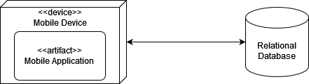

**Data Objects**

Class diagram representing our data domain:

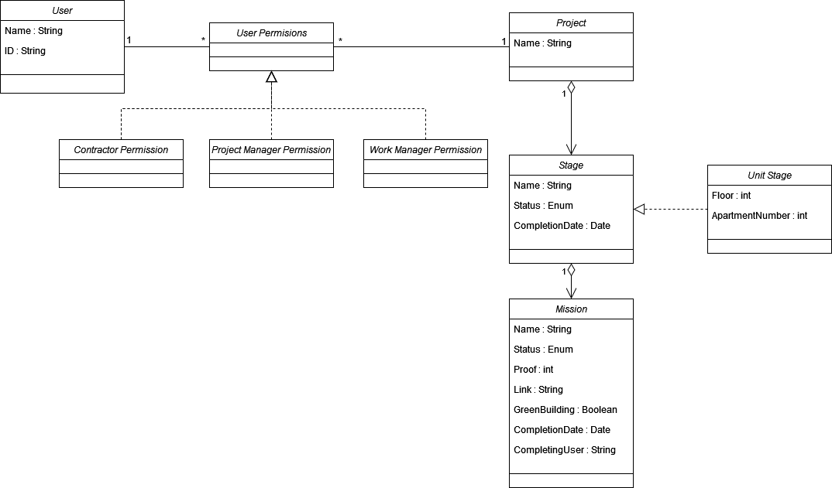

Entity relationship model:

