DevOps - Docker Containers Hands-on

LAB Exercises

Useful links
Docker documentation:
https://docs.docker.com/

Docker commands:
https://docs.docker.com/engine/tutorials/usingdocker/
https://docs.docker.com/engine/reference/commandline/cli/

Setup port forwarding:
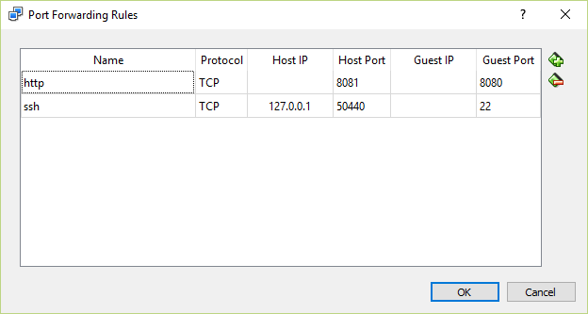

Lab-1
Docker Basics

Use the debian image for the following exercises
- Run debian container with the ls command: (docker run debian ls)
- Run docker ps –a to check container status
- Run the debian container and create a file on the file system with the touch command.
- Start the exited container and attach to it with a bash shell.
- Verify that you can find the file you created on the exited container.
- Run the debian container in the background (-d)
- Attach to the debian containers with a bash shell.
- Stop all containers.
- Delete all containers.

Lab-2
- Use the debian image for the following exercises
- Create a container named c1 with a host name h1
- Create a container named c2 with a host name h2
- Find out the ip addresses of the containers with the inspect command
- Login to each container and verify you can ping the other container by ip
- Use the containers names to stop and then remove the containers
Lab-3
- Use the nginx image to start an nginx container.
- Make sure you expose port 80 to the host machine and use port forwarding on the host vm, so that the port can be accessed from your pc.
- Check that you can access the welcome page from your pc.
- Ssh into the container.
- Install vim (apt-get update; apt-get install vim)
- Change the index page
- Restart the container
- Check that you can access the welcome page from your pc.

Lab-4
- Create a debian container named c71 with a volume share to a dir on the host machine
- Create a file in the shared dir on the host and see that the container sees it.
- Create another debian container named 72 with the same volume share to and a link to the c11 container.
- Verify that you can access the shared dir and share data between the two containers.
- Check that you can access c71 by name from c72 (with ping for example)
- Check the /etc/hosts file on c72

Note: build images on the docker machine
docker-machine ssh
Lab-5
- Create a development image from the ubuntu image using dockerfile.
- Install openjdk-8,
- Install maven
- Install git
- Login to the container and clone the petclinic project from: https://github.com/odedns/petclinic_sdk.git

- compile the petclinic project using maven.

Lab-6
Build a new image based on the image in the previous lab.
- Install the Jenkins ci server.
- Make sure you expose port 8080 to the host machine and use port forwarding on the host vm, so that the port can be accessed from your pc.
- Access the Jenkins ui and create a build plan for the petclinic project.
- Run the build plan.

Lab-7
- Create an image based on the official tomcat image.
- Make sure you expose port 8080 to the host machine and use port forwarding on the host vm, so that the port can be accessed from your pc.
- Copy the petclinit artifact to the tomcat webapp directory.
- Access the petclinic app from your pc's browser.

Lab-8
Docker Hub
- Create an account on the docker hub.
- Push the tomcat image we created in the previous lab to the docker hub tag it with a v1 tag.
- Pull the image and run it in a container.
- Change the Dockerfile for the image install the openssh-server package.
- Build the image and push it to the docker hub with a v2 tag.
- Pull the image and run it in a container.
- Verify that you got the v2 version of the image.

Lab-9
Private registry
- Run a local registry container
- Push the development image from lab-6 to the local repository.
- Remove the local image and pull the image from the local registry.

Lab-10
Networking
- Create a private bridge network.
- Create a debian container with the –net param and point it to the private network.
- Create another debian container on the private network.
- Verify that both containers have access to each other.
- Verify that the containers are not accessible by containers on another network.

Lab-11
Logging and monitoring
- Run cAdvisor as a docker container.
- Make sure you expose port 8080 to the host machine and use port forwarding on the host vm, so that the port can be accessed from your pc.
- Access the cAdvisor UI.
- Inspect your containers

Lab-12
Docker testing
We want to run a docker ci setup:
Run a build of the petclinic in a Jenkins container
Deploy the app to a tomcat container

We will use the Jenkins image and the tomcat image we built in the previous labs.
For that we will need to run docker commands from within the Jenkins container in order to run the tomcat container and deploy the application.
Do do that we need to use docker.sock in order to access the docker process on the host.
We need to do run the command from the docker machine itself :
docker-machine ssh
Run the docker.sock:
docker run -d -v /var/run/docker.sock:/var/run/docker.sock -v $(which docker):/bin/docker <image>

Lab-13
Docker Deployment
Use the following tutorial to setup swarm:
https://docs.docker.com/swarm/install-w-machine/

