import matplotlib.pyplot as plt  
import numpy as np  
import scipy.fft as scf  
  
  
def create_wave_and_dft(sf, duration, A, f, dur_with_zeropad=0, label=" "):  
 """  
 creates a sum of sinewave (without controlling phase) while allowing zeropadding.  
 calculate and plots the normalized dft  
 :param sf: float, sampling rate  
 :param duration: float, in seconds  
 :param A: should be in the same size as f. a list of amplitudes  
 :param f: a list of frequencies  
 :param dur_with_zeropad: means that a total of (dur_with_zeropad-duration) zeros will be added  
 :param label: string to be added for graph  
 :return:  
 """  
 if (dur_with_zeropad < duration): # in case of no zeropad  
 dur_with_zeropad = int(sf * duration)  
 t = np.arange(0, duration, 1 / sf)  
 wave = 0 * t  
 wave_zeropad = np.zeros(dur_with_zeropad)  
 for i in range(len(A)):  
 wave += A[i] * np.cos(2 * np.pi * f[i] * t)  
 wave_zeropad[0:wave.size] = wave  
 dft_normalize = scf.fft(wave_zeropad);  
 freqs = np.fft.fftfreq(dft_normalize.size, t[1] - t[0])  
 dft_normalize = dft_normalize[freqs > 0] / dft_normalize.size  
 freqs = freqs[freqs > 0]  
  
 plt.plot(freqs, dft_normalize, label=label)  
 plt.legend()  
 return (freqs, dft_normalize)

# 1

## A

q1A = create_wave_and_dft(sf=50, duration=0.5, A=[1, 1], f=[4, 5])

c:\python\lib\site-packages\numpy\core\_asarray.py:85: ComplexWarning: Casting complex values to real discards the imaginary part  
 return array(a, dtype, copy=False, order=order)

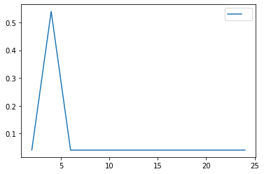

#### i - frequency resolution is 2hz - jumping from 2 to 25(24 actually) in jumps of two. this is because we had 25 samples (12 positive)

#### ii - it has one peak, similar to what we would get for one cosine wave. The reason is that we don't have a lot of samples so we get one coefficient for the 4 and 4 hz waves together

## B

q1B = create_wave_and_dft(sf=50, duration=0.5, A=[1, 1], f=[4, 5], dur_with_zeropad=50 * 5)

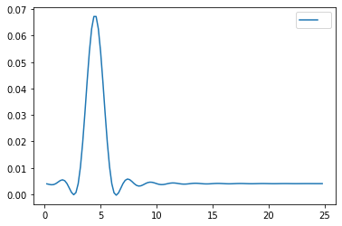

#### i The coeffeicients resolution is bigger by a factor of 10 - 124 instead of 12. this is because we added more samples.

#### The problem was not solved, as we didn't really ad more information that allow us to disentangle 4hz from 5hz

#### ii what we actually did is to multiply the "full" signal of 5 seconds by a boxcar --> meaning we created a convolution of the actual fft with a sinc function in the frequency domain.

## C

q1C = create_wave_and_dft(sf=50, duration=5, A=[1, 1], f=[4, 5])

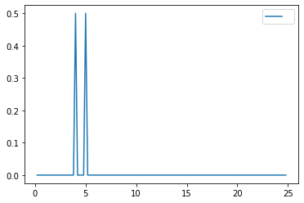

#### we have more samples of actual signal, which improves the information we have. not multiplying the frequency domain by a boxcar saves us the ripples we had before

## D

q1A = create_wave_and_dft(sf=50, duration=0.5, A=[1, 1], f=[4, 6], label="duration 0.5, no zeropad")  
q1B = create_wave_and_dft(sf=50, duration=0.5, A=[1, 1], f=[4, 6], dur_with_zeropad=50 * 5,  
 label="duration 0.5, zeropad to 5sec")  
q1C = create_wave_and_dft(sf=50, duration=5, A=[1, 1], f=[4, 6], label="duration 5, no zeropad")

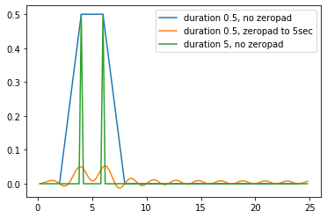

#### We see that now the zeropadding harms the information we get by creating ripples

#### The original resolution of 2hz was enough to catch both frequencies but they were not isolated - the fft pointed towards equal power

#### along the band between 4-6, and extending the signal to 5 seconds revealed that they are actually distinct

## E

#### As the frequency resolution is 2hz, I expect that the fft will be inconclusive between 4 and 6 (there is no possible frequency of 5 in our scale),

#### so we expect part a will return someting similar to d - a wide trapeze over 4-6 (post moetem: actually i was wrong...)

q1A = create_wave_and_dft(sf=50, duration=0.5, A=[1], f=[5], label="duration 0.5, no zeropad")  
q1B = create_wave_and_dft(sf=50, duration=0.5, A=[1], f=[5], dur_with_zeropad=50 * 5,  
 label="duration 0.5, zeropad to 5sec")  
q1C = create_wave_and_dft(sf=50, duration=5, A=[1], f=[5], label="duration 5, no zeropad")

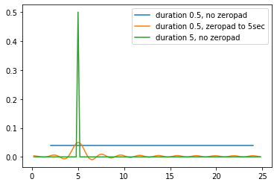

#### Apparently because 5 hz fell outside the resolution,

#### the dot product of both 4 and 6hz sinewaves with our wave resulted in the same normalizred power as all other frequencies.

#### so in this case - zeropadding did help because it increased the resolution (or convolved a constant value with a sinc)