**ODEE NWAFOR**

**ASSIGNMENT 1**

1. When you login with non-existing username, the system will decline you access to the system. As shown on the picture, access was decline because of failed authentication.

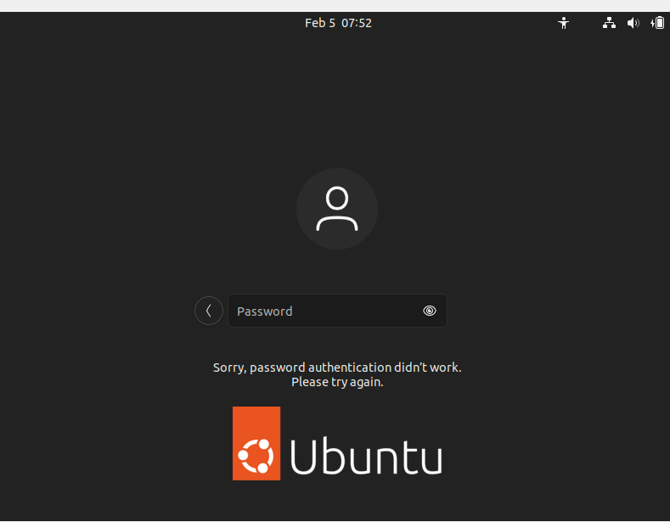

**ASSIGNMENT 2**

1. When I initiated a password change, the system asked for the current password before it prompted for a new password. Password change was successfully when you input correctly the current password, which will allow you to change to a new password.

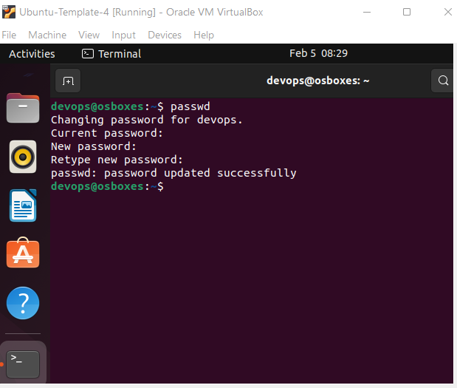

1. Password change failed when I used 1234 or abcd, it prompted password is shorter than 8 character.

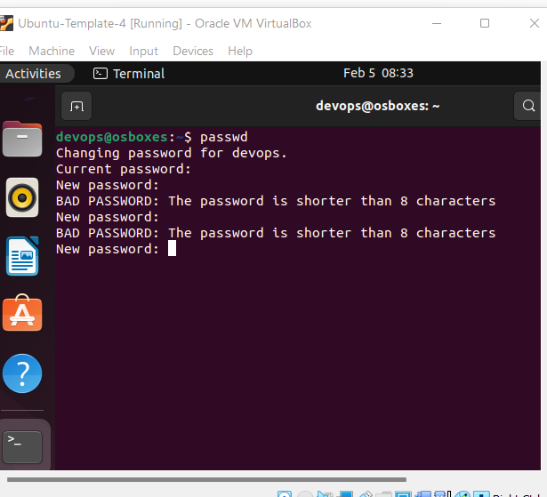

1. When changing password by not using password and hitting Enter key, system prompted no password supplied.

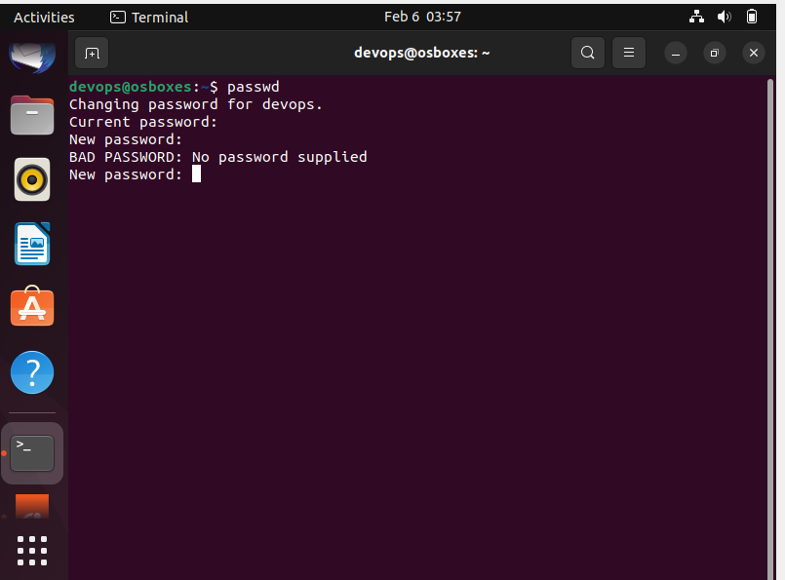

**ASSIGNMENT 3**

1. The output displayed folder content in the root user.

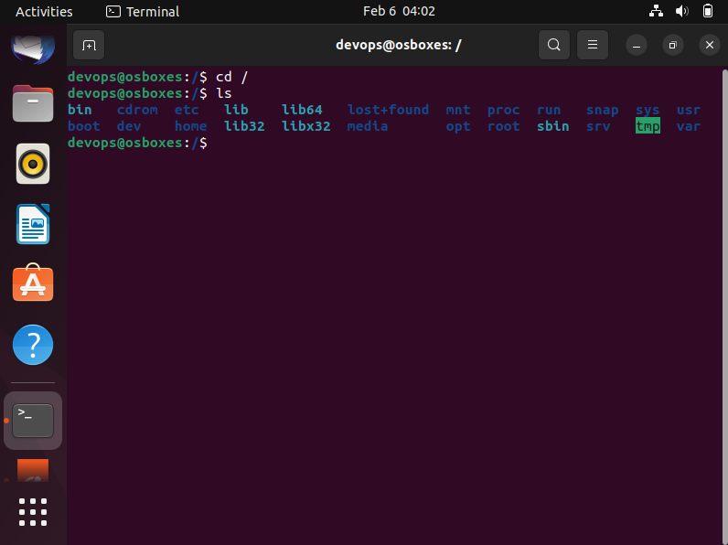

1. Cd Home will take you to Home directory. In addition, with ls command will display home folder content, which include devops, lost + found, osboxes. These are user profile folders.

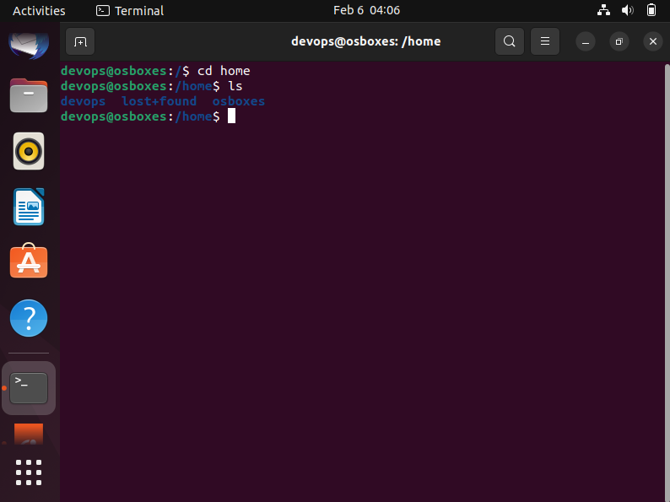

1. After entering Cd .. The command took me back to the parent directory of home.

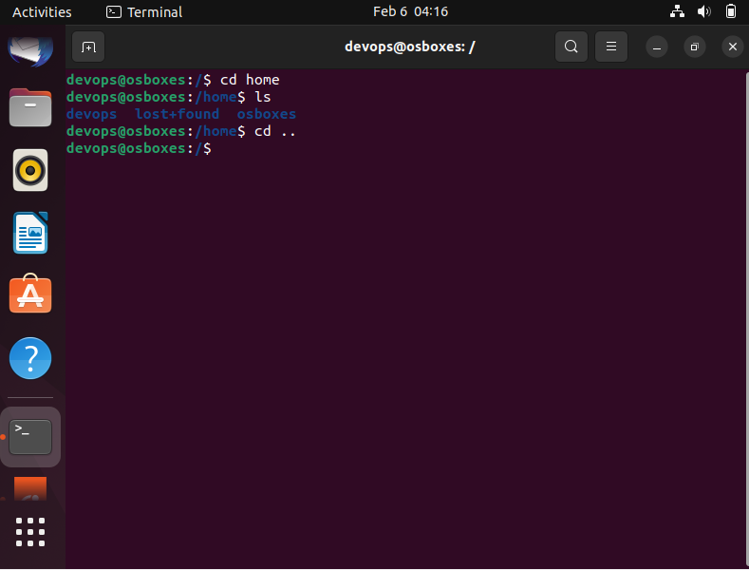

1. The system prompted too may argument without any output.

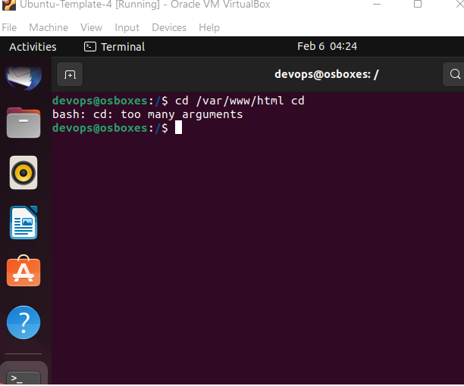

1. When I enter cd /root, access permission denied.

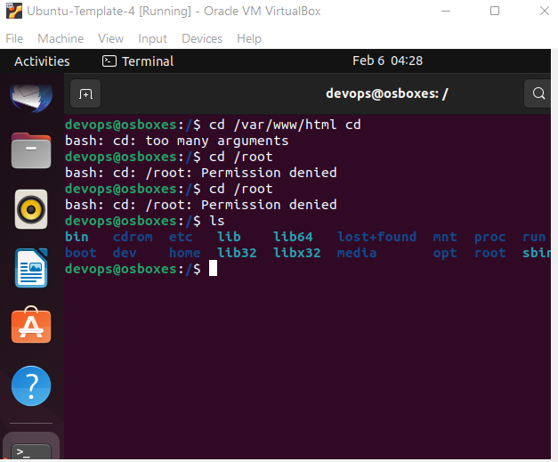

**ASSIGNMENT 4**

1. The screenshot displayed content of folder etc.

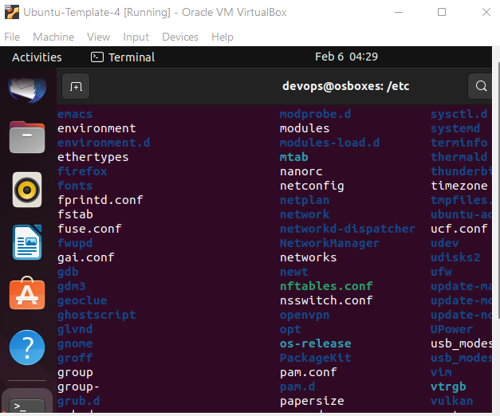

1. The difference is that the content of **Cd /Home** are folders while that of **Cd /etc** are files.

**ASSIGNMENT 5**

1. After restarting of the system and entering pwd, the out displayed showed that I am in home/devops user directory.

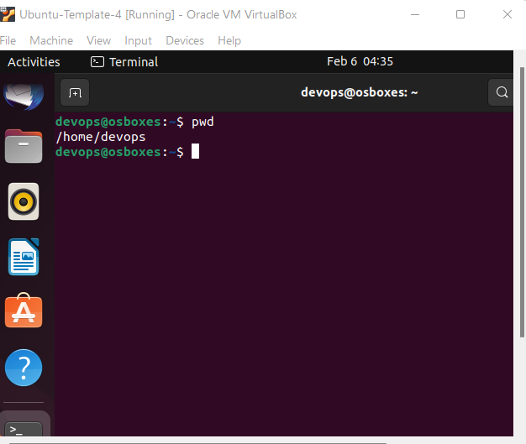

1. Ls displayed content of Cd /var.

