**ODEE NWAFOR**

**ASSIGNMENR-PART3**

1. File1.txt copied to file2.txt

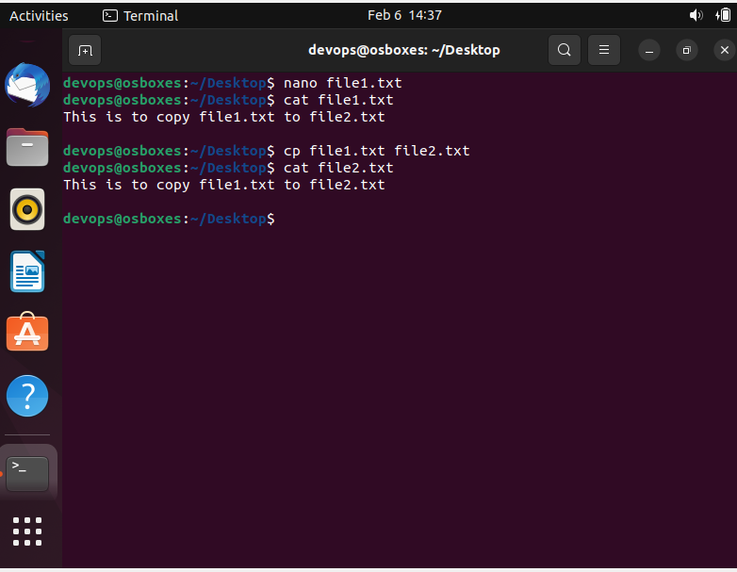

1. Moved file2.txt to Folder home.

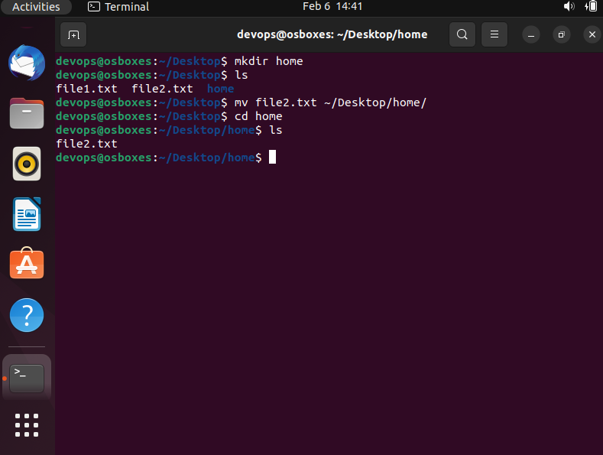

1. Echo “Hello I am newline” > file3.txt output will written to file3.txt. However, if file3.txt exist, the output of > will overwritten the content of file3.txt

Echo “Hello I am newline” >> file4.txt output will be written to the file4.txt and the file4.txt will contain previous content of file4.txt and new output.

