Machine Learning Dataset Profile
Student: Odeliya Charitonova | Attack Category / Tactic: Linux Privilege Escalation (MITRE TA0004) | Dataset: Linux-APT Dataset 2024 | Date: 7.6.2026
1. Dataset Provenance & Metadata
Dataset Name | Linux-APT Dataset 2024 (Linux-APT-Dataset-2024, v2)
Creator / Originating Body | S.S. Karim, M. Afzal, W. Iqbal, D. Al Abri - National University of Science and Technology (NUST), Pakistan & Sultan Qaboos University, Oman
Release Year | 2024 (Data in Brief, Vol. 54, DOI: 10.1016/j.dib.2024.110290). Data collected Oct 2023 -Jan 2024.
Primary Data Format | Comma-Separated Value (CSV) logs exported from WAZUH SIEM v4.5.2. Also available as processed XLSX. Supplementary XML configuration file (local_rules.xml) included.
Total Record Count | 125,898 records (combine.csv). Both general and malicious/suspicious traffic included.
Structure | 17 individual daily files (WAZUH limit: 10,000 records/file) + combine.csv (full merge) + Processed Version.xlsx (compiled, with tactic/technique columns separated and binary label column added).
Repositories | Mendeley Data (v2): doi.org/10.17632/5x68fv63sh.2  Zenodo: doi.org/10.5281/zenodo.10685642
2. Generation Methodology
Testbed: The dataset was generated in a fully Linux-based lab environment .Three Ubuntu 22.04 machines -two end-user nodes on the same subnet, one attacker node on a separate network , monitored by a dedicated WAZUH 4.5.2 SIEM server. A separate Kaspersky AV server forwarded alerts via Syslog. Topology: two end-user nodes on Subnet A, attacker node on isolated Subnet B, WAZUH SIEM server connected to all three.
Benign Traffic: Normal activity was generated by using the machines as standard Linux workstations (directory browsing, file operations, routine admin tasks). This ensures the baseline captures realistic day-to-day auditd and syslog noise rather than synthetic traffic that would be too clean.
Attack Execution: Attacks were simulated using MITRE Caldera (open-source adversary emulation framework), supplemented by custom YARA rules and manual payloads. Coverage includes: (1) APT emulations (APT28, APT29, APT41, Turla/Snake) using documented TTPs; (2) Linux privilege escalation against kernel vulnerabilities; (3) recently published Linux CVEs ;(4) keyloggers and backdoors. Each attack type generates a distinct pattern of auditd syscall events and WAZUH rule triggers.
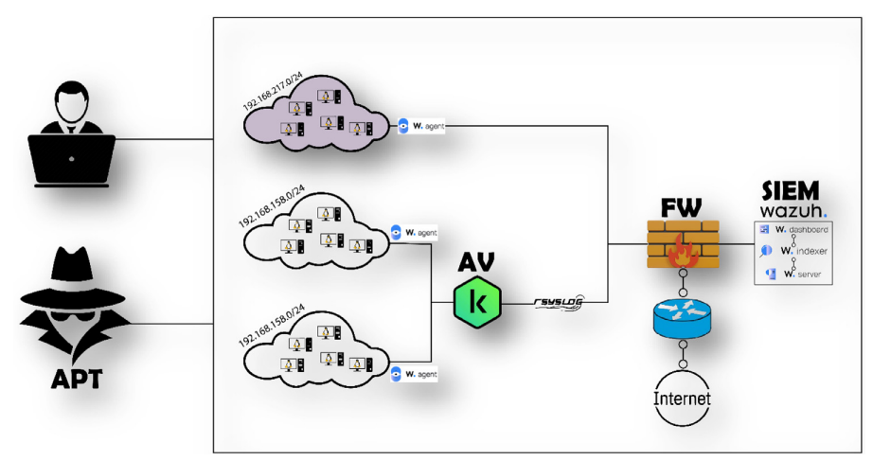
Figure 1: Testbed architecture (reproduced from Karim et al., 2024).
3. Data Structure & Schema
Each row in the dataset is a single WAZUH-parsed log event. The key fields for ML are outlined below:
Field | Category | Notes
Full-log | Raw behavioral | Complete log line - commands, arguments, payload. Primary feature source for NLP/sequence models.
Agent-Name | Host metadata | Hostname of the monitored Linux machine
Rule Description | Semantic label | Human-readable description of the triggered WAZUH rule
MITRE Tactic / Technique | Ground truth | Per-record ATT&CK tactic and technique ID -supports both binary and multi-class classification.
File Hash MD5 / SHA256 | Artifact | Hash of file involved in the event, where applicable
Timestamp | Temporal | ISO 8601 datetime , used for sequence windowing and time-series models.
Source/Dest IP & Port | Network context | Present for network events; null for purely host-side syscall events (impute, do not drop).
Source-log / Source Datatype | Provenance | Identifies which log subsystem produced the record (auditd, syslog, etc.)
Path / Filename | File system | File or directory path involved in the event
Rule PCI-DSS / HIPAA / NIST | Compliance mapping | Regulatory framework tags ,useful for filtering but not primary ML features
Label (Processed file) | Target variable | Binary: 1 = malicious, 0 = benign. Added in Processed Version.xlsx.

Record Schema & Preprocessing: As detailed in the table above, the schema consists of structured WAZUH SIEM log events. Crucially, the numerical features required for classical ML models do not exist out-of-the-box; significant preprocessing (tokenization, sequence extraction) is required to extract behavioral signals from the raw Full-log string.
Feature Categories:
- Payload / Host-based features: The primary signal source. Includes Full-log (system log entries, commands, arguments), Path, Filename, and Agent-Name.
- Network-level features: Includes Source/Dest IP and Port. These are present only for network events and are null for pure host-side syscalls.
- Flow-based features: None. Since this is a host-centric SIEM dataset, no pre-computed network flow statistics (e.g., Flow Duration or Packet Length Variance) are provided.
Feature Count: There are 20 raw independent variables (columns) available in the initial CSV. However, the final feature count for training will be dynamically determined during the NLP/preprocessing stage when extracting n-grams or embeddings from the Full-log column.
Target Labeling: The dataset supports both classification types. For binary classification, the Label column categorizes records as 1 (Malicious) or 0 (Benign). For multi-class classification, the MITRE Tactic and Technique columns provide fine-grained ground truth, allowing models to distinguish between specific attack stages like Privilege Escalation, Defense Evasion, and Initial Access.
4. Statistical & Data Characteristics
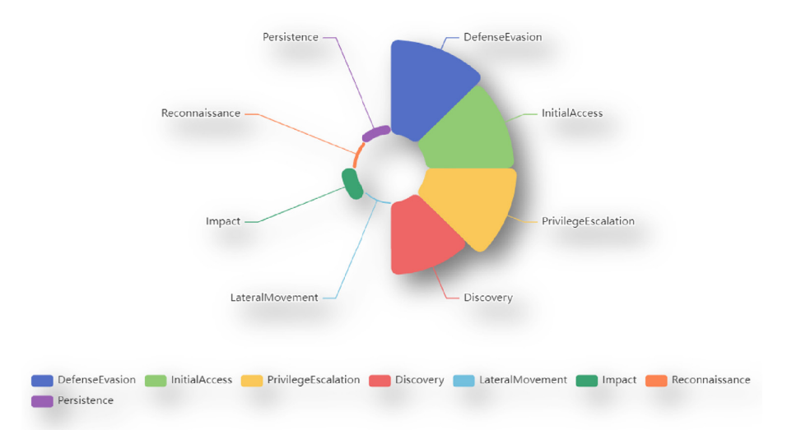
Class Distribution & Imbalance: The dataset contains 125,898 total records. The paper does not report the exact benign/malicious split, but Figure 2 confirms a strong benign majority consistent with real APT environments where malicious instances represent a small minority. This necessitates the use of techniques like SMOTE or class-weighted loss functions during training to prevent the model from becoming biased toward the benign class. The attack distribution is skewed toward specific tactics, with Defense Evasion, Initial Access, Privilege Escalation, and Discovery are the most frequentbeing the most frequent (as visualized in Figure 2).

Figure 2: Attack tactic distribution across malicious records in Linux-APT 2024 (reproduced from Karim et al., 2024).
Data Quality & Preprocessing Required:
- Missing Values: Network-specific fields (Source/Dest IP & Port) contain null values for purely host-side syscall events, which must be handled via imputation or masking.
- Text Processing: The Full-log field is unstructured free text of variable length, requiring tokenization and normalization before ingestion into NLP or sequence-based models.
- Redundancy: Compliance-related fields (PCI-DSS, HIPAA, NIST) are redundant for ML purposes and should be excluded from the training set.
Feature Types: The dataset is predominantly non-numerical.
- Numerical: Only Timestamp is directly numerical, requiring feature engineering for time-series modeling.
- Categorical/Textual: The majority of fields, including Full-log, Agent-Name, MITRE Technique, and Path ,are categorical or unstructured text. Classical tabular models like XGBoost cannot ingest the data without extensive prior transformation.

5. ML Suitability & Justification
Representation of the Technique: The Linux-APT Dataset 2024 is ideal for detecting privilege escalation and APT footprints because it captures rich, granular host-level telemetry. Specifically, the Turla/Snake incident is explicitly included in the dataset's attack simulations. The Full-log field preserves raw command and argument strings (e.g., execve arguments, ptrace invocations, sensitive file paths), which provides the model with the same behavioral signal a live deployment would produce. Furthermore, the per-record MITRE Technique tags provide precise ground truth, allowing the model to learn the distinction between normal administration and specific attack stages such as Defense Evasion.
Suitability for Deep Learning vs. Classical ML: The sequential and unstructured nature of the Full-log data favors Deep Learning architectures. An LSTM or 1D-CNN operating on tokenized sequences can capture temporal patterns across log lines ,such as the specific auditd event chain preceding privilege escalation, that tabular models would miss. Classical models (XGBoost, Random Forest) are still relevant as baselines, applied after converting logs into fixed-length feature vectors (syscall n-gram frequencies or TF-IDF). The ensemble strategy will leverage the DL model's sequence-awareness alongside the interpretability of classical models.
Known Limitations & Biases:
- Simulated Environment Bias: Benign traffic in a lab setting is less diverse than a real enterprise environment, risking overfitting to testbed-specific noise. Mitigation: feature engineering will focus on MITRE-mapped behavioral signals rather than host-specific identifiers.
- Data Fragmentation: The WAZUH 10,000-record-per-file limit fragments chronological sequences. Mitigation: combine.csv will be used exclusively for sequence modeling to ensure uninterrupted time windows.
- Lack of Zero-Day Representation: The dataset contains known TTPs rather than novel zero-day threats. Mitigation: an unsupervised component (Isolation Forest or Autoencoder) will be incorporated into the final ensemble to flag anomalous deviations regardless of whether the attack pattern has been seen before.
6. References
• S.S. Karim et al., "Advanced Persistent Threat (APT) and Intrusion Detection Evaluation Dataset for Linux Systems 2024," Data in Brief, vol. 54, 110290, 2024. doi.org/10.1016/j.dib.2024.110290
• Mendeley Data (v2): doi.org/10.17632/5x68fv63sh.2
• Zenodo: doi.org/10.5281/zenodo.10685642
• MITRE ATT&CK Framework: attack.mitre.org
• MITRE Caldera: caldera.mitre.org
• WAZUH SIEM Documentation v4.5.2: documentation.wazuh.com

