MILESTONE 2 REPORT

Host-Based Behavioral Anomaly
Detection on Linux Systems

Course Name | Workshop on Intrusion Detection Using ML Techniques
Group Identification | Group Number 2
Date of Submission | July 17, 2026

Project Team
Team Member | Email
Alin Loshevsky | alinl@mail.tau.ac.il
Lior Pernik | liorpernik@mail.tau.ac.il
Odeliya Charitonova | odeliyac@mail.tau.ac.il

Chapter 1: Threat Characterization and Telemetry Mapping

1.1 Deep-Dive Threat Analysis
Project scope: General Linux host-based behavioral anomaly detection - when a process's privilege, execution, or resource-access footprint departs from expected normal activity. Within this scope, privilege escalation receives the deepest analytical treatment, as the pivotal stage at which an attacker converts initial access into meaningful host control. Based on the high-volume telemetry present in our evaluation corpora (Dataset 1 and 2), we characterize four primary MITRE ATT&CK sub-techniques: T1548 (Abuse Elevation Control Mechanism: Setuid and Setgid - labeled T1166 in the CAM-LDS dataset's legacy annotation scheme), T1059, and T1222.
T1548 - Privilege Escalation via setreuid/setresuid syscall abuse. A process explicitly invokes the setuid(2)/setreuid(2)/setresuid(2) family to change its real, effective, or saved UID. Legitimate use is narrow and stereotyped - a root-started daemon (e.g., sshd) drops privilege exactly once, immediately at startup. Malicious use is the inverse: a process starting non-root successfully calls setuid(0) after substantial prior non-privileged activity, indicating it gained the CAP_SETUID capability mid-execution via an exploit or misconfiguration. OS-layer observable: anomalous setuid-family syscall timing and an auid/euid mismatch (Table 1, R1–2).
T1059 - Command and Scripting Execution (Suspicious Shells). Post-exploitation often relies on spawning interactive shells to execute arbitrary commands. Production daemons use execve(2) to spawn specific worker threads, not interactive shells; an attacker using a webshell or reverse shell forces the service daemon to invoke execve on a shell binary, routing standard input/output over a network socket. OS-layer observable: daemon-to-shell process lineage with an execve/network spike (Table 1, R6).
T1222 - File and Directory Permissions Modification. To establish persistence or execute dropped payloads, attackers alter filesystem permissions via fchmod(2), fchmodat(2), or chown(2). Benign administrative tools use these calls in predictable, localized bursts; adversarial modification often targets unexpected paths or newly dropped binaries in writable directories like /tmp or /dev/shm. OS-layer observable: elevated privilege-altering syscall frequency by non-administrative processes (Table 1, R5).
T1595 - Active Scanning (Reconnaissance). Prior to escalation, automated tooling frequently probes the host's filesystem and network surface to identify exploitable entry points. This produces a syscall and access-path diversity distinct from a single targeted administrative action. OS-layer observable: elevated unique syscall count and file/network access density preceding an escalation event (Table 1, R8).
1.2 Structural Telemetry Mapping List/Table
# | Adversarial Behavioral Characteristic | Required Telemetry Source | Specific Log Attributes / Raw Fields | Derived / Engineered Feature | Explanation
1 | Effective privilege exceeds real/login identity (T1548) | auditd, type=SYSCALL | uid, euid | max_uid_euid_delta, is_suid_exec, uid_is_root, euid_root | Escalation is a magnitude event, not a binary flag - delta size reflects severity of the privilege jump. The binary root-status flags (uid_is_root/euid_root) are retained alongside the magnitude feature as a simpler baseline check; Ch. 4's algorithmic ranking evaluates whether the added magnitude information is actually used.
2 | Login identity diverges from executing identity, no legitimate authenticated trail | auditd, type=SYSCALL | auid, euid | auid_euid_mismatch | auid is fixed at login and immune to later privilege changes; a mismatch indicates exploit-path escalation rather than an authenticated prompt.
3 | Anomalous execution, scanning, or file-access density (Payload delivery / Active Scanning) | auditd, type=SYSCALL (execve, openat, mmap) | syscall_name, exe, comm, path | exec_count, unique_syscalls, file_access_count, failed_call_rate, failed_call_count | Exploit payloads or automated scanning tools show elevated execution/file-access density and unique syscall usage versus the narrow benign baseline. Both the normalized rate and raw count of failed calls are kept: rate captures relative failure intensity independent of process length, count captures absolute volume.
4 | Privileged process is unusually short-lived | auditd, event timestamps (per-pid), uid | timestamp | lifetime_seconds, events_per_second, ephemeral_privileged | Scripted escalate-then-execute chains complete in sub-second windows; human-invoked privileged actions carry realistic startup/teardown overhead.
5 | Privilege syscalls occur mid-process-lifetime, or in anomalous volumes | auditd, type=SYSCALL | syscall_name ∈ {setuid, setgid, chmod, chown}, sequence position | priv_op_count, seq_length, uid_changed | Position distinguishes benign startup drop from mid-run escalation (T1548); high volume flags T1222. uid_changed flags the same mid-lifetime identity shift at a coarser, binary level.
6 | Shell/binary execution spawned by a long-running service | auditd, type=SYSCALL | comm, exe, parent comm/exe | shell_from_service, parent_child_rarity | Daemon-to-shell spawning is a well-established T1059 signature, rare in benign operation.
7 | File access targeting credential/privilege-configuration stores around escalation | auditd, type=PATH / type=SYSCALL | name (file path) | sensitive_path_access | Access to /etc/shadow, /etc/sudoers, or SSH keys near a privilege transition indicates credential harvesting following escalation.
8 | Automated reconnaissance preceding escalation (T1595) | auditd, type=SYSCALL | syscall_name, file/network access pattern | unique_syscalls, network_count, file_access_count | Scripted scanning generates elevated, repetitive access density distinct from a targeted administrative action.
Table 1: Telemetry & Feature Mapping List, derived from the mechanism analysis in §1.1.

1.3 Theoretical Feature Rationale
Two points beyond what Table 1's Explanation column already states: first, priv_op_count's discriminative power depends on sequence position, not presence alone - the mere occurrence of a setuid-family call is not anomalous (every root-started daemon calls it once, immediately); what distinguishes malicious use is the call occurring after substantial prior unprivileged activity rather than as the first event. Second, ephemeral_privileged jointly encodes short lifetime and root access specifically because automated exploit chains escalate and execute a payload within a sub-second window, a temporal signature a single feature alone (lifetime or privilege) cannot capture.

Chapter 2: Academic Literature Review & Feature Extraction

2.1 Literature Extraction Matrix
Concept | Paper A - Highnam et al., "BETH Dataset" (CAMLIS 2021) [1] | Paper B - Du et al., "DeepLog" (ACM CCS 2017) [2]
Input unit | Per-event kernel record (eBPF-captured) | Per-event log line, parsed to a log-key template
Privilege / identity fields | userId (binary system/user), processId/parentProcessId (process identity/lineage), mountNamespace (binary host/container) | Not modeled - HDFS/OpenStack logs carry no OS-level UID concept
Sequence handling | None - every event scored independently | Core mechanism - an LSTM predicts the next expected log-key given the prior sequence
Granularity | Per-event | Per-event, modeled within a sequence context
Model family | Isolation Forest (unsupervised) | LSTM (supervised on normal-sequence prediction)
Reported result | AUROC = 0.850 (Isolation Forest baseline) | Trained on as little as 1% of HDFS data; high detection accuracy on log-key deviation
Table 2: Paper A anchors the tabular/tree-based paradigm; Paper B grounds the deep learning paradigm.

2.2 Comparative Analytical Essay
(1) Semantic security meaning assigned by the authors. Highnam et al. treat coarse, binary-encoded identity fields (is this UID a system account or a real user; is this process running in a container or on the bare host) as sufficient signal for general host anomaly detection - their claim is that even minimal identity encoding carries meaningful separative power at scale, which BETH's AUROC=0.850 Isolation Forest baseline supports. Du et al. assign semantic meaning to deviation from a learned execution grammar: a system under normal operation produces log-key sequences following a small number of stable patterns, and a sequence that violates the learned next-key prediction is treated as evidence of an anomalous execution path, independent of what any single event's fields contain.
(2) Contrast between Paper A and Paper B's engineering approaches. Paper A is fundamentally a per-event, feature-based approach: every kernel event is scored in isolation using its own field values, with no memory of what came before it. Paper B is fundamentally a sequence-based approach: no single log line is scored in isolation at all - meaning is only assigned relative to the sequence context an LSTM has learned. This is not a difference of degree but of category: Paper A discards temporal order entirely; Paper B's entire mechanism depends on it.
(3) Features adopted, modified, or rejected, with reasoning.
Decision | Feature / Concept | Source | Reasoning
Adopt | Kernel-level privilege/identity fields as core signal | Paper A | Directly relevant to a privilege-escalation threat model; BETH's own result confirms identity fields carry real anomaly signal
Modify | Sequence-based Deep Learning (LSTM) → 1D-CNN on tabular features | Paper B | While Paper B motivated a Deep Learning approach, operational constraints (98.2% single-event processes in Dataset 2) precluded temporal LSTM modeling. We modified this paradigm to a 1D-CNN architecture convolving over fixed-length engineered features (Ch. 6).
Modify | Binary privilege encoding (system/user UID) → continuous UID/EUID delta | Paper A | Chapter 4's empirical ablation finds the magnitude of a privilege change carries independent signal that a binary split discards entirely
Reject | mountNamespace (container vs. host binary flag) | Paper A | Not applicable - our corpora do not distinguish container from host execution context in a way this feature could encode; including it would be a constant, non-discriminative column
Reject | Parameter-value-vector modeling for performance anomalies | Paper B | Out of scope - this project targets binary benign/malicious classification, not the numeric performance-anomaly detection Paper B additionally supports
Extend | Login/execution identity mismatch (auid_euid_mismatch) | - | Neither paper models the login-identity-vs-executing-identity relationship; introduced here as a privilege-escalation-specific signal
Extend | Process-lineage rarity (parent_child_rarity) | - | Neither paper models parent→child process relationships; introduced here to capture anomalous process spawning patterns
Table 3: Adopt / Modify / Reject decisions for this project's feature set.

Chapter 3: Exploratory Data Analysis (EDA) & Domain Justification

3.1 Statistical and Visual Exploration
Dataset 1 (CAM-LDS). 90,805 processes, 46.0% benign / 54.0% attack (symmetric per-source capping applied during extraction, §5.1).
Dataset 2 (CasinoLimit). 82.9% benign / 17.1% attack (4-technique subset: T1548/T1059/T1222/T1595; process-level rollup, §5.1).
Class distribution, per-feature distribution plots, and the correlation matrices for both datasets are provided in Appendix A (Figures 1–3: CAM-LDS, Figures 5–7: CasinoLimit).

3.2 Noise & Redundancy Reduction Analysis
Two Dataset 1 features are retained despite being non-functional, to preserve the full 20-feature schema for cross-dataset comparability (§5.1): sensitive_path_access is zero for both classes (the current extraction reads exe rather than auditd PATH-record name= fields, a scoped future-work item), and uid_is_root/euid_root contribute negligibly (Cohen's d ≈ 0.03, enabled for 99.9%+ of processes regardless of label).
Highly correlated feature pairs (|r| > 0.7, Figure 3) were also retained rather than pruned: Chapter 4's ablation (§4.2) shows apparently-redundant pairs (e.g., is_suid_exec and max_uid_euid_delta) each carry independent marginal contribution once the other is present, so correlation alone was not sufficient grounds for removal.
CasinoLimit has its own non-functional features: uid_changed and network_count are exactly constant (variance = 0) despite being nominally shared with Dataset 1 (Table 7). Notably, uid_changed is CAM-LDS's single highest RF-ranked feature (Table 6) despite this - the same feature carries no signal in one dataset and is the top empirical predictor in the other.

3.3 Empirical Justification Report
Feature | CAM-LDS Cohen's d | CAM-LDS Effect | Casino Cohen's d | Casino Effect
is_suid_exec | +0.081 | negligible | N/A | N/A
auid_euid_mismatch | +0.111 | negligible | -1.483 | large
max_uid_euid_delta | +0.061 | negligible | +1.308 | large
priv_op_count | +0.010 | negligible | +0.287 | small
exec_count | -0.137 | negligible | +8.375 | large
sensitive_path_access | +0.000 | negligible | -0.009 | negligible
shell_from_service | +0.018 | negligible | +1.235 | large
parent_child_rarity | +0.148 | negligible | N/A | N/A
ephemeral_privileged | +0.119 | negligible | N/A | N/A
events_per_second | -0.515 | medium | +0.254 | small
failed_call_rate | -0.018 | negligible | +0.558 | medium
euid_root | -0.033 | negligible | +3.153 | large
uid_is_root | -0.033 | negligible | +1.984 | large
uid_changed | +1.427 | large | +0.000 | negligible
failed_call_count | +0.027 | negligible | +0.346 | small
file_access_count | +0.018 | negligible | -2.868 | large
network_count | +0.027 | negligible | +0.000 | negligible
unique_syscalls | +1.003 | large | +0.129 | negligible
seq_length | +0.027 | negligible | +0.080 | negligible
lifetime_seconds | +0.011 | negligible | -0.063 | negligible
Table 4: Mann-Whitney U test results (Cohen's d, effect size).

Chapter 4: Algorithmic Feature Ranking and Verification

4.1 Tree-Based Feature Importance Ranking
Random Forest feature importance rankings for both datasets are provided in Appendix A (Figure 4: CAM-LDS; Figure 9: CasinoLimit); see §4.2 for the ranking-discrepancy discussion.

4.2 Critical Discrepancy Analysis Report
Comparing the Chapter 1 domain-motivated feature ranking against empirical Random Forest importance gives opposite results per dataset: CAM-LDS shows ρ=−0.553 (p=0.011, significant and negative - domain-ranked-highest features empirically rank lower, and vice versa), while CasinoLimit shows ρ=0.284 (p=0.269, weak, positive, not significant).
Feature | Domain Rank (Ch. 1.3) | CAM-LDS RF Rank | Casino RF Rank
is_suid_exec | #1 | #18 | N/A
auid_euid_mismatch | #2 | #13 | #4
max_uid_euid_delta | #3 | #15 | #8
priv_op_count | #4 | #14 | #11
exec_count | #5 | #9 | #2
sensitive_path_access | #6 | #20 | #14
shell_from_service | #7 | #19 | #9
parent_child_rarity | #8 | #8 | N/A
ephemeral_privileged | #9 | #11 | N/A
events_per_second | #10 | #4 | #7
failed_call_rate | #11 | #5 | #10
euid_root | #12 | #17 | #3
uid_is_root | #13 | #16 | #6
uid_changed | #14 | #1 | #16
failed_call_count | #15 | #3 | #13
file_access_count | #16 | #12 | #1
network_count | #17 | #6 | #17
unique_syscalls | #18 | #7 | #15
seq_length | #19 | #2 | #5
lifetime_seconds | #20 | #10 | #12
Table 5: Domain rank vs. empirical RF rank, both datasets. RF importance charts are provided in Appendix A (Figures 9, 10).

Chapter 5: Multi-Dataset Sourcing & Harmonization

5.1 Unified Feature Schema Definition
Feature | CAM-LDS | Casino | Compatibility
17 shared count/rate/binary features (Table 1) | Native | Native | Direct - 17/20 features
is_suid_exec | Native | Not present | Unavailable
ephemeral_privileged | Native | Not present | Unavailable
parent_child_rarity | Native | Not present | Unavailable
Table 6: CasinoLimit retains 17 of Dataset 1's 20 features natively.

5.2 Cross-Dataset Distribution Shift Analysis
Dataset | Granularity / Subset | AUROC | F1
Dataset 1 (CAM-LDS) | Full 19-technique corpus | 0.8776 ± 0.0088 | 0.7745 ± 0.0123
Dataset 2 (CasinoLimit) | Process-level, 4 stable techniques | 0.9950 ± 0.0103 | 0.9414 ± 0.1791
Table 7: Headline result comparison, same leak-free vector-grouped cross-validation methodology applied to both datasets.
Under identical evaluation methodology, CasinoLimit's AUROC (0.9950±0.0103) is higher than CAM-LDS's (0.8776±0.0088), and both are tight and stable across folds. F1 tells a different story: CAM-LDS is stable (0.7745±0.0123), while CasinoLimit's F1, though higher on average (0.9414), swings far more across folds (±0.1791) - consistent with instability from its extreme duplication (356 unique groups, 15/75 folds undefined) rather than a modeling deficiency.
Side-by-side log1p-scale distribution comparisons for all 17 shared features (not just the 3 top empirical features) are provided in Appendix A (Figure 11).

5.3 Data Scaling & Scaling Remedies
CasinoLimit's raw event-level data (109,994 individual syscall events, prior to the process-level rollup used everywhere else in this report) exhibits 99.6% duplication (411 unique feature vectors), more severe than CAM-LDS's own 91.1% duplication, but the same underlying phenomenon (small numbers of distinct scripted attack/benign patterns, replayed at scale). The following remedies were applied, consistent with CAM-LDS's own methodology:
Leak-free evaluation: 5-fold StratifiedGroupKFold, grouped by exact feature-vector identity (not host), identical to Dataset 1's methodology - a naive split on CasinoLimit gives F1=0.9987/AUROC=1.0000, confirmed to be pure duplication leakage, not genuine performance.
Repeated cross-validation (15 repeats, 75 total folds) rather than a single split: with only 356 unique feature-vector groups, a single 5-fold run's result depends heavily on which fold the few dominant, near-identical patterns land in. Across our 15 repeats, per-repeat F1 ranges from 0.294 to 0.991 - a single split could easily have overstated or understated detection performance; averaging over many splits gives a stable estimate instead.
Class-weighted training (class_weight='balanced') rather than resampling, to address the natural class imbalance in both datasets without introducing synthetic minority-class duplicates on top of the corpora's existing duplication.
Normalization wasn't needed for detection modeling - all four models (Ch. 6) are tree-based/isolation-based, scale-invariant, and trained independently per dataset. The cross-dataset comparison (Ch. 5.2) did need log1p, since several features (like lifetime_seconds, events_per_second) differ by 2–4 orders of magnitude in raw scale between datasets. log1p meaningfully closes the gap for only 2 of 17 features (lifetime_seconds: 28.4%; max_uid_euid_delta: 2.0%); z-score and robust-scaling are mathematically incapable of moving this metric at all. Log1p is therefore for visualization only, not the models.

Chapter 6: Model Selection and Academic Grounding

6.1 Architectural Customization Justification
Paradigm | Model | Structural / Mathematical Justification
Traditional Supervised | Random Forest | Non-linear, high-dimensional boundary mapping via ensemble decision trees is naturally suited to the multicollinear, correlated-feature structure identified in Ch. 4 (privilege-identity features co-occur by construction during genuine escalation events)
Traditional Supervised | XGBoost / Gradient Boosting | Sequential error-correction (boosting) directly targets the hard-to-separate cases already identified in Ch. 3-4 (e.g., near-tautological root-access techniques), often improving discrimination on exactly the residual cases a single RF misses
Deep Learning | 1D-CNN (Tabular Feature Convolution) | While sequential temporal tracking (e.g., LSTMs) is theoretically ideal per Paper B, CasinoLimit's captured processes are overwhelmingly single-event (98.2% of processes generate exactly one syscall; mean 1.08 events/process vs. 10.87 in CAM-LDS, Ch. 5.3), which structurally precludes sequence modeling - there is no meaningful "before" state for an LSTM to learn from. Instead, a 1D-CNN convolving over the fixed-length engineered feature vector is utilized to learn complex, non-linear spatial interactions between adjacent tabular features that traditional decision boundaries might miss.
Unsupervised / Anomaly Detection | Isolation Forest | Root-access and identity-mismatch features (Ch. 1) produce a low-density, separable minority pattern in feature space even without labels; isolation-based partitioning directly exploits this without requiring labeled attack examples during training
Table 8: Four required models, one per paradigm, with structural justification. Each architecture is matched to a specific structural property of the threat established in Chapters 1–4.

6.2 State-of-the-Art Literature Synthesis
Model | Paper | Configuration | Dataset | Reported Metric
Random Forest | Mehmood et al., "Privilege Escalation Attack Detection and Mitigation in Cloud Using Machine Learning," IEEE Access, 2023 | RF among 4 compared classifiers (RF, AdaBoost, XGBoost, LightGBM) | CERT insider-threat dataset (customized multi-file merge) | 86% accuracy
XGBoost / GB | Same paper (Mehmood et al., 2023) | XGBoost, identical experimental setup | Same CERT dataset | 88.27% accuracy
1D-CNN | Ring, Van Oort, Durst, White, Near & Skalka, "Methods for Host-Based Intrusion Detection with Deep Learning," ACM Digital Threats: Research and Practice, 2021 [4] | CNN/RNN hybrid (stacked 1D-convolution layers over per-process syscall traces feeding a recurrent layer) | ADFA-LD / PLAID (host syscall traces captured via strace, incl. a real privilege-escalation exploit) | Mean AUC-ROC over 30 trials, reported comparable to LSTM baselines on the same per-process syscall traces
Isolation Forest | Highnam et al., "BETH Dataset" (Paper A, §2.1) | Isolation Forest, unsupervised, eBPF-captured host kernel telemetry | BETH | AUROC = 0.850
Table 9: Academic literature grounding for each of the four selected models.

References
[1] K. Highnam, K. Arulkumaran, Z. Hanif, N. R. Jennings, "BETH Dataset: Real Cybersecurity Data for Anomaly Detection Research," Conference on Applied Machine Learning for Information Security (CAMLIS), 2021.
[2] M. Du, F. Li, G. Zheng, V. Srikumar, "DeepLog: Anomaly Detection and Diagnosis from System Logs through Deep Learning," Proceedings of the 2017 ACM SIGSAC Conference on Computer and Communications Security (CCS '17), pp. 1285–1298, 2017. DOI: 10.1145/3133956.3134015.
[3] M. Mehmood et al., "Privilege Escalation Attack Detection and Mitigation in Cloud Using Machine Learning," IEEE Access, 2023.
[4] J. H. Ring IV, C. M. Van Oort, S. Durst, V. White, J. P. Near, C. Skalka, "Methods for Host-Based Intrusion Detection with Deep Learning," Digital Threats: Research and Practice, vol. 2, no. 4, Article 26, 2021. DOI: 10.1145/3461462.
Appendix A - Supporting Exploration Graphs
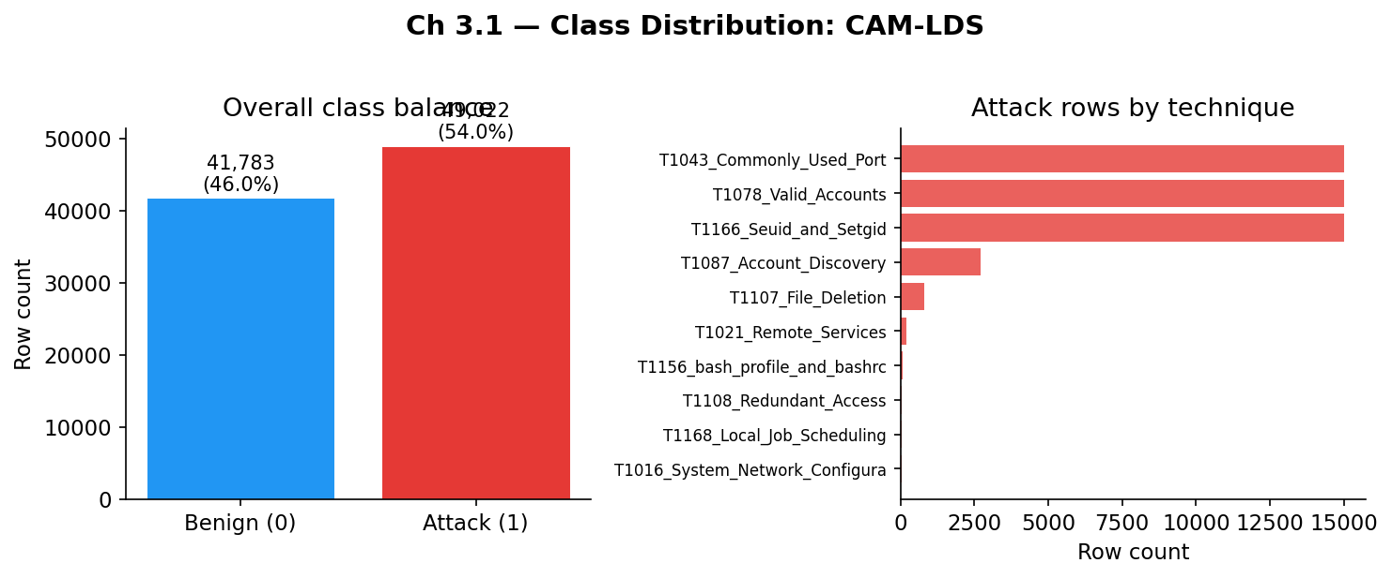
Figure 1: Class distribution for Dataset 1 (CAM-LDS), confirming the near-balanced 46%/54% split.
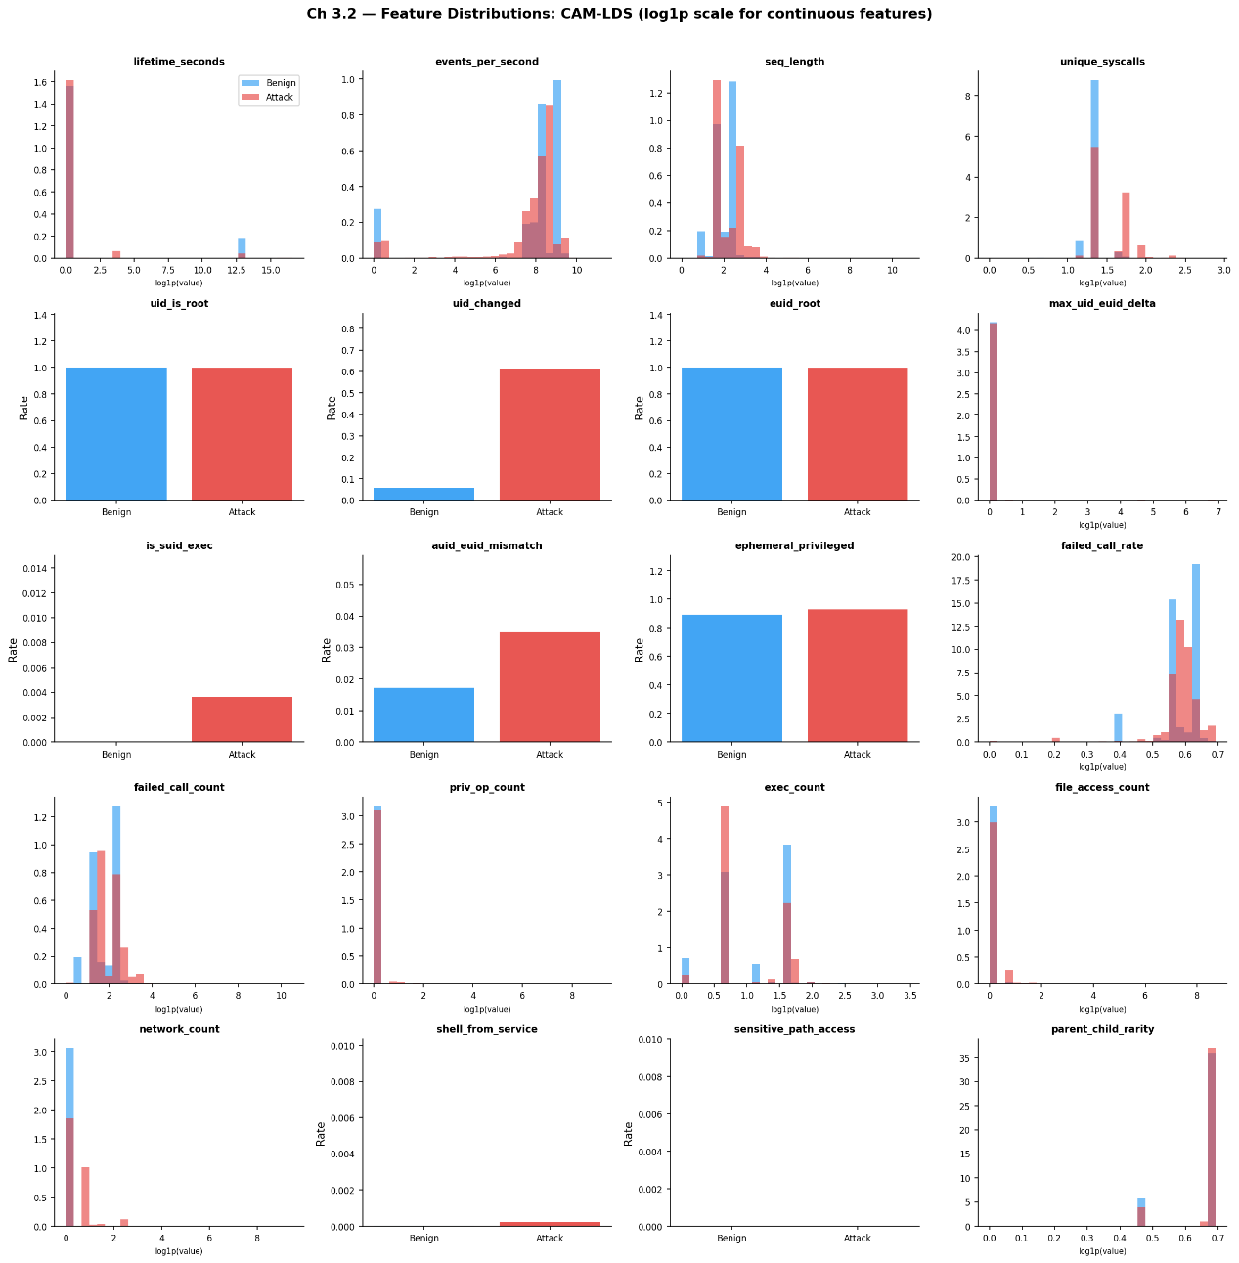
Figure 2: Per-feature distribution plots (benign vs. attack) for all 20 engineered features in Dataset 1.
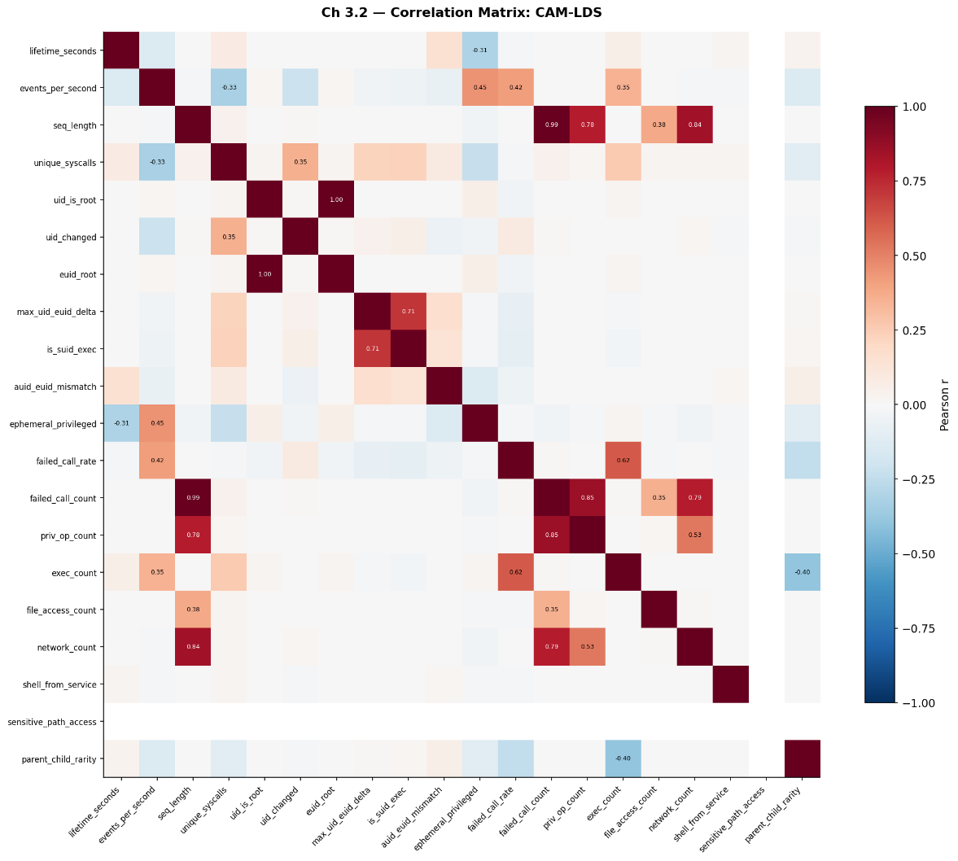
Figure 3: Correlation matrix heatmap for Dataset 1's 20 engineered features; pairs with |r|>0.7 discussed in §3.2.
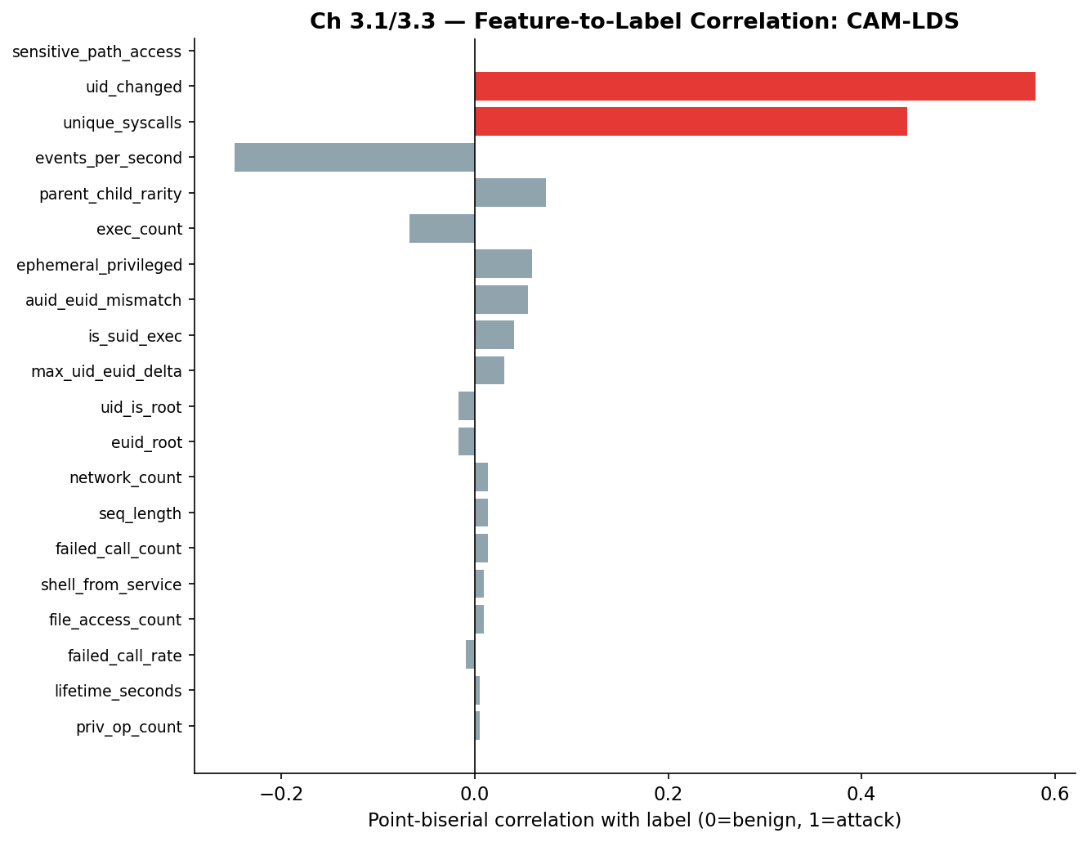
Figure 4: Point-biserial correlation between each feature and the label (benign=0/attack=1), Dataset 1.
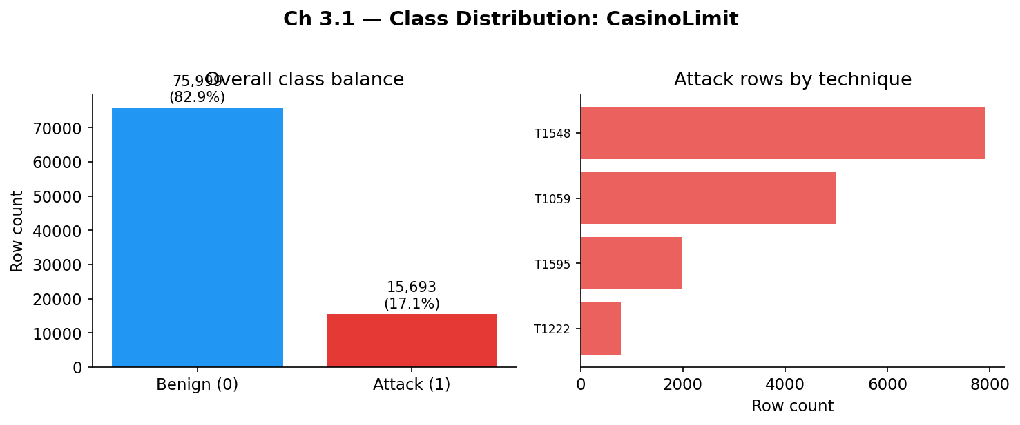
Figure 5: Class distribution for Dataset 2 (CasinoLimit), 4-technique subset, 17.1% attack / 82.9% benign.
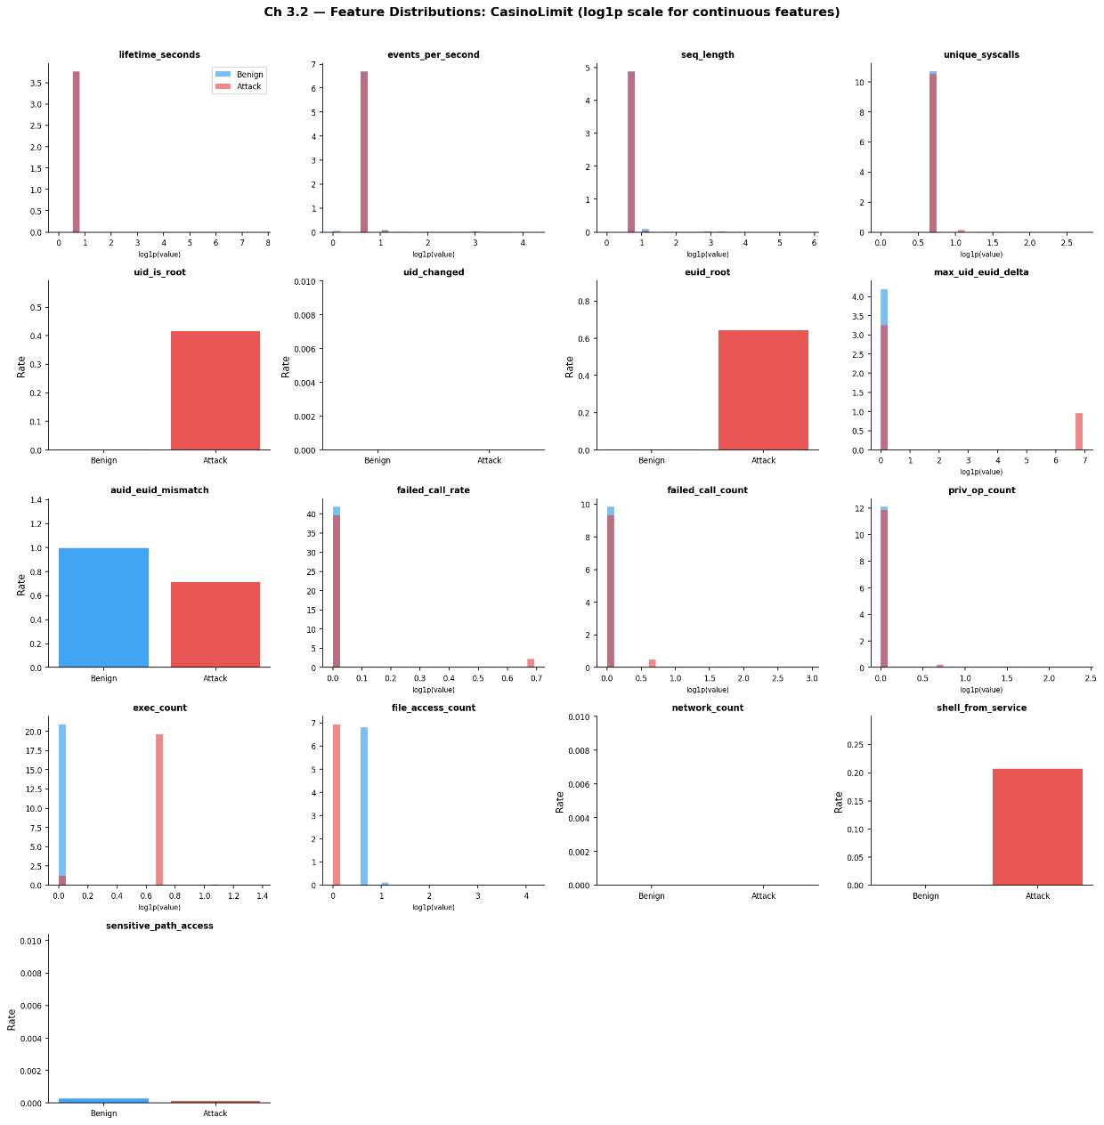
Figure 6: Per-feature distribution plots (benign vs. attack) for CasinoLimit's 17 shared features (log1p scale for continuous features).
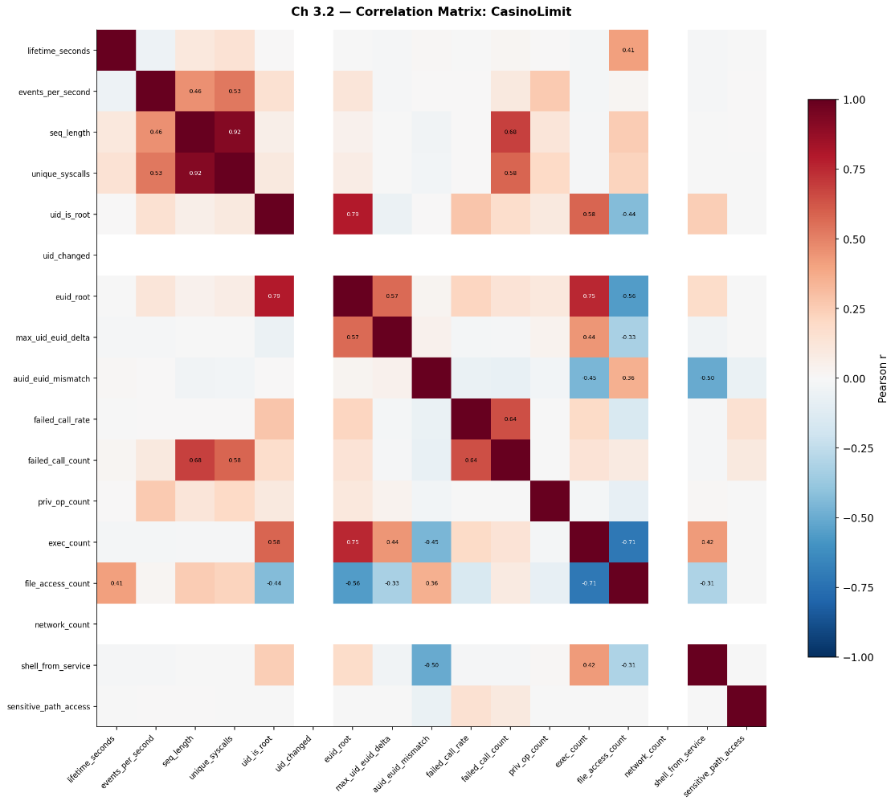
Figure 7: Correlation matrix heatmap for CasinoLimit's 17 shared features.
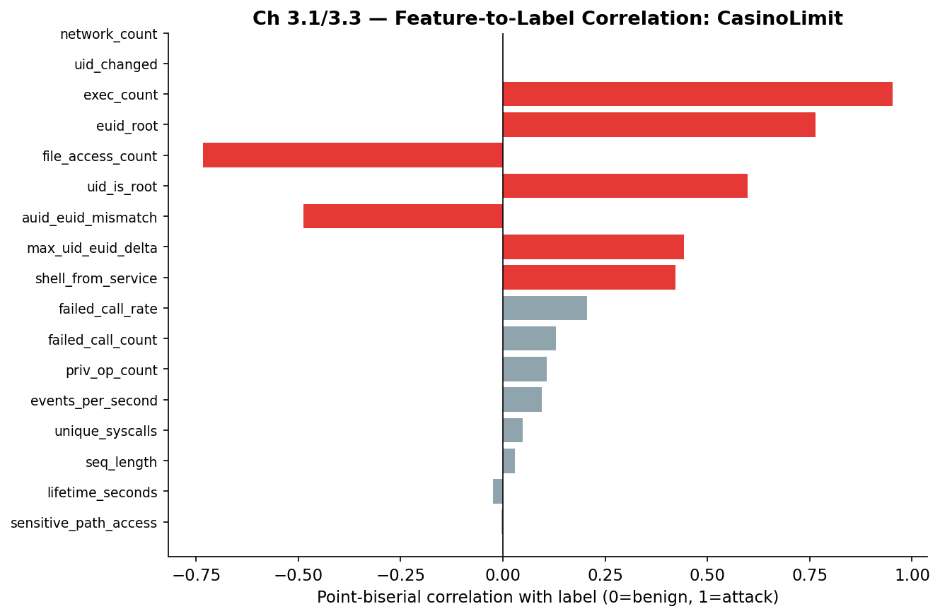
Figure 8: Point-biserial correlation between each feature and the label, Dataset 2.
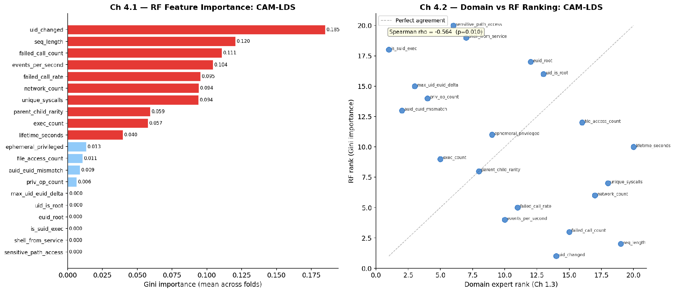
Figure 9: Random Forest feature importance ranking, Dataset 1 (CAM-LDS), 20 features. Top-ranked: uid_changed, failed_call_count, seq_length, events_per_second, failed_call_rate.
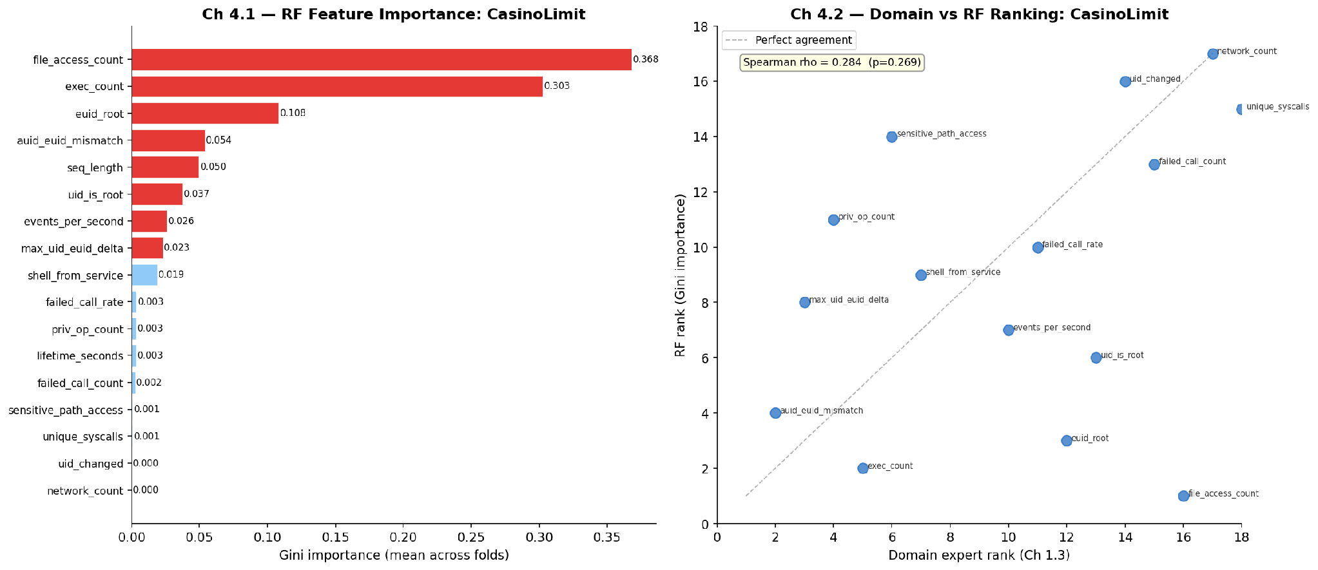
Figure 10: Random Forest feature importance ranking, Dataset 2 (CasinoLimit), 17 features. Top-ranked: file_access_count, exec_count, euid_root, auid_euid_mismatch, seq_length.
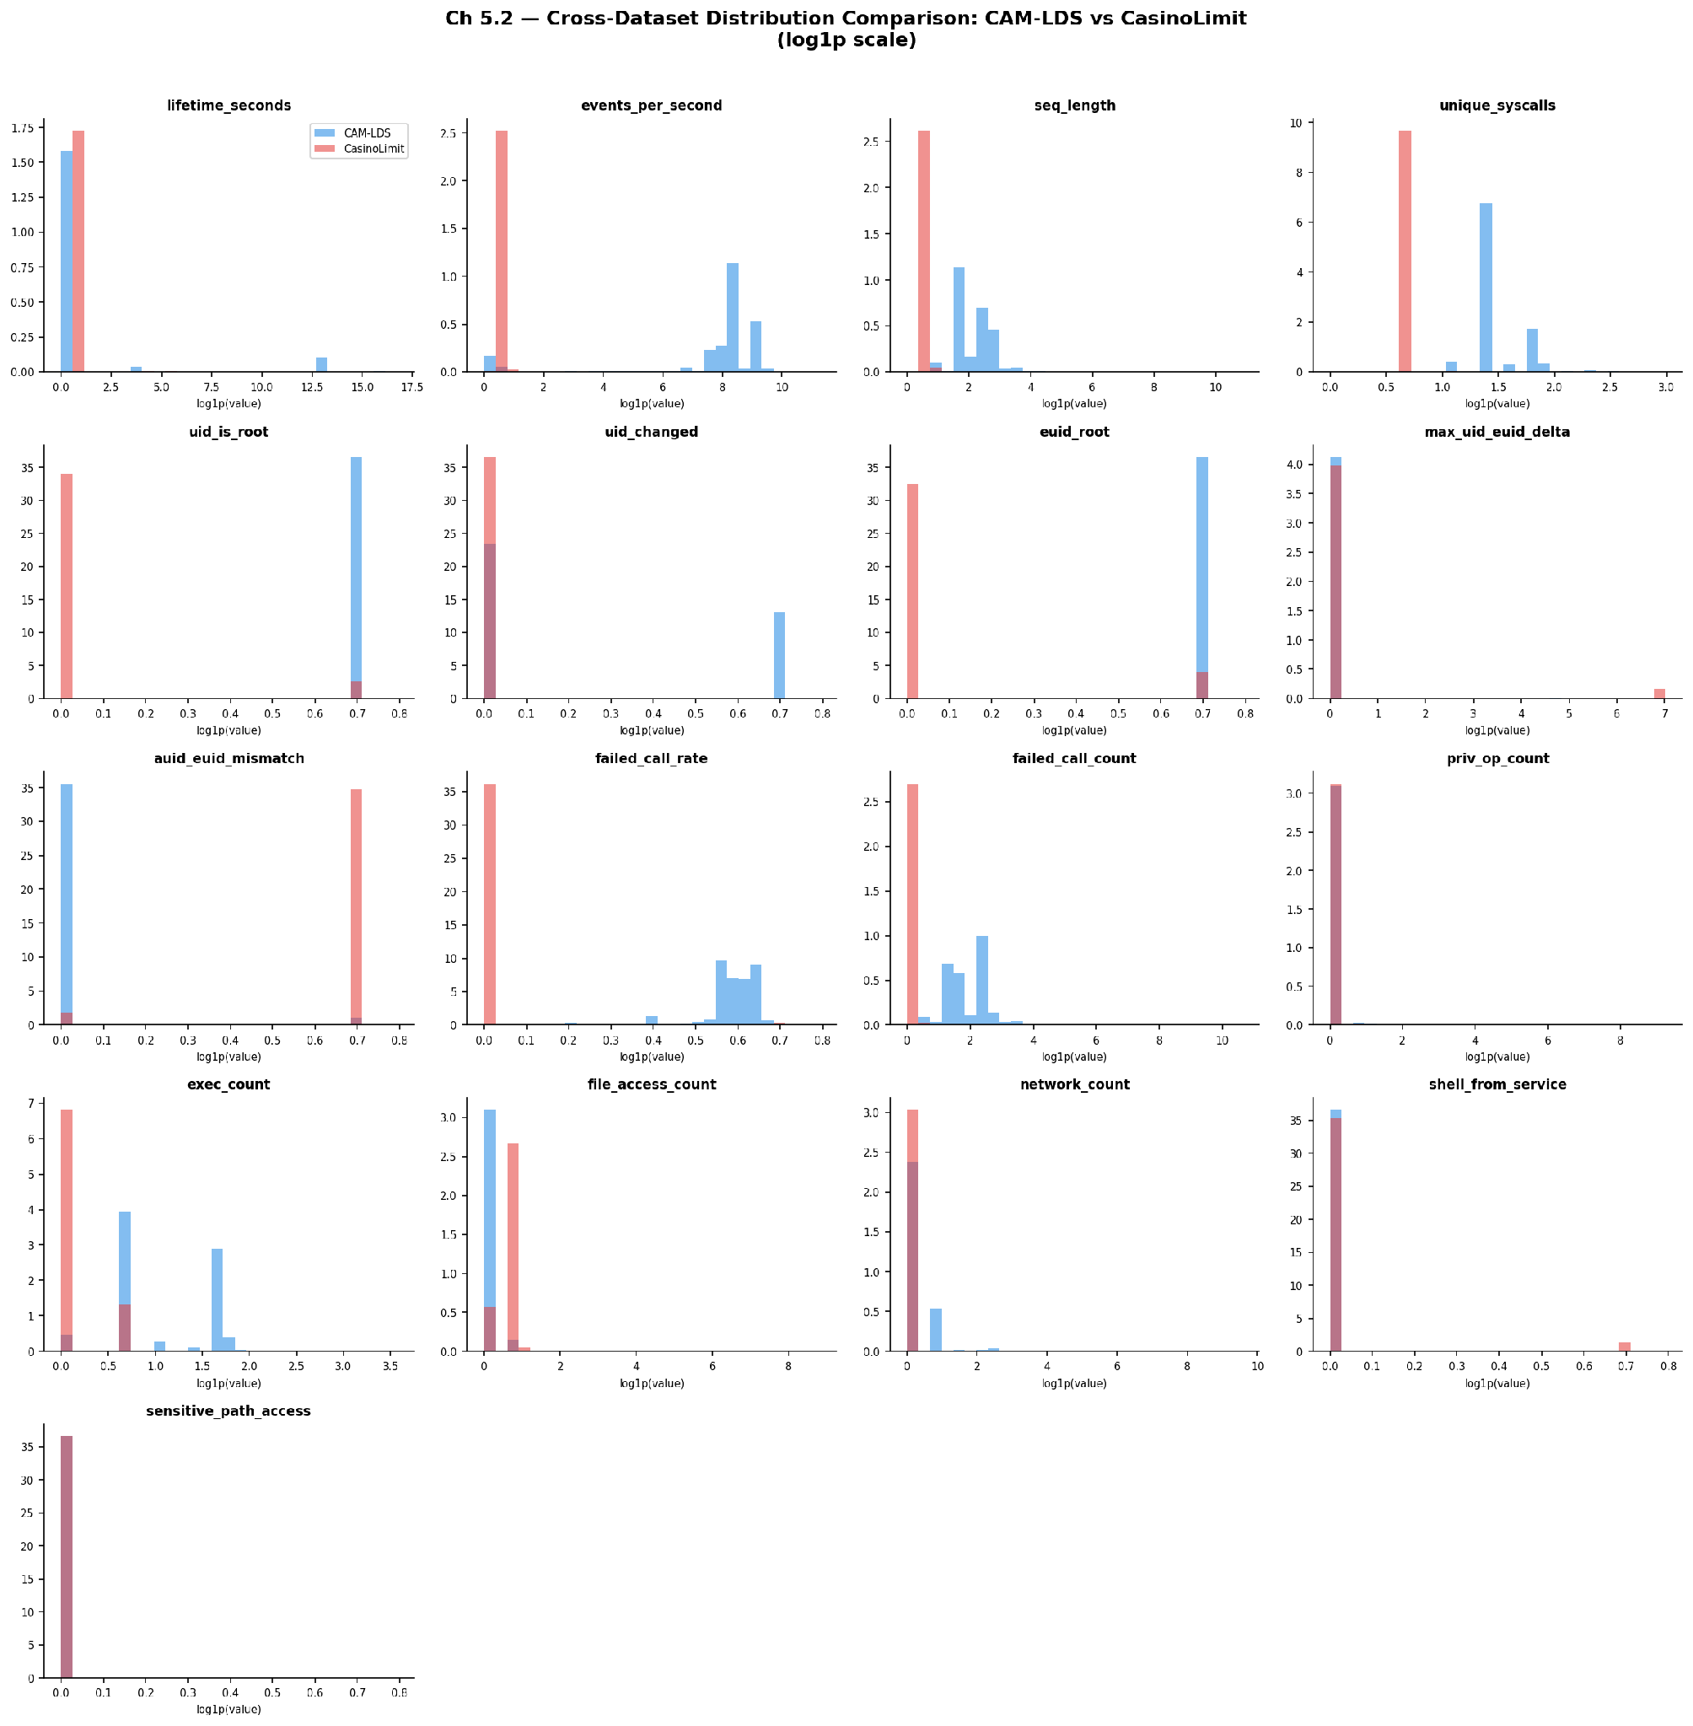
Figure 11: Cross-dataset distribution comparison (log1p scale), all 17 shared features, CAM-LDS vs. CasinoLimit.

