Findings and Discussion

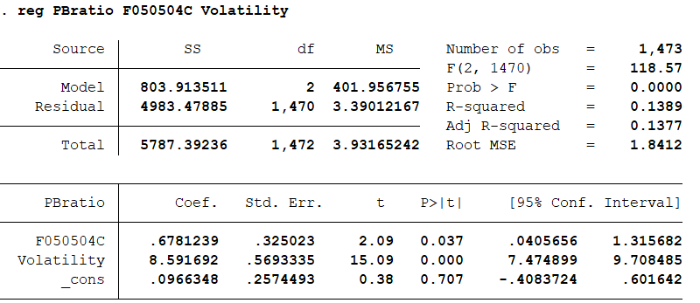

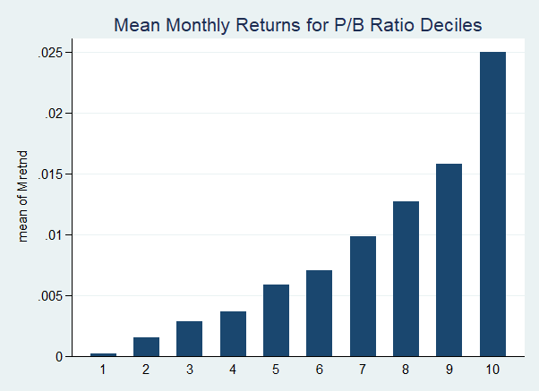

This section summarizes the key empirical findings of the project and discusses possible interpretations.

The return on equity (ROE) is positively associated with the P/B ratio. The regression result shows a statistically significant coefficient of 0.6781 (p = 0.037), indicating that firms with higher profitability tend to have higher valuations.

Volatility is also positively related to the P/B ratio. The coefficient is 8.59 (p < 0.001), suggesting that firms with more volatile stock prices may be more prone to overvaluation. This might reflect speculative behavior in the market.

The R-squared of the regression is 13.89%, meaning the explanatory power is moderate. ROE and volatility explain part of the variation in the P/B ratio, but other firm characteristics and market factors are likely involved.

When firms are grouped into ten portfolios by P/B ratio, average monthly returns increase from the lowest to the highest decile. This is inconsistent with traditional value investing, where low P/B firms are expected to outperform.

One possible explanation is that high P/B stocks are perceived as high-growth or government-supported firms, leading to higher investor attention and return expectations. In China's market, policy support may play an important role.

Overall, the analysis shows that both firm fundamentals and market perceptions affect valuation and return patterns in the A-share market.