Introduction
For this project, I implemented Scenario 4, which requires developing a course selection system with two types of users: students and administrators. The system supports all nine required functions, and each feature has been fully implemented and tested according to the project specifications.
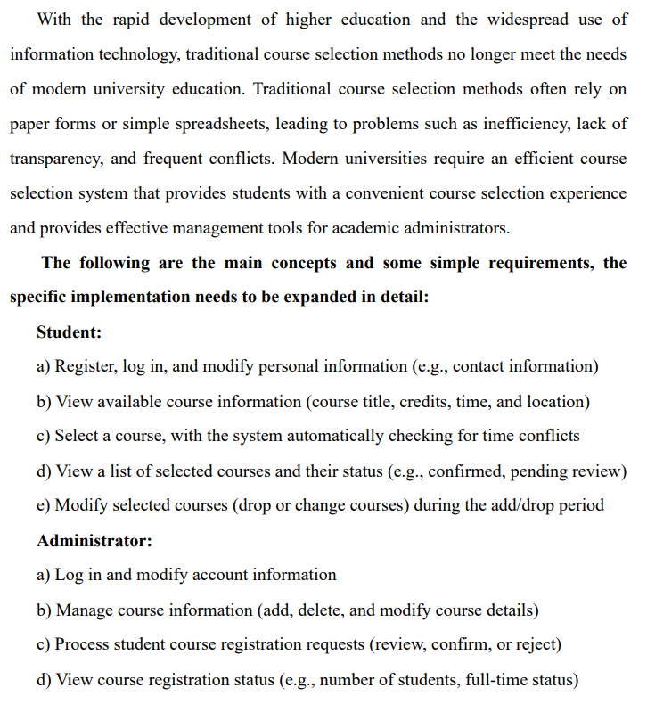
Overview the Structure
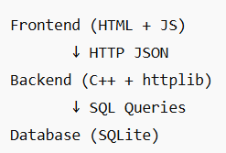
Front End Part
1.login
The login page (login.html) allows users to authenticate as either a student or an administrator. Students who do not have an account can navigate to the registration page to create a new account by providing basic personal information. After successful registration, the user is redirected back to the login page to sign in. Administrator accounts, however, cannot be created from the frontend and must be added manually through the backend.
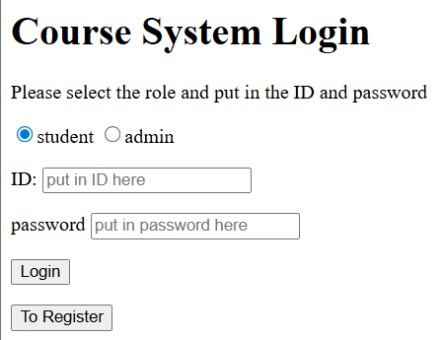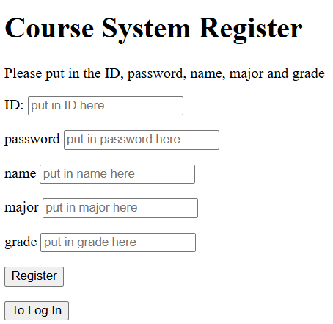
- panel(data center)
After a successful login, students and administrators are directed to different control panels based on their roles. Each panel provides access to role-specific functions through clearly labeled buttons. Additionally, each page contains a header prompt indicating the purpose of the current interface, helping users navigate the system easily.
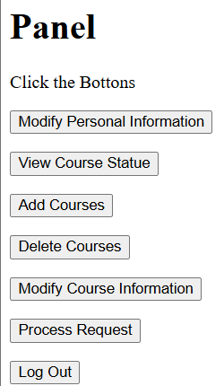
-student
User can 1.modify personal information 2. view available courses 3. select courses 4. drop courses 5. exchange two courses if there are no time conflict 6. view the courses that is selected 7.log out
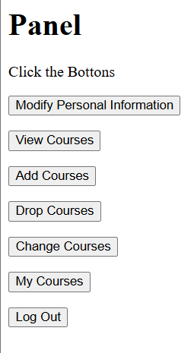

-admin
User can 1.modify personal information 2. view courses information and the registration status 3. add new courses to the database 4. delete courses 5. modify courses information 6. view the pending requests 7.log out

Back End Part
The back end of this project is implemented in C++ using the httplib library to manage HTTP requests and sqlite3 as the database engine. Each incoming request is handled by a dedicated endpoint in main.cpp. The logic for each functional module, such as login, registration, course selection, and course management, is implemented in separate .cpp files to ensure modularity and maintainability. All SQL statements are executed using prepared statements (sqlite3_prepare_v2, sqlite3_bind_*), which effectively prevent SQL injection and improve system stability. In case of any runtime errors, the backend reports detailed messages through the console, allowing quick identification and debugging of issues
Example
- function in main.cpp
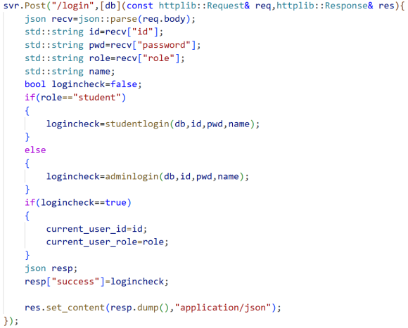.
2. corresponding function in login.cpp
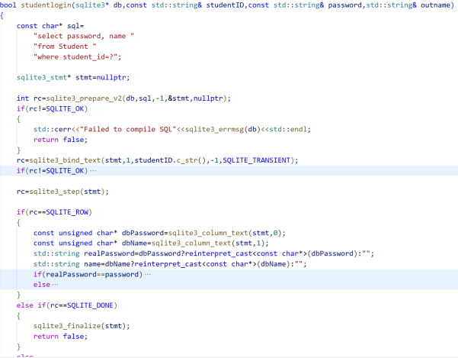

2.
To improve the safety and stability of the system, all database operations are executed using prepared statements, which effectively prevent SQL injection attacks. In the C++ backend, constant references and immutable variables are used whenever possible to avoid unintended modifications and ensure safer memory handling.

The system follows a simple REST-like design, where each function corresponds to a dedicated URL path. All requests use the POST method and transmit data in JSON format.

Overview of routes
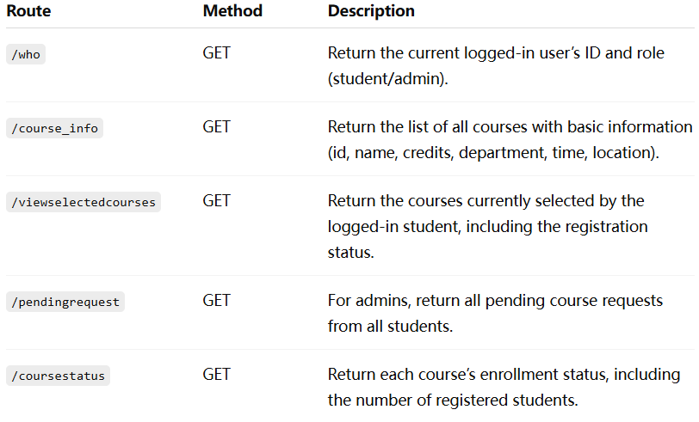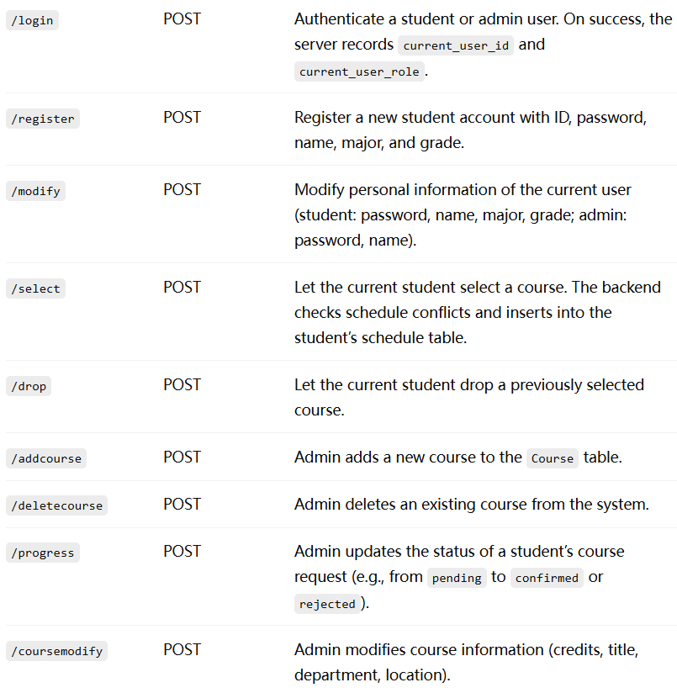

Database Design
The system initializes with three core tables: Student, Admin, and Course.
In addition, the backend dynamically creates a personalized schedule table for each student.
Whenever a new student account is registered, the system automatically generates a new table named Schedule<student_id>, which stores that student's selected courses and their registration status.
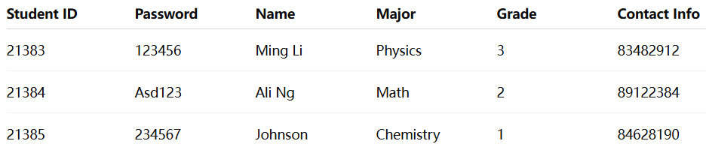
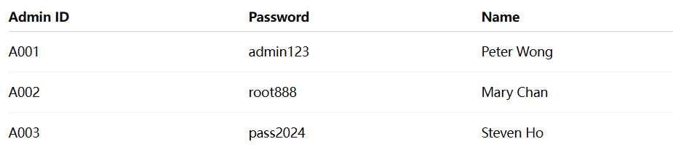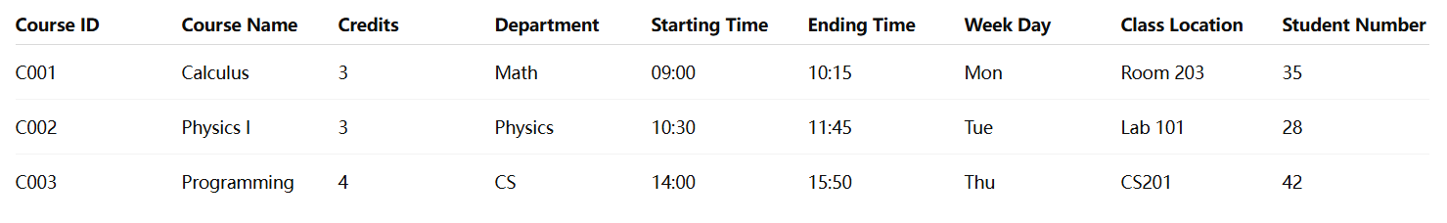


Error handling
Whenever the server encounters an invalid operation—such as attempting to log in without providing an ID, selecting a non-existent course, or performing an action without proper input—it returns a failure message indicating that the operation was not successful. Only valid inputs and legal actions are accepted by the system.
In addition, the backend performs automatic schedule conflict detection. If a student attempts to add a course that overlaps with an existing one, the request is rejected. The system also manages the enrolled student count accurately: when a pending request is approved or when a confirmed course is dropped, the corresponding course’s enrollment number is updated accordingly.


Conclusion
This project provided a valuable opportunity to practice building a full-stack web application, including frontend pages, backend logic, and database integration. Although the CSS styling of the webpages is not fully completed and may be improved in the future, the core functionality of the system has been successfully implemented. The system currently runs locally rather than on an online hosting server, and the hashing feature was not included due to time constraints. Despite these limitations, the project significantly strengthened my skills in HTML, JavaScript, and backend development using C++ and SQLite.

