**What is HTML?**

**HTML** stands for**Hyper Text Markup Language**. It is used to design web pages using the **markup language**. HTML is the combination of **Hypertext** and **Markup language**.

Hypertext defines the link between the web pages and markup language.

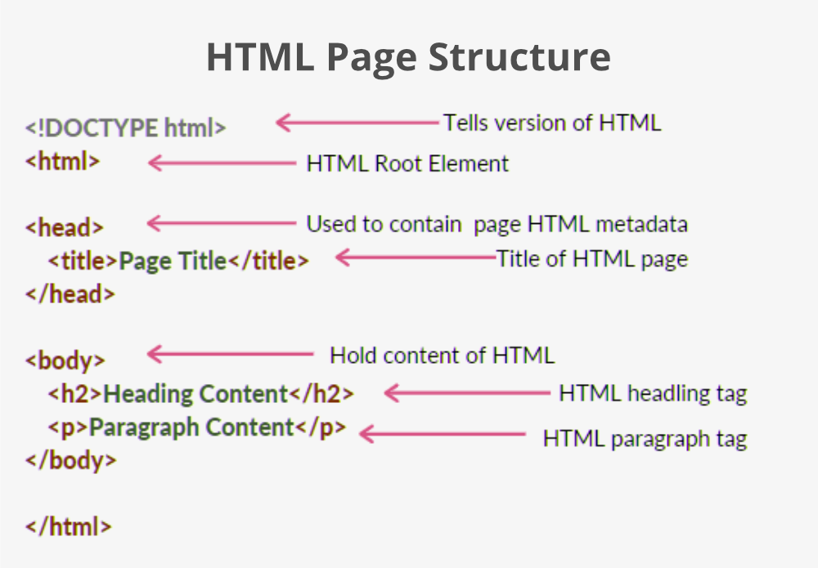

* [**<DOCTYPE! html>**](https://www.geeksforgeeks.org/html-doctypes/)**–** A doctype or document type declaration is an instruction that tells the web browser about the markup language in which the current page is written. It is not an element or tag. The doctype declaration is not case-sensitive.
* [**<html>**](https://www.geeksforgeeks.org/html-html-tag/)**–** This tag is used to define the root element of HTML document. This tag tells the browser that it is an HTML document. It is the second outer container element that contains all other elements within it.
* [**<head>**](https://www.geeksforgeeks.org/html-head-tag/)**–** This tag is used to define the head portion of the HTML document that contains information related to the document. Elements within the head tag are not visible on the front-end of a webpage.
* [**<body>**](https://www.geeksforgeeks.org/html-body-tag/)**–** The body tag is used to enclose all the visible content of a webpage. In other words, the body

content is what the browser will show on the front end.

***2. Semantic and Non-Semantic difference between?***

**A semantic element clearly describes its meaning to both the browser and the developer.** **Examples of non-semantic elements: <div> and <span> - Tells nothing about its content**. Examples of semantic elements: <form>, <table> , and <article> - Clearly defines its content.

***3.What is the difference between html and html5?***

A hypertext markup language (HTML) is the primary language for developing web pages. **HTML5 is a new version of HTML with new functionalities with markup language with Internet technologies**. Language in HTML does not have support for video and audio. HTML5 supports both video and audio.

4.What is the Formatting tags in HTML5?

***4.what is Formatting Elements?***

Formatting elements were designed to display special types of text:

* <b> - Bold text
* <strong> - Important text
* <i> - Italic text
* <em> - Emphasized text
* <mark> - Marked text
* <small> - Smaller text
* <del> - Deleted text
* <ins> - Inserted text
* <sub> - Subscript text
* <sup> - Superscript text

***5.What is the difference between <b> and <strong>?***

Bold tag: The bold (<b>) tag specifies bold text without any extra importance.

Strong tag: The <strong> tag is used to define text with strong importance.