GS Realty Client SOP

- Overview
- Template Sheet: ‘MLS-Comps’
- Template Sheet: ‘Full-MCAO-API’
- Template Sheet: ‘Analysis’
- New UI upload: Complete_LastName_Timestamp.xlsx
- Outstanding To-do

- Overview
  - Please note the updated gs-realty-template.xlsx, and the new detailed Pipeline below. The fields for the analysis page are detailed below, please create documentation and reference data-overlap/Alignment.md if needed for differences between MCAO and MLS. Ask any clarifying questions.
  - Goal: Gain insights into a single property via a generated report from the GSRealty-client portal. For my purposes, this would be for a new listing or a open house to gain insights & increase communications w/ clients.
  - Template: Use gsrealty-client-template.xlsx for the excel uploads from the Admin Dash that should have all necessary fields laid out. Create documentation & plan to implement. All this code and new documentation files to be saved within /Users/garrettsullivan/Desktop/AUTOMATE/Vibe Code/Wabbit/clients/sullivan_realestate/Actual/apps/gsrealty-client. This involves a new UI page called ReportIt. Those details will come after
  - My Pipeline:
    - 1. Subject Property ID (Give APN and/or FULL_ADDRESS) & UI Account Assign (Mozingo)
    - 2. MLS-Comps Upload UI [1.5mile-comps]
    - 3. MLS-Comps Upload UI [3yr-direct-subdivision-comps]
    - Via UI Download of ‘Upload_LastName_Timestamp’
Still Blank is the RENOVATE_SCORE column R.
    - MANUAL ‘RENOVATE_SCORE’, ‘PROPERTY_RADAR-COMPS-Y-N’ & Property-Radar-comp’s enter in Excel
    - MANUAL: Place locally in /RE/Pending-Bin
    - Launch newly created UI page ‘ReportIt’
    - New UI capable of another upload ‘Upload_LastName_Timestamp’ ’ from Pending-Bin
    - Download new .zip that should probably include‘Complete_ReportIt_LastName_Timestamp.xlsx’ (don’t implement this quite yet, we’ll plan out what this .zip contents looks like together, just make a .md for now of what this could entail based on the Break ups insights detailed down below.

- Template Sheet: ‘MLS-Comps’
  - Overview: For output Upload_LastName_Timestamp.xlsx .This is a MLS combined file that brings in the below sheets from the Upload documents section of the UI, including: ‘1.5mile-comps’, ‘3yr-direct-subdivision-comps’ for BOTH 1- Residential (MLS terminology) and 2- Residential Lease. (MLS terminology) . We will also want a Health_check script to run for same alignment for Field headers to ensure consistency in output style hasn’t changed.. Notify via UI if a change. Create dynamic solution to be able to refactor in to what we have, manual intervention here is fine to confirm the changes.

  - 1- Residential ‘1.5mile-comps’
    - Uploaded via UI.
    - ‘1.5mile-comps’ is a MLS generated report with scopes:
      - Closed, Active, Coming Soon, Pending, Cancelled, Accepting Backups
      - Timing of T-12
      - NO: Specific dwelling type
      - +/- 1 BR’s, BA’s
      - +/- 20% of sqft
      - +/- 20% of lot size
    - Note that Column A of 'comps' sheet is added & the MLS uploads will not include a 'Notes' header so all in the MLS uploads should start populating in Column B, always using A blank (manual).

  - 2- Residential Lease ‘1.5mile-comps’
    - Uploaded via UI.
    - ‘1.5mile-comps’ is a MLS generated report with scopes:
      - Closed, Active, Coming Soon, Pending, Cancelled, Accepting Backups
      - Timing of T-12
      - NO: Specific dwelling type
      - +/- 1 for BR’s, BA’s
      - +/- 20% of sqft
      - +/- 20% of lot size
    - Note that Column A of 'comps' sheet is added & the MLS uploads will not include a 'Notes' header so all in the MLS uploads should start populating in Column B, always using A blank (manual).

  - 1- Residential ‘3yr-direct-subdivision-comps’
    - Uploaded via UI.
    - ‘direct-subdivision-comps’ is an MLS generated report with scopes:
      - ‘HOA Name’ or ‘Subdivision’
      - Closed, Active, Coming Soon, Pending, Cancelled, Accepting Backups
      - Timing of T-36
      - NO: Specific dwelling type
      - +/- 1 for BR’s, BA’s
      - +/- 25% of sqft
      - +/- 25% of lot size

  - 2- Residential Lease ‘direct-subdivision-comps’
    - Uploaded via UI.
    - ‘3yr-direct-subdivision-comps’ is an MLS generated report with scopes:
      - ‘HOA Name’ or ‘Subdivision’
      - Closed, Active, Coming Soon, Pending, Cancelled, Accepting Backups
      - Timing of T-36
      - NO: Specific dwelling type
      - +/- 1 for BR’s, BA’s
      - +/- 25% of sqft
      - +/- 25% of lot size

- Template Sheet: ‘Full-MCAO-API’
  - Overview: For output Upload_LastName_Timestamp.xlsx .
  - Note that Column A of 'comps' sheet is added & the MLS uploads will not include a ‘Item’ (updated from ‘Notes) header so all in the MLS uploads should start populating in Column B, always using A blank (manual).
  - Check if MCAO-API consistently pulls in the correct field headers from the API call based on the sheet in the gsrealty-client-template (being mindful that it starts in column B as column A is a manual notes/item section)

- Template Sheet: ‘Analysis’
  - Overview: For output Upload_LastName_Timestamp.xlsx .We want to be creating detailed analysis being conscience of BR, BA, sqft, pricing, etc… But to do that we need to create field mapping alignment documentation to consistently bring in the best matches, for best data population.
  - Field Mapping (Look at /Users/garrettsullivan/Desktop/AUTOMATE/Vibe Code/Wabbit/clients/sullivan_realestate/Actual/apps/gsrealty-client/data-overlap/Alignment.md for higher confidence match if Value is in BOTH MLS-Comps and Full-MCAO-API. Use your best judgement if marked EITHER in this Field Mapping below between the two data sets.
    - Column A: ‘Item’ This is just the title of which .xlsx/.csv upload from the UI i.e. ‘1.5mi’ or ‘direct
    - Column B: ‘FULL_ADDRESS’ This is from column D ‘PropertyAddress’ of Full-MCAO-API
    - Column C: ‘APN’ This is coming from column KA ‘APN’ from Full-MCAO-API.
    - Column D: ‘STATUS’ This is from column R ‘Status’ of MLS-Comps
    - Column E: ‘OG_LIST_DATE’ This is from column N ‘List Date’ from MLS-Comps
    - Column F: ‘OG_LIST_PRICE’ This is from ‘Original List Price’ from column W of MLS-Comps
    - Column G: ‘SALE_DATE’ This is from column T ‘Status Change Date’ IF column R ‘Status’ has value of ‘C’ for closed.
    - Column H: ‘SALE_PRICE’ This is from column Y ‘Sold Price’ of MLS-Comps
    - Column I: ‘SELLER_BASIS’ This is from column AG ‘Owner_SalePrice’ from Full-MCAO-API.
    - Column J: ‘SELLER_BASIS_DATE’ This is column AH ‘Owner_SaleDate’ from Full-MCAO-API.
    - Column K: ‘BR’ This is from column AS ‘# Bedrooms’ from MLS-Comps.
    - Column L: ‘BA’ This is from column AT ‘Total Bathrooms’ from MLS-Comps.
    - Column M: ‘SQFT’ This is from EITHER column AP ‘Approx SQFT’ from MLS-Comps or column EW ‘ResidentialPropertyData_LivableSpace’ from Full-MCAO-API.
    - Column N: ‘LOT_SIZE’ This is from
    - Column O: ‘MLS_MCAO_DISCREPENCY_CONCAT’ This is
    - Column P: ‘IS_RENTAL’ This is from column AO ‘IsRental’ from Full-MCAO-API.
    - Column Q: ‘AGENCY_PHONE’ This is from column D ‘Agency Phone’ of MLS-Comps.
    - Column R: ‘RENOVATE_SCORE’.. MANUAL leave blank
    - Column S: ‘PROPERTY_RADAR-COMP-Y-N’ This should be BLANK for the Upload.xlsx generation.
    - Column T: ‘IN_MLS?’ if a lookup is performed and the record does not exist in the MLS, then value should be ‘N’, if so then ‘Y’
    - Column U: ‘IN_MCAO?’ if a lookup is performed and the record does not exist in the MCAO, then value should be ‘N’, if so then ‘Y’
    - Column V: ‘CANCEL_DATE’ this is ‘Cancel Date’ column U from MLS-Comps.
    - Column W: ‘UC_DATE’ this is column P ‘Under Contract Date’ from MLS-Comps.
    - Column X: ‘LAT’ this is from EITHER MLS-Comps column AN ‘Geo Lat’ or Full-MCAO-API column AL ‘Geo_lat’
    - Column Y: ‘LON’ this is from EITHER MLS-Comps column AO ‘Geo Lon’ or Full-MCAO-API column AM ‘Geo_long’
    - Column Z: ‘YEAR_BUILT’: ‘Year Built’ column AR from MLS-Comps
    - Column AA: ‘DAYS_ON_MARKET’ This is coming from MLS-Comps column CT ‘Days on Market’
    - Column AB: ‘DWELLING_TYPE’ Full-MCAO-API value of column Q ‘PropertyType’
    - Column AC: ‘SUBDIVISION_NAME’ This is from the Full-MCAO-API column L of ‘SubdivisionName’
    - Column AD: Property-Radar-comp-1 MANUAL leave blank
    - Column AE: Property-Radar-comp-2 MANUAL leave blank
    - Column AF: Property-Radar-comp-3 MANUAL leave blank
    - Column AG: Property-Radar-comp-4 MANUAL leave blank
    - Column AH: Property-Radar-comp-5 MANUAL leave blank
    - Column AI: Property-Radar-comp-6 MANUAL leave blank
    - Column AJ: Property-Radar-comp-7 MANUAL leave blank
    - Column AK: Property-Radar-comp-8 MANUAL leave blank
    - Column AL: Property-Radar-comp-9 MANUAL leave blank
    - Column AM: Property-Radar-comp-10 MANUAL leave blank
    - Column AN: Property-Radar-comp-11 MANUAL leave blank
    - Column AO: Property-Radar-comp-12 MANUAL leave blank

- New UI upload: Complete_LastName_Timestamp.xlsx
  - This will generate a .zip file output with naming convention: Break-ups-LastName.xlsx. In a newly created UI page of ‘Upload’ via the site, we will upload the now complete .xlsx & our goal is to have great analysis and visuals (pie chart and line charts) looking at Break ups as core comparison analysis points.
  - Break ups:
      - BR sizes
      - HOA vs not
      - STR vs not
      - RENOVATE_SCORE Y vs N vs .5
      - Comps (Y) vs Comps (N)
      - Within 20% sqft vs not
      - Within 20% est. price vs not
      - Lease sqft vs Expected value sqft
      - PropertyRadar comps vs COMPS-Y-N
      - Property-Radarcomp comparrisons
      - Exact BR vs within +/- 1BR
      - T-36 vs T-12
      - Direct vs Indirect 1.5mi
      - T-12 Direct vs T-12 Indirect 1.5mi
      - Active vs Closed
      - Active vs Pending
      - Δ $/sqft (Y REOVATION_SCORE vs N RENOVATION_SCORE) = Avg $/sqft(Y) − Avg $/sqft(N)
      - Δ $/sqft (.5 vs N) = Avg $/sqft(.5) − Avg $/sqft(N)
      - Interquartile range: 25th to 75th percentile
      - Tails: 10th–90th and 5th–95th percentiles
      - Expected annual NOI leasing
      - Expected annual NOI leasing for N paying cosmetic changes to get to a .5 value.
  - Create a .md plan to implement a downloadable, presentable data for the above Break ups. We’ll plan out together what this .zip file noted in the pipeline.

> We have some logic we need updating. The template is not
fully being observed for MLS Uploads. Make sure for the
sheets 'MLS-Resi-Comps' and 'MLS-Lease-Comps' they are
split up accordingly and expressly detailed in their
respective column A value for the origin input either
'Residential 1.5 Mile Comps', or 'Residential 3 yr
Direct Subdivision Comps' in MLS-Resi-Comps Column A
'Item'. For MLS-Lease-Comps Column A 'Item' should be a
value of either 'Residential Lease 1.5 Mile Comps', or
'Residential Leaase 3yr Direct Subdivision Comps'. For
all addresses, the APN search process should be grabbed
for each of the addresses INCLUDING the subject property
for population in Full-MCAO-API sheet. Then be sure to
get perfect 1:1 matching alignment with the template for
this as well as Analysis (currently not). Ask any
clarifying questions.

- Outstanding To-do
  - What happens when a Property-Radar comp is outside of the 1.5mi radius?
  - Notion SOP shared via the Admin dash where SaaS clients can edit what they see fit for the
  - Markdown report via a ‘Scopes’ question Text box in admin dash when uploading the MLS documents.
  - Upon ‘Generate’ a new upload, create a update for *new* page of UI site ‘Admin Analysis Dashboard’. This should have a (Google Maps or Tableau?) with only values from Analysis marked ‘COMPS-Y-N’ field with value of ‘Y’.
  - Introduce a Debt aspect?
  - Introduce a Rental aspect? Pull comps of what things are renting at.
  - There has to be a manual point as there is no way to scrape MLS pictures for RENOVATE_SCORE to either individual UI Rank or ML train. I don’t even think there’s a way to PULL the link to the Property’s MLS page to jump to sites without manually having to search the MLS.
    - Maybe: Message the agents from the Details page as we know we have that.
    - Maybe: No directly pulling UI tool but rather have a Bot auto-scroll the Details print-off WITH pictures. In-real-time have a feed (literal camera recording a screen) that goes to another Monitoring device, because the rate of scroll & timeline-aware data table of a simple Monitoring Rank-UI could record user responses (Y,.5,N) , it could log & note for a UPLOAD_RENO_SCORE.xlsx for final confirmation before processing export file ‘COMPLETE_RENO_SCORE.xlsx’ that ultimately gives ‘final.xlsx’
  - Cromford Report bring in:
    - At least one
  - PropertyRadar
  - AirDNA STR’s

  - 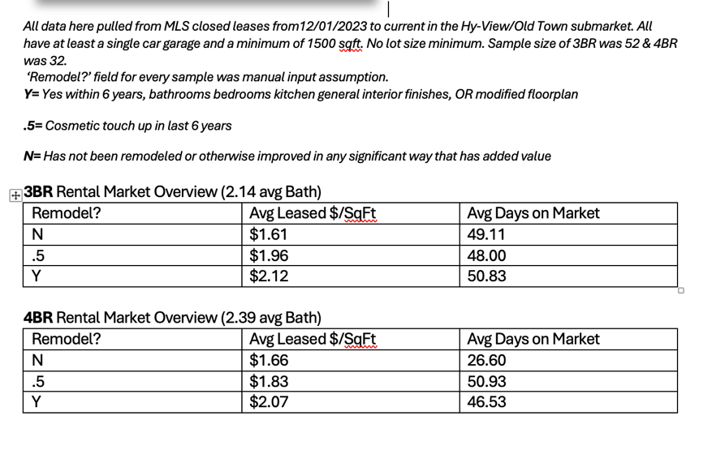
  - Issue for Bringing-In ALLLL 2- Residential Lease ones is that there could be 3,000+ records that would need to go through….
  - 1- Residential Default for Dates range:
    - Under Contract Date = 12 months
    - Close of Escrow Date = 6 months
    - Expire Date = 6 months
    - Temp Off Market Date = 12 months
    - Cancel Date = 12 months
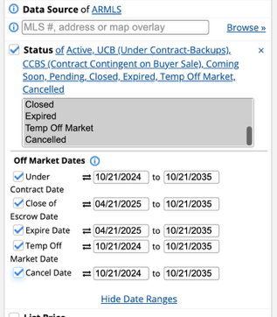

  - 2- Residential LeaseDefault for Dates range:
    - Lease Sign Date = 12 months
    - Lease Start Date = 6 months
    - Expire Date = 6 months
    - Temp Off Market Date = 12 months
    - Cancel Date = 12 months
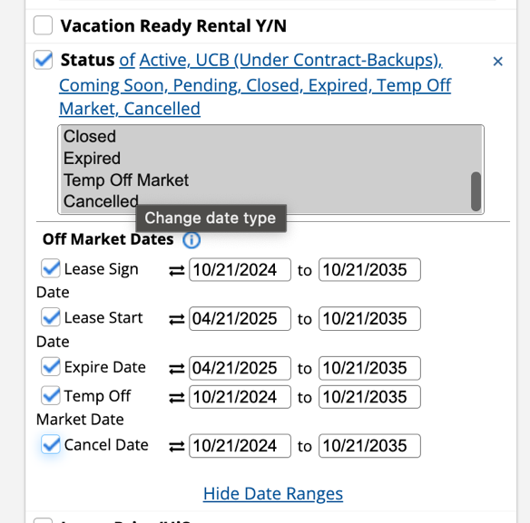

Is there a way to Edit for OTHER defaults?

- Prompt
  - Create a .zip download with the following:
    - Excel output
    - HTML/JSON- Google Maps API w/ Dashboard view

  - Differentiating for Analysis
    - The direct subdivision comps is good to have a T-36 (3 years) as it can give a snapshot to direct comps better & chart over time when comparing to overall market trends.
    - What if shows negative point to sell? Then, all the more reason to say Hey the market’s tougher, let’s bring a stronger product to market.

