Monthly Research Progress Summary
Master's Thesis: Migrating Relational (SQL) Databases to Apache Cassandra
1. Introduction
My Master's thesis addresses a central problem in modern data engineering: how to migrate a relational (SQL) database schema into a wide-column, NoSQL data model such as Apache Cassandra. Cassandra does not support joins and requires a *query-driven*, denormalized data model, which means schema migration is not a mechanical translation — it requires re-thinking how data should be grouped, partitioned, and duplicated to serve an application's access patterns efficiently.
During the last month, I implemented and tested two independent approaches for generating a candidate Cassandra schema from a relational schema, using the DVD Store 2 (DS2) benchmark database (a MySQL e-commerce schema with 8 tables and 52 columns) as the test case:
- A clustering-based approach, which groups columns using semantic embeddings and unsupervised machine learning clustering.
- An LLM-based approach, which prompts Google's Gemini model to reason about the schema directly and propose a Cassandra design.
I ran both pipelines end-to-end, generated concrete outputs (JSON table definitions, CQL schema files, and visualizations), and built a comparison analysis between the two. This document summarizes the implementation, the results, and what they suggest for the next phase of the thesis.
2. Clustering-Based Approach
Purpose
This approach explores whether Cassandra table groupings can be discovered automatically, without any external AI model, purely by measuring how *semantically similar* column names are to each other.
Input
The pipeline connects to the MySQL DS2 database and extracts the schema using MySQL's introspection commands (SHOW TABLES, SHOW COLUMNS FROM <table>). The result is a flat list of strings such as customers.CUSTOMERID, orders.ORDERDATE, etc. It is important to note that only table and column names are extracted — no data types, no primary/foreign key constraints, and no sample data are used anywhere downstream.
Processing and Features
Each table.column string is converted into a 384-dimension semantic vector using the pretrained sentence-embedding model all-MiniLM-L6-v2 (from the sentence-transformers library). A pairwise cosine similarity matrix is then computed across all columns, and converted into a distance matrix (distance = 1 − similarity). The only "feature" driving the entire process is this embedding-based textual similarity of column names — there is no use of column type, cardinality, or query information.
Clustering Technique
The implementation uses Agglomerative Hierarchical Clustering (scikit-learn, average linkage, operating on the precomputed cosine distance matrix). The number of clusters is not learned — it is fixed in advance to equal the number of original SQL tables (8, in the DS2 case).
From Clusters to a Cassandra Schema
Each cluster of columns becomes one candidate Cassandra table. The table name is built by joining the names of the source tables that contributed columns to that cluster (e.g., a cluster combining orders, orderlines, and reorder becomes orderlines_orders_reorder_data). Within each generated table:
- Partition key = the *first column* in the cluster's column list — a positional choice, not one based on cardinality, access frequency, or any scoring method.
- Clustering columns: none are generated. Every resulting table has a single-column primary key.
- Column types: every column is generated as CQL text, regardless of its original SQL type (integer, date, decimal, etc.).
- Relationships between tables: handled only implicitly — if two columns from different source tables (e.g., PROD_ID in products and PROD_ID in inventory) are semantically close, they may end up in the same cluster and thus the same table. There is no explicit foreign-key traversal, because the DS2 schema itself declares almost no foreign keys.
Conceptual Flow
SQL Schema (MySQL introspection) → table.column strings → Sentence Embeddings → Cosine Similarity / Distance Matrix → Agglomerative Clustering (k = number of tables) → Cluster-to-Table mapping → CQL Schema (text columns, single-column partition key, no clustering columns)
3. Gemini / LLM-Based Approach
Purpose
Where the clustering approach relies purely on name similarity, this approach investigates whether a large language model can perform the more nuanced, query-driven reasoning that Cassandra schema design actually requires — reasoning about what data is likely to be queried together, and proposing denormalization accordingly.
Input Provided to Gemini
The same flat list of table.column strings (identical input to the clustering approach) is serialized as JSON and embedded directly into the prompt text. No SQL types, constraints, or query logs are provided — Gemini only sees column names, exactly like the clustering approach.
Prompt Construction
Two separate prompts are sent to the Gemini API (model: gemini-2.5-flash), each prepended with a short system-style instruction framing Gemini as "an expert database architect specializing in migrating relational databases to NoSQL column-oriented databases like Cassandra":
- Prompt 1 (structured request): asks Gemini to group the given columns into Cassandra tables and to "Return ONLY a valid JSON object" mapping table names to column-name arrays, explicitly instructing it to "group columns that are frequently queried together" and to "consider denormalization for query optimization."
- Prompt 2 (detailed strategy): asks Gemini, in free text, to explain (1) the overall migration approach, (2) suggested partition keys and clustering columns, (3) denormalization strategy, (4) which query patterns the design optimizes for, and (5) example CQL statements.
No temperature, sampling, or structured-output/JSON-mode setting is configured for these calls — the API is invoked with its default generation settings, and JSON formatting is requested through prompt wording only, not through a schema-enforcing API feature.
Parsing and Validation
Gemini's response to Prompt 1 is cleaned of markdown code fences (stripping triple backticks and a leading json tag) and parsed with json.loads(). If parsing fails, the failure is logged and the run continues without that output — there is no retry with a corrected prompt, and no validation that the columns Gemini names actually exist in the original schema. A retry mechanism does exist, but only for API rate-limit errors (up to 5 attempts with increasing wait times). Gemini's response to Prompt 2 is not parsed at all — it is saved as-is, as a human-readable text report.
From Gemini's Response to a Cassandra Schema
The structured JSON output (table → column list) is the only machine-readable schema Gemini produces. It contains no partition-key or clustering-key information — that reasoning exists only in the unstructured Prompt 2 text (e.g., "Partition Key: category, Clustering Columns: title, prod_id"), which is never programmatically converted into an executable CQL schema. In the current implementation, no separate CQL file is generated from Gemini's suggestions at all.
Conceptual Flow
SQL Schema (table.column strings) → Prompt Construction (system framing + schema + task instructions) → Gemini API (gemini-2.5-flash, two sequential calls) → JSON response (table→columns) + free-text strategy → Markdown-fence stripping + json.loads() → Validated structured tables (no keys) + unparsed key/denormalization rationale (text only)
4. Results / Outputs
Both pipelines were run against the same DS2 schema (8 tables, 52 columns), and their outputs were compared programmatically.
- The clustering approach produced 7 tables covering 49 of the 52 original columns, with almost no column duplication — its output behaves closer to a straight *partition* of the schema than a denormalized redesign. Every table has a single-column primary key chosen positionally, and no clustering columns.
- The Gemini approach produced 6 tables using 79 column-slots derived from the same 52 source columns — meaning columns are duplicated across roughly 1.5 tables on average. This reflects deliberate denormalization: for example, its order_details_by_order table (25 columns) merges data from orders, orderlines, customers, and products into one wide row, explicitly designed to answer "get everything about this order" in a single query.
- A quantitative comparison (Jaccard similarity between each Gemini table and its best-matching clustering-approach table) showed an average similarity of 58%, with zero table pairs above 90% similarity — the two methods never fully agree on how columns should be grouped, even where they align reasonably well (their best match, on reorder/inventory-related data, was 71%).
What this demonstrates: the clustering approach tends to preserve something close to the original table boundaries (grouping by name similarity mostly recovers each source table on its own), while the Gemini approach actively reorganizes the schema around inferred *query intent* — it is willing to duplicate data across tables in a way the clustering approach never does, because nothing in the clustering approach represents the concept of "a query" at all. However, this richer reasoning from Gemini is only available as human-readable prose; the machine-readable JSON it produces is, in terms of structure, just as key-less as the clustering approach's output. This is an important practical limitation: today, neither pipeline's *automatically parseable* output actually contains a full partition-key/clustering-key design — only Gemini's unstructured text does.
5. Comparison and Discussion
Aspect | Clustering Approach | Gemini/LLM Approach
Basis for decisions | Textual/semantic similarity of column names only | Model's inferred understanding of likely query patterns
Denormalization | Minimal / incidental | Deliberate and explicit
Partition key selection | Positional (first column in cluster) | Reasoned about in text, but not present in structured output
Clustering columns | Never generated | Proposed in text only, not machine-parsed
Determinism | Fully deterministic given the same input | Not deterministic (no fixed seed/temperature); can vary between runs
Explainability | Low — similarity score has no domain rationale | High in free-text output; low in the structured JSON output
External dependency | None (fully local computation) | Requires Gemini API access, quota, and a valid key
Adapting to a new schema | Automatic, no manual work | Automatic, but quality depends on the model's domain reasoning

Advantages of clustering: reproducible, fully local, fast, and requires no external service — useful as a deterministic baseline.
Advantages of the Gemini approach: captures query-driven reasoning and produces human-readable justifications for design choices (something the clustering approach cannot do at all), which is closer to how Cassandra modeling is actually taught and practiced.
Key limitation shared by both, as currently implemented: neither pipeline uses column data types, primary/foreign key constraints, or real query logs — both work from column names alone. This is partly a property of the test schema itself (the DS2 database declares almost no foreign keys), so the current comparison under-tests how well either method would handle a schema with richer relational metadata.
Future work: incorporate column types and any available key constraints into the feature set for clustering; enforce a structured/schema-validated output from Gemini so that its partition/clustering-key reasoning becomes machine-usable rather than prose-only; and, as already outlined in project notes but not yet implemented, incorporate real or simulated query-log data to prioritize which access patterns should drive table design, rather than relying on name similarity or model inference alone.
6. Figures
Three visualizations were generated directly by the project code and are reproduced below (originals available in the output/ folder).
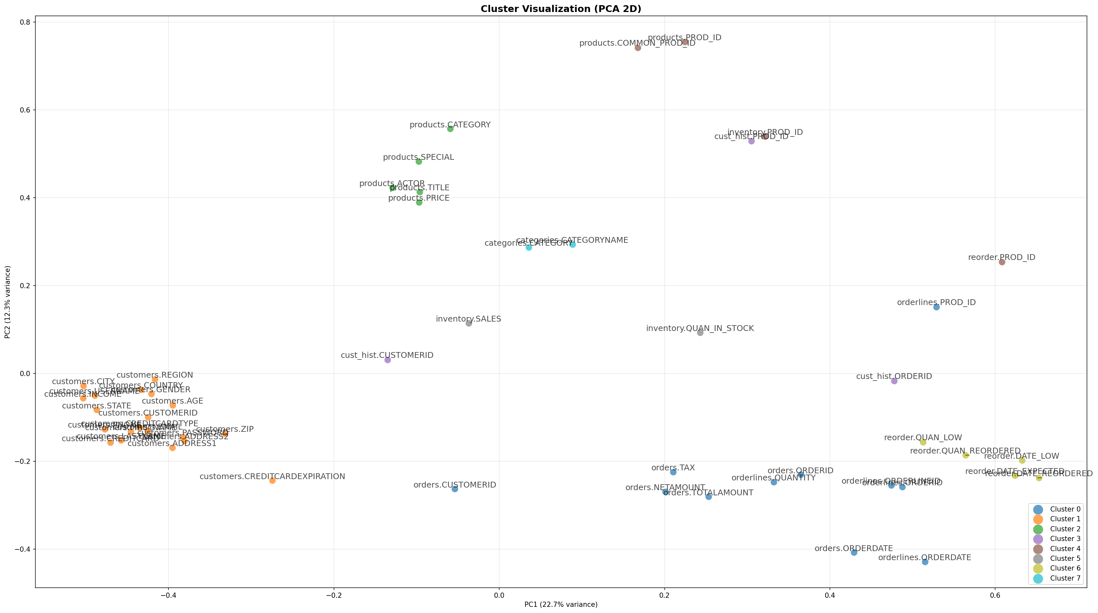
Figure 1 — Clustering approach. 2D PCA projection of column embeddings, colored by the Agglomerative Clustering result. Columns from the same source table (e.g., all customers.* fields) land close together, while cross-table columns sharing naming patterns (e.g., PROD_ID across products, inventory, reorder) drift toward each other in embedding space.
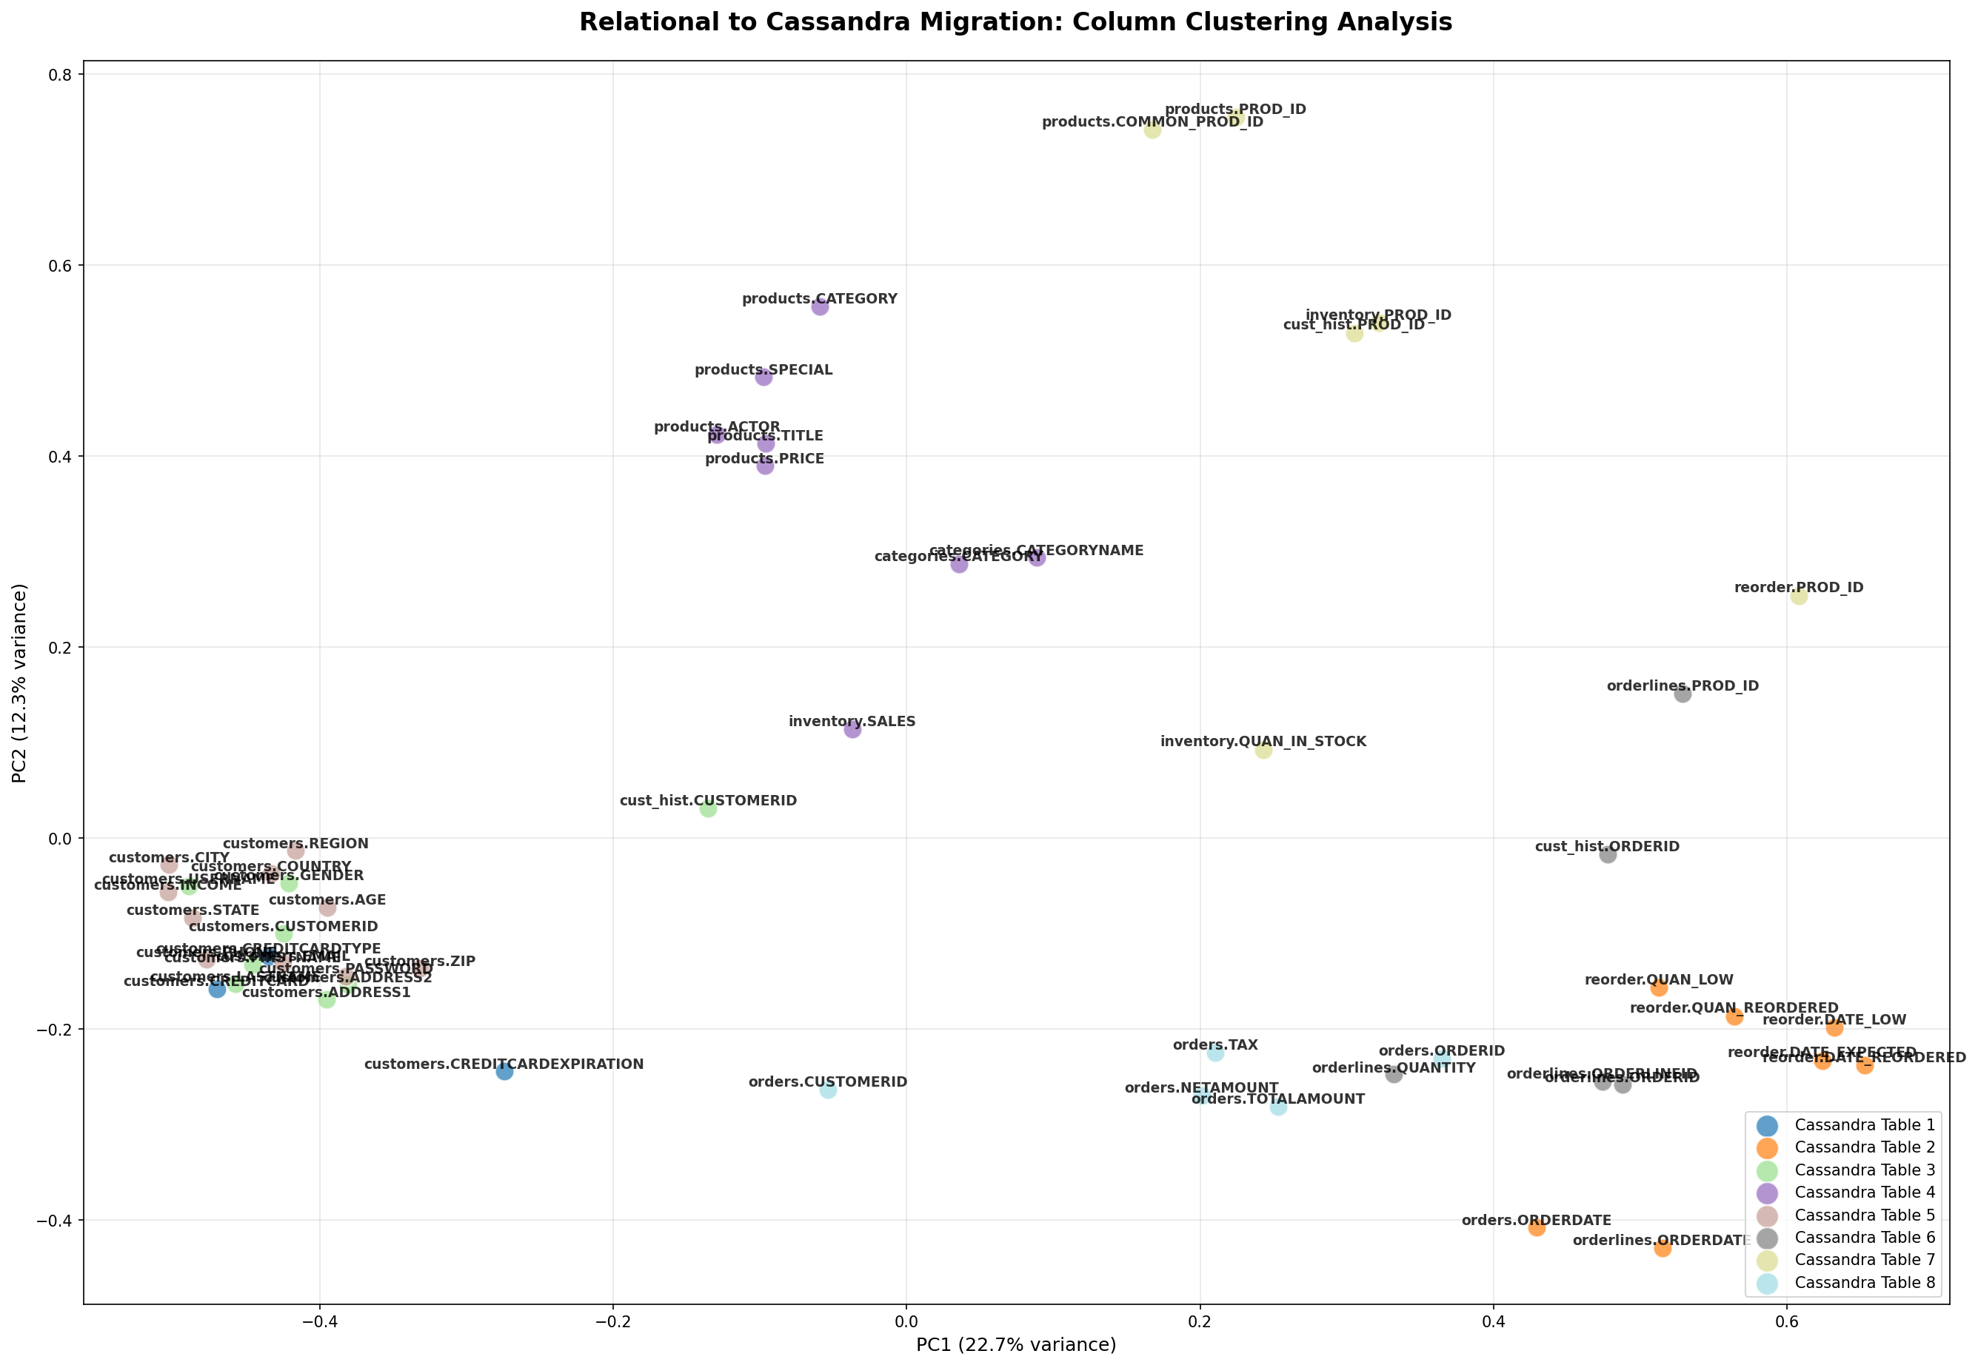
Figure 2 — Gemini pipeline's internal KMeans clustering step. Same style of 2D PCA projection, based on the KMeans clustering computed inside the Gemini script; used for visual comparison against Figure 1.
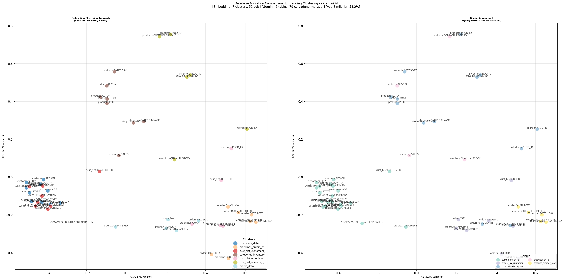
Figure 3 — Side-by-side comparison. Scatter plots directly contrasting the clustering-based table groupings (left) against the columns Gemini assigned to each of its suggested tables (right), making the difference in grouping strategy visually apparent.
Figures to Add in a Future Iteration
- A table-level comparison diagram (e.g., a Sankey or alluvial diagram) showing how columns from each original SQL table were redistributed across the final Cassandra tables in each approach — this would make the denormalization difference more intuitive than the scatter plots alone.
- A side-by-side CQL schema diagram rendering the actual generated CREATE TABLE statements from both approaches next to the original DS2 entity-relationship diagram (DELL-DVD-ERD-diagram.svg, already present in the repository) to visually trace which source tables fed into which target table.
Summary of Progress
- Implemented and ran a clustering-based Cassandra schema migration pipeline using sentence embeddings (all-MiniLM-L6-v2) and Agglomerative Clustering over the DS2 relational schema.
- Implemented and ran an LLM-based migration pipeline using Google's Gemini API, including structured (JSON) and free-text prompting strategies.
- Generated and inspected concrete outputs from both approaches: candidate Cassandra table definitions, a CQL schema file, and PCA-based visualizations.
- Built a quantitative comparison between the two approaches (Jaccard similarity across generated tables), showing an average agreement of only 58% and no near-identical table matches.
- Identified concrete implementation limitations in both pipelines (no partition/clustering-key logic in the clustering approach; Gemini's key-design reasoning existing only as unstructured text) that will inform the next phase of the thesis.
Next Steps
- Extend the schema-extraction step to capture column data types and any declared primary/foreign keys, and feed this information into both pipelines instead of using column names alone.
- Convert Gemini's free-text partition-key/clustering-key reasoning into a machine-parsable, validated schema (e.g., by requesting structured output with an explicit key-design field) so it can be automatically turned into CQL.
- Investigate query-log-driven prioritization, as outlined conceptually in the project's own notes but not yet implemented, to ground table-design decisions in actual or simulated access patterns rather than name similarity or model inference alone.
- Test both pipelines against a schema with richer relational metadata (explicit foreign keys) to evaluate relationship-handling more rigorously than the current DS2 dataset allows.
- Define an evaluation methodology for schema "quality" beyond similarity between the two approaches — e.g., measuring read-query efficiency of the generated schemas against a representative workload.

