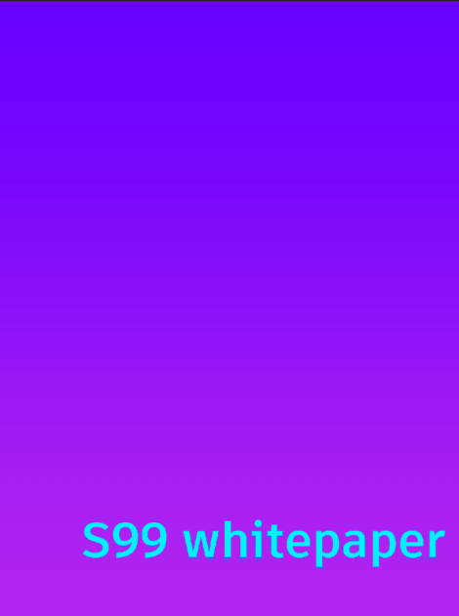

1. **What is S99**

The S99 was launched in September 2021 as a project for the interaction of two emerging and very promising areas of our time. These are streaming and cryptocurrencies. The task of our company is to create an NFT platform for streamers. Using modern blockchain technologies, we are creating a platform where people can participate in the distribution of NFT packs of their favorite streamers, exchange and sell their NFT tokens. Our technology will allow to work with streamers from any platforms like Twitch, YouTube and so on.

Also, participants will be able to take part in various interactive programs from us. For example, rewarding the most active streamer users with rare NFT tokens.

The company wants to unite the community of the cryptoindustry and the world of streamers and believes that project will serve the development of these two leading directions of our life.

1. **What is S99 token (S99)?**

The **S99** token issued by our company will act as a means of payment on our platform.

This token is created on Binance Smart Chain (BSC). Why BSC? Everything is simple!

This ensures that transactions, staking, and NFTS trading are all carried out at the lowest possible cost while keeping the maximum possible yields.

1. **Tokenomics**

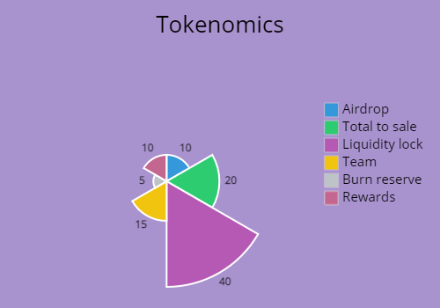

Total supply - 1,000,000 **S99** (100%)

Airdrop- 100,000 **S99** (10%)

Total to sale - 200,000 **S99** (20%)

Liquidity lock - 400,000 **S99** (40%)

Team - 150,000 **S99** (15%)

Burn reserve - 50,000 **S99** (5%)

Rewards - 100,000 **S99** (10%)

The token burning system will be arranged in such a way that 5% of all commissions will be burned. All commissions are understood as commissions on our site and in the BSC network.

Holders of airdrop will be able to sell their tokens only 20% per month, while they will be able to use them in full on our site, without any restrictions.

Contract address will be added shortly.

Follow the next updates on our social media networks.

1. **Rewards**

You will be able to stake S99/BNB on our platform.

For watching streams, you will randomly receive packs with NFT tokens of your favorite streamers. Then you can do whatever you want with them: sell, transfer to other users. In the future, the function of renting your NFT tokens will be added.

Liquidity pools will also be available:

By adding their tokens to liquidity pools, or "LPs," users can contribute liquidity to S99 tokens pools.

When users add their tokens to a liquidity pool, they will receive LP tokens. (AGA tokens version of liquidity provider tokens).

For example, if you combine S99 tokens and BNB in a liquidity pool, you will receive AGA- BNB tokens.

The number of tokens you receive represents your share of the AGA-BNB liquidity pool.

Additionally, you can withdraw your liquidity at any time to redeem your funds. Provision of liquidity is not without risk, as you may suffer a temporary loss.

“In other words, the difference between storing tokens in an AMM and in a wallet is impermanent loss.”

However, it is not all bad news for liquidity providers ,as you will be compensated with trading fees.

When someone trades AGA tokens, they pay a 0.2 percent commission, 0.33 percent of which goes toward the swap pair's liquidity pool.

1. **RoadMap**
2. Launch Token - 09.09.2021
3. AirDrop - 11.09.2021 - 11.11.2021
4. Presale- 12.11.2021 - 29.11.2021
5. Listing on Pancakeswap - 1.12.2021
6. Platform launch - 1.12.2021
7. First streams with our platform - 2.12.2021
8. First NFT drops - 2.12.2021
9. Staking program launch - start of 2022

Follow the next updates on our social media networks.

1. **Presale**

Start date - 12.11.2021

End date - 29.11.2021

Available tokens for sale - 200,000 (20%)

S99 Tokenprice - 0,000003333 BNB

Min buy - 0.01 BNB

Max Buy - 15 BNB

Soft CAP - 1,000 BNB

Hard CAP - 2,000 BNB

If Tokens are sold out at a really fast rate, after every 100,000 tokens sold the price after each AGA token purchase will be increased by 1% to make tokens more expensive and archieve hardcap (faster)

If Tokens are sold out before end of first presale date, then crowdsale will kickoff immediately

If Hardcap is reached during Presale, Or Crowdsale, The tokensale will be halted immediately and unsold tokens will be burnt

If Tokens are not sold out completely at the last date of the crowdsale, all unsold tokens will be burnt as well.

1. **Links**

Our site - s99.info

Telegram - <https://t.me/s99nft>

Twitter - https://twitter.com/CommunityS99