Seminar 1

Object-Oriented Design, IV1350

Ossian Dillner – ossiand@kth.se

2017-05-02

## Contents

1 Introduction 3

2 Method 4

3 Result 5

4 Discussion 6

# Introduction

In preparation for this seminar the students received two tasks to perform, both of these tasks included the development of UML-diagrams describing the system used during a given scenario. The scenario in question being an inspector performing a standard inspection of a customer’s vehicle while utilizing the system described by the student.

More specifically, the first task required the student to create a domain model describing the different entities involved in the scenario and their corresponding associations. This is done in order to gain further perspective and understanding necessary for developing a relevant and well-structured system for handling the given scenario.

The second task was to produce a system sequence diagram which is used to describe what functionality the system contains from the eyes of the end user while ignoring the inner workings of the system. This type of UML-diagram is most commonly used to produce a rough specification of the systems functionality, allowing the client and developer to share a clear picture of their expectations and to hopefully avoid future misunderstandings.

I performed both of these tasks as well as writing this report by myself.

# Method

Task 1

When developing the domain model describing the given scenario I first utilized noun identification to develop an initial draft of the different entities to be included in the model. I then further developed the list of entities using a category list inspired by the list given in chapter 4, subsection 2 of the course literature.

I then eliminated redundant entities that would not further my understanding of the scenario, but rather serve as an unnecessary complication. Continuing this simplification of the entity list I identified entities that would be better represented as attributes of other entities rather than individual ones.

Finally, I added associations between the different entities, making sure that each association clearly defined the relation between the two associated entities in order to further clarify the given scenario rather than complicate it. I also made sure to avoid common pitfalls such as chains or associations or painfully obvious associations.

Task 2

When developing the system sequence diagram, I started out by identifying the actors in the given scenario. The inspector is of course a given actor as he constantly interacts with the system throughout the whole scenario. After identifying the actor, I then included the external systems present in the scenario into the diagram. I then carefully examined all the interactions described by the scenario, making sure to eliminate any action that is does not directly involve the system, such as interactions between actors.

I then started adding these interactions to the diagram, making sure to carefully follow present naming standards to make sure the diagram was as descriptive as possible and bring clarity to the scenario rather than further complicate it.

# Result

Task 1

[Link to higher resolution image of domain diagram.](http://i.imgur.com/dPkQsvO.jpg)

In fig. 3.1 or on the page in the above link you can see the domain diagram that I’ve designed. It’s fairly simple, only containing what I consider the necessary entitities and actors detailed in the given scenario.

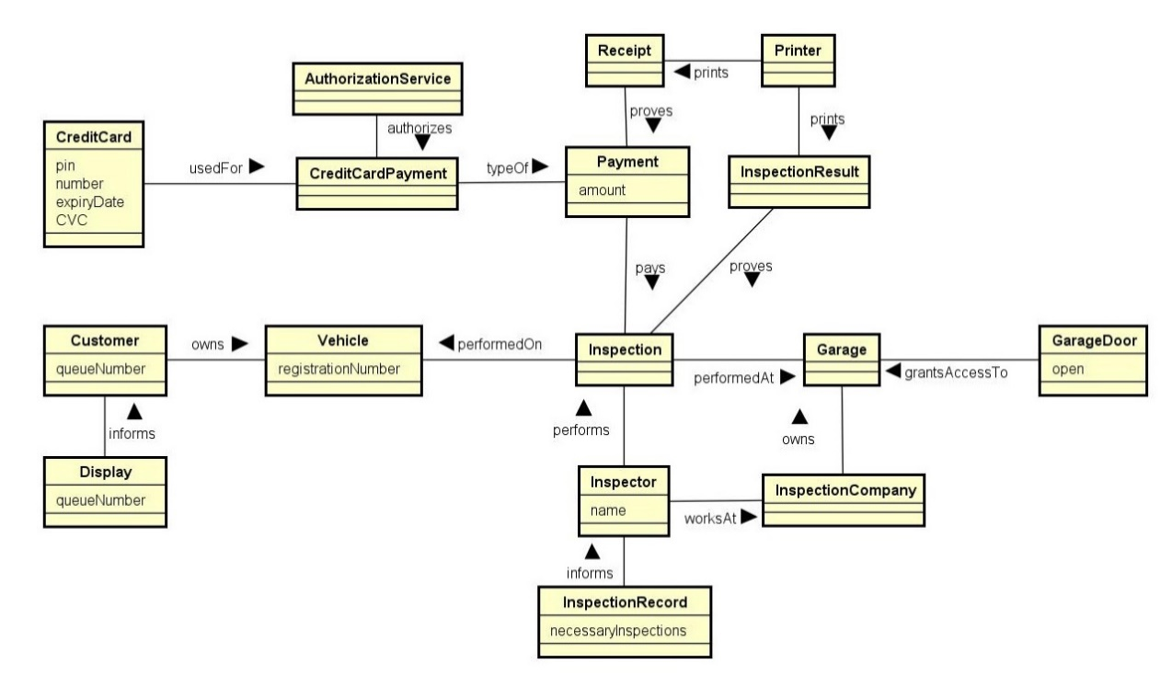

Fig 3.1

Task 2

[Link to image of complete system sequence diagram.](http://i.imgur.com/PAcojkl.jpg)

Because the system sequence diagram that I designed is far too unwieldy to display in it’s whole in the report you’ll have to follow the above link for a complete view of the aforementioned diagram.

The diagram in itself is fairly simple and straightforward, barring from perhaps the two loops illustrated in fig 3.2 and fig 3.3, both of which are I will explain further.

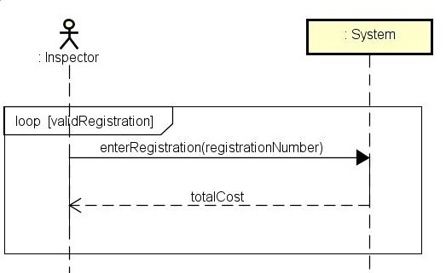

Fig 3.2

This operation describes the process of entering the customers vehicle into the system and how the inspector has to keep entering new registration numbers in case the previously entered one is not valid, which can happen for a multitude of reasons.

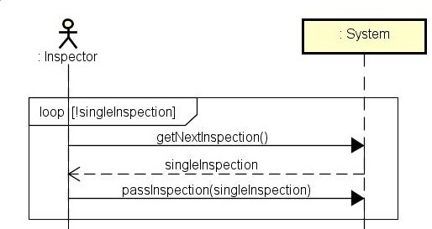

Fig 3.3

This operations describes the main inspection process where the inspector asks for a single inspection to perform on the vehicle, if such an inspection exists the inspector then performs the given inspection and inputs the results of said inspection into the system. The inspector repeats this process until all the inspections are finished and the system no longer has anymore inspections to give the inspector.

# Discussion

As far as I can tell, both the system sequence diagram and the domain diagram mostly fulfill the assessment criteria. However, I find it quite difficult to concretely assess and evaluate the aforementioned diagrams as the process of creating the diagrams and their purpose appear to be very subjective, especially regarding the domain diagram.

While performing the later seminar tasks I’ve often gone back to the system sequence diagram as I’ve found it a useful depiction of exactly what features the system is expected to contain, unfortunately, I’ve not found the domain diagram as useful.