**Recovery on the Harbor**

***Position Description***

TITLE: Peer Leader

REPORTS TO: Volunteer Coordinator/Director

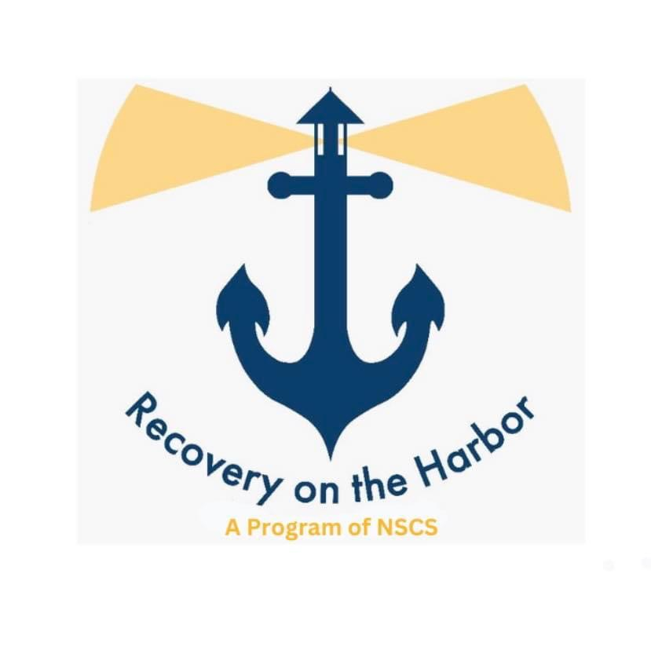SUMMARY: The Peer Leader works as an integral part of the Team. The Peer Leader will perform but not limited to the following duties: serve as a role model, mentor, advocate, and motivator in order to help promote long-term recovery, and to perform all the essential volunteer duties to Recovery on the Harbor membership, and community.

ESSENTIAL FUNCTIONS:

Position Specific Duties:

* Provide a model for both members in or seeking recovery and staff by demonstrating that recovery is possible.
* Share personal recovery experiences in order to foster authentic peer-to-peer relationships.
* Ongoing education and learning commitment on individual pathways of recovery, drug, and alcohol treatment system.
* Assist members to identify their personal interests, goals, strengths and challenges regarding recovery.
* Assist members developing their own, self-directed Wellness Plan for advancing their recovery and increasing their recovery capital; for “getting the life they want.”
* Promote self-advocacy by assisting members to have their voices fully heard; their needs, goals and objectives established as the focal point of their recovery while receiving community-based services.
* Be a resource broker
* Support connections to community based, mutual self-help groups. Provide hope and encouragement for opportunities at varying levels of involvement in community-based activities (e.g., work, school, relationships, physical activity, self-directed hobbies, etc.).
* Outreach to individuals in or seeking recovery from substance use in the community.
* Outreach, orient, and develop relationships with community-based service providers and agencies.
* Attend and participate at resource fairs and on Substance Addition Task Force meetings, etc.
* Provide orientation to new members and educate on the participatory process.
* Learn and utilize recovery-based language (e.g. member not client, medicated supported recovery not drug replacement, etc.).
* Provide group facilitation and one on one peer support.
* Respond to crisis by assessing severity of the situation, de-escalating the member(s), and ***assist*** in resolving the crisis.
* If needed, respond to emergency situations by placing calls to Fire, Rescue, Police, and Medical, etc.

Administrative Tasks:

* Participate in required supervisions, volunteer meetings and trainings.
* Participate and cooperate in any investigations conducted by internal and external agencies.

Compliance Requirements:

* Remain awake during your shift at all times.
* Attend all mandatory trainings.
* Adhere to program/project/department requirements and services.

QUALIFICATION REQUIREMENTS: The Peer Recovery leader must perform each essential function satisfactorily. Reasonable accommodations may be made to enable individuals with disabilities to perform essential functions. The qualifications listed below are representative of the knowledge/skill and/or ability required.

* At least 90 days in recovery; Must be an active Volunteer; Must be an active member in the center, and have attended the New Member Orientation; Must have an understanding of the participatory process and the peer-to-peer model.

**Volunteer Non-Cash Incentive**

* Monthly Stipend: Recovery on the Harbor will provide two Peer Leaders

with a monthly stipend of $100 in the form of gift cards.

* Each Peer Leader must volunteer a minimum of 20 hours at the Recovery Center within the given month.
* At the end of the month, Peer Leaders will submit a timesheet detailing their hours worked and the activities they participated in. Upon receipt, the Volunteer Coordinator will verify hours for compliance, obtain the Center Director’s sign-off, and prepare the gift cards.
* The gift cards will be presented at the first Community Meeting of the following month to acknowledge Peer Leaders’ contributions and encourage ongoing participation in the Recovery on the Harbor community.

ACKNOWLEDGEMENT

I have read this position description and understand my responsibilities and the knowledge, skill and/or ability required to satisfactorily perform the essential functions. I understand from time to time I may be required to perform job functions that are not included in this position description.

I will abide by all guidelines in the Code of Conduct & Ethics.

______________________________________________ _____________________________________

Peer Leader Signature Date

______________________________________________ _____________________________________

Staff Signature Date