Materials Design for Data Center Thermal Management and Waste Heat Recovery:
Dielectric Fluids, Gallium Liquid Metals, and Embedded Two-Phase Cooling
Michael Bustamante^{1,2}, Kristina Lilova²
¹Odinzen LLC, Houston, TX, United States
² Center for Materials of the Universe, School of Molecular Sciences, Arizona State University,
P.O. Box 871604, Tempe, AZ 85287-1604, USA

Corresponding author Michael Bustamante, Email: michaelbusta@odinzen.io
Highlights
AI data center waste heat depends strongly on coolant material selection.
Dielectric immersion cooling captures waste heat at 65 to 75 °C for district heating.
Gallium liquid metals: 200–600× the thermal conductivity of dielectric fluids.
Embedded two-phase microfluidics remove up to 1 kW/cm² of heat at the chip surface.
The coolant melting range can be tailored by varying the alloy composition.
Graphical Abstract
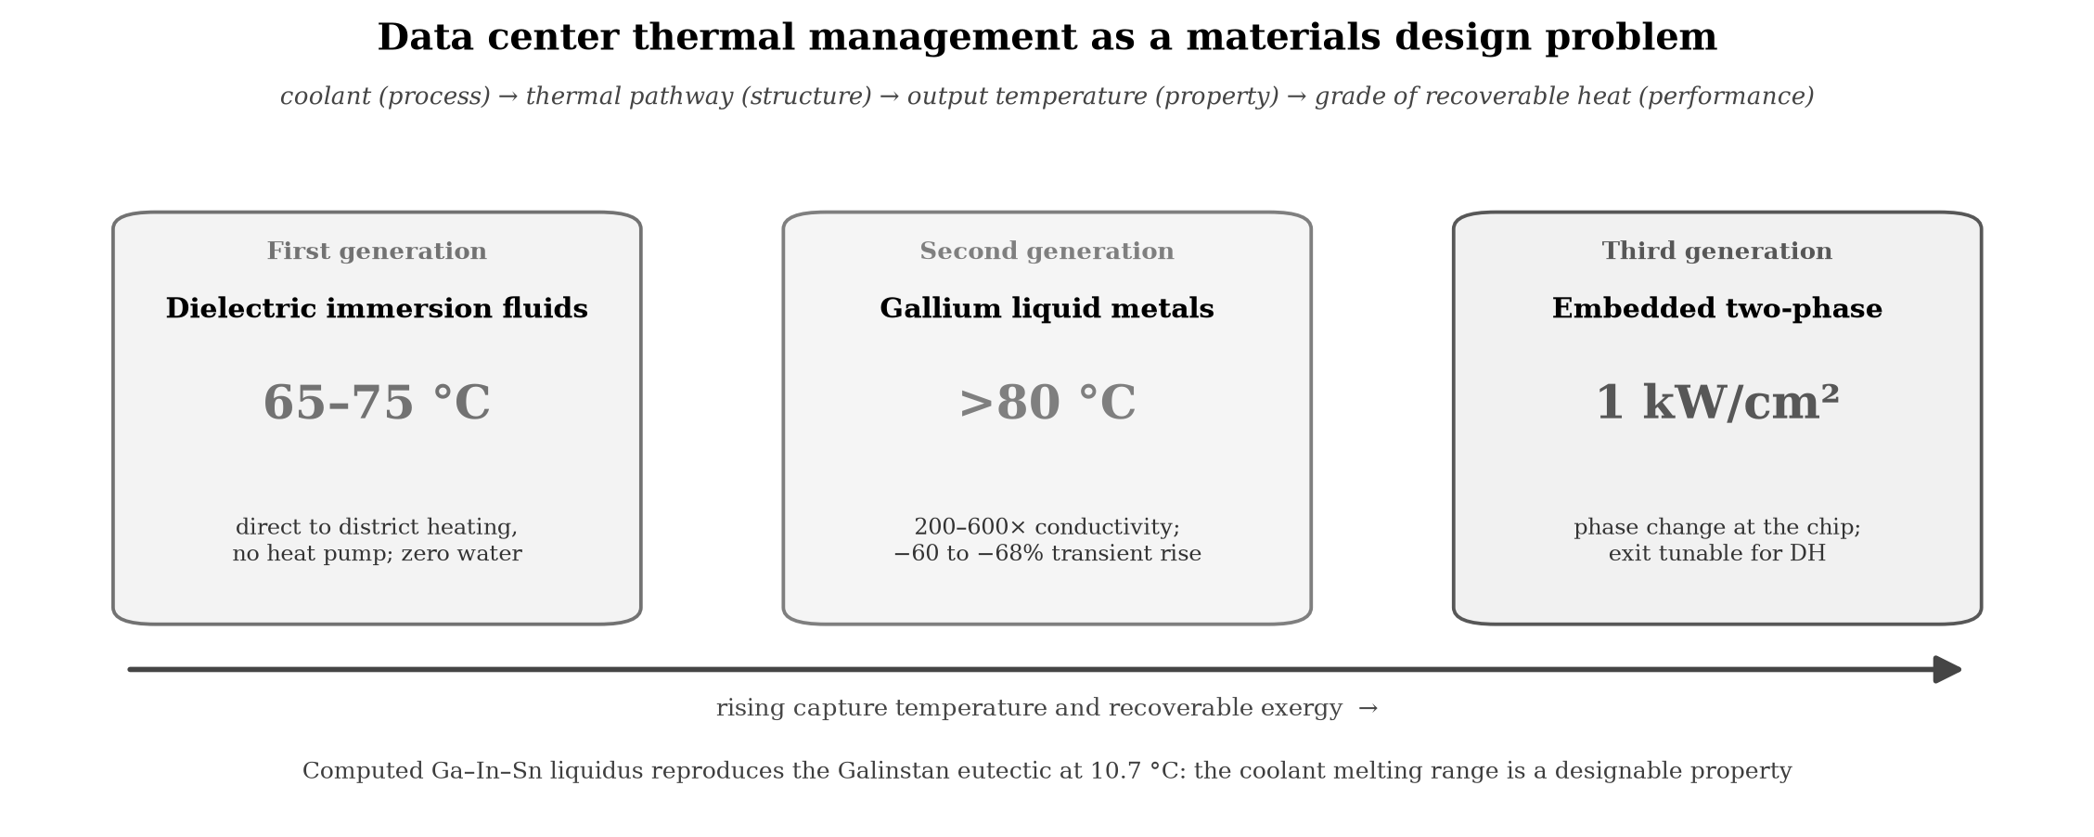

Abstract
AI and large language model data centers will exceed 1,000 TWh of annual electricity by the end of 2026, and nearly all of it leaves the facility as heat. The present study treats data center thermal management as a materials design problem: coolant selection (process) determines the thermal pathway (structure), which sets the output temperature and resistance (property), and ultimately defines the grade of recoverable waste heat (performance). Three coolant generations are examined. Dielectric immersion fluids, which capture waste heat at 65 to 75 °C, are directly usable for district heating without heat pumps, and six operating systems are documented. Gallium based liquid metals increase thermal conductivity 200 to 600 times in comparison with the dielectric fluid and reduce the transient temperature rise by 60 to 68 percent. Embedded two phase microfluidics, demonstrated at 1 kW/cm², extend the approach to the chip. Across these generations the coolant melting range emerges as a designable rather than a fixed property; a companion thermodynamic assessment of the Ga–In–Sn system establishes this quantitatively. The materials choice is shown to be an energy systems decision with direct consequences for waste heat recovery, water use, and carbon displacement.
Keywords – Data center thermal management; Immersion cooling; Gallium liquid metals; Phase change materials; Waste heat recovery; CALPHAD

1. Introduction: The Thermal Problem as a Materials Problem
Every processor turns electricity almost entirely into heat. As AI inference and training scale, that heat becomes a large and fast growing thermal resource. The International Energy Agency projects that AI data centers will exceed 1,000 TWh of annual electricity by the end of 2026, approximately seven times the electricity used for global Bitcoin mining [1]. Recovered at sufficiently high temperatures, a resource of that size could supply a meaningful share of the space and water heating demand of northern Europe. Whether it can be recovered is set by one choice: the type of cooling material, and the temperature at which it delivers heat.
Bitcoin mining set the precedent. Operators submerging mining rigs in dielectric fluid have delivered the resulting heat into district networks. A Scandinavian container of 160 immersed rigs delivers about 1.7 MW to a grid that heats roughly 2,000 homes. The operator, Latvia-based Power Mining, describes itself as a heating company that also mines Bitcoin [2]. A Manitoba installation of 360 liquid-cooled servers captures about 90% of its input power as 75 °C heat for a greenhouse [3]. In Dublin, an Amazon Web Services data center supplies waste heat to a Technological University campus [4]. Mining adopted immersion cooling, renewable sourcing, and heat reuse three to five years before AI infrastructure met the same constraints at larger scale, and those solutions are now the engineering baseline for AI data centers.
These systems share a common engineering feature: the cooling material determines the output temperature, and the output temperature determines the heat's industrial utility. Air cooled systems reject heat at 25–35 °C, which is below the 60–80 °C supply temperatures typically required by district heating networks [5]. Immersion in dielectric fluid raises the capture temperature to 65–75 °C, crossing the district heating threshold. Gallium based liquid metals, which exhibit thermal conductivities two to three orders of magnitude higher than dielectric fluids, can raise output temperatures above 80 °C while simultaneously managing the escalating heat flux densities of AI accelerators. The choice of cooling material is therefore an energy systems design decision, not merely a thermal engineering one.
The analytical frame is the process, structure, property, and performance paradigm of Olson [6]. The coolant selection (process) sets the thermal pathway (structure), which determines the output temperature and thermal resistance (property), which defines the grade of recoverable heat (performance). Each cooling generation is therefore not merely a thermal upgrade but a redefinition of the downstream energy product. This materials to device view extends prior work linking coolant and surface selection to system level heat recovery [7].
The present study examines three generations of data center cooling materials: dielectric fluids, gallium based liquid metals, and embedded two phase microfluidic systems. It documents the operating systems that validate first generation technology, reviews the materials science frontier of second and third generation systems, and identifies the engineering gap between laboratory demonstration and facility scale operation.
The energy baseline comes from the Cambridge Centre for Alternative Finance's Digital Mining Industry Report (April 2025), a survey of 49 firms covering 48% of global hash rate [8]. Bitcoin mining consumes 138 TWh/yr (upper estimate 211 TWh [9]) with a sustainable energy share of 52.4% (42.6% renewables, 9.8% nuclear).
These figures carry a selection bias. The Cambridge survey's respondents are disproportionately publicly listed (41%) and North American, whereas the unreported 52% includes operations in Central Asia and Africa where coal and gas typically dominate. The true global sustainable share may therefore be materially lower than 52.4% [8].

2. Thermodynamic Framework
The thermodynamic limits of waste heat recovery are determined by the first and second laws of thermodynamics. The first law postulates that energy is conserved, and the second law requires a progressive degradation in energy quality. Electricity enters the facility as high grade exergy and leaves as low grade heat at 65 °C, which is suitable for space and water heating but not for mechanical or electronic work. Although the total energy is conserved, its ability to perform useful work decreases irreversibly.
A heat pump delivers 3–4 joules of thermal energy per joule of electricity consumed (coefficient of performance (COP) of 3–4). A mining rig delivers approximately 1 joule of heat per joule of electricity, plus cryptocurrency revenue. Using waste heat as a heat source is therefore thermodynamically inferior to a heat pump for pure heating purposes and is economically competitive only when computation revenue offsets the COP gap. The materials question is how to maximize the temperature and quality of the rejected heat so that the gap narrows and the coproduct value increases. The same principle applies to AI data centers, where revenue is generated by training and inference services rather than by cryptocurrency mining, making waste heat recovery a secondary benefit of computational activity.

3. First Generation Cooling Materials: Dielectric Fluids

3.1. Thermal properties and performance envelope
Single phase immersion fluids, engineered hydrocarbons or synthetic esters, exhibit thermal conductivities of 0.06–0.14 W/m·K, specific heat capacities of 1.5–2.1 kJ/kg·K, and operating ranges from −40 °C to +200 °C [10, 11, 12]. They are chemically inert, not electrically conductive, and not flammable. Two phase fluorocarbon fluids have higher heat transfer coefficients through phase change latent heat, but several formulations fall under PFAS ((per- and polyfluoroalkyl substances) classification, which may limit future applications [13, 14]. PFAS-free alternatives, including hydrocarbon-based fluids, ester-based fluids, and nanoparticle-enhanced coolants, are under active development but have not yet demonstrated thermal performance comparable to fluorinated dielectric fluids in published studies. The broader liquid cooling market for AI data centers is projected to grow from $2.8 billion in 2025 to over $21 billion by 2032 at 30%+ CAGR, underscoring the industrial scale of this materials challenge.
Single phase fluids exhibit measurable total acid number (TAN) increases after 8,000–12,000 hours of continuous operation above 60 °C, indicating oxidative degradation. Replacement intervals of 5–8 years are typical for closed loop systems with adequate oxygen exclusion [10, 11, 12]. Operational complexity at scale (leak detection, fluid quality monitoring, modified fire suppression, and maintenance retraining) represents substantial transition cost for facilities migrating from air cooled architectures.

3.2. The temperature gradient breakthrough
District heating networks require supply temperatures of 60–80 °C [5], while air cooled data centers produce waste heat at 25–35 °C. Bridging this temperature gap typically requires heat pumps, adding approximately $500,000–$2 million in capital costs while increasing electricity consumption. As a result, data center waste heat recovery has historically been limited to a relatively small number of specially built facilities. Immersion cooling fundamentally changes the approach to waste heat recovery. By submerging electronic components in dielectric fluid, heat can be recovered at 65–75 °C, a temperature range compatible with conventional district heating networks without the need for a heat pump. Commercial systems have already demonstrated that capability, with Power Mining reporting coolant outlet temperatures of approximately 65 °C and Canaan producing water at 75 °C [2, 3]. From a materials design perspective, this improvement is due to the coolant rather than the hardware. Within the process, structure, property, performance framework, the dielectric fluid selection (process) creates a direct chip to fluid thermal pathway (structure), resulting in 65–75 °C output temperature and low thermal resistance (property), which yields district heating grade waste heat (performance). This perspective emphasizes that coolant selection determines not only the cooling performance but also the downstream integration of data centers with thermal energy systems.
Beyond commercial applications, academic research has expanded the operating envelope beyond current industrial practice. Birbarah et al. demonstrated direct water immersion cooling of high power density electronics at over 500 W/cm², roughly twice the industrial leading edge, by employing hydrophobic conformal coatings to enable safe submersion of active components [15]. This result establishes that even within first generation cooling materials the pairing of fluid selection and surface engineering can substantially extend the achievable heat flux envelope.

3.3. Water elimination
Evaporative cooling, the dominant paradigm for large, air cooled data centers, consumes approximately 110 million gallons of freshwater annually for a medium facility (~10 MW), with 80% permanently lost through evaporation [16]. For an equivalent 10 MW immersion-cooled facility, water consumption associated with cooling is effectively zero, as the dielectric fluid circulates in a sealed closed-loop system without evaporative losses. Each 100-word AI prompt processed in an evaporatively cooled data center has been estimated to consume approximately 519 mL of water, including both direct cooling and indirect water use associated with electricity generation [17]. At the national scale, U.S. data centers are estimated to consume approximately 163.7 billion gallons of water annually [16]. Replacing evaporative cooling with immersion cooling eliminates freshwater use by the cooling system entirely.

4. Engineering Validation: Operating Systems

4.1. Documented heat reuse systems
Six operational commercial systems validate the first generation materials approach (Table 1). The Dublin AWS scheme is the only system with independently measured emissions data: 704 tCO₂ abated in 2024, verified by TU Dublin [4]. For the Bitcoin mining systems, environmental claims are based on engineering projections from reported specifications, not measured outcomes. The commercial systems include: Power Mining (Scandinavia), 160 immersed rigs, 1.7 MW thermal, 65 °C output, approximately 2,000 homes heated; Canaan/Bitforest (Manitoba), 360 liquid cooled servers, 75 °C output, greenhouse heating capturing approximately 90% of consumed electricity [2, 3]; MintGreen (Lonsdale, BC), providing 96% of a commercial building's heating demand from mining waste heat [18]; and AWS Dublin, AI and cloud waste heat delivered to a university campus with independent CO₂ measurement [4].

Table 1. Standardized comparison of the six heat-reuse systems. Thermal output (MW) and output temperature (°C) are listed where reported (n.r. = not reported). All environmental claims are engineering projections except AWS Dublin, the only system with independently measured CO₂ abatement.
System | Thermal | Output | Application | Verification
Power Mining (Scandinavia) | 1.7 MW | 65 °C | district heating, ~2,000 homes | projection
Canaan / Bitforest (Manitoba) | n.r. | 75 °C | greenhouse heating | projection
MintGreen (Lonsdale, BC) | n.r. | n.r. | building heating, 96% | projection
MARA / MintGreen digital boiler | n.r. | n.r. | Lonsdale Energy buildings | projection
Tallaght scheme (Heat Works) | n.r. | n.r. | district heating | projection
AWS Dublin | n.r. | n.r. | university campus, 704 tCO₂ | measured (TU Dublin)

4.2. Lifecycle CO₂ displacement model
The annual CO₂ displacement of a representative system can be estimated from published specifications. Table 2 sets out the calculation for a single Power Mining container (1.7 MW thermal output, 65 °C, operating in a Nordic climate with an eight-month heating season); the result is an engineering projection, not a measured value.
Table 2. Lifecycle CO₂ displacement model for a single 1.7 MW Power Mining container over an eight-month heating season. Values are engineering projections from published specifications.
Quantity | Value | Basis
Thermal output | 1.7 MW | Power Mining specification [5]
Annual operating hours | 5,840 h | eight-month Nordic heating season
Delivered thermal energy | 9,928 MWh/yr | 1.7 MW × 5,840 h
Displaced-fuel emission factor | 0.20 / 0.27 / 0.38 tCO₂/MWh | natural gas / fuel oil / peat
Annual CO₂ displacement | 2,000–3,800 tCO₂ | by displaced fuel, full utilization
Mining-electricity emissions | 0.29 tCO₂/MWh | Bitcoin mix, 52.4% sustainable
These estimates assume full thermal utilization during the heating season and exclude district-network distribution losses (typically 5–15%). The net climate benefit is the difference between the displaced heating emissions and the emissions of the electricity consumed by the mining hardware, which at the current Bitcoin energy mix amounts to approximately 0.29 tCO₂ per MWh.

4.3. Scalability and geographic constraints
Finland, Sweden, Denmark, and Norway supply more than 50% of their space heating through district heating networks. AI data center waste heat can be readily integrated into these systems because of the long heating season (8–10 months), extensive district heating infrastructure, supportive municipal policies, and relatively high conventional heating costs [5]. At the European scale, recoverable data center waste heat has been estimated to meet the heating demand of several million homes by 2035 [19]. Replicating the same model outside Scandinavia presents several challenges, since most cities in North America and Asia lack district heating infrastructure, and constructing new networks requires substantial capital investment, typically on the order of $5–20 million per kilometer. Year round heat applications such as greenhouses, aquaculture, and industrial process heating can extend geographical applicability without removing the seasonal constraint.
District heating networks are typically designed for service lifetimes of approximately 30 years, whereas cryptocurrency mining hardware is generally replaced every 3–5 years and data center servers every 7–10 years. As a result, municipalities integrating data center waste heat into district heating systems should plan for multiple hardware replacement cycles over the lifetime of the thermal infrastructure [20]. Although the difference in infrastructure and hardware lifetimes does not prevent the implementation of waste heat recovery, it introduces long-term planning and investment challenges that are largely absent for conventional heat sources.

5. Second Generation Materials: Gallium Based Liquid Metal Systems

5.1. Thermal performance
The dielectric fluids documented in Section 3 represent the first generation of data center liquid cooling. A second generation is emerging from materials science: gallium based liquid metal alloys. Pure gallium exhibits a thermal conductivity of 33.7 W/m·K in the solid state and 24 W/m·K as a liquid, with a latent heat of 80,300 J/kg at a melting point of 29.8 °C [21]. This represents a 200–600× improvement in thermal conductivity over current dielectric fluids. GaInSn eutectic alloys (Galinstan: 68.5% Ga, 21.5% In, 10% Sn) achieve thermal conductivities of 26–39 W/m·K as thermal interface materials, with optimized formulations reaching 16–86 W/m·K depending on composition and geometry [22, 23].
The melting range of a gallium coolant is itself a design variable. Because the Ga–In–Sn liquidus can be described thermodynamically, an alloy can be engineered toward a target operating window rather than selected from a fixed catalogue. We develop this Ga–In–Sn assessment, including the calculated liquidus and its validation, in a companion CALPHAD paper [24]; here we note only that the eutectic and the surrounding liquidus are reproduced by an assessed thermodynamic model, which makes the coolant melting range a designable property.

5.2. Phase change properties and figures of merit
The performance advantage of gallium extends beyond thermal conductivity. Boteler et al. demonstrated that for a ΔT of 20 °C, gallium absorbs 7× more energy per unit volume than copper and 3× more than organic paraffin phase change materials, owing to its combination of high thermal conductivity and substantial latent heat [21]. Shao et al. developed a figure of merit (FOM) for PCM cooling capacity defined as the product κL × ρ × h (thermal conductivity × density × latent heat); metallic alloys achieve FOMs 1–2 orders of magnitude higher than organic PCMs (2,603 × 10³ W² s/(K m⁴) for Bi based metallic alloy vs. 22 × 10³ for paraffin wax) [25].

5.3. Experimental validation under pulsed thermal loads
Gonzalez-Nino et al. experimentally demonstrated that metallic PCMs reduced temperature rise by 60–68% under 19 ms pulsed thermal loads at heat fluxes up to 338 W/cm², compared to only 14–17% reduction for the best performing organic PCM [26]. At 160 W pulse power, the metallic PCM maintained a temperature within 5 °C of its melting point while the dielectric baseline rose 119 °C; the metallic PCM absorbed pulses 3–4× more powerful at equivalent temperature. These results are directly relevant to the pulsed and bursty thermal profiles characteristic of AI training workloads, where heat flux transients can exceed steady state averages by an order of magnitude.
Ma and Liu proposed the concept of nano liquid metal fluid, gallium based coolants enhanced with conductive nanoparticles, as a route to the ultimate coolant, demonstrating thermal conductivity enhancement ratios up to 2.3× with 20% carbon nanotube volume fraction in liquid gallium [27]. The liquid metal TIM market reached $305.9 million in 2025, driven primarily by AI accelerator thermal demands, and is projected to grow at 6.6% CAGR to $479.7 million by 2032 [28]. Sony’s PlayStation 5 uses a Galinstan based thermal interface in mass production (patented 2020), demonstrating that gallium based cooling has crossed from laboratory to manufacturing at consumer scale.
Beyond passive thermal interfaces, gallium has been deployed in actively controlled thermal management devices. Yang et al. demonstrated a millimeter scale liquid metal droplet thermal switch with switching ratios exceeding 70× at heat fluxes near 10 W/cm² [29], and subsequently integrated this concept into a packaged thermal switch for active management of high power electronics [30]. These devices demonstrate that gallium handling at the chip scale is not a laboratory curiosity but a tractable engineering problem with manufacturable solutions.
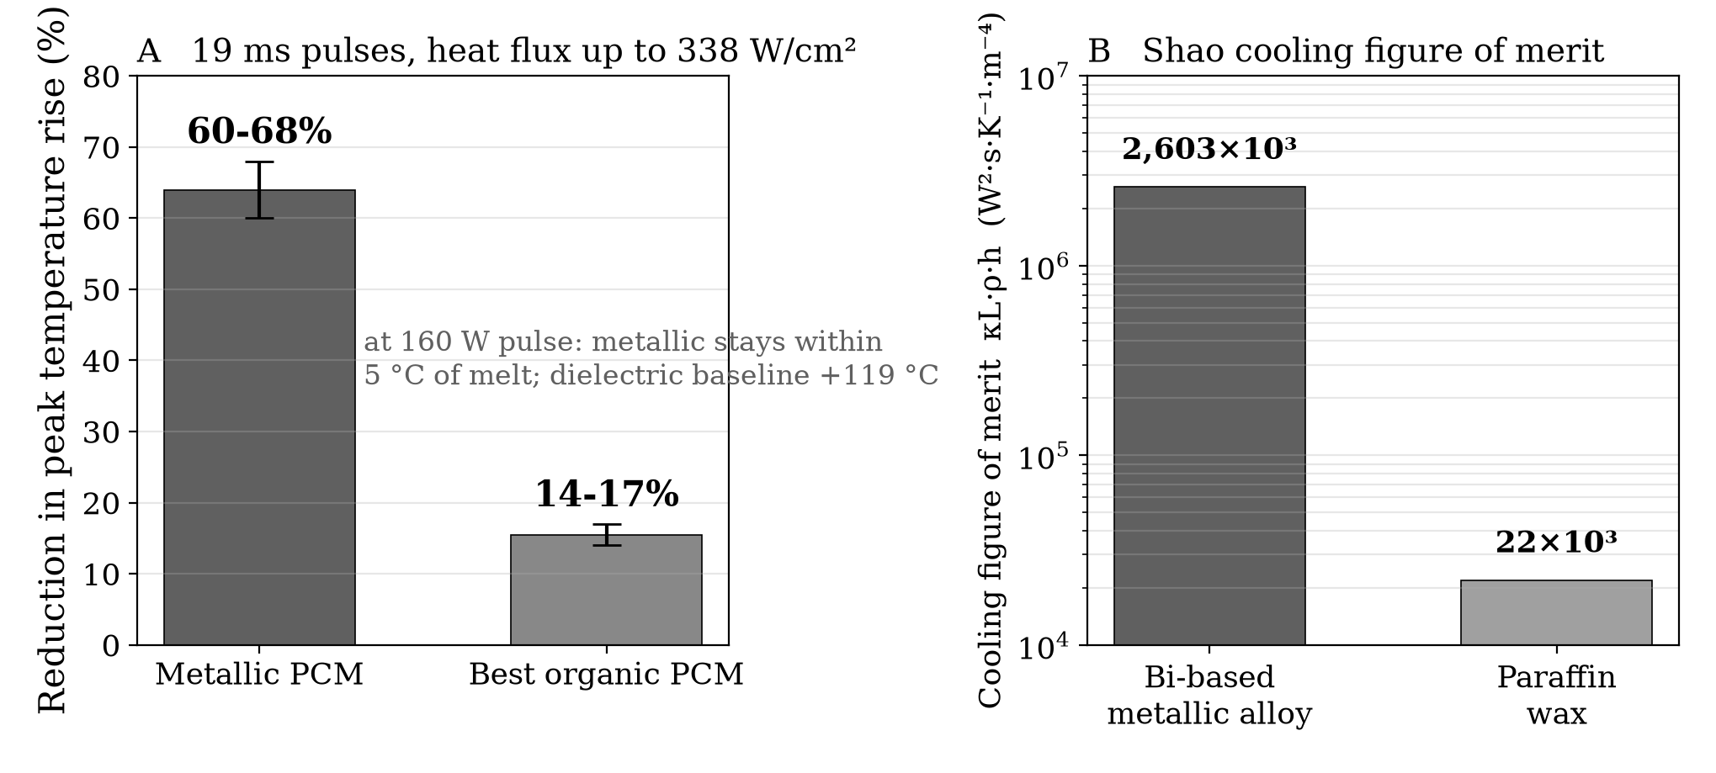
Figure 1. Metallic phase change materials under transient thermal load. Panel A: under 19 ms pulses at heat fluxes up to 338 W/cm², metallic phase change materials reduce the temperature rise by 60 to 68%, against 14 to 17% for the best organic candidate. Panel B: the Shao cooling figure of merit places a bismuth based metallic alloy two orders of magnitude above paraffin wax. Sources: refs [25, 26].

6. Engineering Challenges for Gallium Based Cooling Systems

6.1. Corrosion and material compatibility
Gallium alloys aggressively attack aluminum via liquid metal embrittlement, requiring complete exclusion of aluminum from any cooling loop. Deng and Liu tested liquid gallium against four metal substrates at temperatures relevant to chip cooling and found that 6063 aluminum alloy suffered complete gallium infiltration within five hours at 120 °C, with SEM/EDS analysis revealing gallium concentrations of 25–35% throughout the corrosion diffusion zone [31]. T2 copper alloy exhibited slow, general corrosion at a rate of approximately 30–60 micrometers per month at 60 °C, with corrosion products that could shed and block flow channels in a dynamic system. By contrast, 1Cr18Ni9 stainless steel showed zero detectable gallium infiltration after 30 days of continuous exposure at 60 °C, confirming its suitability as the structural material of choice despite its lower thermal conductivity [31]. For data center cooling applications, the practical materials palette is nickel plated copper or 316L stainless steel throughout the cooling loop [27].
An alternative containment strategy bypasses the corrosion problem entirely by isolating the electronics from the cooling medium through conformal protective coatings. Gebrael et al. demonstrated that thin copper coatings deposited directly onto packaged electronic devices enable direct liquid immersion cooling while maintaining electrical isolation and improving thermal performance over conventional thermal interface materials [32]. For gallium systems, an analogous coating strategy could decouple the structural materials of the cooling loop from the active electronics, broadening the practical materials palette.
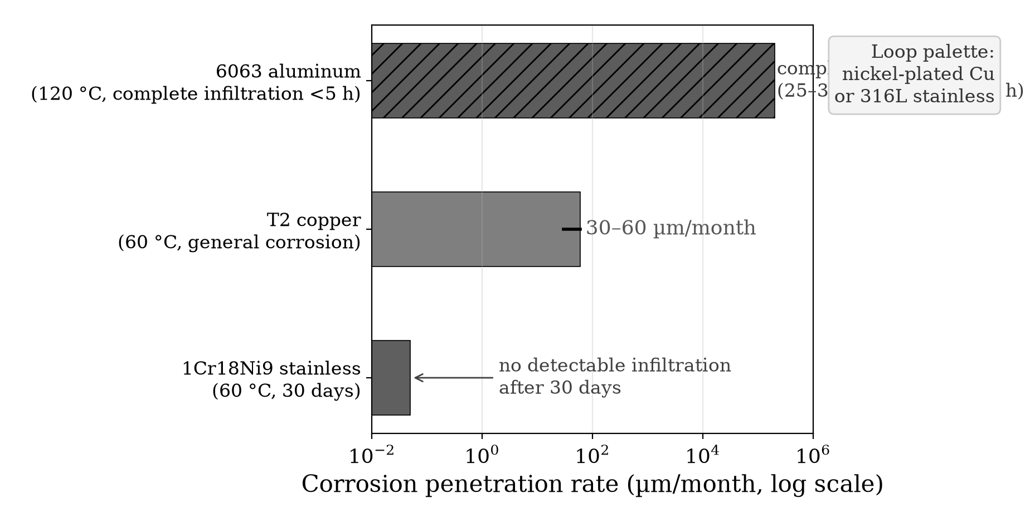
Figure 2. Substrate compatibility with liquid gallium. Corrosion penetration rate on a logarithmic axis for the three substrates tested by Deng and Liu. Aluminum suffers complete infiltration within hours and is excluded outright; copper corrodes slowly; 1Cr18Ni9 stainless steel shows no detectable attack after 30 days. The practical loop palette is nickel plated copper or 316L stainless steel. Source: ref [31].

6.2. Electrical conductivity and containment
Unlike dielectric fluids, liquid metals are electrically conductive (approximately 3.5 × 10⁶ S/m for gallium), demanding rigorous containment and leak detection infrastructure. A dielectric fluid leak is a maintenance event; a liquid metal leak near active electronics is a catastrophic short circuit risk. This constraint changes facility design requirements substantially relative to current immersion cooling, where hardware is submerged directly in the cooling medium. Gallium based systems require sealed, isolated cooling channels rather than open bath immersion.

6.3. Surface tension and wettability
Gallium exhibits high surface tension (approximately 709 mN/m vs. approximately 73 mN/m for water [27]), which limits wettability on untreated surfaces and requires oxide layer engineering for uniform thermal contact. In practice, a native gallium oxide film forms rapidly on exposed surfaces, and controlled management of this oxide layer (through surface treatments, reduced oxygen environments, or chemical reduction) is necessary to achieve consistent thermal interface performance. Sony’s PS5 implementation and Indium Corporation’s commercial GalliTHERM product line demonstrate that these challenges are solvable at manufacturing scale, but they increase system complexity relative to current dielectric immersion.

6.4. Supercooling mitigation
A separate engineering challenge for gallium as a phase change thermal storage medium is its pronounced supercooling: bulk gallium can remain liquid to approximately −38 °C, nearly 68 °C below its 29.8 °C melting point, and nanoparticle forms exhibit even larger supercooling. Zhang et al. demonstrated that adding 0.5 wt.% TeO₂ particles, whose lattice constants closely match those of α-Ga, reduced gallium’s supercooling by 44%, from 67.8 °C to 38.2 °C [33]. Mitigating supercooling is essential if gallium based PCMs are to function reliably in seasonal thermal storage applications where predictable freeze–thaw cycling at the design temperature is required.
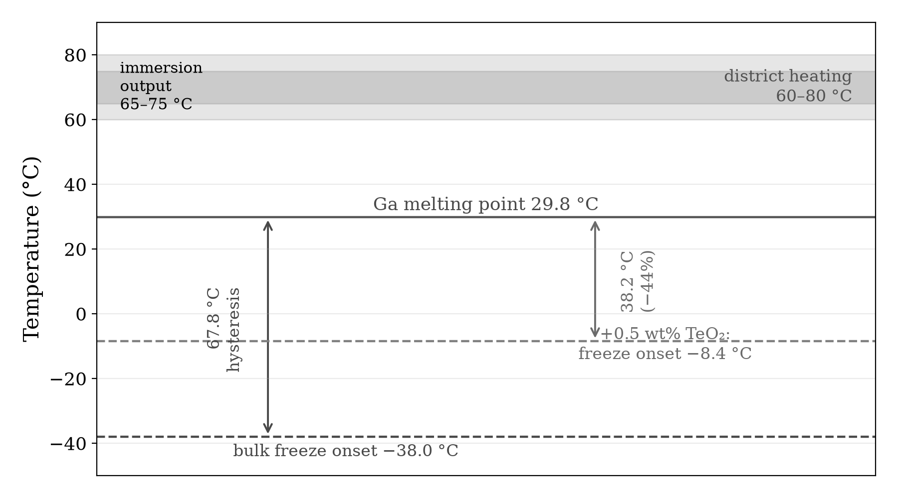
Figure 3. Gallium phase behavior and supercooling mitigation. Bulk gallium melts at 29.8 °C yet remains liquid to approximately −38 °C, a 67.8 °C hysteresis. Adding 0.5 wt% TeO₂, whose lattice closely matches α-Ga, raises the freeze onset to −8.4 °C, a 44% reduction. The district heating window and immersion output band are shown for reference. Sources: refs [5, 21, 33].

6.5. Implications for heat reuse systems
For the heat reuse framework developed in the present study, gallium based cooling has a direct implication: a gallium cooling loop could capture waste heat at higher temperatures with lower thermal resistance than hydrocarbon based systems, potentially enabling output temperatures above 80 °C. This is a projection based on the reduced thermal resistance at the chip to coolant interface, not yet demonstrated in district heating applications. Higher output temperatures would expand the range of industrial heat applications (including absorption chilling, food processing, and low temperature industrial drying) accessible from data center waste heat.
A complementary design principle is time matched phase change materials, in which metallic PCMs (gallium, Bi based alloys) are integrated alongside organic PCMs to leverage the high thermal conductivity of metals for rapid initial heat absorption and the high latent heat of organics for sustained thermal buffering. Boteler et al. demonstrated that this approach enables thermal solutions 25–50% lighter than pure metallic systems while maintaining comparable thermal performance [21]. For data center heat recovery, PCM thermal storage could address the seasonal mismatch problem (mining produces heat throughout the year but heating demand is seasonal) by absorbing excess heat during summer and releasing it during heating season. Salt hydrates (30–80 °C) and metallic PCMs with melting points in the 29–60 °C range overlap with immersion cooling output temperatures, making integration architecturally feasible though largely unexplored in the literature.

7. Gallium Supply Chain Constraints
Gallium is not mined directly; it is recovered almost exclusively as a byproduct during the processing of aluminum from bauxite and, secondarily, from electrolytic zinc refining [34]. Its crustal abundance is approximately 16 parts per million. Although world bauxite resources are estimated to host in excess of 1 billion kg of gallium, only a small fraction is economically recoverable because extraction depends on the operational decisions of primary aluminum and zinc producers. Approximately 95% of annual gallium consumption is directed toward gallium arsenide (GaAs) wafer fabrication for the electronics industry, the same semiconductor substrate underpinning optoelectronic devices, LEDs, laser diodes, RF transceivers, and defense grade integrated circuits [34]. Gallium nitride (GaN) power electronics represent a second, rapidly growing source of competing demand.
In July 2023, China, which accounts for approximately 80% of global primary gallium production, imposed export controls requiring special licenses for shipment [35, 36]. These controls triggered immediate price increases and highlighted the fragility of concentrated supply. The European Union, the United States, and Japan have since designated gallium as a critical raw material. Efforts to diversify sourcing through recycling, secondary recovery from zinc residues, and new extraction capacity in Canada, Australia, and Germany are under way but remain years from meaningful scale. A lifecycle analysis of global gallium flows from 2000 to 2021 quantifies the untapped reservoir: of 5,862 tonnes entering the industrial cycle, only 967 tonnes remain in active use, with 83.5% wasted and 4,446 tonnes accumulating in manufacturing and electronic waste [37].
For data center cooling specifically, the quantities of gallium required are orders of magnitude smaller than semiconductor wafer fabrication volumes; a single PlayStation 5, for example, contains only a few grams of Galinstan. Facility scale cooling loops are circulatory systems in which gallium recirculates indefinitely, so the operative supply chain metric is the makeup volume needed to offset leak and maintenance losses rather than the total fill volume. This substantially reduces ongoing demand relative to the semiconductor pathway, in which gallium is permanently embedded in wafers. The supply constraint is therefore manageable at currently projected adoption rates, although it introduces a materials dependency that facility planners must monitor, particularly given the geopolitical volatility of gallium markets and the competing demand from GaN power electronics for electric vehicles, 5G infrastructure, and defense systems.

8. Third Generation Materials: Embedded Two Phase Cooling

8.1. The ICECool program
The immersion cooling systems documented in the present study, single phase dielectric baths operating at 65–75 °C, represent facility level thermal management. As AI accelerator heat fluxes approach 1 kW/cm² and localized hot spots reach several kW/cm², a different approach is required: embedding two phase microfluidic cooling directly within the chip substrate. DARPA’s Intrachip Enhanced Cooling (ICECool) program targeted and achieved an order of magnitude improvement over conventional remote cooling [38].
In the ICECool program, microchannels and micropin fin arrays were etched directly into silicon die, and dielectric coolants (HFE-7000, R1234ze, R245fa) were pumped through these structures, undergoing evaporative phase change at the heat source. Multiple research teams demonstrated chip level heat flux removal exceeding 1 kW/cm², with hot spot cooling approaching 5 kW/cm². IBM demonstrated this in a commercial two socket server: microchannels etched into a production microprocessor achieved junction temperatures approximately 25 °C lower than the air cooled baseline at full power, while simultaneously reducing processor power consumption by over 10 W [38]. Purdue University’s hierarchical manifold microchannel design dissipated over 1,020 W/cm² across a 5 mm × 5 mm chip area while simultaneously managing 2,700 W/cm² hot spots [38].
For heat reuse, embedded two phase cooling anchors the exit fluid temperature near the refrigerant's saturation temperature, because the coolant undergoes phase change at the chip surface. R1234ze (GWP < 1) can be operated at elevated pressures to produce exit temperatures in the 60–80 °C range suitable for district heating, while simultaneously removing heat at densities that single phase immersion cannot reach. The Stanford/Raytheon ICECool team further demonstrated that polycrystalline diamond extended surfaces (thermal conductivity approximately 1,500 W/m·K) integrated with microporous copper wicks achieved over 1,300 W/cm² at less than 35 K above saturation [38]. Commercial deployment requires solving manufacturing scalability, sustained reliability (particularly microchannel clogging and erosion), and integration with existing facility infrastructure. Microsoft collaborated with Corintis in 2025 to design AI optimized microchannels for its Azure Maia accelerator, and deployed the world’s first NVIDIA GB300 cluster with advanced liquid cooling in Q4 2025.

8.2. Where the other materials fit
Several other high conductivity materials merit consideration here, although none is a direct competitor to gallium for the same function. They operate at different length scales and address different segments of the thermal chain.
The highest reported thermal conductivities belong to CVD diamond: 1,700–2,000 W/m·K for polycrystalline films, and in excess of 3,000 W/m·K for isotopically purified samples. In 2025, Stanford demonstrated direct diamond growth on GaN transistors at 400 °C, a result that drew interest from Applied Materials, Samsung, and TSMC. Diamond, however, is a solid state heat spreader rather than a circulating fluid: it manages hot spots at the transistor, within the last hundred micrometers of the thermal chain, whereas gallium based systems transport heat through meters of piping at the facility level. The two materials therefore address different parts of the thermal path rather than competing for the same function.
Graphene enhanced nanofluids are more directly comparable to gallium as a circulating coolant, and they have an important practical advantage: they can be injected into existing dielectric fluid infrastructure without hardware modification. The performance gap is large, however. Current graphene nanofluids achieve thermal conductivities of roughly 1–2 W/m·K, a meaningful 36%+ improvement over base dielectric fluids, but still 15–30× below gallium based systems. For facilities that cannot justify the cost and complexity of a gallium retrofit, graphene nanofluids may represent the best upgrade path in the near term within existing immersion architectures.
Hexagonal boron nitride (hBN) is the most promising prospect over the longer term, because it offers a property gallium cannot: electrical insulation. Its theoretical thermal conductivity (1,700–2,000 W/m·K) rivals that of diamond, and an electrically insulating coolant with thermal performance approaching gallium would eliminate the containment and leak detection requirements discussed in Section 6.2. In practice, however, hBN composite thermal interface materials currently reach only 5–15 W/m·K; the gap between single crystal theory and manufacturable composite behavior is large, and closing it is likely to remain a materials science problem for decades. The integration challenge for data center cooling is therefore not to identify a single optimal material but to design systems that deploy each material where its properties are strongest: diamond at the transistor, gallium through the facility, a dielectric or two phase fluid as the immersion medium, and, potentially, hBN composites as a bridge between them if the manufacturing gap can be closed.

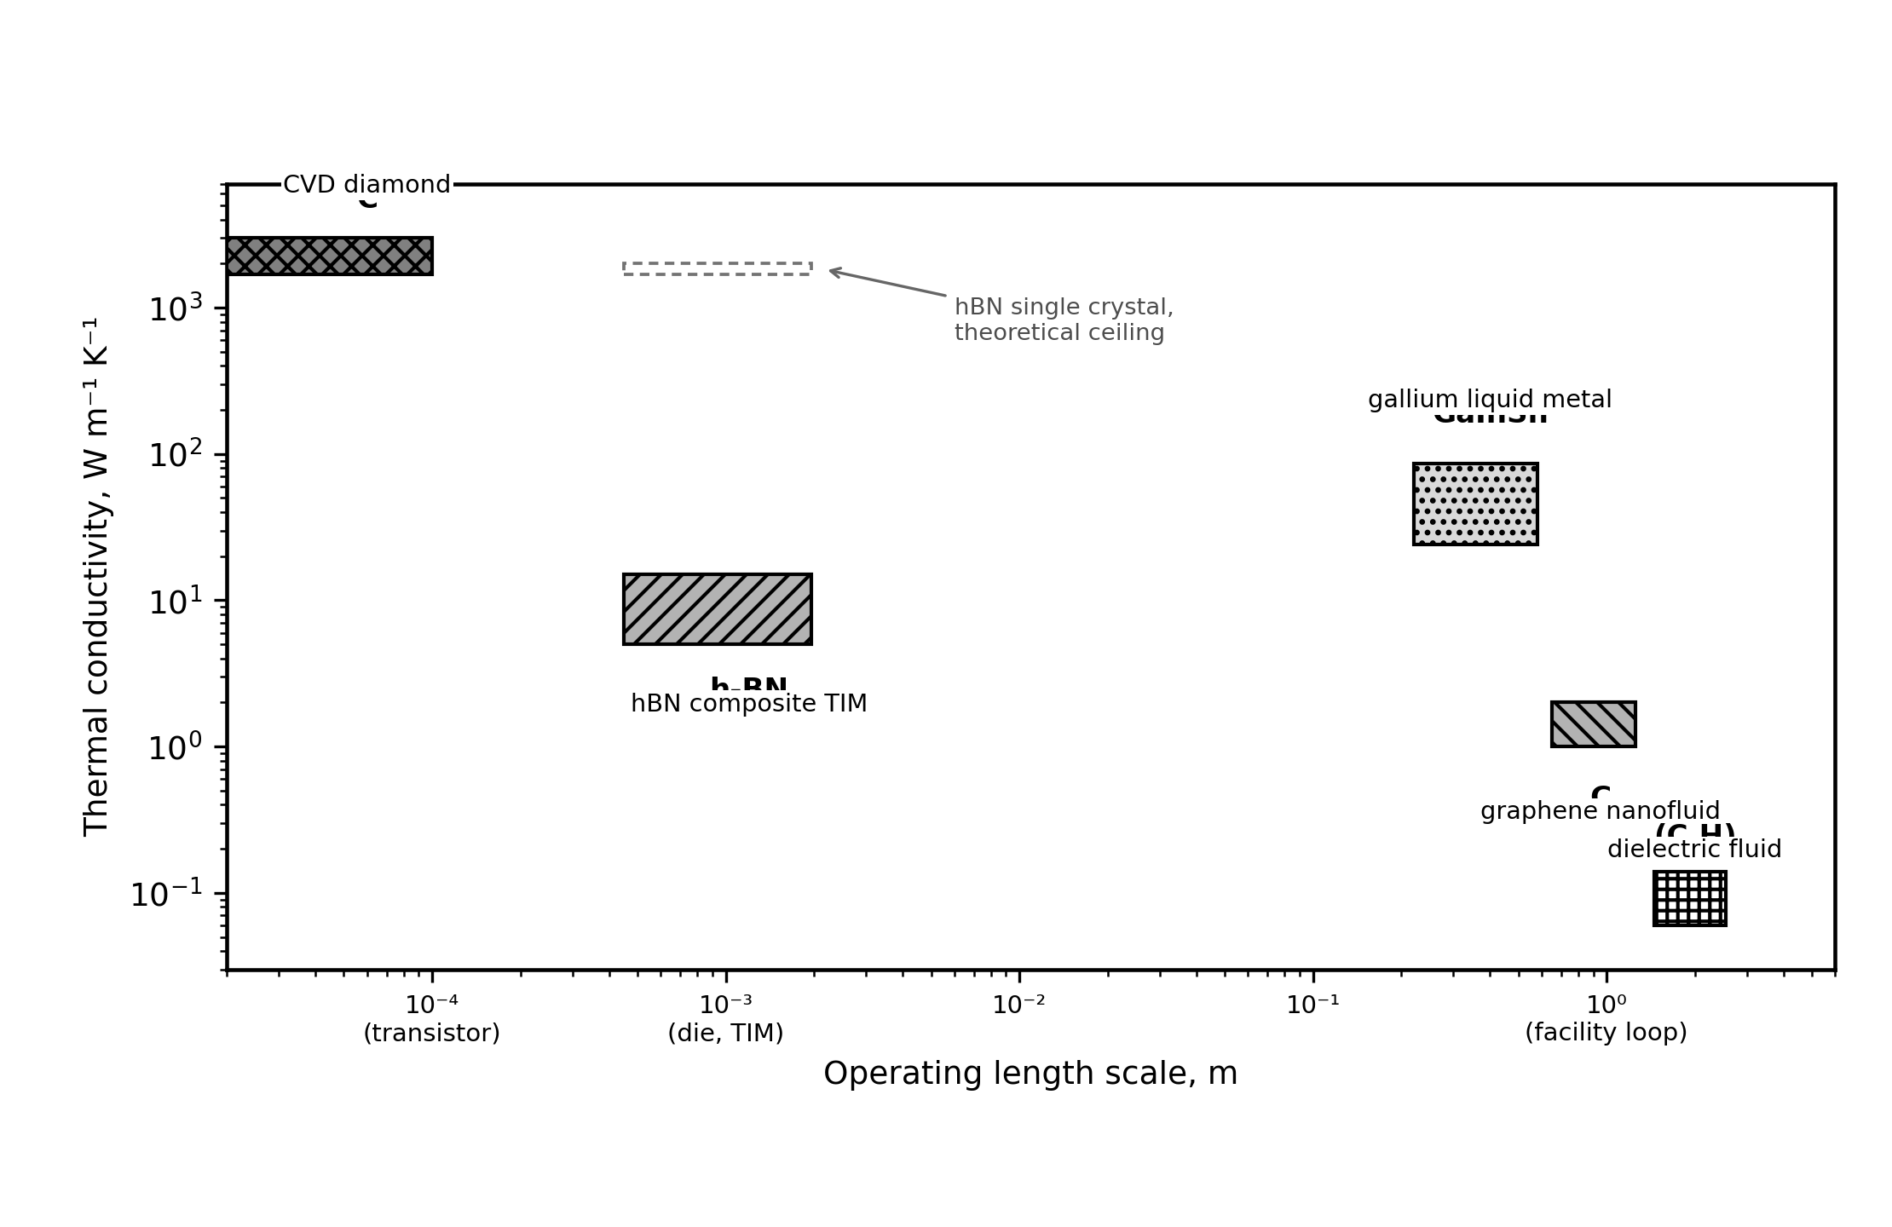
Figure 4. Materials comparison across three generations. Thermal conductivity (W/m·K) plotted against operating length scale for dielectric fluids, gallium based liquid metals, graphene nanofluids, CVD diamond, and hBN composites. Each material class occupies a distinct region of the design space; no single material spans the full thermal chain from transistor to district heating grid.

9. Conclusion
The environmental debate around data centers has largely been framed as a problem of consumption, but this framing is incomplete. Every watt consumed by a processor exits as heat, and the materials chosen to manage that heat determine whether it is wasted or recovered as a coproduct with industrial value, including warming homes, growing food, displacing fossil fuels, and reducing freshwater consumption. As AI and large language model data centers drive global data center electricity demand past 1,000 TWh annually, the materials design choices made at the facility level will determine whether that thermal output becomes an environmental cost or an energy asset.
The process, structure, property, performance paradigm unifies the trajectory across the three generations reviewed here. In the first generation, the dielectric fluid (process) creates a chip to fluid thermal pathway (structure), yields 65–75 °C output at low thermal resistance (property), and delivers district heating grade heat (performance). In the second generation, a gallium alloy (process) enables a chip integrated metallic interface (structure), reduces thermal resistance by 200–600× and raises the output temperature (property), and broadens the range of accessible industrial heat applications (performance). In the third generation, an embedded phase change coolant (process) positions the phase boundary at the chip surface (structure), anchors the exit temperature near the refrigerant saturation point (property), and simultaneously achieves heat removal exceeding 1 kW/cm² and a district grade exit temperature (performance). Across the three generations, each successive coolant raises not only the cooling performance but also the grade, and therefore the value, of the recoverable waste heat.
First generation dielectric fluids (0.06–0.14 W/m·K) enabled the temperature gradient improvement, raising waste heat output from 25–35 °C to 65–75 °C, crossing the district heating threshold and removing the need for heat pumps. Six operating systems validate this approach, with an estimated CO₂ displacement of 2,000–3,800 tonnes per 1.7 MW container per year, although independently verified emissions data exist for only one system. Second generation gallium based liquid metals (26–39 W/m·K) offer a 200–600× improvement in thermal conductivity and an experimentally demonstrated 60–68% reduction in temperature rise under pulsed loads, but they face engineering challenges in corrosion, electrical conductivity, surface tension, and a geopolitically concentrated supply chain. Third generation embedded two phase cooling, demonstrated at 1 kW/cm² in the ICECool program, points toward chip level thermal management at heat flux densities that facility level immersion cannot reach, with exit temperatures that can be tuned for district heating integration. The designability of the gallium coolant melting range, developed quantitatively in a companion CALPHAD assessment [24], extends the materials-design view from coolant selection to coolant formulation.
Several limitations should be acknowledged. Heat reuse does not render Bitcoin mining carbon neutral: the renewable share of mining electricity is approximately 52%, not 100%, and ASIC hardware obsolescence generates an estimated 15,000–30,000 tonnes of electronic waste annually. The heat reuse benefits described here apply primarily in cold climates with existing district heating infrastructure and do not generalize to tropical or subtropical regions. Finally, the gallium based systems that represent the materials frontier remain largely at laboratory and niche consumer scale rather than facility scale operation.
As summarized in Figure 5, Bitcoin mining thermal innovations (immersion cooling, renewable sourcing, and heat reuse) have consistently preceded AI data center adoption of the same technologies by three to five years. This pattern reflects not the primacy of mining but the value of the engineering precedent it established under demanding operating conditions. The trajectory from dielectric fluids to gallium based liquid metals to embedded phase change systems is the path along which both sectors, including the AI data center industry that now dominates in scale, are likely to continue advancing.

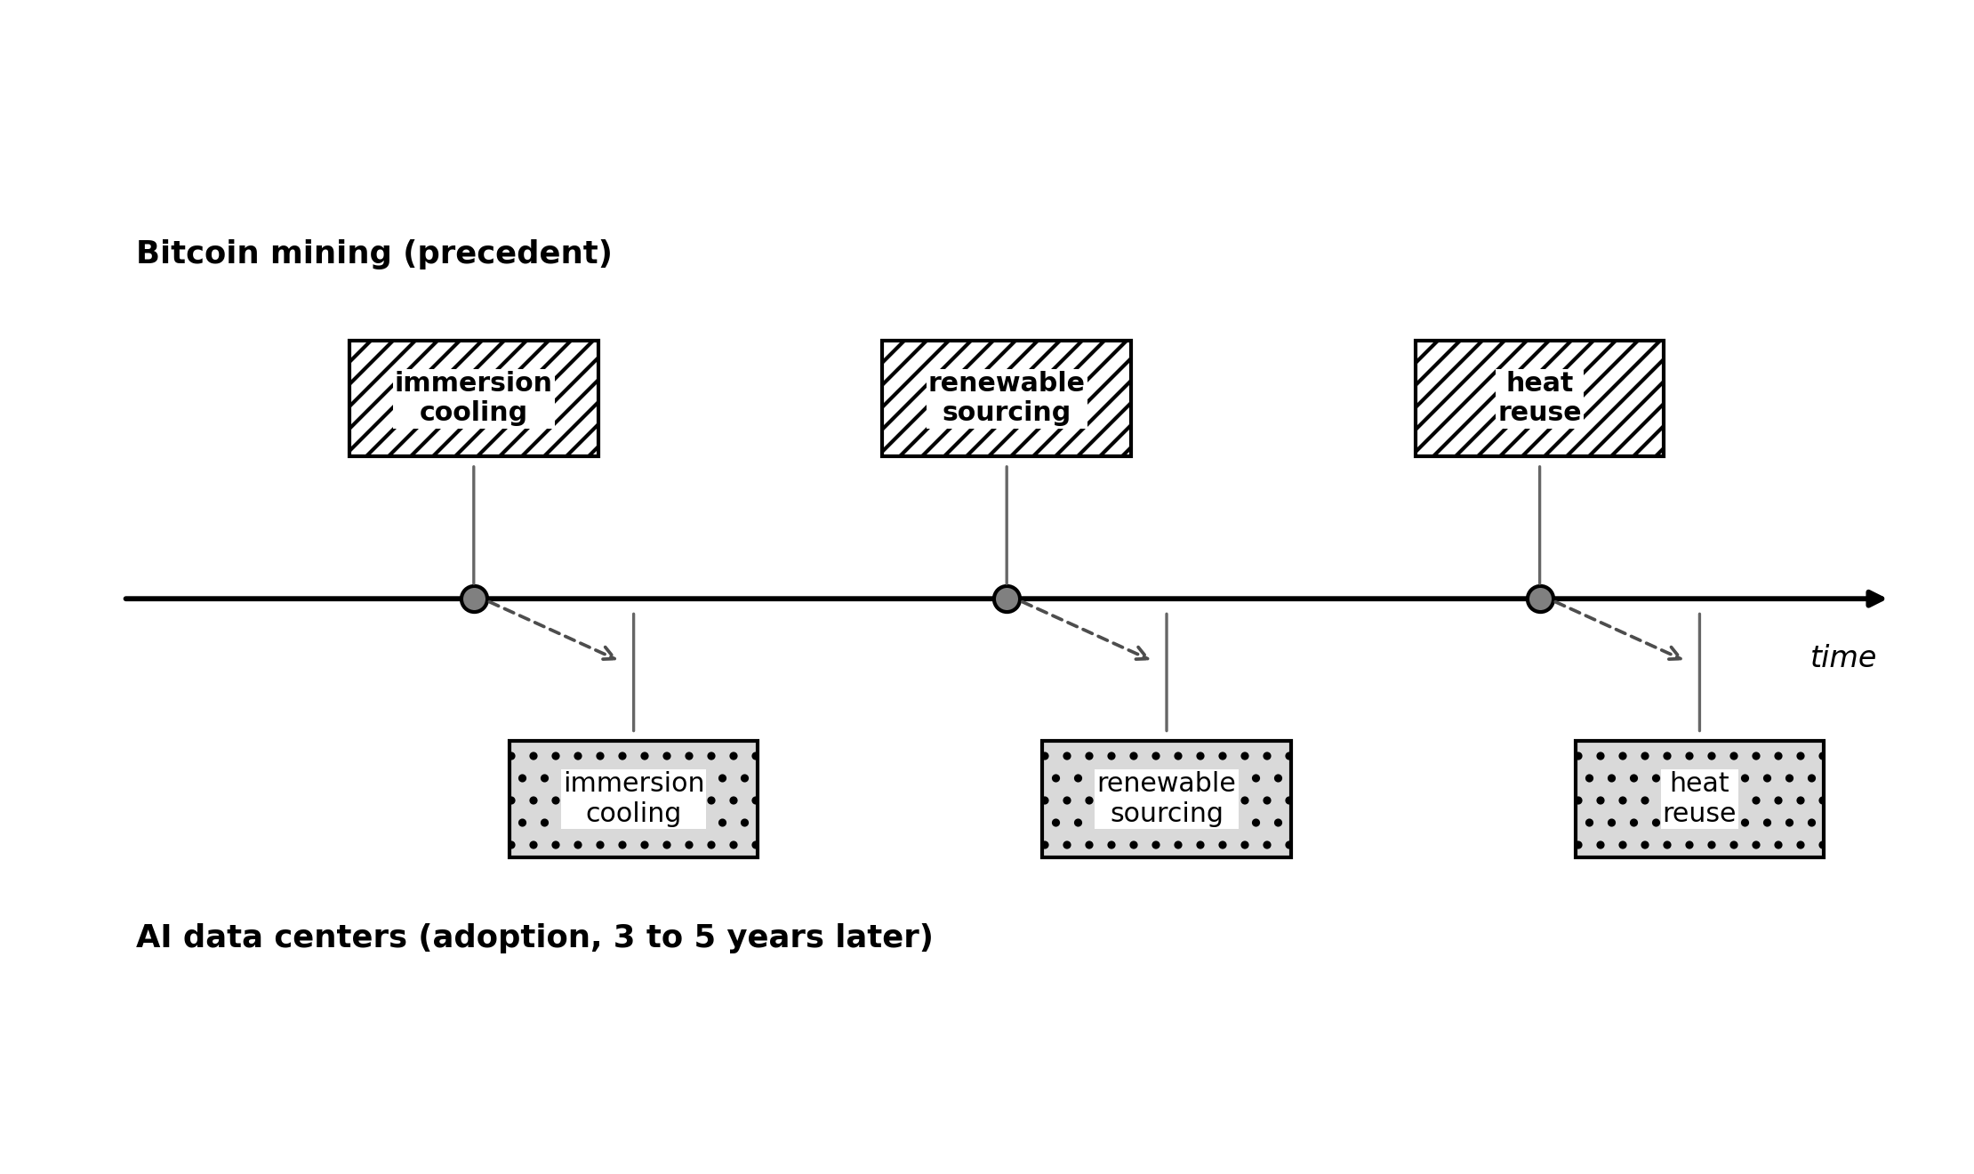
Figure 5. Convergence timeline. Bitcoin mining thermal innovations (above axis) consistently precede AI data center adoption of the same technologies (below axis) by 3 to 5 years across cooling materials, power sourcing, and heat reuse.

Acknowledgments
The authors acknowledge Cambridge Centre for Alternative Finance, Power Mining, MARA, Canaan, MintGreen, and the operators of the Tallaght District Heating Scheme (Heat Works, Dublin) for publicly documented data.

Use of AI Assisted Tools
The authors used Anthropic Claude (Opus) for editorial revision, structural reorganization, image production, and formatting. All analytical content, materials science review, engineering analysis, and conclusions are the authors' work. Source identification and selection were performed by the authors; the AI tool was used to organize and cross reference sources the authors had already collected.

Declaration of Competing Interest
The authors declare no competing financial interests or personal relationships that could have appeared to influence the work reported in this paper.

CRediT Authorship Contribution Statement
Michael Bustamante: Conceptualization, Methodology, Software, Formal analysis, Investigation, Visualization, Writing - original draft, Writing - review and editing. Kristina Lilova: Validation, Writing - review and editing, Supervision.

Data Availability
This review does not generate primary datasets. The thermodynamic databases and computational scripts underlying the gallium melting-range discussion are provided with the companion CALPHAD assessment [24].

10. Cross-Generation Quantitative Comparison
The three cooling generations span four orders of magnitude in peak areal heat flux and roughly double the fraction of input electricity recoverable as useful exergy. Table 3 summarises seven representative configurations from forced-air rejection through embedded two-phase microfluidics, drawing on data from Sections 2-9 and the primary sources cited there. Exergy fractions are computed at T0 = 283 K (10 degrees C) as Ex/W = 1 - T0/Tout, where Tout is the absolute outlet temperature.
Table 3. Cross-generation thermal performance. k: coolant thermal conductivity (W m-1 K-1). q_max: peak demonstrated areal heat flux (W cm-2). Tout: coolant outlet temperature (degrees C). Ex: recoverable exergy fraction of facility input at Tout (T0 = 283 K, 10 degrees C).
Configuration | k  (W m⁻¹ K⁻¹) | qₘₐˣ  (W cm⁻²) | T₀ᵁᵗ  (°C) | Ex | Refs
Forced-air convection | 0.026 | ~1 | 25-35 | ~8% | [5]
Liquid cold plate  (single-phase water) | 0.6 | ~30 | 50-65 | 12-15% | [5]
Dielectric single-phase immersion | 0.06-0.14 | ~65 | 65-75 | 16-19% | [10, 11, 12]
Dielectric two-phase immersion | 0.06-0.14 | ~200 | 50-65 | 12-16% | [15, 38]
Gallium-based liquid metal  (single-phase) | 16-86 | ~500 | >80 | 20-23% | [22, 27, 31, 33]
Embedded single-phase microfluidics  (monolithic Cu) | ~400 | 790-900 | 50-70 | 12-16% | [32]
Embedded two-phase  (jet / microchannels) | -- | ~3,000 | 50-60 | 12-14% | [38]
The comparison in Table 3 quantifies the core trade-off: configurations optimised for maximum heat flux deliver the lowest recoverable exergy fraction, while gallium-based liquid metals uniquely advance both metrics. The companion thermodynamic assessment [24] maps the composition space that controls the operational window of Configuration 5, supporting the transition from a fixed-alloy product to a designable coolant [22, 29, 30].

References

Note on literature scope: The literature review was conducted across materials science, thermal engineering, energy systems, and digital asset databases. The author does not claim the reference set is exhaustive. Readers should consult Deng and Liu, Liquid Metals for Advanced Energy Applications (AIP Publishing, 2022) and Advanced Liquid Metal Cooling (Springer, 2024) for additional references.
[1] International Energy Agency, "Electricity 2024: Analysis and Forecast to 2026," IEA, Paris, 2024.
[2] "Power Mining's Bitcoin-heated shipping containers warm Scandinavian homes," DataCenterDynamics, Feb. 2026.
[3] "Canaan's liquid-cooled mining system heats Manitoba greenhouse," The Block, Jan. 2026.
[4] "AWS data center heats Dublin university campus," CNBC, Jan. 2026. TU Dublin independent CO₂ measurement: 704 tCO₂ abated, 2024.
[5] Euroheat & Power, "District Heating in the Nordic Countries," 2024.
[6] G.B. Olson, "Computational Design of Hierarchically Structured Materials," Science, vol. 277, no. 5330, pp. 1237-1242, 1997. doi:10.1126/science.277.5330.1237.
[7] M.C. Rajagopal, H.C. Chang, T. Man, G. Kuntumalla, Y. Meng, S. Sundar, H. Zhao, S. Salapaka, C. Shao, P. Ferreira, N. Miljkovic, S. Sinha, "Materials-to-device design of hybrid metal-polymer heat exchanger tubes for low temperature waste heat recovery," Int. J. Heat Mass Transfer, vol. 143, Art. no. 118497, 2019.
[8] Cambridge Blockchain Network Sustainability Index (CBECI), ccaf.io/cbnsi/cbeci, Sep. 2025.
[9] Cambridge Centre for Alternative Finance, "Cambridge Digital Mining Industry Report," Apr. 2025.
[10] 3M, "Novec Engineered Fluids for Immersion Cooling," Product Technical Datasheet, 2024.
[11] Shell, "Immersion Cooling Fluid S5 X," Product Technical Datasheet, 2025.
[12] Engineered Fluids, "ElectroCool Dielectric Coolant," Product Technical Datasheet, 2024.
[13] European Chemicals Agency, "Restriction proposal for per- and polyfluoroalkyl substances (PFAS)," REACH Annex XV Restriction Report, 2023.
[14] European Parliament and Council, "Energy Efficiency Directive (recast)," Directive (EU) 2023/1791, Sep. 2023.
[15] P. Birbarah, T. Gebrael, T. Foulkes, A. Stillwell, A. Moore, R. Pilawa-Podgurski, N. Miljkovic, "Water immersion cooling of high power density electronics," Int. J. Heat Mass Transfer, vol. 147, Art. no. 118918, 2020. doi:10.1016/j.ijheatmasstransfer.2019.118918.
[16] Environmental and Energy Study Institute, "Data Centers and Water Consumption," EESI Fact Sheet, 2023.
[17] P. Li, J. Yang, M.A. Islam, S. Ren, “Making AI Less Thirsty: Uncovering and Addressing the Secret Water Footprint of AI Models,” Communications of the ACM, 2025 (arXiv:2304.03271).
[18] "MintGreen's digital boiler heats Lonsdale Energy buildings," MARA, Oct. 2025.
[19] EnergiRaven and Viegand Maagøe, "Data center waste heat potential: 3.5 million homes by 2035," 2025.
[20] World Economic Forum, "The $3.3 trillion question: Can digital infrastructure drive sustainable growth?" Oct. 2025.
[21] L. Boteler, M. Fish, M. Berman, J. Wang, "Understanding Trade-offs of Phase Change Materials for Transient Thermal Mitigation," IEEE 18th ITHERM Conference, 2019.
[22] Y. Yan, Y. Zhuang, H. Ouyang, J. Hao, X. Han, "Experimental investigation on optimization of the performance of gallium-based liquid metal with high thermal conductivity as thermal interface material for efficient electronic cooling," Int. J. Heat Mass Transfer, vol. 226, Art. no. 125455, 2024. doi:10.1016/j.ijheatmasstransfer.2024.125455.
[23] Patsnap/Eureka, "Liquid Metal Cooling for AI Accelerators: Technical Review," Aug. 2025. Ga-based systems: 16–86 W/m·K.
[24] M. Bustamante, K. Lilova, “A CALPHAD assessment of the Ga–In–Sn liquidus for designable low-melting liquid-metal coolants,” in preparation, 2026.
[25] L. Shao et al., "Figure-of-merit for phase-change materials used in thermal management," Int. J. Heat Mass Transfer, vol. 101, pp. 764–771, 2016.
[26] D. Gonzalez-Nino et al., "Experimental evaluation of metallic phase change materials for thermal transient mitigation," Int. J. Heat Mass Transfer, vol. 116, pp. 512–519, 2018.
[27] K.-Q. Ma, J. Liu, "Nano liquid-metal fluid as ultimate coolant," Physics Letters A, vol. 361, pp. 252–256, 2007.
[28] 360iResearch, "Liquid Metal Thermal Interface Material Market Report," 2025. $305.9M (2025), $479.7M projected (2032), 6.63% CAGR.
[29] T. Yang, B. Kwon, P.B. Weisensee, J.G. Kang, X. Li, P. Braun, N. Miljkovic, W.P. King, "Millimeter-scale liquid metal droplet thermal switch," Appl. Phys. Lett., vol. 112, no. 6, Art. no. 063505, 2018. doi:10.1063/1.5013623.
[30] T. Yang, T. Foulkes, B. Kwon, J.G. Kang, P.V. Braun, W.P. King, N. Miljkovic, "An integrated liquid metal thermal switch for active thermal management of electronics," IEEE Trans. Compon. Packag. Manuf. Technol., vol. 9, no. 12, pp. 2341–2351, 2019.
[31] Y.-G. Deng, J. Liu, "Corrosion development between liquid gallium and four typical metal substrates used in chip cooling device," Appl. Phys. A, vol. 95, pp. 907–915, 2009.
[32] T. Gebrael, J. Li, A.R. Gamboa, J. Ma, J. Schaadt, L. Horowitz, R. Pilawa-Podgurski, N. Miljkovic, "High-efficiency cooling via the monolithic integration of copper on electronic devices," Nature Electronics, vol. 5, no. 6, pp. 394–402, 2022. doi:10.1038/s41928-022-00748-4.
[33] C. Zhang et al., "Study on the nucleating agents for gallium to reduce its supercooling," Int. J. Heat Mass Transfer, vol. 148, Art. no. 119055, 2020.
[34] R.R. Moskalyk, "Gallium: the backbone of the electronics industry," Minerals Engineering, vol. 16, pp. 921–929, 2003.
[35] USGS, "Gallium," Mineral Commodity Summaries, 2024.
[36] PRC Ministry of Commerce, "Export control announcement on gallium and germanium," Jul. 2023.
[37] T. Guan, M. Guo, L. Wang, J. Liu, "Production and recycling of the cutting edge material of gallium: A review," Sci. Total Environ., vol. 971, Art. no. 179046, 2025.
[38] A. Bar-Cohen et al., "The ICECool Fundamentals Effort on Evaporative Cooling of Microelectronics," IEEE Trans. Compon. Packag. Manuf. Technol., vol. 11, no. 10, pp. 1546–1564, Oct. 2021.

