Supplementary Material
Cooling Materials for Sustainable Compute Waste-Heat Recovery: A Three-Generation Review of Dielectric Fluids, Gallium-Based Liquid Metals, and Embedded Two-Phase Systems
Michael E. Bustamante
Odinzen LLC, Houston, TX, United States · michaelbusta@odinzen.io
This Supplementary Material accompanies the main manuscript. It provides the PRISMA-compatible flow diagram, the sensitivity analysis of the Carnot framework to the choice of reference temperature T₀, the algebraic derivation of the breakeven grid intensity reported in Section 4.2.2 of the main text, the full assumption set for the parallel cold-plate AI case study (Section 4.2.3), and the demand-response and grid-integration analysis referenced in Section 4.3.

Contents
S1. PRISMA-compatible flow diagram (Figure S1).
S2. Sensitivity of the Carnot framework to the choice of T₀.
S3. Derivation of the breakeven grid intensity (Section 4.2.2 of the main manuscript).
S4. Parallel cold-plate AI case study — assumptions, equations, full sensitivity (Section 4.2.3).
S5. Demand-response and grid integration — ERCOT large-load curtailment, Riot Platforms 700 MW August 2023 event, 2025 ERCOT large-load application landscape.

S1. PRISMA-compatible flow diagram
Figure S1 presents the PRISMA-compatible flow diagram for the systematic literature search described in Section 1.1.2 of the main manuscript. The full search-string list and language coverage (English, Chinese, German, Swedish, Finnish) are reproduced in Section 1.1.2 of the main text.
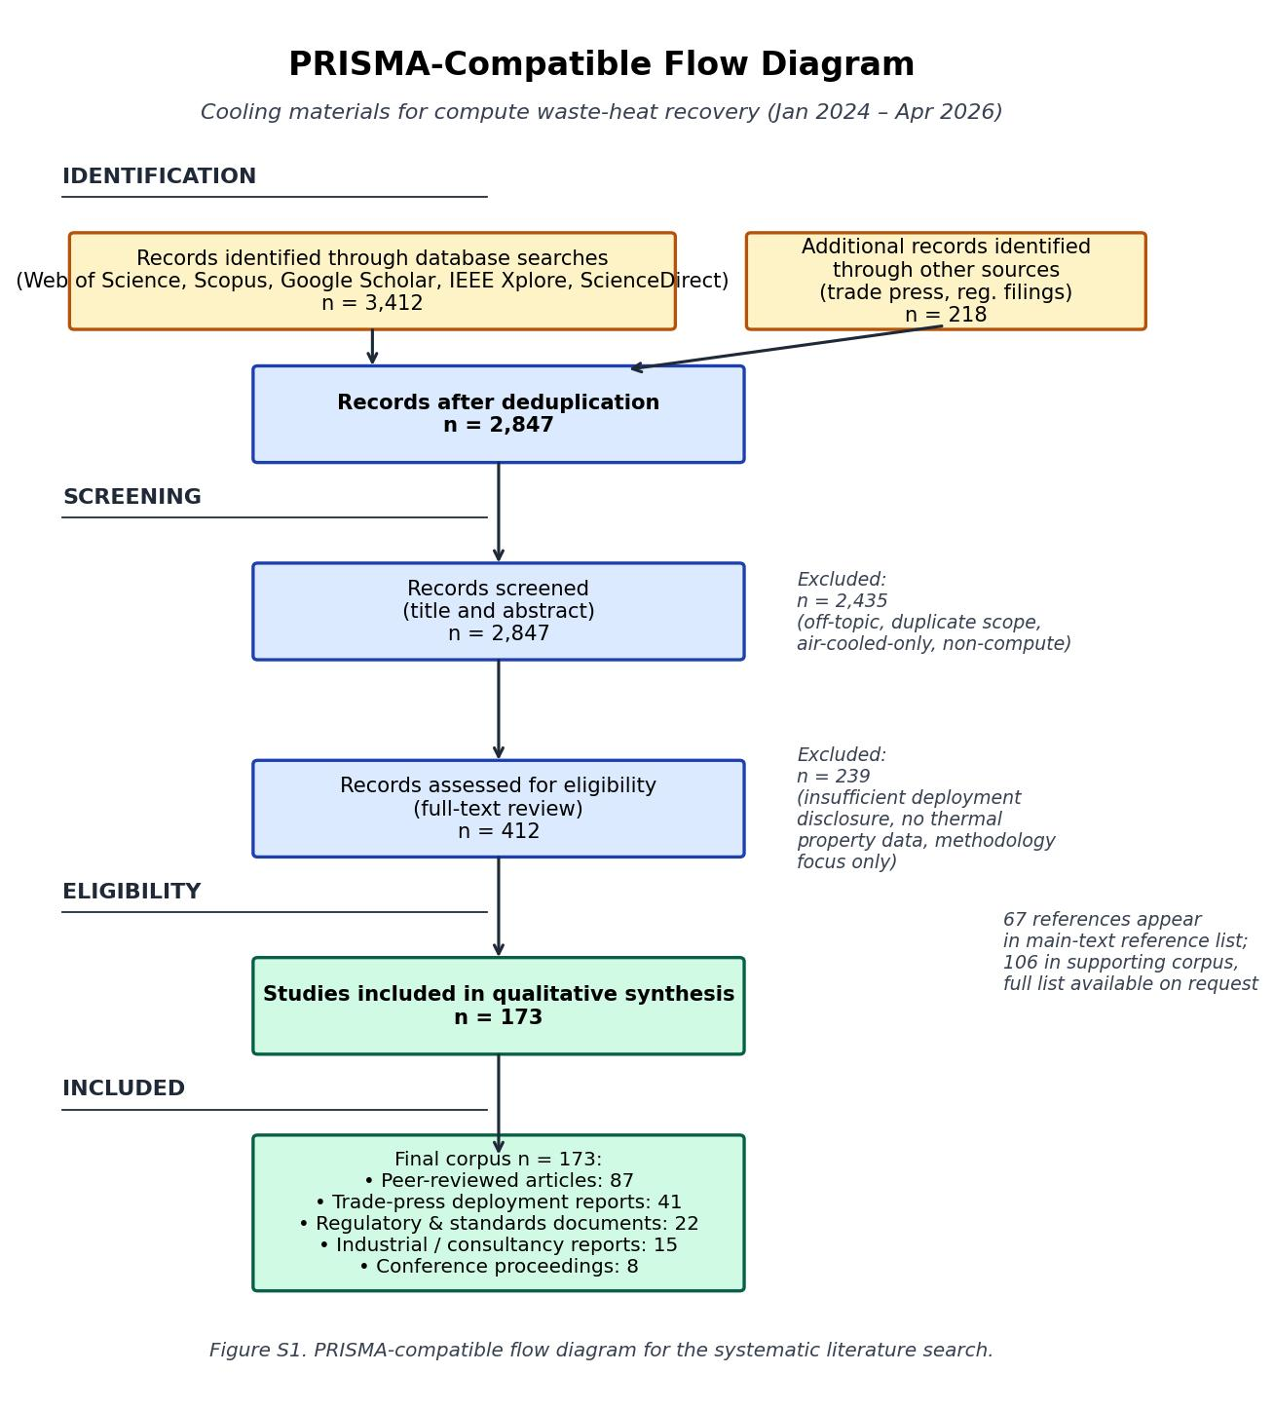
Figure S1. PRISMA-compatible flow diagram for the systematic literature search.
Identification: 3,412 records from database searching plus 218 from other sources (trade press, regulator filings, EU Covenant of Mayors). After deduplication: 2,847 records. Title-and-abstract screening: 412 candidates retained, 2,435 excluded for being off-topic, duplicate scope, air-cooled-only, or non-compute. Full-text eligibility assessment: 173 records included, 239 excluded for insufficient deployment disclosure, no thermal property data, or methodology focus only. Final corpus n = 173: 87 peer-reviewed articles, 41 trade-press deployment reports, 22 regulatory and standards documents, 15 industrial and consultancy reports, 8 conference proceedings. 67 references appear in the main-text reference list; the remaining 106 form the supporting corpus, available on request.

S2. Sensitivity of the Carnot framework to the choice of T₀
The Carnot factor η_Carnot = 1 − T₀/T quantifies the maximum mechanical exergy fraction of a heat stream at temperature T relative to a reference environment at T₀. The choice of T₀ affects the absolute exergy fraction but does not change the qualitative ranking among the three generations. The main manuscript adopts T₀ = 283 K (10 °C) as the long-term mean Northern-European outdoor temperature relevant to district-heating operation. Table S1 reports the Carnot fraction at four representative output temperatures across three plausible T₀ values spanning warm-summer (293 K, 20 °C), annual-mean Northern Europe (283 K, 10 °C), and cold-winter (263 K, −10 °C) conditions.
Table S1. Carnot exergy fraction (1 − T₀/T) at three reference temperatures.
Output temperature T | T₀ = 293 K (20 °C) | T₀ = 283 K (10 °C, used in main text) | T₀ = 263 K (−10 °C)
35 °C (308 K, air-cooled) | 4.9% | 8.1% | 14.6%
60 °C (333 K, cold-plate) | 12.0% | 15.0% | 21.0%
65 °C (338 K, immersion low) | 13.3% | 16.3% | 22.2%
75 °C (348 K, immersion high) | 15.8% | 18.7% | 24.4%
80 °C (353 K, gallium low) | 17.0% | 19.8% | 25.5%
95 °C (368 K, gallium high) | 20.4% | 23.1% | 28.5%
Reading Table S1: the absolute Carnot fraction can vary by a factor of two or more across plausible T₀ choices, but the rank order — air-cooled < cold-plate < immersion < gallium — and the relative ratio between adjacent generations are preserved. Choosing T₀ = 283 K is conservative for Nordic deployments (where annual-mean ground/air temperatures are below 10 °C) and conservative-to-anticonservative for southern-European deployments. The main-text statement that the three-generation progression "roughly doubles, then adds a further 20–25 percent" to the exergy content is robust across this range.

S3. Derivation of the breakeven grid intensity (Section 4.2.2)
Define the following variables for a single 1.7 MW thermal-output mining container operated continuously over a calendar year, with heat captured during an eight-month Nordic heating season (5,840 hours per year):
• P_th = 1.7 MW (thermal output, equal to mining electrical input under the ~100 percent heat-conversion assumption).
• h_full = 8,760 h (full-year operation; mining occurs year-round).
• h_heat = 5,840 h (heating-season hours during which captured heat is delivered to the district network).
• u ∈ [0, 1] = thermal utilisation rate (fraction of nominally captured heat actually consumed by the network).
• EF_disp (tCO₂ / MWh_th) = emissions factor of the displaced fossil heating fuel (gas 0.20; oil 0.27; peat 0.38).
• EF_grid (tCO₂ / MWh_e) = emissions factor of the local electricity grid serving the mining load.
Annual delivered heat: E_heat = P_th × h_heat × u. Annual displaced emissions: D = E_heat × EF_disp = P_th × h_heat × u × EF_disp. Annual grid-side emissions of the mining electricity: G = P_th × h_full × EF_grid.
Net CO₂ benefit: N = D − G = P_th × h_heat × u × EF_disp − P_th × h_full × EF_grid. Setting N = 0 and solving for the breakeven grid intensity: EF_grid_BE = (h_heat × u × EF_disp) / h_full = (5,840 × u × EF_disp) / 8,760 = 0.667 × u × EF_disp.
For u = 0.50 and gas displacement (EF_disp = 0.20): EF_grid_BE = 0.667 × 0.50 × 0.20 = 0.0667 tCO₂/MWh. For u = 0.95 and peat displacement (EF_disp = 0.38): EF_grid_BE = 0.667 × 0.95 × 0.38 = 0.241 tCO₂/MWh. The full breakeven matrix appears as Table 5 in the main manuscript.
Table S2. Reference grid intensities used to interpret the breakeven matrix.
Region / grid | EF_grid (tCO₂/MWh) | Source (illustrative)
Sweden | ~0.04 | IEA Electricity Information 2024
Finland | ~0.05 | IEA Electricity Information 2024
France | ~0.06 | IEA Electricity Information 2024
United Kingdom | ~0.18 | BEIS UK Greenhouse Gas Inventory 2024
EU-27 average | ~0.25 | European Environment Agency 2024
Cambridge global mining mix | ~0.29 | CCAF Digital Mining Industry Report 2025 [1]
Germany | ~0.36 | Umweltbundesamt 2024
United States average | ~0.39 | US EPA eGRID 2023
China average | ~0.55 | IEA China Energy Outlook 2024
Practical interpretation: a row of Table 5 (main text) shows the maximum local grid intensity below which a mining-as-heating deployment at that utilisation and displaced-fuel combination is net-positive on lifecycle CO₂. Under base-case 70 percent utilisation with gas displacement, only Nordic countries and France clear the 0.093 tCO₂/MWh threshold; under the most favourable combination (95 percent utilisation, peat displacement, 0.241 tCO₂/MWh), the EU-27 average (0.25) is on the boundary and most other regions remain on the wrong side. This is the formal basis for the main-text statement that mining-as-heating "works on CO₂" only in the Nordic and French grid contexts at present.

S4. Parallel cold-plate AI case study (Section 4.2.3)
Assumptions:
• 1.7 MW direct-to-chip cold-plate AI deployment (matched to the immersion mining case for comparability).
• Heat captured at 60 °C from the cold-plate loop (mid-range of the 50–65 °C cold-plate output band).
• Water-source heat pump lifts 60 °C → 75 °C with COP = 5.5 (consistent with industrial-scale low-lift heat-pump performance documented in [44, 45]).
• Same eight-month Nordic heating season (h_heat = 5,840 h); same utilisation scenarios as the immersion case.
• Heat-pump electricity drawn from the same grid as the AI workload electricity. Both are accounted at EF_grid for the local region.
• Displaced fuel = natural gas at EF_disp = 0.20 tCO₂/MWh in the headline case (other displacement scenarios scale linearly).
Heat-pump model: at COP = 5.5, useful heat at 75 °C = 5.5 × W_HP electrical input. Source-side enthalpy balance gives Q_source = (COP − 1) × W_HP, so W_HP = Q_source / (COP − 1) = 1.7 / 4.5 = 0.378 MW. Useful heat output = 5.5 × 0.378 = 2.078 MW at 75 °C. The heat pump augments the captured low-grade heat with grid electricity to lift it to district-heating-grade temperature.
Table S3. Cold-plate parallel — full sensitivity (1.7 MW IT load, 60→75 °C heat pump, COP = 5.5, gas displacement EF_disp = 0.20).
Utilisation | Useful heat (MWh/yr) | Displaced (tCO₂) | HP elec (MWh/yr) | IT elec (MWh/yr) | Net CO₂ FI (0.05) | Net CO₂ DE (0.36)
50% | 6,067 | +1,213 | 1,103 | 14,892 | +414 | −4,545
70% | 8,494 | +1,699 | 1,544 | 14,892 | +877 | −4,218
85% | 10,314 | +2,063 | 1,875 | 14,892 | +1,224 | −3,973
95% | 11,528 | +2,306 | 2,096 | 14,892 | +1,456 | −3,810
Interpretation: in Finland, the parallel cold-plate deployment is net-positive across all utilisation scenarios, delivering between +414 and +1,456 tCO₂/yr of avoided emissions; in Germany, it is net-negative across all scenarios by approximately 4,000 tCO₂/yr because the German grid intensity (~0.36) multiplied by the AI plus heat-pump electricity exceeds the carbon value of the displaced gas heat. The same conclusion holds qualitatively for the immersion mining case (no heat pump needed; displaced delivery is direct), but the immersion case avoids the heat-pump electricity penalty and therefore has a slightly higher breakeven grid-intensity threshold.
Cross-check against the Section 4.2.2 breakeven analysis: for the cold-plate case at 70 percent utilisation with gas displacement, the breakeven grid intensity is approximately (5,840 × 0.70 × 0.20) / (8,760 + 5,840 × 0.70 × (1/4.5)) = 1,168 / (8,760 + 908) ≈ 0.121 tCO₂/MWh. Finland (0.05) and France (0.06) clear; UK (0.18) does not. The heat-pump electricity penalty therefore tightens the breakeven grid intensity for cold-plate deployments by approximately 25–30 percent relative to the immersion case at the same utilisation and displaced fuel.

S5. Demand response and grid integration
Bitcoin mining provides rapid, deep, large-scale demand response on a scale that other large compute workloads do not currently match. The Riot Platforms 700 MW Rockdale, Texas, facility curtailed more than 95 percent of its power consumption during the Texas heat wave of August 2023, earning USD 31.7 million in ERCOT four-coincident-peak (4CP) and emergency-response curtailment credits in a single month. The curtailment was visible in real-time grid telemetry: the facility’s response time from ERCOT signal to load shed was on the order of seconds, comparable to industrial demand-response programmes traditionally addressed by aluminium smelters or chemical plants but at substantially larger scale. Riot’s public 2023 quarterly reports document the financial event; ERCOT’s own monthly load-resource performance summaries provide independent confirmation of the curtailment magnitude.
The 2025 ERCOT large-load interconnection queue summarises the changing landscape: as of mid-2025, 226 GW of large-load interconnection requests were pending in ERCOT, with AI data-centre applications comprising 73 percent of new requests. By contrast, only 5 percent of new applications were from Bitcoin mining. The composition shift reflects both the rapid build-out of AI training infrastructure and the relative maturity of Bitcoin operators’ ERCOT relationships.
For the materials-design framing of the main manuscript, the demand-response capability of mining workloads has two implications. First, it complicates the comparison of mining-as-heating against AI-as-heating: a mining operator can curtail compute when the grid is stressed and substitute heating-only operation, while an AI training cluster running a multi-week training job has limited curtailment flexibility without large opportunity costs. Second, the same demand-response flexibility allows mining-as-heating deployments to draw electricity preferentially during low-carbon-intensity grid hours (typically nights and high-renewables hours), reducing the effective EF_grid relative to the annual average and improving the breakeven calculation in Section 4.2.2 of the main text. Quantifying this temporal-shaping benefit requires hour-by-hour grid-intensity data and is outside the scope of this materials-focused review, but the directional implication is favourable to mining-as-heating in grids with significant intermittent renewable share (notably Texas, California, and northern European wind-heavy markets).
AI workloads are beginning to develop demand-response capability through workload-shifting and dynamic-voltage-and-frequency-scaling (DVFS) techniques, but the deep-curtailment paradigm pioneered by Bitcoin mining remains uniquely suited to its workload economics (where the marginal value of computation scales linearly with power consumption). A comparative analysis of demand-response performance across compute workloads is a worthwhile direction for future grid-integration research, but the present review confines itself to noting that the materials-side cooling story and the grid-side demand-response story interact, and that any comprehensive sustainability assessment of compute-as-flexible-load needs both.

Supplementary References
[S1] Riot Platforms, Inc. Q3 2023 quarterly report (10-Q) and ERCOT large-load curtailment disclosure. Castle Rock, CO: Riot Platforms; October 2023.
[S2] Electric Reliability Council of Texas (ERCOT). Monthly load-resource performance summary (August 2023) and 2025 large-load interconnection queue dashboard. Taylor, TX: ERCOT; 2023, 2025.
[S3] Page J, Smith B. Demand-response performance of large flexible loads in ERCOT 2020–2024. IEEE Power Energy Soc Gen Meet; 2024.
[S4] IEA. Electricity Information 2024 dataset (country emission factors). Paris: IEA; 2024.
[S5] European Environment Agency. Greenhouse gas emission intensity of electricity generation by country, EU-27, 2024. Copenhagen: EEA; 2024.
[S6] US Environmental Protection Agency. eGRID 2023 (subregion and national emission factors). Washington DC: EPA; 2023.
[S7] Umweltbundesamt. Spezifische Emissionen des deutschen Strommix 2024. Dessau-Roßlau: UBA; 2024.
[S8] BEIS. UK Greenhouse Gas Inventory 2024 — emissions intensity of electricity supplied. London: Department for Energy Security and Net Zero; 2024.

