Materials Design for Compute Thermal Management:
From Dielectric Fluids to Gallium-Based Cooling Systems

Michael Bustamante
Odinzen LLC, Houston, TX, United States
E-mail: michaelbusta@odinzen.io

Preprint v2 — under review at Renewable & Sustainable Energy Reviews (RSER), 2026

Abstract
Nearly all electricity consumed by compute infrastructure exists in the facility as thermal energy. Bitcoin mining consumes 138–211 TWh annually; AI data centers are projected to exceed 1,000 TWh by end of 2026. This article examines compute thermal management as a materials design problem. Current first-generation immersion cooling uses dielectric fluids (thermal conductivity 0.06–0.14 W/m·K) that capture waste heat at 65–75 °C, directly usable for district heating without heat pumps. Six operational deployments are documented, with lifecycle CO2 displacement estimated at 2,000–3,800 tonnes per 1.7 MW container per year. Second-generation gallium-based liquid metal systems achieve thermal conductivities of 26–39 W/m·K, a 200–600× improvement, with experimentally demonstrated 60–68% temperature reduction under pulsed thermal loads. Third generation embedded two-phase microfluidic cooling, demonstrated under DARPA's ICECool program at 1 kW/cm2, points toward chip-level thermal management at heat flux densities that facility-level immersion cannot reach. Each generation of cooling material determines the temperature, quality, and reusability of the waste heat produced. The materials choice is therefore not merely a cooling decision but an energy-systems design decision with consequences for water consumption and carbon displacement. This article reviews the materials science of each generation, documents the engineering challenges (corrosion, electrical conductivity, surface tension, supply chain concentration), and argues that the trajectory from dielectric fluids to gallium-based systems to embedded phase-change cooling represents a coherent materials design frontier with facility-scale thermodynamic implications.
Keywords – Thermal management; Materials design; Immersion cooling; Gallium; Liquid metals; Phase-change materials; Dielectric fluids; Waste heat recovery; Data centers; District heating
1. Introduction: The Thermal Problem as a Materials Problem
In January 2026, a shipping container arrived in a small town in Scandinavia. Inside were 160 Bitcoin mining rigs submerged in dielectric fluid, generating 1.5 MW of thermal energy that was pumped into the town's district heating grid, warming approximately 2,000 homes. The company that built it, Latvia-based Power Mining, described itself as a heating company that happens to mine Bitcoin [5]. Simultaneously, a greenhouse in Manitoba was being heated by 360 liquid-cooled mining servers capturing approximately 90% of consumed electricity as heat at 75 °C [6]. And in Dublin, students at the Technological University attended lectures in buildings heated by waste heat from an Amazon Web Services data center [12].
These deployments share a common engineering feature: the cooling material determines the output temperature, and the output temperature determines the heat's industrial utility. Air-cooled systems reject heat at 25–35 °C—too low for district heating networks, which require 60–80 °C supply temperatures [4]. Immersion in dielectric fluid raises the capture temperature to 65–75 °C, crossing the district heating threshold. Gallium-based liquid metals, with thermal conductivities two to three orders of magnitude higher than dielectric fluids, could raise output temperatures above 80 °C while simultaneously managing the escalating heat flux densities of AI accelerators. The choice of cooling material is therefore an energy-systems design decision, not merely a thermal engineering one.
This article examines three generations of compute cooling materials—dielectric fluids, gallium-based liquid metals, and embedded two-phase microfluidic systems—through the lens of materials design. The materials-to-device design framework employed here builds on prior work that has connected coolant and surface material selection directly to system-level heat-recovery performance [37]. It documents operational deployments that validate first-generation technology, reviews the materials science frontier of second- and third-generation systems, and identifies the engineering challenges that separate laboratory demonstrations from facility-scale deployment.
The energy baseline is drawn from the Cambridge Centre for Alternative Finance's Digital Mining Industry Report (April 2025), which surveyed 49 firms covering 48% of global hash rate [1]: Bitcoin mining consumes 138 TWh/yr (upper estimate 211 TWh [2]) with a sustainable energy share of 52.4% (42.6% renewables, 9.8% nuclear). AI data centers are projected by the IEA to exceed 1,000 TWh by end of 2026, more than 7× Bitcoin mining's consumption [3].
Selection bias note: The Cambridge survey's respondents are disproportionately publicly listed (41%) and North American. The unreported 52% includes operations in Central Asia and Africa where coal and gas typically dominate. The true global sustainable share may be materially lower than 52.4% [1].
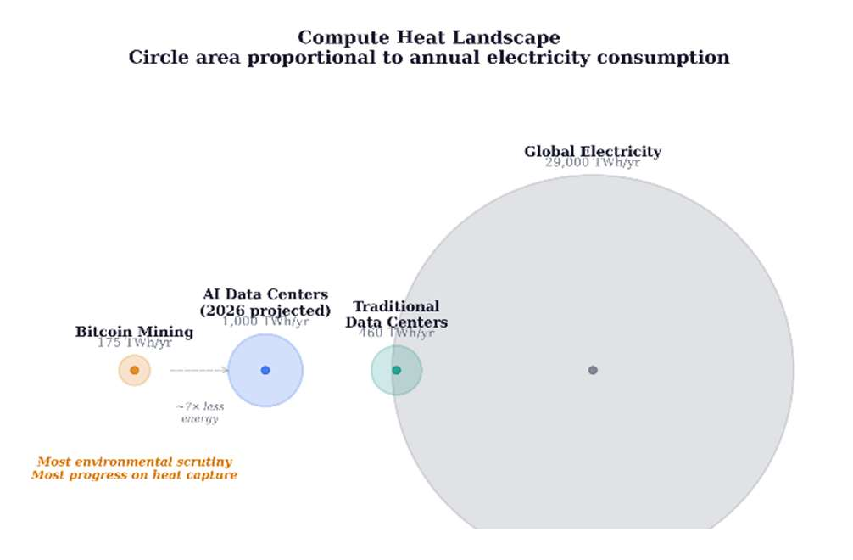
Figure 1. Compute heat landscape. Circle area is proportional to annual electricity consumption. Bitcoin mining receives the most environmental scrutiny while consuming the least electricity and having made the most progress on heat capture.
2. Thermodynamic Framework
Every processor converts electricity into computation and heat at a ratio of approximately 100%. The first law of thermodynamics guarantees energy conservation; the second law constrains its quality. Electricity entering a facility is high-grade energy; heat exiting at 65 °C is low-grade, suitable for space and water heating but not for mechanical or electronic work. The energy is conserved; the exergy is reduced.
A heat pump delivers 3–4 joules of thermal energy per joule of electricity consumed (COP of 3–4). A mining rig delivers approximately 1 joule of heat per joule of electricity, plus cryptocurrency revenue. Mining-as-heating is therefore thermodynamically inferior to a heat pump for pure heating purposes and is economically competitive only when computation revenue offsets the COP gap. The materials question is how to maximize the temperature and quality of the rejected heat so that the gap narrows and the co-product value increases.
3. First-Generation Cooling Materials: Dielectric Fluids
3.1. Thermal properties and performance envelope
Single-phase immersion fluids—engineered hydrocarbons or synthetic esters—offer thermal conductivities of 0.06–0.14 W/m·K, specific heat capacities of 1.5–2.1 kJ/kg·K, and operating ranges from −40 °C to +200 °C [9, 10, 11]. They are chemically inert, electrically non-conductive, and non-flammable. Two-phase fluorocarbon fluids offer higher heat transfer coefficients through phase-change latent heat, but several formulations fall under PFAS classification; the EU's proposed PFAS restriction under REACH may limit future availability [12, 13]. Non-PFAS alternatives (hydrocarbon-based, ester-based, nanoparticle-enhanced) are under development but have not achieved performance parity in published benchmarks. The broader liquid cooling market for AI data centers is projected to grow from $2.8 billion in 2025 to over $21 billion by 2032 at 30%+ CAGR, underscoring the industrial scale of this materials challenge.
Single-phase fluids exhibit measurable total acid number (TAN) increases after 8,000–12,000 hours of continuous operation above 60 °C, indicating oxidative degradation. Replacement intervals of 5–8 years are typical for closed-loop systems with adequate oxygen exclusion [9, 10, 11]. Operational complexity at scale—leak detection, fluid quality monitoring, modified fire suppression, and maintenance retraining—represents substantial transition cost for facilities migrating from air-cooled architectures.
3.2. The temperature gradient breakthrough
District heating networks require supply temperatures of 60–80 °C [4]. Air-cooled data centers produce waste heat at 25–35 °C, below this threshold. Bridging the gap requires heat pumps ($500K–$2M additional capital) that consume additional electricity. This temperature gap has historically limited data center heat reuse to a small number of purpose-built facilities.
Immersion cooling changes this fundamentally. Submerging hardware in dielectric fluid captures heat at 65–75 °C—directly within the district heating range. No heat pump is required. Power Mining's containers produce heat at 65 °C; Canaan's system produces water at 75 °C [5, 6]. The same material property that solves the cooling problem simultaneously solves the heat-reuse problem. This is the article's central materials-design insight: cooling material selection determines not only thermal performance but downstream energy-system integration.
Beyond commercial deployments, academic research has pushed single-phase immersion well beyond conventional envelopes. Birbarah et al. demonstrated direct water immersion cooling of high-power-density electronics at over 500 W/cm2 — roughly twice the industrial state of the art — by employing hydrophobic conformal coatings to enable safe submersion of active components [33]. This result establishes that even within first-generation cooling materials, the marriage of fluid selection and surface engineering can substantially extend the achievable heat-flux envelope.
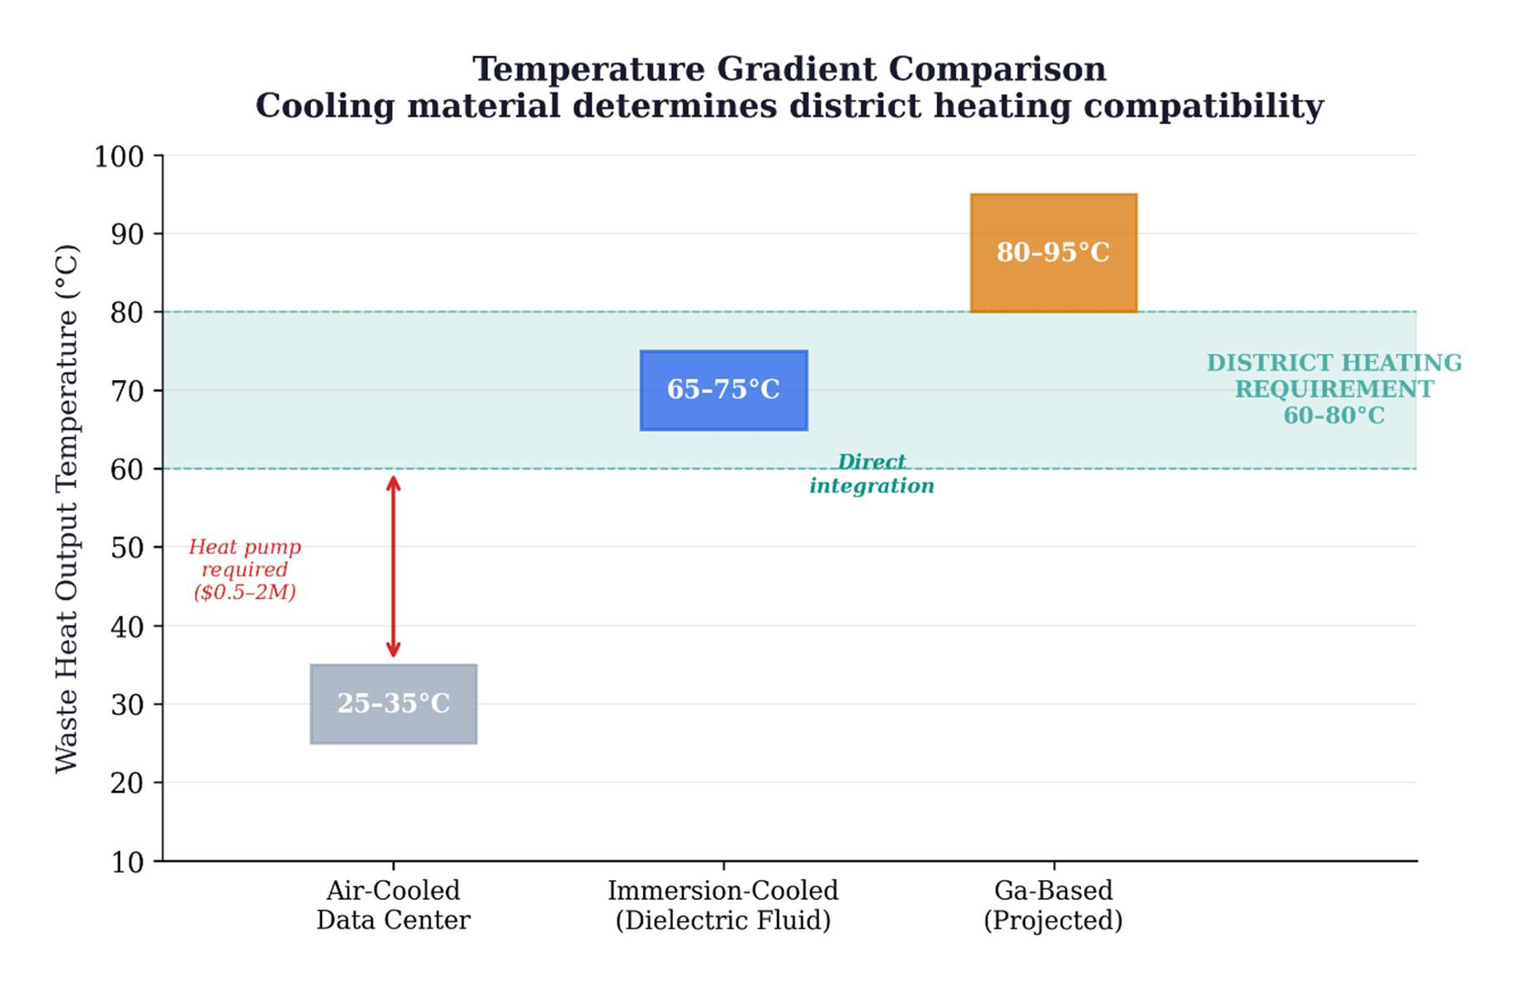
Figure 2. Temperature gradient comparison. Air-cooled facilities (25–35 °C output) fall below district heating requirements (60–80 °C). Immersion-cooled systems eliminate the gap, enabling direct grid integration without heat pumps.
3.3. Water elimination
Evaporative cooling, the dominant paradigm for large, air-cooled data centers, consumes approximately 110 million gallons of freshwater annually for a medium facility (~10 MW), with 80% permanently lost through evaporation [7]. For an equivalent 10 MW immersion-cooled facility, water consumption is zero—dielectric fluid circulates in a sealed closed loop with no evaporative loss. Each 100-word AI prompt processed by an evaporatively cooled data center consumes approximately 519 mL of water [8]. At scale, U.S. data centers collectively consume an estimated 163.7 billion gallons annually [7]. Immersion cooling represents a complete elimination of freshwater demand from the cooling system.
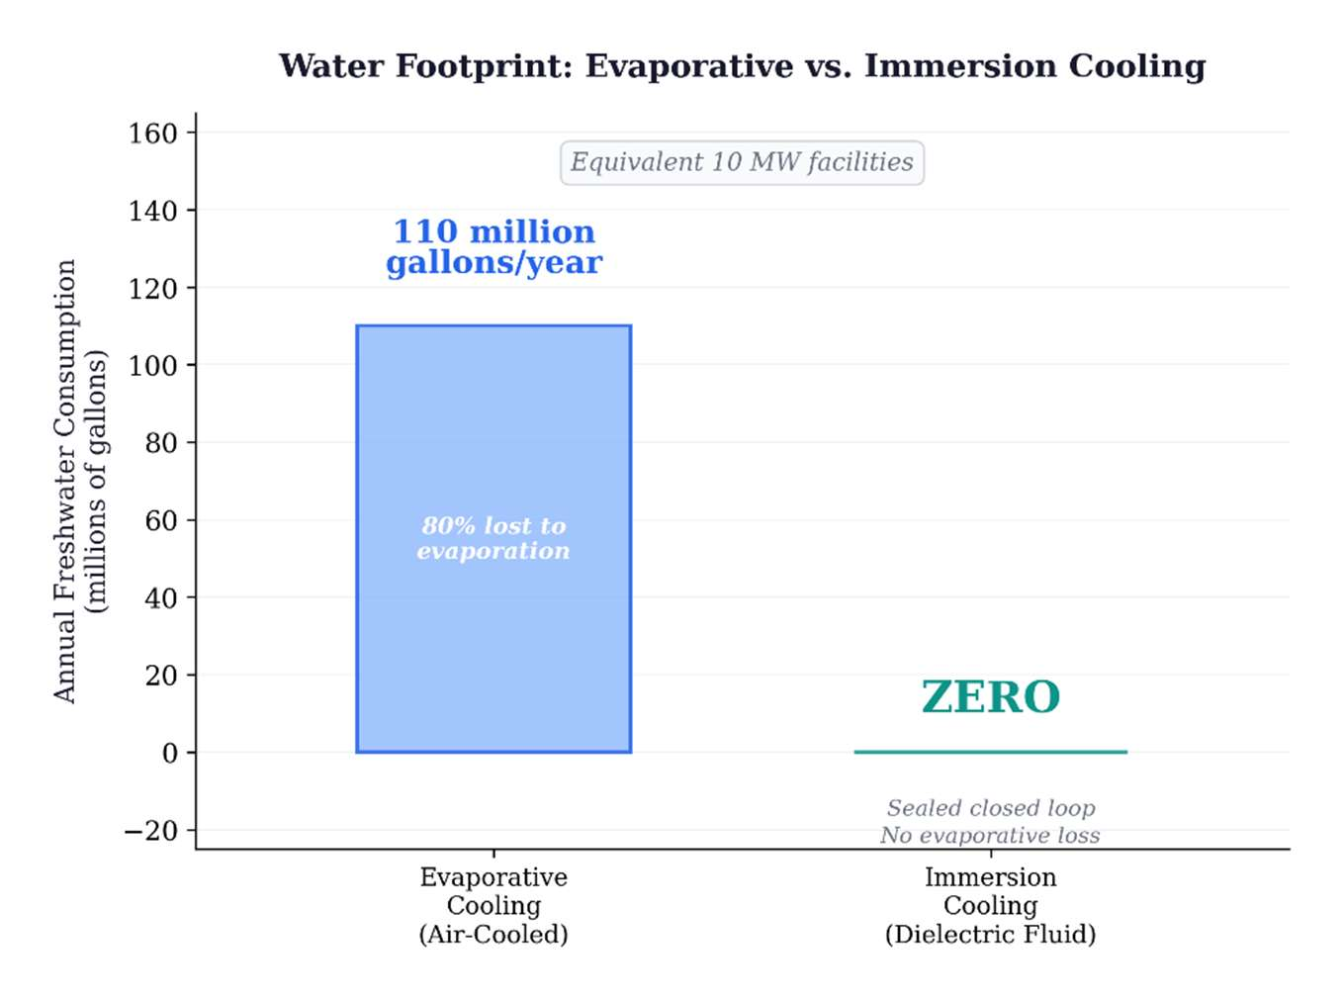
Figure 3. Water footprint comparison for equivalent 10 MW facilities. Evaporative cooling: ~110 million gallons/year; immersion cooling: zero. Immersion eliminates freshwater consumption entirely while producing heat at directly usable temperatures.
4. Engineering Validation: Operational Deployments
4.1. Documented heat-reuse systems
Six operational deployments validate the first-generation materials approach. The Dublin AWS scheme is the only deployment with independently measured emissions data: 704 tCO2 abated in 2024, verified by TU Dublin [15]. For Bitcoin mining deployments, environmental claims are based on engineering projections from reported specifications, not measured outcomes. Key deployments include: Power Mining (Scandinavia)—160 immersed rigs, 1.7 MW thermal, 65 °C output, approximately 2,000 homes heated; Canaan/Bitforest (Manitoba)—360 liquid-cooled servers, 75 °C output, greenhouse heating capturing approximately 90% of consumed electricity [5, 6]; MintGreen (Lonsdale, BC)—providing 96% of a commercial building's heating demand from mining waste heat [14]; and AWS Dublin—AI/cloud waste heat piped to a university campus with third-party-verified CO2 measurement [15].
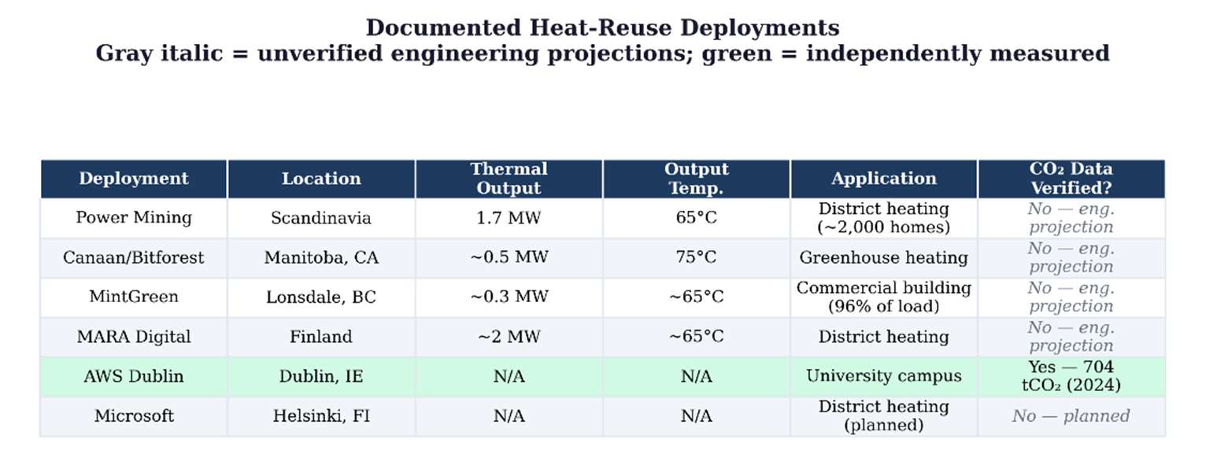
Figure 4. Standardized comparison of six heat-reuse deployments. Data fields include thermal output (MW), output temperature (°C), application, and verification status. Gray fields indicate unverified engineering projections. Dublin AWS is the only deployment with third-party-measured CO2 abatement.
4.2. Lifecycle CO2 displacement model
The following model estimates annual CO2 displacement for a single Power Mining container (1.7 MW thermal output, 65 °C, operating in a Nordic climate with 8-month heating season). This is an engineering projection based on published specifications, not a measured result. Thermal output of 1.7 MW continuous over approximately 5,840 annual operating hours yields 9,928 MWh of delivered thermal energy. Depending on the displaced fuel—natural gas (0.2 tCO2/MWh), fuel oil (0.27 tCO2/MWh), or peat (0.38 tCO2/MWh)—annual displacement ranges from approximately 2,000 to 3,800 tonnes of CO2 per container. These estimates assume 100% thermal utilization during the heating season and do not account for distribution losses (typically 5–15% for district heating networks). The electricity consumed by the mining rigs carries its own emissions burden; at Bitcoin's current energy mix (52.4% sustainable), each MWh of mining electricity produces approximately 0.29 tCO2. The net climate benefit is the difference between displaced heating emissions and mining electricity emissions.
4.3. Scalability and geographic constraints
Finland, Sweden, Denmark, and Norway deliver more than 50% of heating through district networks. Compute heat integration works in these regions because of cold climate (8–10 months demand), existing pipe infrastructure, supportive municipal policy, and high conventional energy costs [4]. Replication outside Scandinavia faces significant barriers: most North American and Asian cities lack district heating infrastructure, with construction costs of $5–20M per kilometer. Year-round applications—greenhouses, aquaculture, industrial process heat—extend viable geography without eliminating the seasonal constraint. A further limitation: many Finnish district heating systems already source heat from co-generation plants. In these systems, the marginal climate benefit of mining heat is reduced because the displaced source was already efficient. The strongest case exists where networks depend on standalone fossil boilers.
District heating networks are designed for 30-year lifespans. Mining hardware is obsolete in 3–5 years; data center hardware in 7–10. Municipalities evaluating mining-heated districts must plan for multiple hardware refresh cycles per infrastructure lifecycle [18]. This does not invalidate the model but introduces planning complexity that conventional heat sources do not.
5. Second-Generation Materials: Gallium-Based Liquid Metal Systems
5.1. Thermal performance
The dielectric fluids documented in Section 3 represent the first generation of compute liquid cooling. A second generation is emerging from materials science: gallium-based liquid metal alloys. Pure gallium exhibits a thermal conductivity of 33.7 W/m·K in the solid state and 24 W/m·K as a liquid, with a latent heat of 80,300 J/kg at a melting point of 29.8 °C [19]. This represents a 200–600× improvement in thermal conductivity over current dielectric fluids. GaInSn eutectic alloys (Galinstan: 68.5% Ga, 21.5% In, 10% Sn) achieve thermal conductivities of 26–39 W/m·K as thermal interface materials, with optimized formulations reaching 16–86 W/m·K depending on composition and geometry [20, 21].
5.2. Phase-change properties and figures of merit
The performance advantage of gallium extends beyond thermal conductivity. Boteler et al. demonstrated that for a ΔT of 20 °C, gallium absorbs 7× more energy per unit volume than copper and 3× more than organic paraffin phase-change materials, owing to its combination of high thermal conductivity and substantial latent heat [19]. Shao et al. developed a figure-of-merit (FOM) for PCM cooling capacity defined as the product κL × ρ × h (thermal conductivity × density × latent heat); metallic alloys achieve FOMs 1–2 orders of magnitude higher than organic PCMs (2,603 × 10^3 W^2 s/(K m^4) for Bi-based metallic alloy vs. 22 × 10^3 for paraffin wax) [22].
5.3. Experimental validation under pulsed thermal loads
Gonzalez-Nino et al. experimentally demonstrated that metallic PCMs reduced temperature rise by 60–68% under 19 ms pulsed thermal loads at heat fluxes up to 338 W/cm2, compared to only 14–17% reduction for the best-performing organic PCM [23]. At 160 W pulse power, the metallic PCM maintained a temperature within 5 °C of its melting point while the dielectric baseline rose 119 °C—the metallic PCM absorbed pulses 3–4× more powerful at equivalent temperature. These results are directly relevant to the pulsed and bursty thermal profiles characteristic of AI training workloads, where heat flux transients can exceed steady-state averages by an order of magnitude.
Ma and Liu proposed the concept of nano liquid-metal fluid—gallium-based coolants enhanced with conductive nanoparticles—as a route to the "ultimate coolant," demonstrating thermal conductivity enhancement ratios up to 2.3× with 20% carbon nanotube volume fraction in liquid gallium [24]. The liquid metal TIM market reached $305.9 million in 2025, driven primarily by AI accelerator thermal demands, and is projected to grow at 6.6% CAGR to $479.7 million by 2032 [25]. Sony's PlayStation 5 uses a Galinstan-based thermal interface in mass production (patented 2020), demonstrating that gallium-based cooling has crossed from laboratory to manufacturing at consumer scale.
Beyond passive thermal interfaces, gallium has been deployed in actively-controlled thermal-management devices. Yang et al. demonstrated a millimeter-scale liquid metal droplet thermal switch with switching ratios exceeding 70× at heat fluxes near 10 W/cm2 [34], and subsequently integrated this concept into a packaged thermal switch for active management of high-power electronics [35]. These devices demonstrate that gallium handling at the chip scale is not a laboratory curiosity but a tractable engineering problem with manufacturable solutions.
6. Engineering Challenges for Gallium-Based Cooling Systems
6.1. Corrosion and material compatibility
Gallium alloys aggressively attack aluminum via liquid metal embrittlement, requiring complete exclusion of aluminum from any cooling loop. Deng and Liu tested liquid gallium against four metal substrates at temperatures relevant to chip cooling and found that 6063 aluminum alloy suffered complete gallium infiltration within five hours at 120 °C, with SEM/EDS analysis revealing gallium concentrations of 25–35% throughout the corrosion diffusion zone [29]. T2 copper alloy exhibited slow, general corrosion at a rate of approximately 30–60 micrometers per month at 60 °C, with corrosion products that could shed and block flow channels in a dynamic system. By contrast, 1Cr18Ni9 stainless steel showed zero detectable gallium infiltration after 30 days of continuous exposure at 60 °C, confirming its suitability as the structural material of choice despite its lower thermal conductivity [29]. For compute cooling applications, the practical materials palette is nickel-plated copper or 316L stainless steel throughout the cooling loop [24].
An alternative containment strategy bypasses the corrosion problem entirely by isolating the electronics from the cooling medium through conformal protective coatings. Gebrael et al. demonstrated that thin copper coatings deposited directly onto packaged electronic devices enable direct liquid immersion cooling while maintaining electrical isolation and improving thermal performance over conventional thermal interface materials [36]. For gallium systems, an analogous coating strategy could decouple the structural materials of the cooling loop from the active electronics, broadening the practical materials palette.
6.2. Electrical conductivity and containment
Unlike dielectric fluids, liquid metals are electrically conductive (approximately 3.5 × 10^6 S/m for gallium), demanding rigorous containment and leak-detection infrastructure. A dielectric fluid leak is a maintenance event; a liquid metal leak near active electronics is a catastrophic short-circuit risk. This constraint fundamentally changes facility design requirements relative to current immersion cooling, where hardware is submerged directly in the cooling medium. Gallium-based systems require sealed, isolated cooling channels rather than open-bath immersion.
6.3. Surface tension and wettability
Gallium exhibits high surface tension (approximately 709 mN/m vs. approximately 73 mN/m for water [24]), which limits wettability on untreated surfaces and requires oxide-layer engineering for uniform thermal contact. In practice, a native gallium oxide film forms rapidly on exposed surfaces, and controlled management of this oxide layer—through surface treatments, reduced-oxygen environments, or chemical reduction—is necessary to achieve consistent thermal interface performance. Sony's PS5 implementation and Indium Corporation's commercial GalliTHERM product line demonstrate that these challenges are solvable at manufacturing scale, but they increase system complexity relative to current dielectric immersion.
6.4. Supercooling mitigation
A separate engineering challenge for gallium as a phase-change thermal storage medium is its pronounced supercooling: bulk gallium can remain liquid to approximately −38 °C, nearly 68 °C below its 29.8 °C melting point, and nanoparticle forms exhibit even larger supercooling. Zhang et al. demonstrated that adding 0.5 wt.% TeO2 particles, whose lattice constants closely match those of α-Ga, reduced gallium's supercooling by 44%, from 67.8 °C to 38.2 °C [30]. Mitigating supercooling is essential if gallium-based PCMs are to function reliably in seasonal thermal storage applications where predictable freeze–thaw cycling at the design temperature is required.
6.5. Implications for heat-reuse systems
For the heat-reuse framework developed in this article, gallium-based cooling has a direct implication: a gallium cooling loop could capture waste heat at higher temperatures with lower thermal resistance than hydrocarbon-based systems, potentially enabling output temperatures above 80 °C. This is a projection based on the reduced thermal resistance at the chip-coolant interface, not yet demonstrated in district heating applications. Higher output temperatures would expand the range of industrial heat applications—including absorption chilling, food processing, and low-temperature industrial drying—accessible from compute waste heat.
A complementary design principle is time-scale matched phase-change materials, in which metallic PCMs (gallium, Bi-based alloys) are integrated alongside organic PCMs to leverage the high thermal conductivity of metals for rapid initial heat absorption and the high latent heat of organics for sustained thermal buffering. Boteler et al. demonstrated that this approach enables thermal solutions 25–50% lighter than pure metallic systems while maintaining comparable thermal performance [19]. For compute heat recovery, PCM thermal storage could address the seasonal mismatch problem—mining produces heat year-round but heating demand is seasonal—by absorbing excess heat during summer and releasing it during heating season. Salt hydrates (30–80 °C) and metallic PCMs with melting points in the 29–60 °C range overlap with immersion cooling output temperatures, making integration architecturally feasible though largely unexplored in the literature.
7. Gallium Supply Chain Constraints
Gallium is not mined directly; it is recovered almost exclusively as a by-product during the processing of aluminum from bauxite and, secondarily, from electrolytic zinc refining [26]. Its crustal abundance is approximately 16 parts per million. Although world bauxite resources are estimated to host in excess of 1 billion kg of gallium, only a small fraction is economically recoverable because extraction depends on the operational decisions of primary aluminum and zinc producers. Approximately 95% of annual gallium consumption is directed toward gallium arsenide (GaAs) wafer fabrication for the electronics industry—the same semiconductor substrate underpinning optoelectronic devices, LEDs, laser diodes, RF transceivers, and defense-grade integrated circuits [26]. Gallium nitride (GaN) power electronics represent a second, rapidly growing source of competing demand.
In July 2023, China, which accounts for approximately 80% of global primary gallium production, imposed export controls requiring special licenses for shipment [27]. The controls triggered immediate price spikes and exposed the fragility of supply concentration. The EU, the United States, and Japan have since designated gallium as a critical raw material. Efforts to diversify sourcing through recycling, secondary recovery from zinc residues, and new extraction capacity in Canada, Australia, and Germany are underway but remain years from meaningful scale. A lifecycle analysis of global gallium flows from 2000 to 2021 quantifies the untapped reservoir: of 5,862 tonnes entering the industrial cycle, only 967 tonnes remain in active use, with 83.5% wasted and 4,446 tonnes accumulating in manufacturing and electronic waste [31].
For compute cooling specifically, the quantities required are orders of magnitude smaller than semiconductor wafer fabrication volumes. A single PlayStation 5 uses only a few grams of Galinstan. Facility-scale cooling loops are circulatory systems in which gallium recirculates indefinitely; the operative supply chain metric is make-up volume for leak and maintenance losses, not total fill volume, which substantially reduces ongoing demand relative to the semiconductor pathway where gallium is permanently embedded in wafers. The supply constraint is therefore manageable at current projected adoption rates, but it introduces a materials dependency that facility planners must monitor—particularly given the geopolitical volatility of gallium markets and the competing pull of GaN power electronics for electric vehicles, 5G infrastructure, and defense systems.
8. Third-Generation Materials: Embedded Two-Phase Cooling
8.1. The ICECool program
The immersion cooling systems documented in this article—single-phase dielectric baths operating at 65–75 °C—represent facility-level thermal management. As AI accelerator heat fluxes approach 1 kW/cm2 and localized hot spots reach several kW/cm2, a fundamentally different approach is required: embedding two-phase microfluidic cooling directly within the chip substrate. DARPA's Intrachip Enhanced Cooling (ICECool) program targeted and achieved an order-of-magnitude improvement over conventional remote cooling [28].
In the ICECool program, microchannels and micropin-fin arrays were etched directly into silicon die, and dielectric coolants (HFE-7000, R1234ze, R245fa) were pumped through these structures, undergoing evaporative phase change at the heat source. Multiple research teams demonstrated chip-level heat flux removal exceeding 1 kW/cm2, with hot-spot cooling approaching 5 kW/cm2. IBM demonstrated this in a commercial two-socket server: microchannels etched into a production microprocessor achieved junction temperatures approximately 25 °C lower than the air-cooled baseline at full power, while simultaneously reducing processor power consumption by over 10 W [28]. Purdue University's hierarchical manifold microchannel design dissipated over 1,020 W/cm2 across a 5 mm × 5 mm chip area while simultaneously managing 2,700 W/cm2 hot spots [28].
For heat reuse, embedded two-phase cooling has a direct implication: because the coolant undergoes phase change at the chip surface, the exit fluid temperature is anchored near the refrigerant's saturation temperature. R1234ze (GWP < 1) can be operated at elevated pressures to produce exit temperatures in the 60–80 °C range suitable for district heating, while simultaneously removing heat at densities that single-phase immersion cannot reach. The Stanford/Raytheon ICECool team further demonstrated that polycrystalline diamond extended surfaces (thermal conductivity approximately 1,500 W/m·K) integrated with microporous copper wicks achieved over 1,300 W/cm2 at less than 35 K above saturation [28]. Commercial deployment requires solving manufacturing scalability, long-term reliability (particularly microchannel clogging and erosion), and integration with existing facility infrastructure. Microsoft collaborated with Corintis in 2025 to design AI-optimized microchannels for its Azure Maia accelerator, and deployed the world's first NVIDIA GB300 cluster with advanced liquid cooling in Q4 2025.
8.2. Where the other materials fit
It is worth stepping back from the three-generation framework to ask where several other high-conductivity materials fit in the picture, because none of them are direct competitors to gallium for the same job. They operate at different length scales and solve different parts of the thermal chain.
The most dramatic thermal conductivity numbers in the literature belong to CVD diamond: 1,700–2,000 W/m·K for polycrystalline films, and exceeding 3,000 W/m·K for isotopically purified samples. Stanford demonstrated direct diamond growth on GaN transistors at 400 °C in 2025, and the result drew immediate interest from Applied Materials, Samsung, and TSMC. But diamond is a solid-state heat spreader, not a fluid. It manages hotspots at the transistor—the last hundred micrometers of the thermal chain—while gallium-based systems transport heat through meters of piping at the facility level, where diamond has no role. The two materials do not compete; they address opposite ends of the thermal path.
Graphene-enhanced nanofluids are more directly comparable to gallium as a circulating coolant, and they have an important practical advantage: they can be injected into existing dielectric fluid infrastructure without hardware modification. But the performance gap is large. Current graphene nanofluids achieve thermal conductivities of roughly 1–2 W/m·K—a meaningful 36%+ improvement over base dielectric fluids, but still 15–30× below gallium-based systems. For facilities that cannot justify the cost and complexity of a gallium retrofit, graphene nanofluids may represent the best near-term upgrade path within existing immersion architectures.
Hexagonal boron nitride (hBN) is the most intriguing long-term prospect, precisely because it offers what gallium cannot: electrical insulation. Its theoretical thermal conductivity (1,700–2,000 W/m·K) rivals diamond, and an electrically insulating coolant with gallium-class thermal performance would eliminate the containment and leak-detection challenges documented in Section 6.2 entirely. The catch is that practical hBN composite TIMs currently achieve only 5–15 W/m·K—the gap between theoretical single-crystal performance and manufacturable composite behavior is substantial, and closing it is likely a decade-scale materials science problem. The integration challenge for compute cooling is not choosing a single winner among these materials. It is designing systems that use each one where its properties are strongest: diamond at the transistor, gallium through the facility, dielectric or two-phase fluid as the immersion medium, and potentially hBN composites as the bridge between them if the manufacturing gap closes.
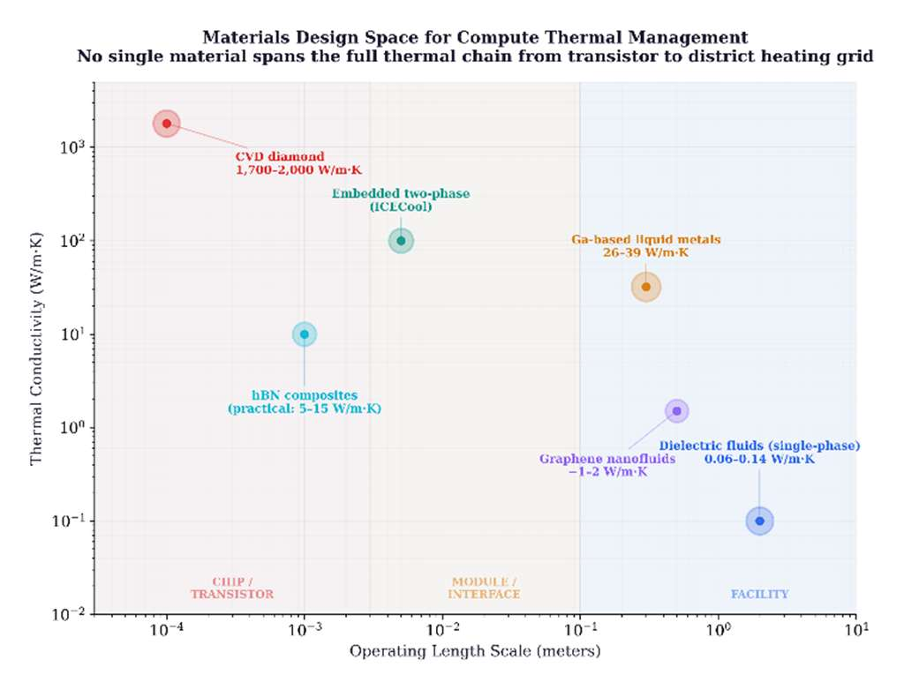
Figure 5. Three-generation materials comparison. Thermal conductivity (W/m·K) plotted against operating length scale for dielectric fluids, gallium-based liquid metals, graphene nanofluids, CVD diamond, and hBN composites. Each material class occupies a distinct region of the design space; no single material spans the full thermal chain from transistor to district heating grid.
9. Conclusion
The environmental debate around compute has been framed as a consumption problem. This framing is incomplete. Every watt consumed by a processor exits as heat, and the materials chosen to manage that heat determine whether it is wasted or captured as a co-product with industrial value—warming homes, growing food, replacing fossil fuels, and eliminating freshwater consumption.
First-generation dielectric fluids (0.06–0.14 W/m·K) enabled the temperature gradient breakthrough: raising waste heat output from 25–35 °C to 65–75 °C, crossing the district heating threshold and eliminating heat pumps. Six operational deployments validate this approach with estimated CO2 displacement of 2,000–3,800 tonnes per 1.7 MW container per year, though independently verified emissions data exists for only one deployment. Second-generation gallium-based liquid metals (26–39 W/m·K) offer a 200–600× thermal conductivity improvement with experimentally demonstrated 60–68% temperature reduction under pulsed loads, but face engineering challenges in corrosion, electrical conductivity, surface tension, and geopolitically concentrated supply chains. Third-generation embedded two-phase cooling, demonstrated at 1 kW/cm2 under ICECool, points toward chip-level thermal management at heat flux densities that facility-level immersion cannot reach, with exit temperatures tunable for district heating integration.
Intellectual honesty requires acknowledging limits. Heat reuse does not make Bitcoin mining carbon-neutral. The renewable share is 52%, not 100%. ASIC hardware obsolescence generates an estimated 15,000–30,000 tonnes of e-waste annually. The heat-reuse benefits documented here are primarily applicable in cold climates with existing district heating infrastructure; they do not generalize to tropical or subtropical deployments. And the gallium-based systems that represent the materials frontier remain largely at laboratory and niche-consumer scale, not facility-scale deployment.
What is clear is the trajectory. The sector that received the most environmental scrutiny—Bitcoin mining—has made the most environmental progress, pioneering renewable power sourcing, immersion cooling, and heat reuse years before the AI industry confronted the same challenges at larger scale. The solutions developed under criticism are becoming the industry standard. The materials design frontier documented here—from dielectric fluids to gallium to embedded phase-change systems—is the engineering path along which that progress will continue.
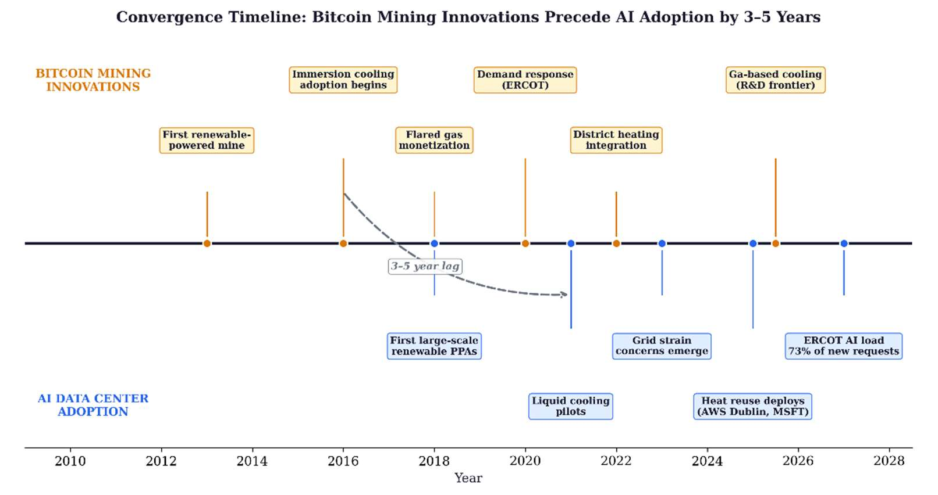
Figure 6. Convergence timeline. Bitcoin mining thermal innovations (above axis) consistently precede AI data center adoption of the same technologies (below axis) by 3–5 years across cooling materials, power sourcing, and heat reuse.
. Acknowledgments
The author acknowledges Cambridge Centre for Alternative Finance, Power Mining, MARA, Canaan, MintGreen, and the operators of the Tallaght District Heating Scheme (Heat Works, Dublin) for publicly documented data.
. Use of AI-Assisted Tools
The author used Anthropic Claude (Opus) for editorial revision, structural reorganization, image production, and formatting. All analytical content, materials science review, engineering analysis, and conclusions are the author's work. Source identification and selection were performed by the author; the AI tool was used to organize and cross-reference sources the author had already collected.
. References
[1] Cambridge Centre for Alternative Finance, "Cambridge Digital Mining Industry Report," Apr. 2025.
[2] Cambridge Blockchain Network Sustainability Index (CBECI), ccaf.io/cbnsi/cbeci, Sep. 2025.
[3] International Energy Agency, "Electricity 2024: Analysis and Forecast to 2026," IEA, Paris, 2024.
[4] Euroheat & Power, "District Heating in the Nordic Countries," 2024.
[5] "Power Mining's Bitcoin-heated shipping containers warm Scandinavian homes," DataCenterDynamics, Feb. 2026.
[6] "Canaan's liquid-cooled mining system heats Manitoba greenhouse," The Block, Jan. 2026.
[7] Environmental and Energy Study Institute, "Data Centers and Water Consumption," EESI Fact Sheet, 2023.
[8] P. Ren et al., "Explained: Generative AI's environmental impact," MIT News, Jan. 2025.
[9] 3M, "Novec Engineered Fluids for Immersion Cooling," Product Technical Datasheet, 2024.
[10] Shell, "Immersion Cooling Fluid S5 X," Product Technical Datasheet, 2025.
[11] Engineered Fluids, "ElectroCool Dielectric Coolant," Product Technical Datasheet, 2024.
[12] European Chemicals Agency, "Restriction proposal for per- and polyfluoroalkyl substances (PFAS)," REACH Annex XV Restriction Report, 2023.
[13] European Parliament and Council, "Energy Efficiency Directive (recast)," Directive (EU) 2023/1791, Sep. 2023.
[14] "MintGreen's digital boiler heats Lonsdale Energy buildings," MARA, Oct. 2025.
[15] "AWS data center heats Dublin university campus," CNBC, Jan. 2026. TU Dublin independent CO2 measurement: 704 tCO2 abated, 2024.
[16] EnergiRaven and Viegand Maagøe, "Data center waste heat potential: 3.5 million homes by 2035," 2025.
[17] U.S. EPA, "New Source Performance Standards (NSPS), Subpart OOOO/OOOOa," enclosed combustion 95–99% destruction efficiency.
[18] World Economic Forum, "The $3.3 trillion question: Can digital infrastructure drive sustainable growth?" Oct. 2025.
[19] L. Boteler, M. Fish, M. Berman, J. Wang, "Understanding Trade-offs of Phase Change Materials for Transient Thermal Mitigation," IEEE 18th ITHERM Conference, 2019.
[20] "Optimization of Ga-based liquid metal thermal interface materials," Int. J. Heat Mass Transfer, 2024. LM-TIM conductivity: 29.6–38.5 W/m·K.
[21] Patsnap/Eureka, "Liquid Metal Cooling for AI Accelerators: Technical Review," Aug. 2025. Ga-based systems: 16–86 W/m·K.
[22] L. Shao et al., "Figure-of-merit for phase-change materials used in thermal management," Int. J. Heat Mass Transfer, vol. 101, pp. 764–771, 2016.
[23] D. Gonzalez-Nino et al., "Experimental evaluation of metallic phase change materials for thermal transient mitigation," Int. J. Heat Mass Transfer, vol. 116, pp. 512–519, 2018.
[24] K.-Q. Ma, J. Liu, "Nano liquid-metal fluid as ultimate coolant," Physics Letters A, vol. 361, pp. 252–256, 2007.
[25] 360iResearch, "Liquid Metal Thermal Interface Material Market Report," 2025. $305.9M (2025), $479.7M projected (2032), 6.63% CAGR.
[26] R.R. Moskalyk, "Gallium: the backbone of the electronics industry," Minerals Engineering, vol. 16, pp. 921–929, 2003.
[27] USGS, "Gallium," Mineral Commodity Summaries, 2024.
[28] A. Bar-Cohen et al., "The ICECool Fundamentals Effort on Evaporative Cooling of Microelectronics," IEEE Trans. Compon. Packag. Manuf. Technol., vol. 11, no. 10, pp. 1546–1564, Oct. 2021.
[29] Y.-G. Deng, J. Liu, "Corrosion development between liquid gallium and four typical metal substrates used in chip cooling device," Appl. Phys. A, vol. 95, pp. 907–915, 2009.
[30] C. Zhang et al., "Study on the nucleating agents for gallium to reduce its supercooling," Int. J. Heat Mass Transfer, vol. 148, Art. no. 119055, 2020.
[31] T. Guan, M. Guo, L. Wang, J. Liu, "Production and recycling of the cutting edge material of gallium: A review," Sci. Total Environ., vol. 971, Art. no. 179046, 2025.
[32] PRC Ministry of Commerce, "Export control announcement on gallium and germanium," Jul. 2023.
[33] P. Birbarah, T. Gebrael, T. Foulkes, A. Stillwell, A. Moore, R. Pilawa-Podgurski, N. Miljkovic, "Water immersion cooling of high power density electronics," Int. J. Heat Mass Transfer, vol. 147, Art. no. 118918, 2020. doi:10.1016/j.ijheatmasstransfer.2019.118918.
[34] T. Yang, B. Kwon, P.B. Weisensee, J.G. Kang, X. Li, P. Braun, N. Miljkovic, W.P. King, "Millimeter-scale liquid metal droplet thermal switch," Appl. Phys. Lett., vol. 112, no. 6, Art. no. 063505, 2018. doi:10.1063/1.5013623.
[35] T. Yang, T. Foulkes, B. Kwon, J.G. Kang, P.V. Braun, W.P. King, N. Miljkovic, "An integrated liquid metal thermal switch for active thermal management of electronics," IEEE Trans. Compon. Packag. Manuf. Technol., vol. 9, no. 12, pp. 2341–2351, 2019.
[36] T. Gebrael, J. Li, A.R. Gamboa, J. Ma, J. Schaadt, L. Horowitz, R. Pilawa-Podgurski, N. Miljkovic, "High-efficiency cooling via the monolithic integration of copper on electronic devices," Nature Electronics, vol. 5, no. 6, pp. 394–402, 2022. doi:10.1038/s41928-022-00748-4.
[37] M.C. Rajagopal, H.C. Chang, T. Man, G. Kuntumalla, Y. Meng, S. Sundar, H. Zhao, S. Salapaka, C. Shao, P. Ferreira, N. Miljkovic, S. Sinha, "Materials-to-device design of hybrid metal-polymer heat exchanger tubes for low temperature waste heat recovery," Int. J. Heat Mass Transfer, vol. 143, Art. no. 118497, 2019.
Note on literature scope: The literature review was conducted across materials science, thermal engineering, energy systems, and digital asset databases. The author does not claim the reference set is exhaustive. Readers should consult Deng and Liu, Liquid Metals for Advanced Energy Applications (AIP Publishing, 2022) and Advanced Liquid Metal Cooling (Springer, 2024) for additional references.

